

L&T Finance Ltd.

Fortinet Firewall Signoff & Applied Policy Details

Title | Fortinet Firewall Deployment – Mahape (Navi Mumbai)
Category | Customer Requirement | Customer Name: L&T Finance Ltd.
Date | 27-03-2025
Created By | Atharva Sathe

Table of Contents

Sr. No. | Contents
1 | Perimeter Firewall Design
2 | Scope of Work
3 | Handover
4 | Project Closure

\

Perimeter Firewall Design

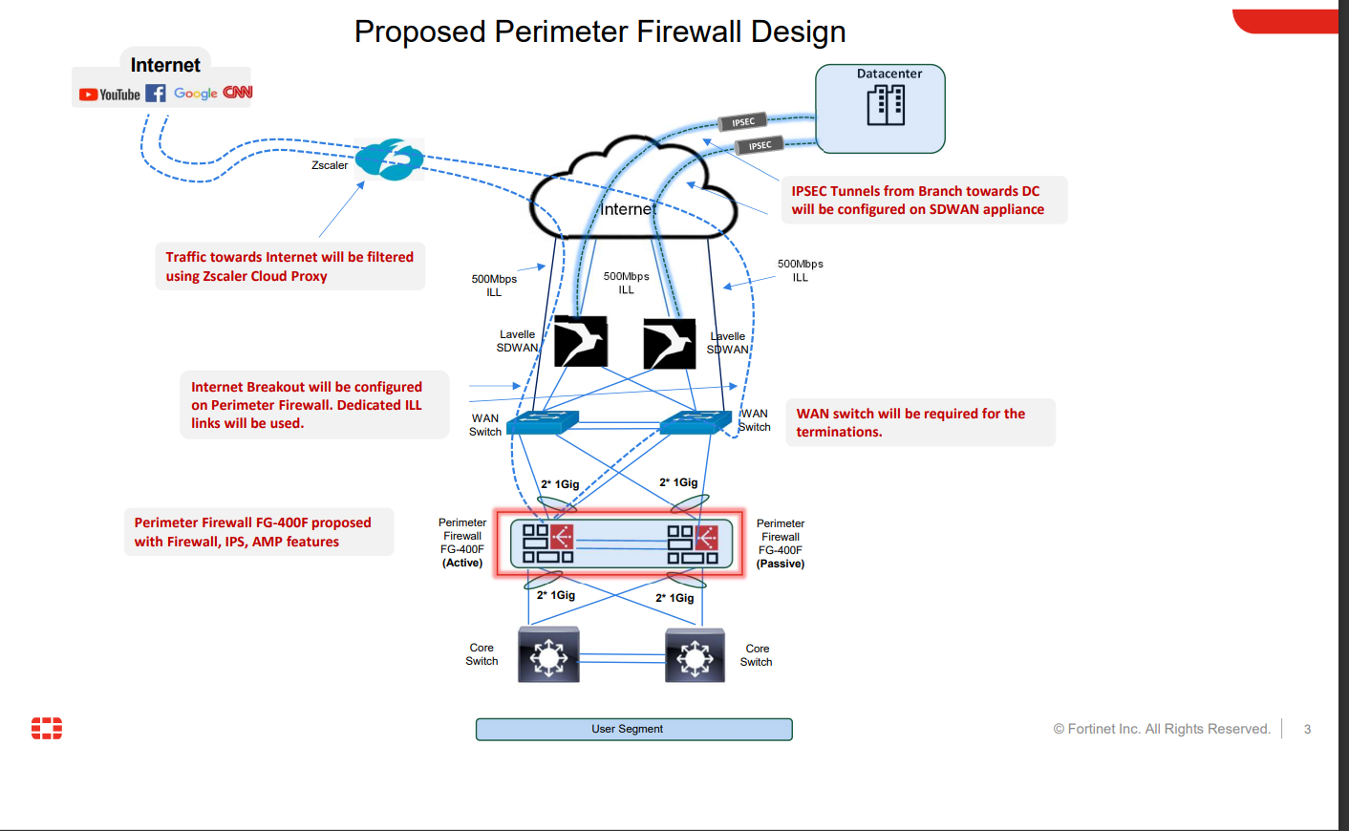

Configuration & Migration Scope of Work (Firewall)

Sr No. | Description | SOW | Comments
1 | Background | Perimeter Firewall | Mahape (New Mumbai)
2 | Installation and Hardware Setup : (POST) | Rack, stack & mounting of FortiGate 400F appliance and connecting power, network cables to perform POST.
3 | Initial Configuration | Access the FortiGate web- based manager or command line interface (CLI).  Perform basic initial configurations, including setting the system hostname, time zone, and administrator  credentials.
4 | OS Upgradation | Upgrading to latest OS recommended by OEM
5 | Migration configuration | Migrating existing Sonicwall/Fortigate to Fortigate 400F | Migration will be as-is from existing configuration.
5 | Basic Routing | Import or creating the routes for basic connectivity between networks
6 | Security Policies | Define and implement security policies based on organizational requirements upto 10 new policies of firewall rules, routing rules & NAT policies. | For more policies, please indicate.
7 | Object Creations | Objects and group creation | We have assumed 30 new objects.
9 | HA Configuration | Active-Passive | Already configured
10 | Testing and Verification | Conduct testing of the firewall configurations.  Verify the functionality of firewall rules, VPN connections. | - The Airtel ILL was assigned a port number of 2 and an IP address associated with the gateway. The second Airtel ILL was assigned the shared IP address and was placed on port 8.  - Both firewalls have been backed up from their initial configuration. The default policy has been setup.  - You checked and were able to connect to the firewall via the WAN IP.
11 | GO-Live support | Support during Live Deployment and monitoring (2Days) | Firewall is live which Sanjay has confirmed.
12 | Knowledge Transfer | Knowledge Transfer Session will be provided
13 | Project Closure | Project Closure document will be provided

Handover
The Techsec Digital team will provide the Knowledge transfer session on the configuration of policies and provide the reports.
Project Closure
After successful completion of Wireless Access Point Implementation, User acceptance
test & handover of project technical documentation, both Techsec Digital and L&T Finance Ltd.
will sign the project completion milestone report.
Project Sign off
By signing this document, the client acknowledges that the work detailed above has
been completed as per the agreed Scope of Work (SOW) and is deemed satisfactory.

Name | Role | Signature | Date

By signing below, you agree to the terms and conditions listed in the scope of work above. No changes or additions to the scope of work will be accepted after the date that appears below. Additional work MUST be scheduled as a separate service by executing a Change Order, which may be chargeable.

