# 2022

## Base mode: (no break from 2022 till now)

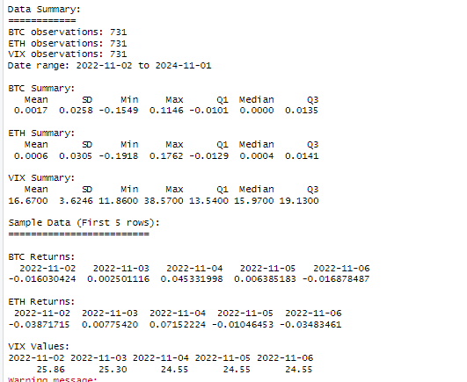

### Data:

"D:\VARX_BEKK\main_mean_model_nobreak\base_model_results.csv"

### Visualization:

## 23 Model with Break: (break with 2 year) 23:

start_date <- as.Date("2022-11-01")

end_date <- as.Date("2024-11-01")

break_date <- as.Date("2023-10-23")

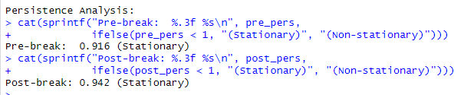

### Data :

"D:\VARX_BEKK\bekk_reults\crypto_analysis_results_23_nochange.csv"

### Visualization:

## 10 Model with Break: (break with 2 year) 10:

start_date <- as.Date("2022-11-01")

end_date <- as.Date("2024-11-01")

break_date <- as.Date("2023-01-10")

### Data:

"D:\VARX_BEKK\bekk_reults\crypto_analysis_results_10_nochnage.csv"

### Visualization:

# 2022 (FINAL)

## Break as 23:

### Data:

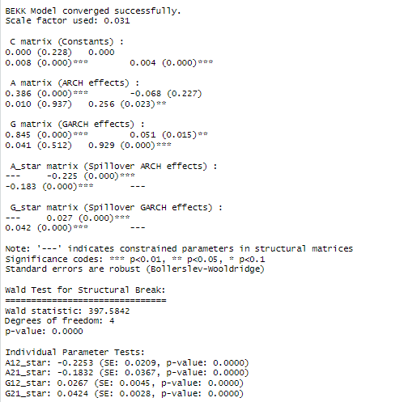

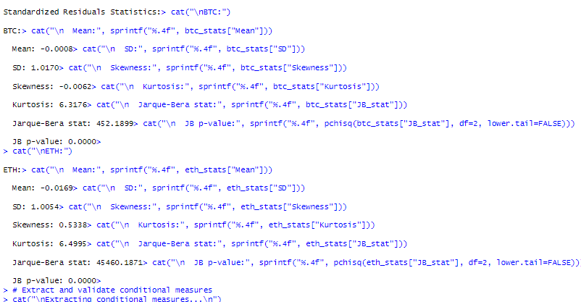

### Visualization:

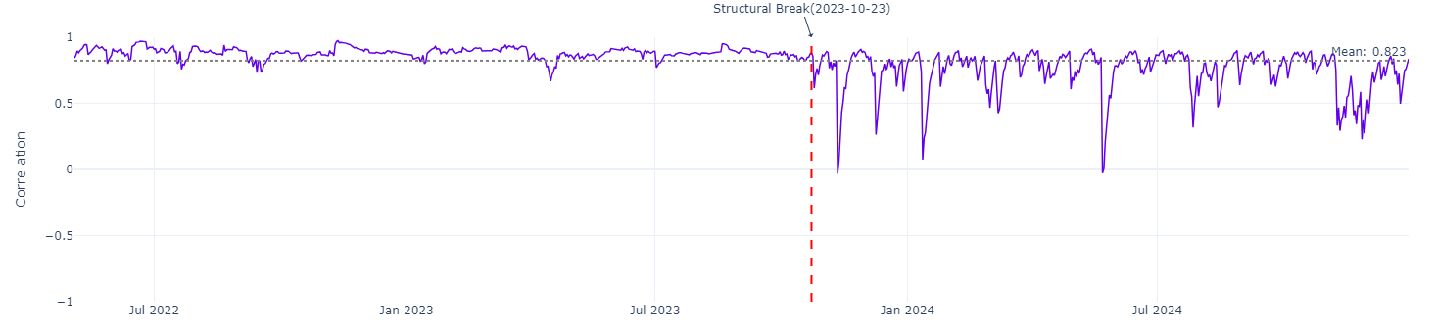

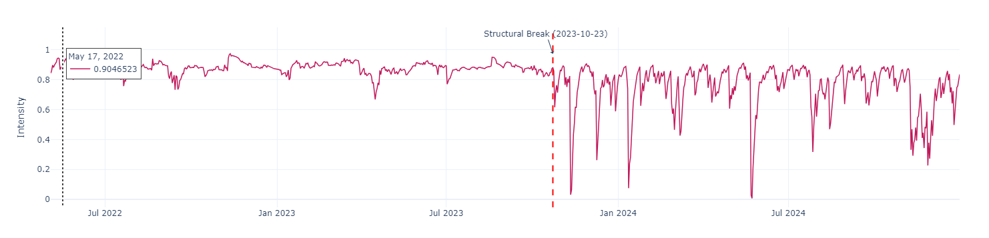

## Break as 10:

# 2020

## Base mode: (no break from 2020 till now)

start_date <- as.Date("2020-11-01")

end_date <- as.Date("2024-12-19")

### Data:

"D:\VARX_BEKK\main_mean_model_nobreak\base_model_results.csv"

### Visualization:

BTC vs ETH Returns

BTC vs ETH Volatility

## 23 Model with Break: (break with 5 year) 23:

start_date <- as.Date("2020-01-01")

end_date <- as.Date("2024-12-22")

break_date <- as.Date("2023-10-23")

### Data:

"D:\VARX_BEKK\bekk_reults\crypto_analysis_23_extended_end.csv"

### Visualization:

## 10 Model with Break: (break with 5 year) 10:

start_date <- as.Date("2020-01-01")

end_date <- as.Date("2024-12-22")

break_date <- as.Date("2024-01-10")

### Data:

"D:\VARX_BEKK\bekk_reults\crypto_analysis_10_extended_end.csv"

### Visualization: