**(PRACTISE SET OF SQL QURERIES) *D.KAVITA***

Q1.Retrieve names of the students enrolled in any course.

SELECT STUDENT.student_name FROM STUDENT;

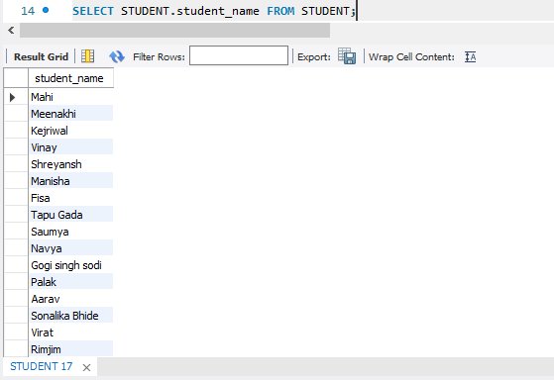

Q2. Retrieve names of the students enrolled in at least one part time course.

SELECT STUDENT.student_name from STUDENT

WHERE STUDENT.roll_no in (select distinct ADMISSION.roll_no from

ADMISSION

left join COURSE

ON ADMISSION.CID=COURSE.CID

WHERE COURSE.course_type="parttime");

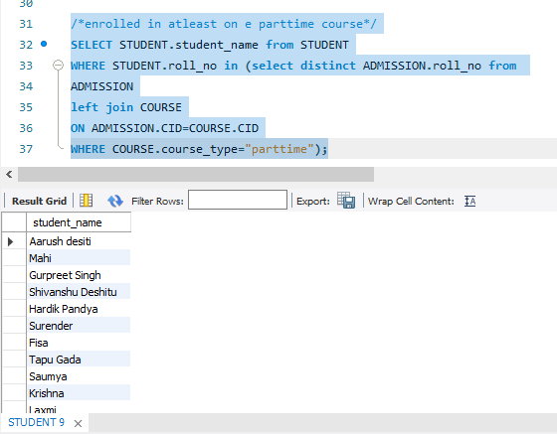

Q3.Retrieve student’s names starting with letter “A”.

SELECT student_name FROM STUDENT

WHERE student_name LIKE "A%";

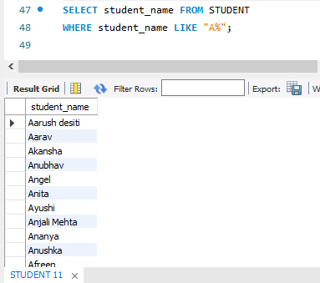

Q4. Retrieve student’details studying in course “coumputer science” or “chemistry”.

SELECT STUDENT.roll_no,STUDENT.student_name,CID,DOB,course_name,course_type FROM

STUDENT JOIN COURSE

ON STUDENT.course_ID=COURSE.CID

WHERE course_name="computer science" or course_name="chemistry" ;

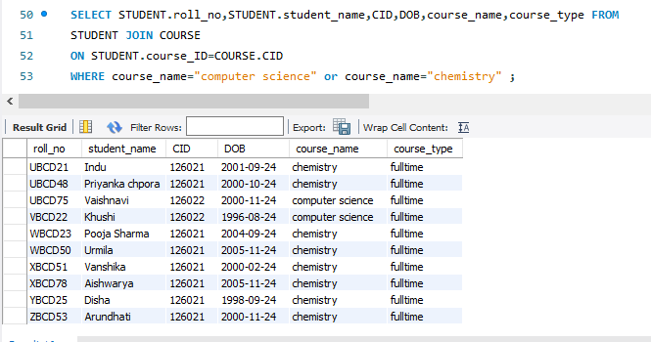

Q5.Retrieve student’s names whose roll no either starts with “X” or “Z” and ends with “9”.

SELECT roll_no,student_name FROM STUDENT

WHERE (roll_no LIKE "X%" OR roll_no LIKE "Z%") AND roll_no LIKE "%9" ;

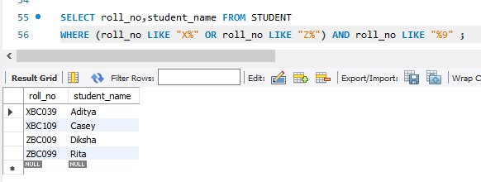

Q6.Update student table for modifying a student name.

UPDATE STUDENT

SET student_name="Arwind Kejriwal"

WHERE roll_no="ABCD54";

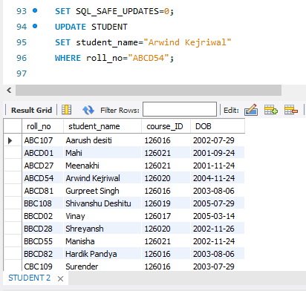

Q7.Find course name in which more than five sudents have enrolled.

SELECT COURSE.*, D.CID_Count FROM COURSE

JOIN

(SELECT CID,COUNT(CID) AS CID_count FROM ADMISSION

GROUP BY CID ) AS D

ON COURSE.CID=D.CID

HAVING CID_count>5;

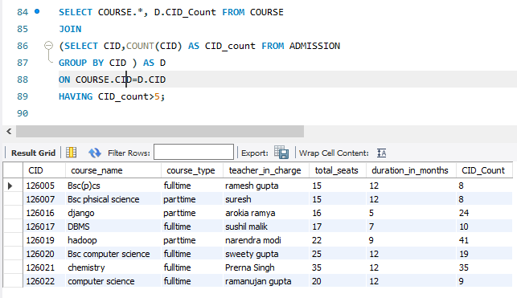

Q8.Find the name of the youngest student enrolled in course “Bsc(P)CS”.

SELECT STUDENT.student_name,course_name,AGE FROM

STUDENT JOIN COURSE

ON STUDENT.course_ID=COURSE.CID

WHERE course_name="Bsc(p)cs"

ORDER BY AGE ASC LIMIT 1;

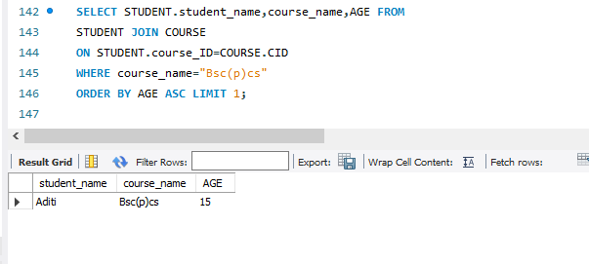

Q9.Find the name of the most popular society (on the basis of enrolled students).

SELECT COURSE.course_name FROM COURSE

WHERE No_of_enrollments=(SELECT max(No_of_enrollments) FROM COURSE);

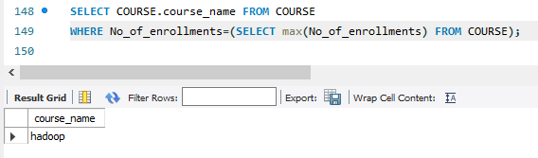

Q10.Find the name of two popular parttime course (on the basis of enrolled students).

SELECT course_name,No_of_enrollments FROM COURSE

WHERE course_type="parttime"

ORDER BY No_of_enrollments DESC LIMIT 2;

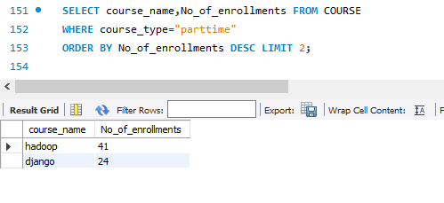

Q11.Find the student names who are admitted to full time course only.

SELECT roll_no,student_name FROM STUDENT

WHERE roll_no not in (SELECT roll_no FROM COURSE

RIGHT JOIN ADMISSION

ON COURSE.CID=ADMISSION.CID

WHERE course_type="parttime") ;

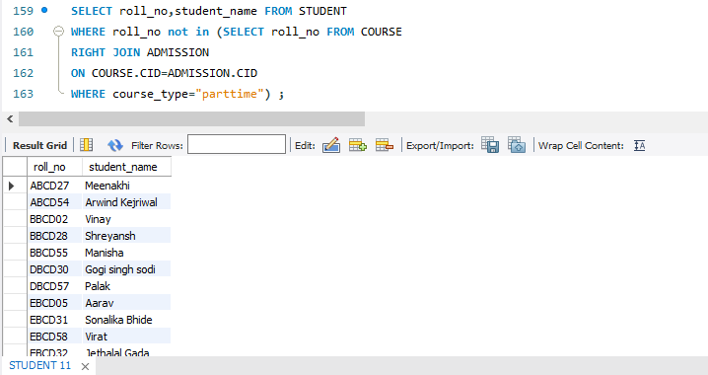

Q12.Find course names in which more than 30 students took admission.

SELECT CID,course_name,No_of_enrollments FROM COURSE

WHERE No_of_enrollments>30;

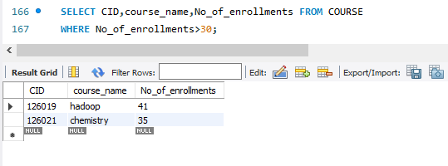

Q13.Find the name of all students who took admision to any course and course names in which at least one student has enrolled.

SELECT student_name FROM STUDENT

WHERE course_ID is not null;

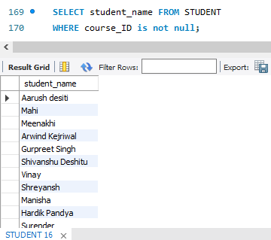

SELECT course_name,No_of_enrollments FROM COURSE

WHERE No_of_enrollments>0;

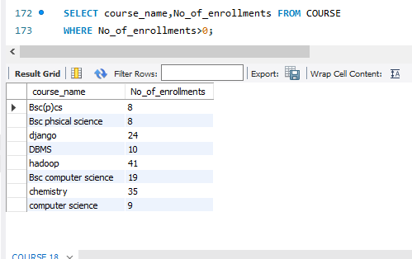

Q14.Find course names where teacher_in_charge has “gupta” as surname and the course is full time.

select CID,course_name,course_type,teacher_in_charge from COURSE

WHERE teacher_in_charge LIKE "%gupta" AND course_type="fulltime";

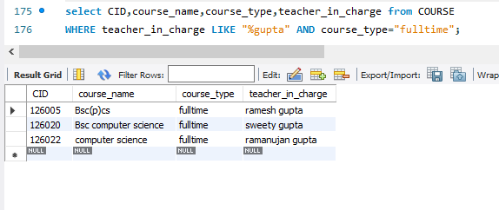

Q15.Find course names in which the number of enrolled students is only 10% of its total seats.

SELECT CID,course_name,total_seats,No_of_enrollments FROM COURSE

WHERE No_of_enrollments=total_seats*0.1;

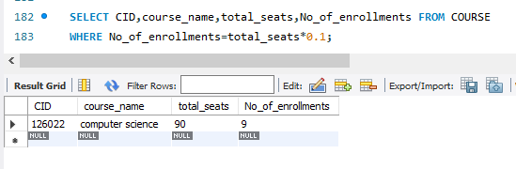

Q16.Display the vacant seats for each course.

SELECT CID,course_name,total_seats,No_of_enrollments,

(total_seats - No_of_enrollments) as Vacant_seats

FROM COURSE;

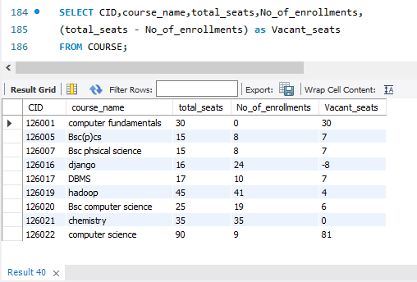

Q17.Increment total seats of each course by 20%.

UPDATE COURSE

SET total_seats=total_seats+(total_seats*0.2);

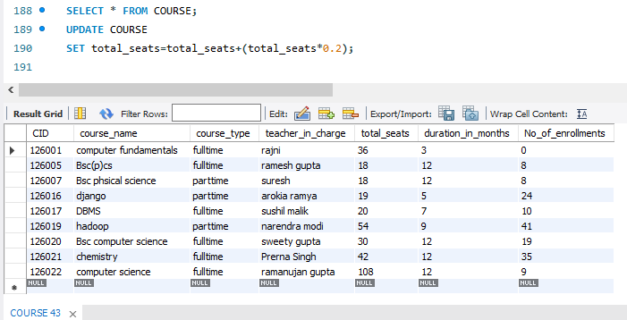

Q18.Add enrollment fees paid (“yes”/”no”) field in the enrollment table.

UPDATE ADMISSION

SET Fee_Paid= CASE WHEN RAND()<=0.8 THEN "YES" ELSE "NO" END;

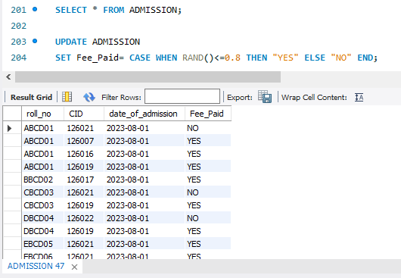

Q19.Update the date of admission for all courses by 1 year.

UPDATE ADMISSION

SET date_of_admission = DATE_ADD(date_of_admission,INTERVAL 1 YEAR) ;

BEFORE

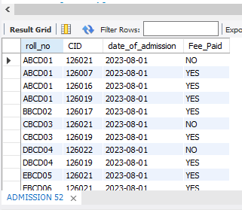

AFTER

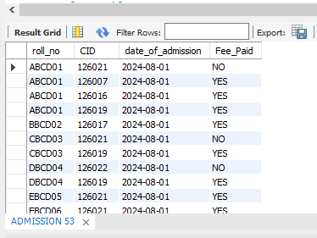

Q20.Count the number of courses with more than 5 students enrolled for each type of course.

SELECT count(CID) FROM COURSE

WHERE No_of_enrollments>5;

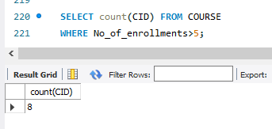

Q21.Add column mobile number in student table with default value “9999999999”.

ALTER TABLE STUDENT

ADD COLUMN Mobile_no varchar(10) default 9999999999;

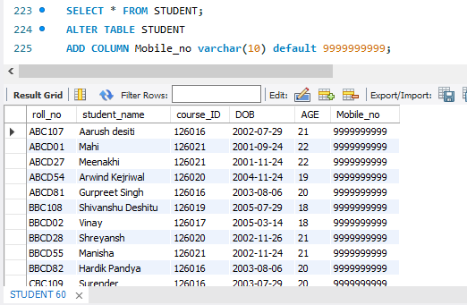

Q22.Find the total number of students whose age is>18.

SELECT count(*) AS ADULTS FROM STUDENT

WHERE AGE>18;

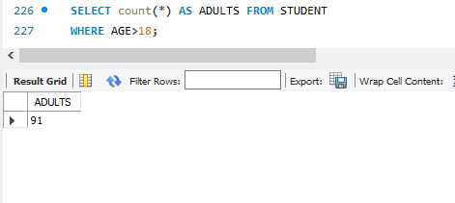

Q23.Find the names of students who are born in 2001 and are admitted to at least one part time course.

SELECT DISTINCT STUDENT.roll_no,student_name,DOB,course_type FROM STUDENT

RIGHT JOIN

(SELECT ADMISSION.*,COURSE.course_type FROM

ADMISSION LEFT JOIN COURSE

ON ADMISSION.CID=COURSE.CID) as D

ON STUDENT.roll_no=D.roll_no

WHERE YEAR(DOB)=2001 AND D.course_type="parttime";

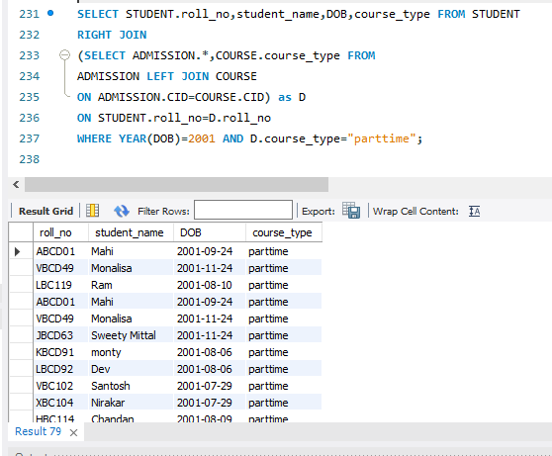

Q24.Count all courses having “science” in the name and staring with the word “B.sc”.

SELECT * FROM COURSE

WHERE course_name LIKE "Bsc%" AND course_name LIKE "%science%";



