OutOfMemoryError-Demo

import java.util.ArrayList;

public class Main {

public static void main(String[] args)throws Exception {

ArrayList<Integer> ar=new ArrayList<Integer>();

int i=0;

while(true){

ar.add(i);

i++;

}

}

}

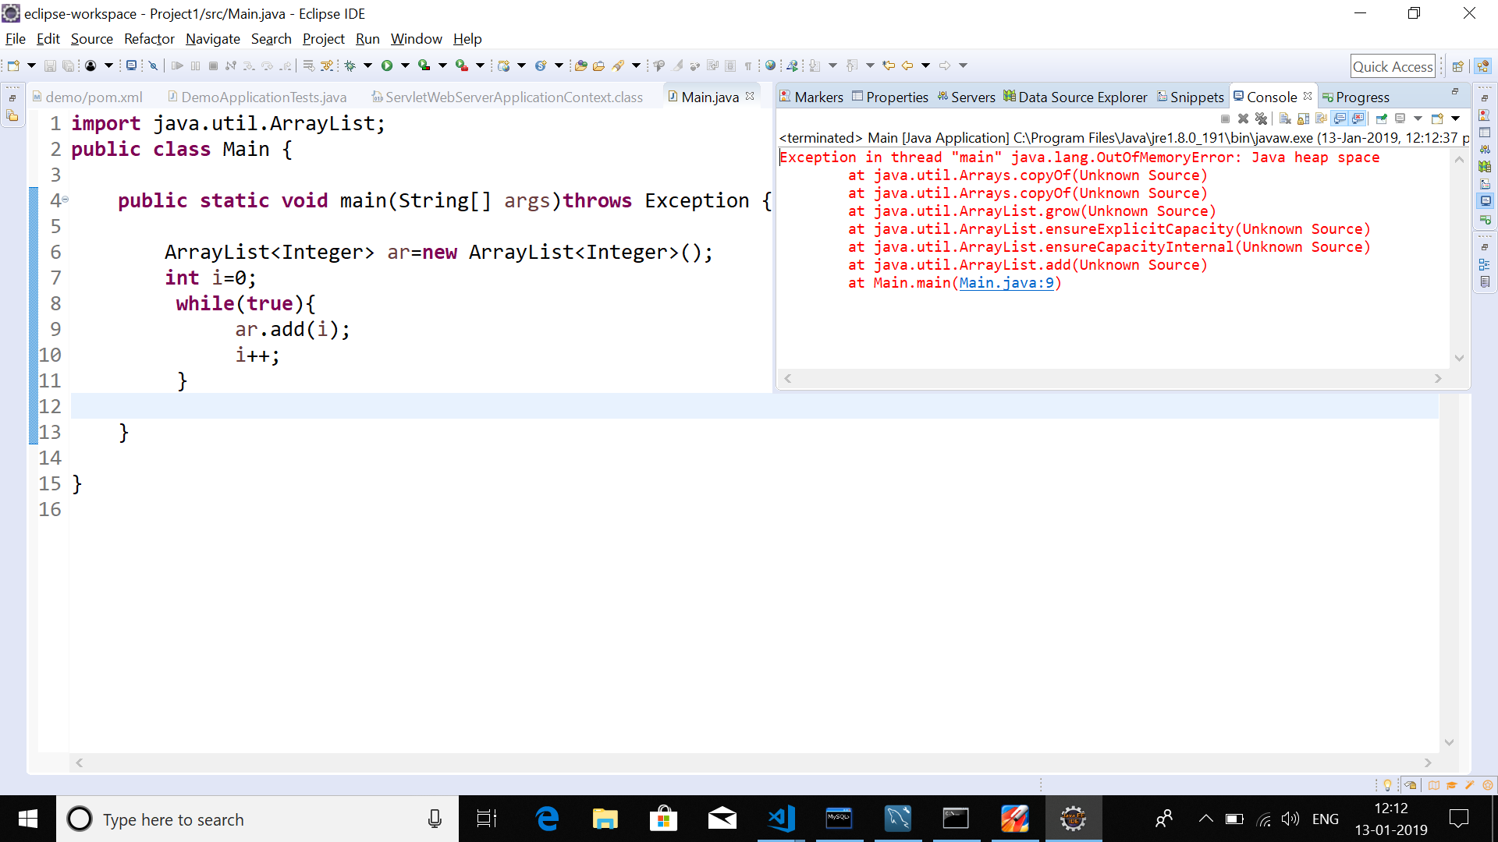

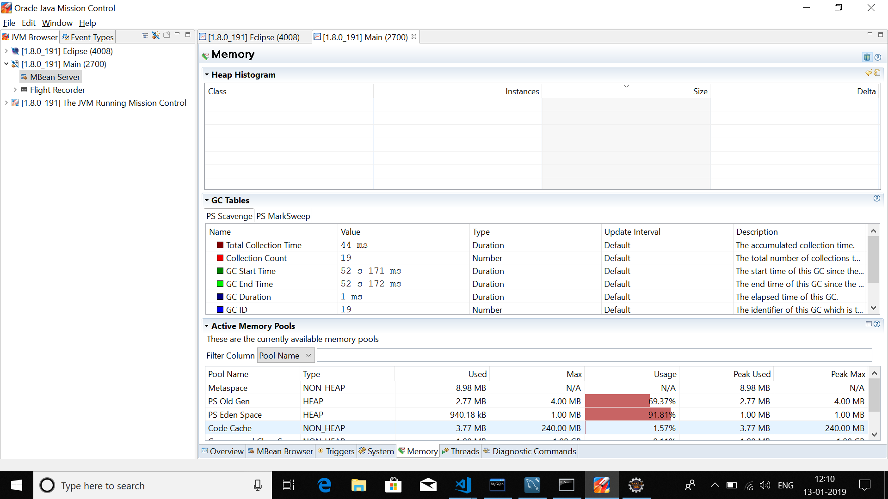

SpringBoot Project:

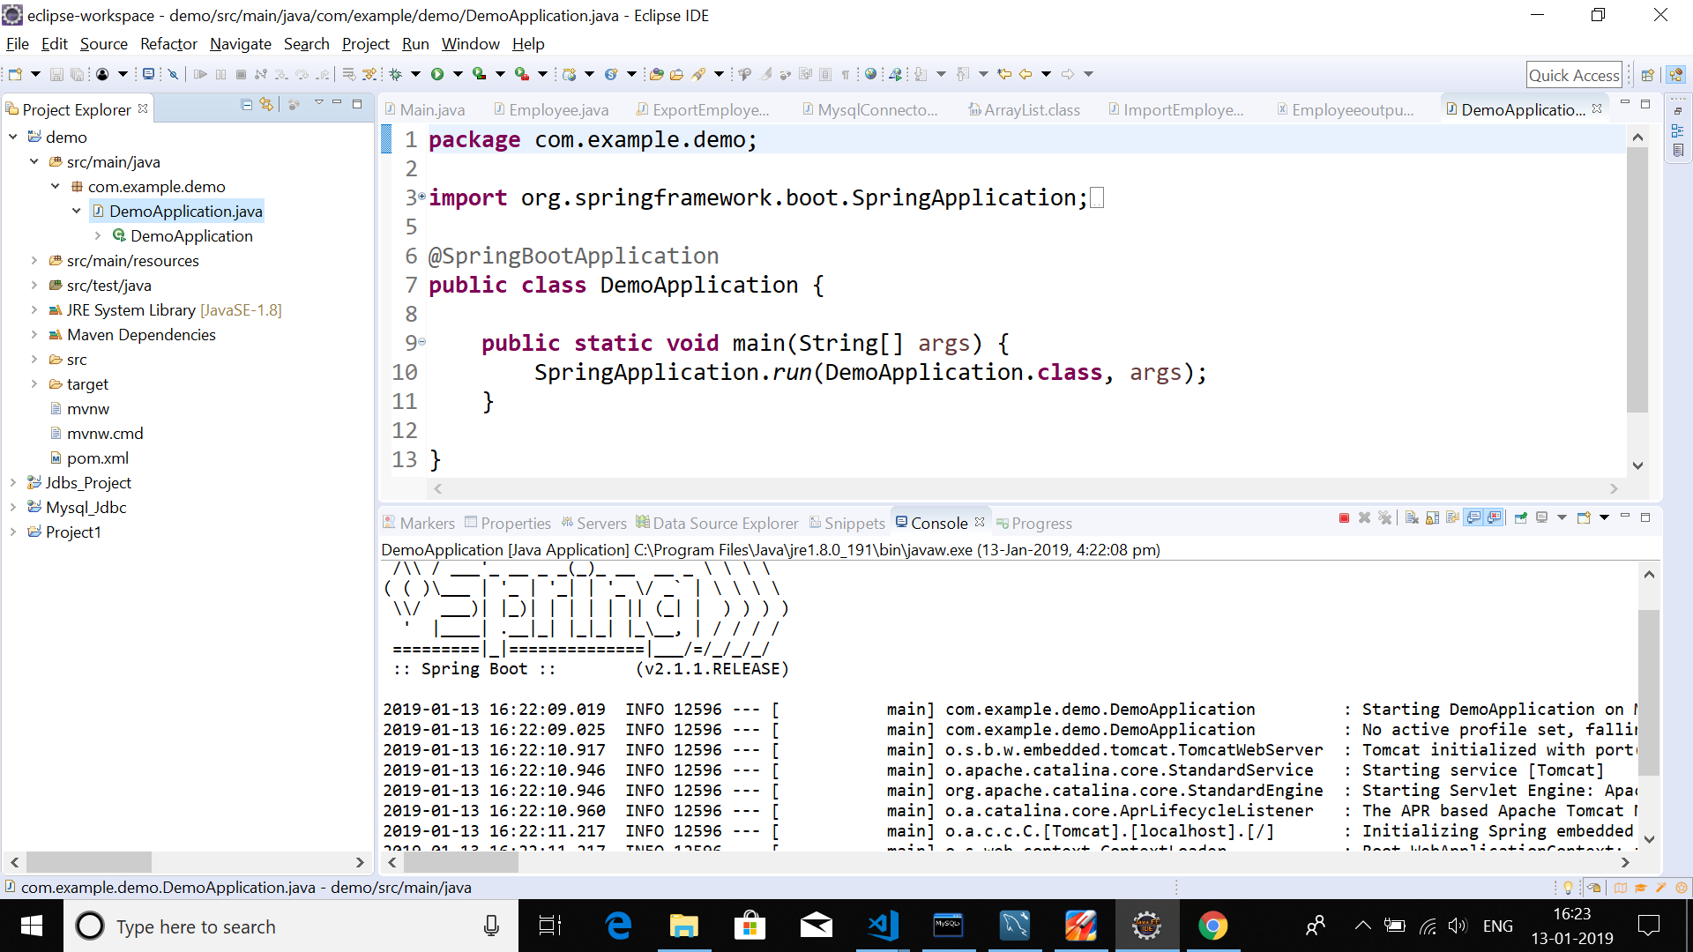

SpringBoot project Default Heap Sizes;

