Course Title: Advanced Database Systems

PORTFOLIO 3: TRANSACTIONS AND CONCURRENCY CONTROL
Course Code: MIT 8103
Project Title: University Student Result Management System
Name: Agbo Gad-David Oyioche
Matriculation Number: 2026/A/MIT/0495
Programme: Master of Information Technology
Database Management System: PostgreSQL
Database Name: university_result_db

1. Introduction
Transactions and concurrency control are important concepts in database management systems. Transactions allow a group of database operations to be executed as a logical unit, while concurrency control ensures that multiple users can access and modify data without compromising its consistency and integrity.
This portfolio demonstrates transaction management and concurrency control using PostgreSQL and the University Student Result Management System database. The practical exercises cover transaction rollback, commit operations, concurrent access from two database sessions, and row-level locking.

2. Objectives
The objectives of this practical exercise were to:
Demonstrate how PostgreSQL transactions work.
Use ROLLBACK to cancel an uncommitted database change.
Use COMMIT to make a database change permanent.
Examine how two database sessions interact when accessing the same record.
Demonstrate the effect of uncommitted changes under the READ COMMITTED isolation level.
Demonstrate row-level locking using SELECT FOR UPDATE.
Maintain database consistency by restoring the original test data.

3. Tools and Environment
The following tools and components were used:
PostgreSQL relational database management system.
pgAdmin Query Tool for executing SQL statements.
Two Query Tool sessions connected to the same database.
The registrations table in the university_result_db database.
The academic_session column of the registrations table was used for controlled testing. Its data type is VARCHAR(9), so short test values were used to avoid exceeding the column's character limit.

4. Transaction Management and ROLLBACK

4.1 Description
A transaction is a sequence of database operations treated as a single logical unit of work. The ROLLBACK command cancels changes made during an active transaction that have not been committed.

4.2 SQL Implementation
BEGIN;

UPDATE registrations
SET academic_session = 'TEST2026'
WHERE registration_id = 1;

SELECT registration_id, academic_session
FROM registrations
WHERE registration_id = 1;

ROLLBACK;
After the rollback, the record was queried again to verify that the original academic session value had been restored.
SELECT registration_id, academic_session
FROM registrations
WHERE registration_id = 1;

4.3 Result
The temporary value was visible within the transaction, but the ROLLBACK operation cancelled the update. The original value, 2026/2027, was subsequently confirmed.
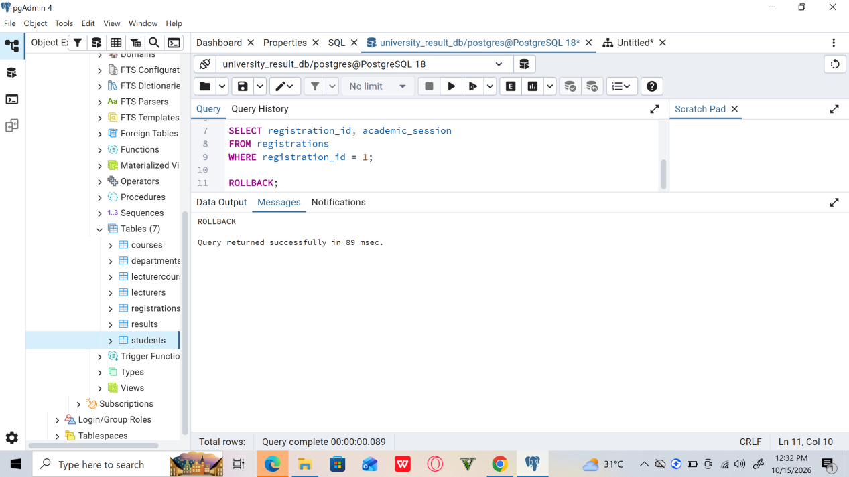

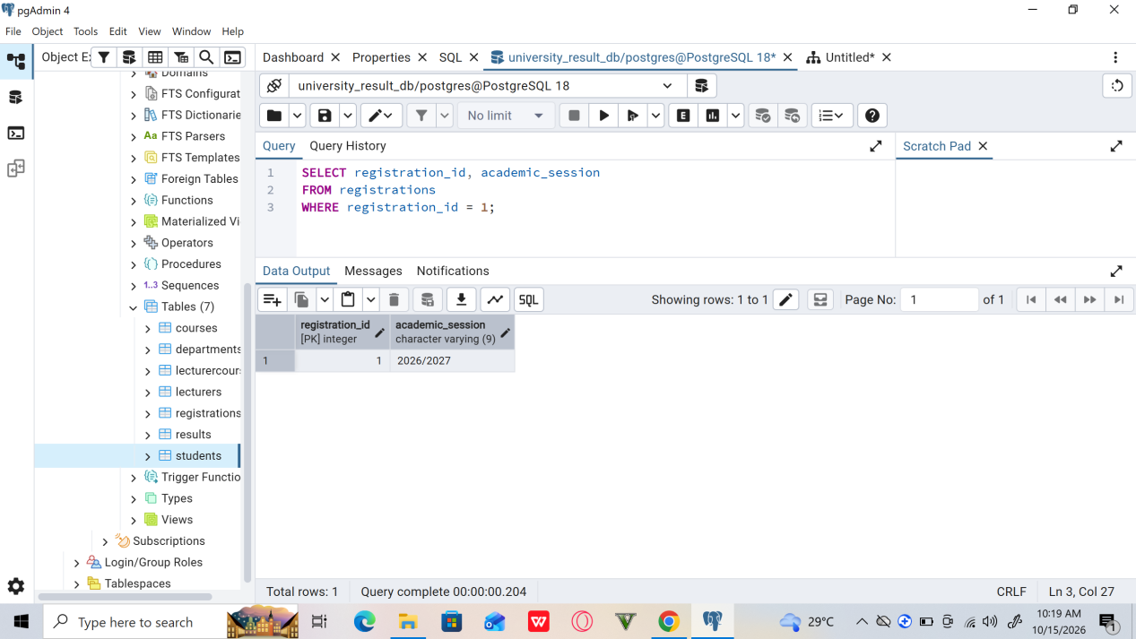

5. Transaction Management and COMMIT

5.1 Description
The COMMIT command permanently saves the changes made during an active transaction. Once committed, the changes are visible to other transactions according to the database's isolation rules and are not undone by a later ROLLBACK issued outside that transaction.

5.2 SQL Implementation
BEGIN;

UPDATE registrations
SET academic_session = 'COMMIT26'
WHERE registration_id = 1;

SELECT registration_id, academic_session
FROM registrations
WHERE registration_id = 1;

COMMIT;
The record was queried after the transaction to confirm the committed value.

5.3 Result
The value COMMIT26 was successfully saved and remained in the record after the transaction ended. This demonstrated that COMMIT makes a transaction's changes permanent.
The original academic session was then restored to 2026/2027, and the restored value was verified.

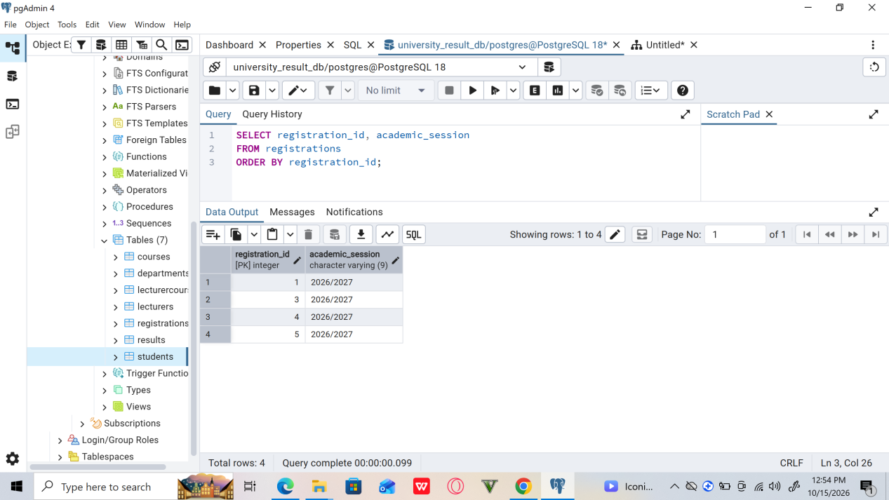

6. Concurrency Control Using Two Database Sessions

6.1 Description
Concurrency control manages simultaneous database operations from different sessions. PostgreSQL's default READ COMMITTED isolation level prevents a transaction from reading another transaction's uncommitted changes.

6.2 Session A: Uncommitted Update
The first Query Tool session started a transaction and modified the academic session for registration ID 1.
BEGIN;

UPDATE registrations
SET academic_session = 'TEST2026'
WHERE registration_id = 1;

SELECT registration_id, academic_session
FROM registrations
WHERE registration_id = 1;
Session A could see its own uncommitted update.

6.3 Session B: Reading the Record
While Session A's transaction remained open, a SELECT statement was executed in Session B.
SELECT registration_id, academic_session
FROM registrations
WHERE registration_id = 1;
Session B displayed the previously committed value, 2026/2027, rather than the uncommitted value from Session A.

6.4 Result
The experiment demonstrated that Session A could read its own changes while Session B continued to see the last committed version of the record. This behaviour is consistent with PostgreSQL's READ COMMITTED isolation level.
Session A was subsequently rolled back, and the original data was verified.
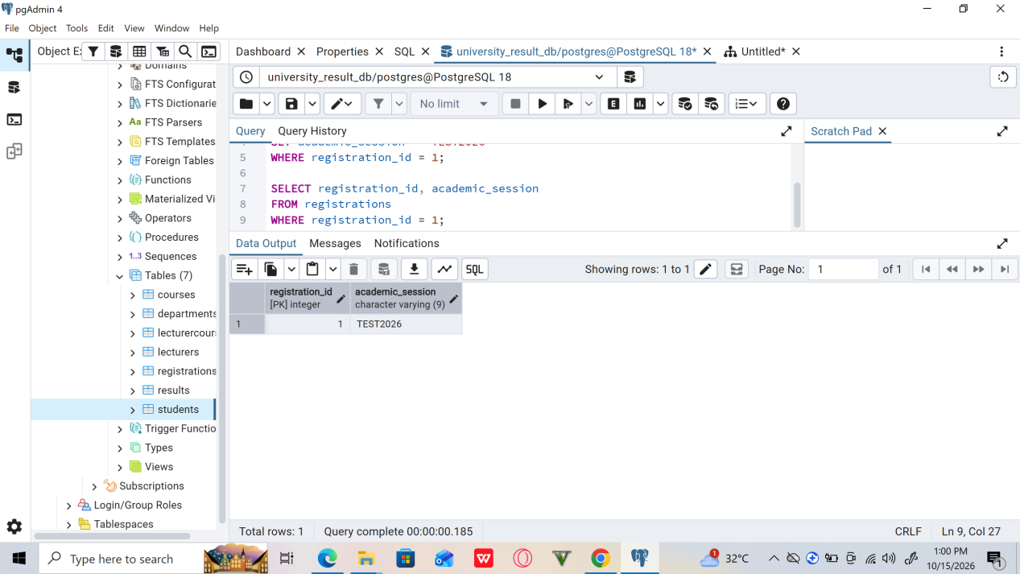
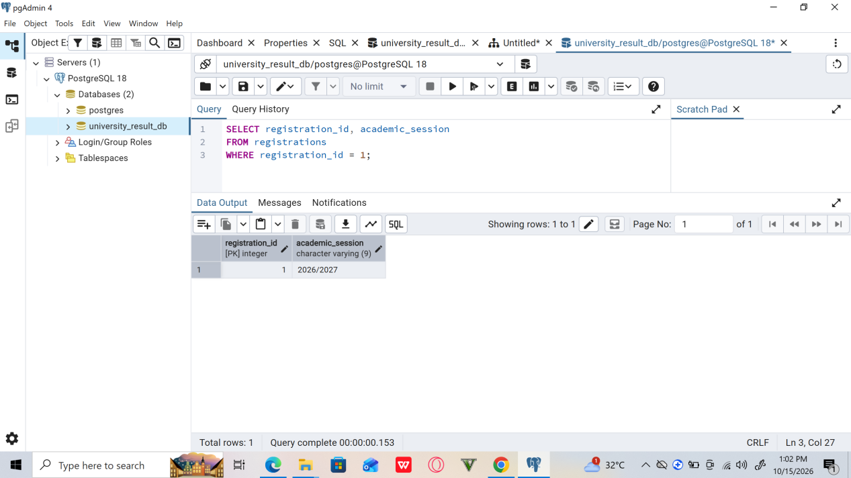
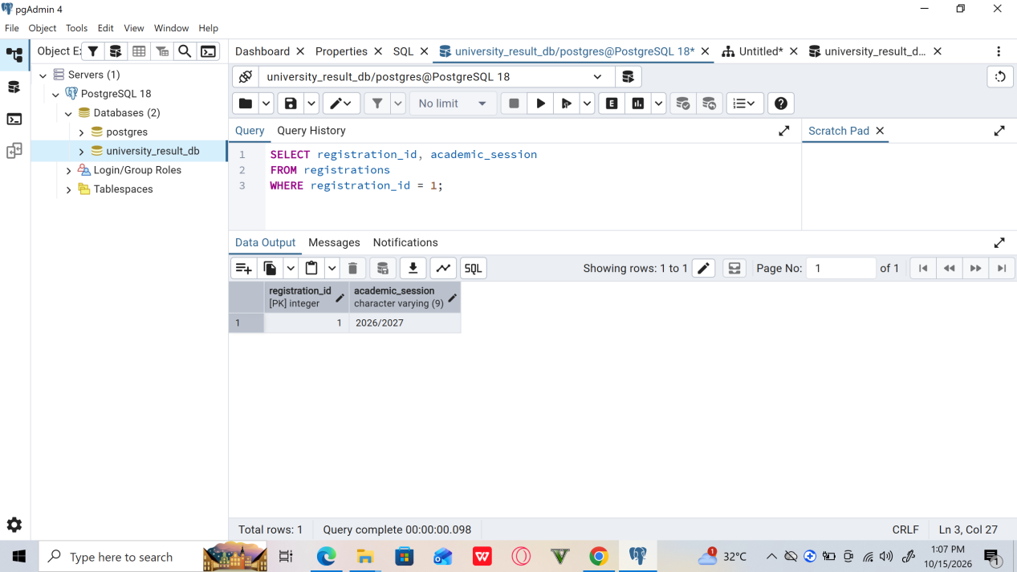

7. Row-Level Locking

7.1 Description
Row-level locking helps prevent conflicting transactions from modifying the same record simultaneously. PostgreSQL provides the SELECT FOR UPDATE statement to lock selected rows against conflicting updates and locking operations until the transaction ends.

7.2 SQL Implementation
In Session A, the record was selected for update within an active transaction.
BEGIN;

SELECT registration_id, academic_session
FROM registrations
WHERE registration_id = 1
FOR UPDATE;
In Session B, an update was attempted on the same record.
UPDATE registrations
SET academic_session = 'LOCKTEST'
WHERE registration_id = 1;

7.3 Result
Session A acquired a row-level lock on the selected record. Session B's conflicting update waited while the lock was held. After Session A's transaction ended with ROLLBACK, the waiting update was able to proceed.
The test transaction was then rolled back or the original value was restored, depending on the state of Session B. The final verification confirmed that the academic session was 2026/2027.
This experiment demonstrated how row-level locking coordinates conflicting operations and helps maintain data consistency.

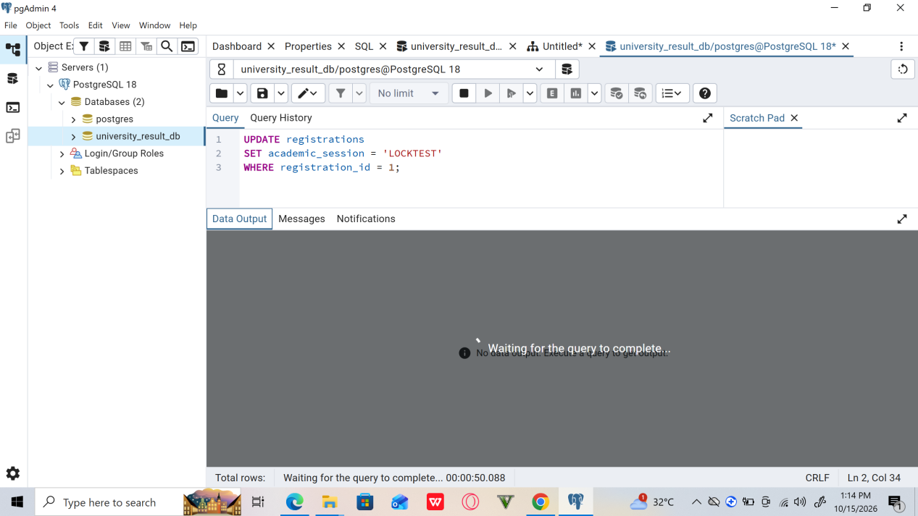

8. Findings and Discussion
The practical exercises demonstrated several important database concepts:
Transaction atomicity: ROLLBACK cancelled an uncommitted update, leaving the original data intact.
Permanent changes: COMMIT saved a transaction's update until a subsequent explicit change restored the original value.
Isolation: Session B did not see Session A's uncommitted update under READ COMMITTED.
Row-level locking: SELECT FOR UPDATE held a lock that caused a conflicting update from another session to wait.
Data integrity: Verification queries confirmed that the test record was restored after the experiments.
These exercises illustrate why transaction management and concurrency control are essential when multiple users interact with a database.

Conclusion
This portfolio successfully demonstrated transaction management and concurrency control using PostgreSQL. The ROLLBACK and COMMIT commands were used to distinguish between temporary and permanent changes. A two-session experiment demonstrated the behaviour of uncommitted data under READ COMMITTED isolation, while SELECT FOR UPDATE illustrated the use of row-level locking.
The exercises strengthened the understanding of transaction boundaries, isolation, locking, and database consistency. The original academic session value was restored after the experiments, leaving the test record in its expected state.

Recommendations
Use transactions for operations that involve related database changes.
Use ROLLBACK when an uncommitted operation must be cancelled.
Use COMMIT only after confirming that the intended changes are correct.
Select an appropriate transaction isolation level for each application's requirements.
Keep transactions as short as practical to reduce lock contention.
Verify data after practical tests and restore any temporary changes.
Apply suitable access controls and database constraints to protect data integrity.

