MIT 8103 – ADVANCED DATABASE SYSTEMS

PORTFOLIO 1: DATABASE DESIGN AND MODELING
Project Title: University Student Result Management System
Name: Agbo Gad-David Oyioche
Matriculation Number: 2026/A/MIT/0495
Programme: Master of Information Technology
Course Code: MIT 8103
Database Management System: PostgreSQL
Database Name: university_result_db

1.1 Introduction
The Entity Relationship Diagram (ERD) represents the logical structure of the University Student Result Management System. It illustrates the entities within the database, their attributes, and the relationships between them.
The database was designed using PostgreSQL to manage information about students, departments, lecturers, courses, course registrations, and academic results. The design aims to minimize unnecessary data duplication, maintain data integrity, and make information retrieval easier.

1.2 Objectives of the ER Diagram
The objectives of the ERD are to:
Identify the major entities required for the university result management system.
Define the attributes associated with each entity.
Identify primary keys and foreign keys.
Establish relationships between related entities.
Maintain referential integrity and reduce data redundancy.
Provide a clear blueprint for implementing the database in PostgreSQL.
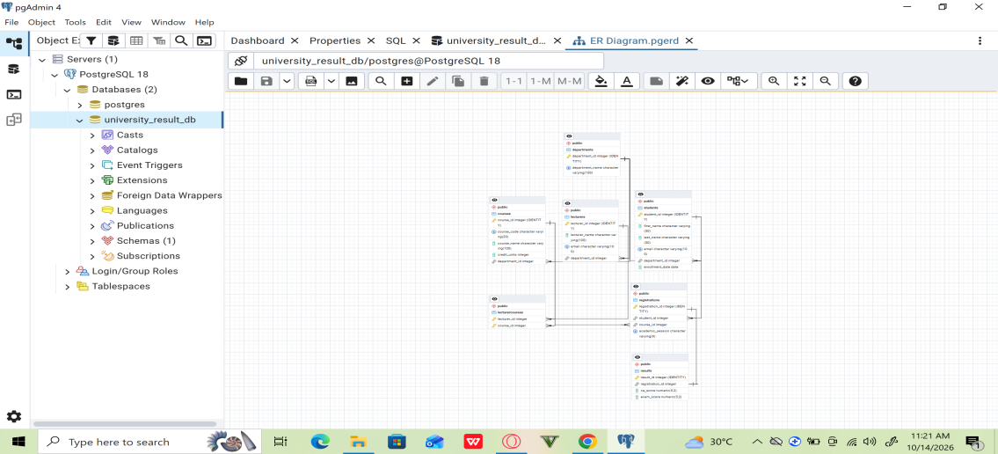
Figure 1: Entity Relationship Diagram of the University Student Result Management System.
1.3 Identification of Entities
The database consists of six main entities.

1. Departments
The Departments entity stores information about the academic departments within the university.
Its primary key is department_id, which uniquely identifies each department. The department information is referenced by related records in the Students, Lecturers, and Courses tables.

2. Students
The Students entity stores students' personal and academic registration information, such as their student identifier, names, email address, department, and enrollment date.
The primary key is student_id. The department_id foreign key links each student to the appropriate department.

3. Lecturers
The Lecturers entity stores information about lecturers, including their identifiers, names, and departments.
The primary key is lecturer_id, while department_id links each lecturer to a department.

4. Courses
The Courses entity contains information about the courses offered by the university. Its attributes include the course identifier, course code, course name, credit units, and department identifier.
The primary key is course_id. The department_id foreign key associates each course with its department.

5. Registrations
The Registrations entity records students' registration for courses. It connects the Students and Courses entities and may also store the academic session for each registration.
The primary key is registration_id, while student_id and course_id are foreign keys referencing their respective tables.

6. Results
The Results entity stores academic performance information associated with course registrations. Depending on the implemented schema, this may include continuous assessment scores and examination scores.
The primary key is result_id, while registration_id links a result to a course registration.

1.4 Relationships Between Entities
The ERD illustrates the following relationships:
Departments and Students: A department can have multiple students, while each student is associated with a department.
Departments and Lecturers: A department can employ multiple lecturers, while each lecturer is associated with a department.
Departments and Courses: A department can offer multiple courses, while each course belongs to a department.
Students and Registrations: A student can have multiple course registrations, while each registration belongs to a student.
Courses and Registrations: A course can appear in multiple registrations, while each registration refers to a course.
Registrations and Results: A registration can have an associated result. If the database enforces a unique registration_id in the Results table, each registration can have at most one result.

1.5 Primary Keys and Foreign Keys
Primary keys uniquely identify records in their respective tables. Foreign keys connect related tables and help enforce referential integrity.
Entity | Primary key | Foreign keys
Departments | department_id | None
Students | student_id | department_id
Lecturers | lecturer_id | department_id
Courses | course_id | department_id
Registrations | registration_id | student_id, course_id
Results | result_id | registration_id
These keys help prevent invalid references between records and support consistency across the database.

1.6 Importance of the ERD
The ERD provides a visual representation of the database structure before and during implementation. It helps the developer understand how information is organized and how the different entities interact.
It also supports database maintenance, troubleshooting, and future development. For example, the registration structure allows the system to associate students with courses, while the Results entity connects academic scores to the appropriate registrations.

1.7 Conclusion
The ERD provides a foundation for the University Student Result Management System. By identifying entities, defining keys, and establishing relationships, the design supports structured data management, referential integrity, and efficient access to academic information.
The diagram was generated using pgAdmin and reflects the relationships implemented in the PostgreSQL database. It serves as a reference for subsequent database operations, queries, and reporting functions.

