MIT 8103 – ADVANCED DATABASE SYSTEMS

PORTFOLIO 2: QUERY PROCESSING AND OPTIMIZATION
Project Title: University Student Result Management System
Name: Agbo Gad-David Oyioche
Matriculation Number: 2026/A/MIT/0495
Programme: Master of Information Technology
Course Code: MIT 8103
Database Management System: PostgreSQL
Database Name: university_result_db

1.0 INTRODUCTION
Query processing and optimization are important aspects of database management systems. Query processing involves interpreting an SQL statement, determining how to retrieve the requested information, and executing the operations needed to produce the result. Query optimization involves selecting an efficient execution strategy based on the database structure, available indexes, data statistics, and estimated execution costs.
This portfolio examines query processing and optimization using PostgreSQL and the University Student Result Management System developed in Portfolio 1.
The practical exercises involve executing SQL queries, retrieving information from multiple related tables, examining execution plans, creating indexes, and updating database statistics. The PostgreSQL command EXPLAIN ANALYZE is used to inspect the execution plans and actual execution times of selected queries.
The practical work demonstrates how PostgreSQL processes queries and why its query planner may select one execution strategy over another.

2.0 AIM AND OBJECTIVES

2.1 Aim
The aim of this portfolio is to investigate query processing and optimization techniques in PostgreSQL using the University Student Result Management System.

2.2 Objectives
The objectives are to:
Execute SQL queries to retrieve information from the database.
Use JOIN operations to retrieve related information from multiple tables.
Examine query execution plans using EXPLAIN ANALYZE.
Create indexes on selected database columns.
Verify the existence and definitions of created indexes.
Investigate how PostgreSQL selects between sequential scans and index scans.
Examine filtering and sorting operations in query execution plans.
Update database statistics using the ANALYZE command.
Interpret query execution plans and identify factors that influence query performance.
Document the results of the practical experiments.

3.0 TOOLS AND TECHNOLOGIES
The following tools and technologies were used during the practical work.
Tool or Technology | Purpose
PostgreSQL | Relational database management system used to store and retrieve information.
pgAdmin | Graphical administration tool used to execute SQL commands and inspect results.
SQL | Language used to retrieve and manipulate database information.
EXPLAIN ANALYZE | PostgreSQL command used to display an execution plan and actual execution statistics.
PostgreSQL indexes | Structures created to support efficient data retrieval.

4.0 DATABASE OVERVIEW
The practical work was performed using the university_result_db database created for the University Student Result Management System.The database contains six principal tables:
Departments
Students
Lecturers
Courses
Registrations
Results
These tables represent the main entities involved in managing students, academic departments, lecturers, courses, course registrations, and academic results.
The Registrations table is particularly relevant to this portfolio because it connects students to courses and provides an example for examining filtering, sorting, indexing, and query execution plans.
The database schema and relationships were established in Portfolio 1. This portfolio focuses on the execution and optimization of queries against that existing database.

5.0 PRACTICAL IMPLEMENTATION

5.1 Execution of a Basic SQL Query
The first experiment involved retrieving course information from the Courses table.
The following SQL query was executed:
SELECT
course_id,
course_code,
course_name,
credit_units,
department_id
FROM courses
ORDER BY course_code;

Explanation
The query retrieves the course identifier, course code, course name, credit units, and department identifier from the Courses table.
The ORDER BY clause sorts the resulting records according to course code.
This experiment demonstrates basic query processing and the retrieval of structured information from a relational database.

Result
The query executed successfully and returned the course records available in the database, ordered by course code.
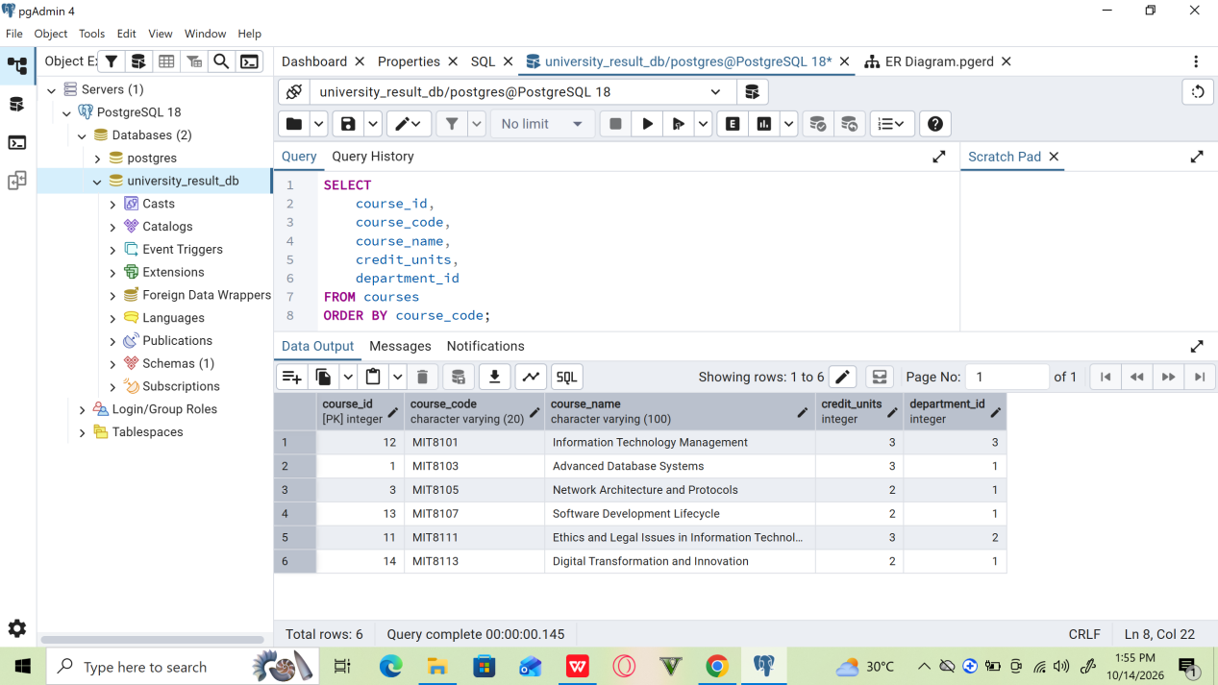
Figure 1: Execution of a basic SQL query to retrieve course information.

5.2 Retrieval of Data Using JOIN Operations
The second experiment involved retrieving related information from the Students, Registrations, and Courses tables.
The following query was executed:
SELECT
s.student_id,
s.first_name,
s.last_name,
c.course_code,
c.course_name
FROM students AS s
JOIN registrations AS r
ON s.student_id = r.student_id
JOIN courses AS c
ON r.course_id = c.course_id
ORDER BY s.last_name, c.course_code;

Explanation
The query uses JOIN operations to combine related records from three tables.
The first JOIN connects Students with Registrations through student_id. The second JOIN connects Registrations with Courses through course_id.
The query returns the student identifier, first name, last name, course code, and course name.
The ORDER BY clause sorts the results by student surname and course code.

Result
The query executed successfully and demonstrated how relational database tables can be combined to retrieve related information.
This approach avoids unnecessarily storing all student and course information repeatedly in the Registrations table.
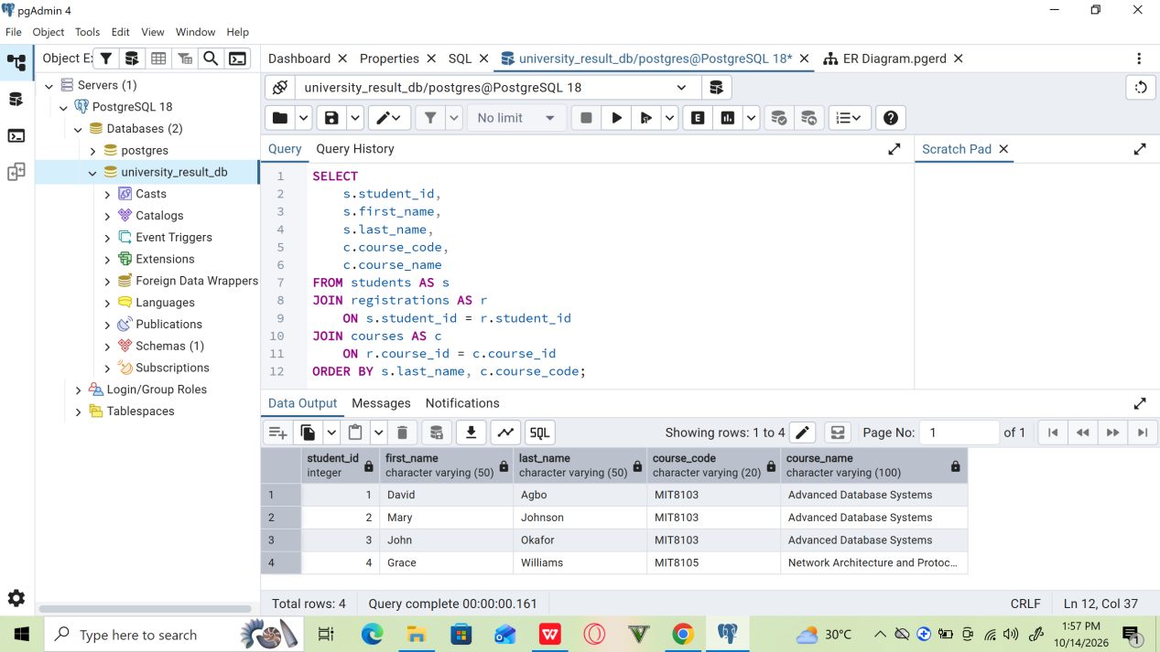
Figure 2: Retrieval of student and course information using JOIN operations.

5.3 Examination of Query Execution Plans
PostgreSQL provides the EXPLAIN ANALYZE command for examining how a query is executed.
The following query was used:
EXPLAIN ANALYZE
SELECT
s.student_id,
s.first_name,
s.last_name,
c.course_code,
c.course_name
FROM students AS s
JOIN registrations AS r
ON s.student_id = r.student_id
JOIN courses AS c
ON r.course_id = c.course_id;

Explanation
The command displays the execution plan selected by PostgreSQL and executes the query to collect actual execution statistics.
The execution plan may contain scan operations, join operations, estimated costs, actual execution times, and the number of rows processed.
The main components examined include:
Scan operations: These indicate how PostgreSQL accesses table records.
Join operations: These describe how PostgreSQL combines related records from different tables.
Estimated cost: This represents PostgreSQL's estimated resource cost for executing an operation.
Actual time: This indicates the measured time associated with an execution-plan operation.
Planning time: This measures the time PostgreSQL spent planning the query.
Execution time: This measures the total execution time reported for the query.

Result
The execution plan was successfully generated. This allowed the query's execution strategy and performance statistics to be examined.
The experiment established a baseline for understanding how PostgreSQL processes a query involving multiple related tables.
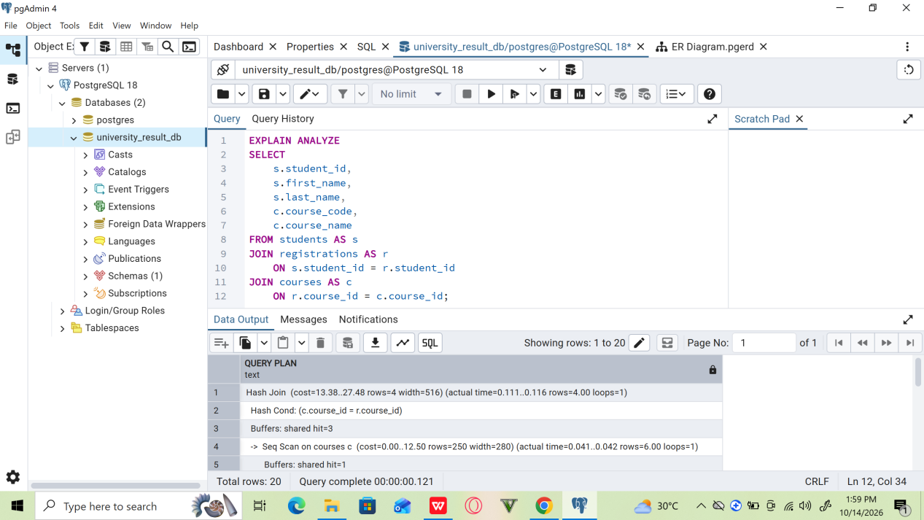
Figure 3: Initial query execution plan generated using EXPLAIN ANALYZE.

5.4 Creation of an Index on the Student Identifier
An index was created on the student_id column of the Registrations table.
The following command was executed:
CREATE INDEX idx_registrations_student_id
ON registrations (student_id);

Explanation
An index is a database structure that can help PostgreSQL locate records without examining every row of a table.
The index created in this experiment covers the student_id column. It may be useful for queries that filter registrations by student identifier or join Registrations with Students.

Result
The index was created successfully.
The experiment demonstrated how an index can be introduced into an existing PostgreSQL database to support query processing.
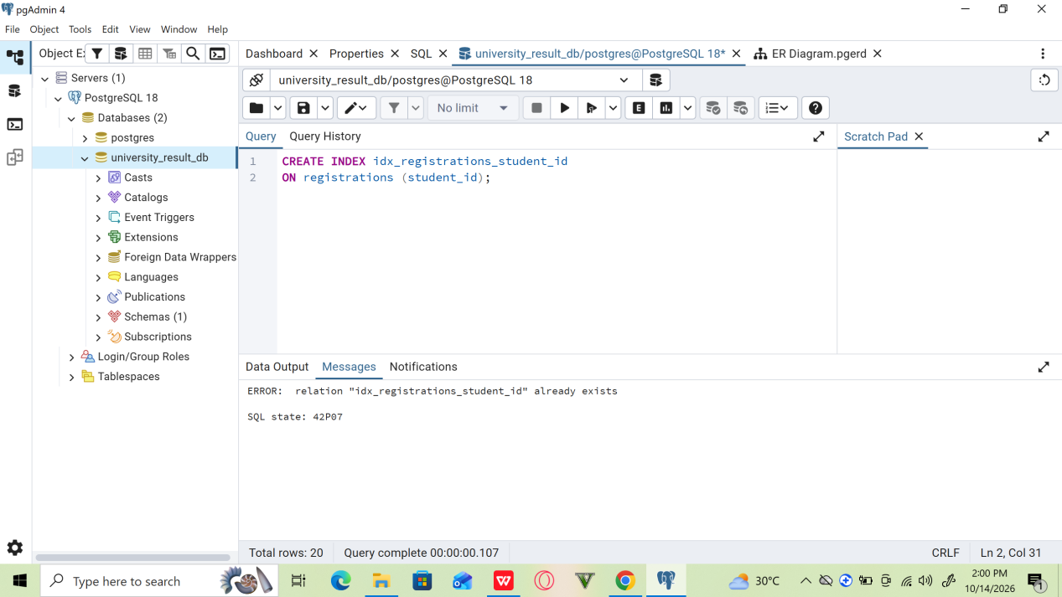
Figure 4: Creation of an index on the student_id column.

5.5 Verification of the Created Index
After creating the index, a verification query was executed to confirm its existence.
SELECT
indexname,
indexdef
FROM pg_indexes
WHERE tablename = 'registrations';

Explanation
The pg_indexes view provides information about indexes defined in PostgreSQL databases.
The query retrieves index names and their corresponding definitions for the Registrations table.

Result
The output included idx_registrations_student_id, confirming that the index had been created successfully.
This verification step was important because it established that the index was present before testing its possible effect on query execution.
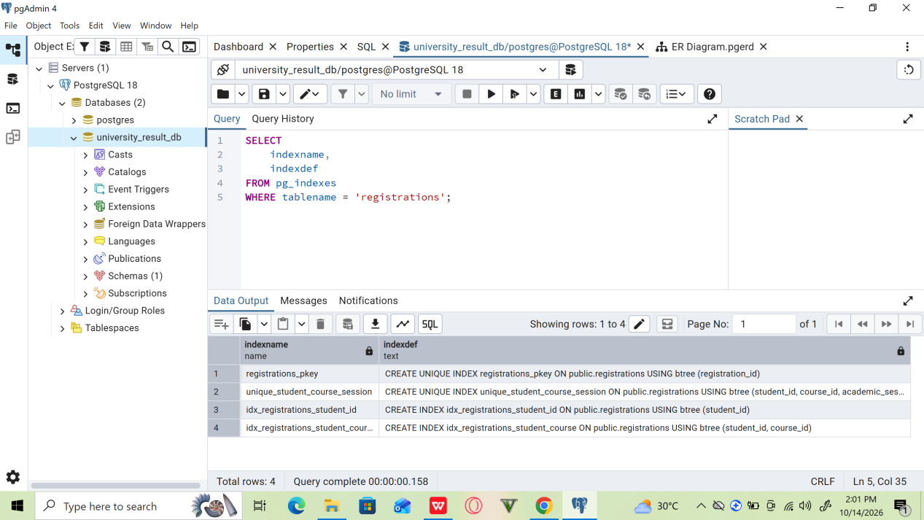
Figure 5: Verification of indexes defined on the Registrations table.

5.6 Analysis of Query Performance After Index Creation
The next experiment examined whether PostgreSQL would use the newly created index when retrieving registrations for a particular student.
The following query was executed:
EXPLAIN ANALYZE
SELECT *
FROM registrations
WHERE student_id = 1;

Explanation
The query retrieves registration records associated with the student whose identifier is
The EXPLAIN ANALYZE command displays the execution strategy selected by PostgreSQL and the measured execution statistics.

Result
The execution plan reported a Sequential Scan on the Registrations table.
The observed output included the following information:
The scan operation was Seq Scan on registrations.
The filter condition was student_id = 1.
One row matched the condition.
Three rows were removed by the filter.
The reported execution time was approximately 0.044 milliseconds in the observed run.
PostgreSQL did not use the newly created index for this query.
This was a reasonable outcome because the table contained only four records. Scanning such a small table can be less expensive than accessing an index and retrieving the corresponding table rows.
The experiment demonstrated that creating an index does not guarantee that PostgreSQL will use it for every query.
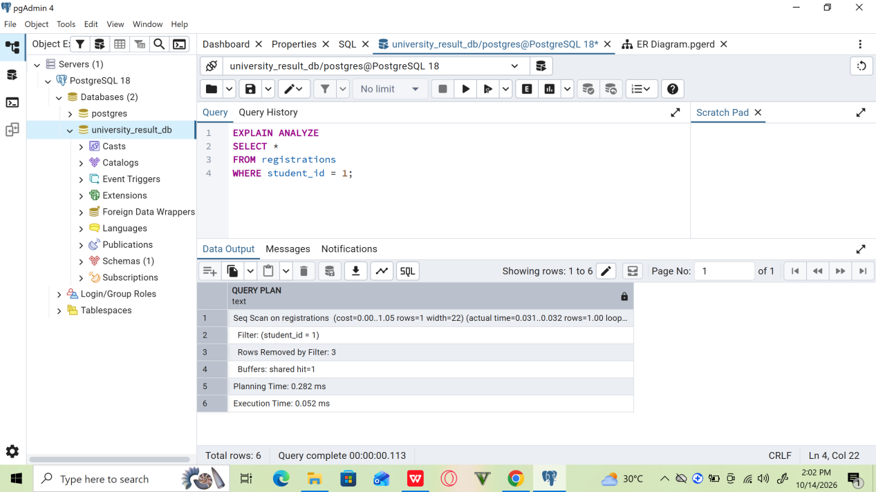
Figure 6: Query execution plan after creating the student identifier index.

5.7 Creation of a Composite Index
A composite index was created on the student_id and course_id columns of the Registrations table.
The following SQL statement was executed:
CREATE INDEX idx_registrations_student_course
ON registrations (student_id, course_id);

Explanation
A composite index covers more than one column.
In this experiment, student_id is the leading column, followed by course_id.
Such an index may support queries that filter by student identifier and, where appropriate, retrieve records ordered by course identifier.
Its effectiveness depends on the query conditions, the number of records, the data distribution, and PostgreSQL's estimated execution costs.

Result
The composite index was created successfully.
The experiment demonstrated how indexes involving multiple columns can be defined to support queries involving related filtering and ordering conditions.
However, creating the index alone does not establish that query performance has improved.
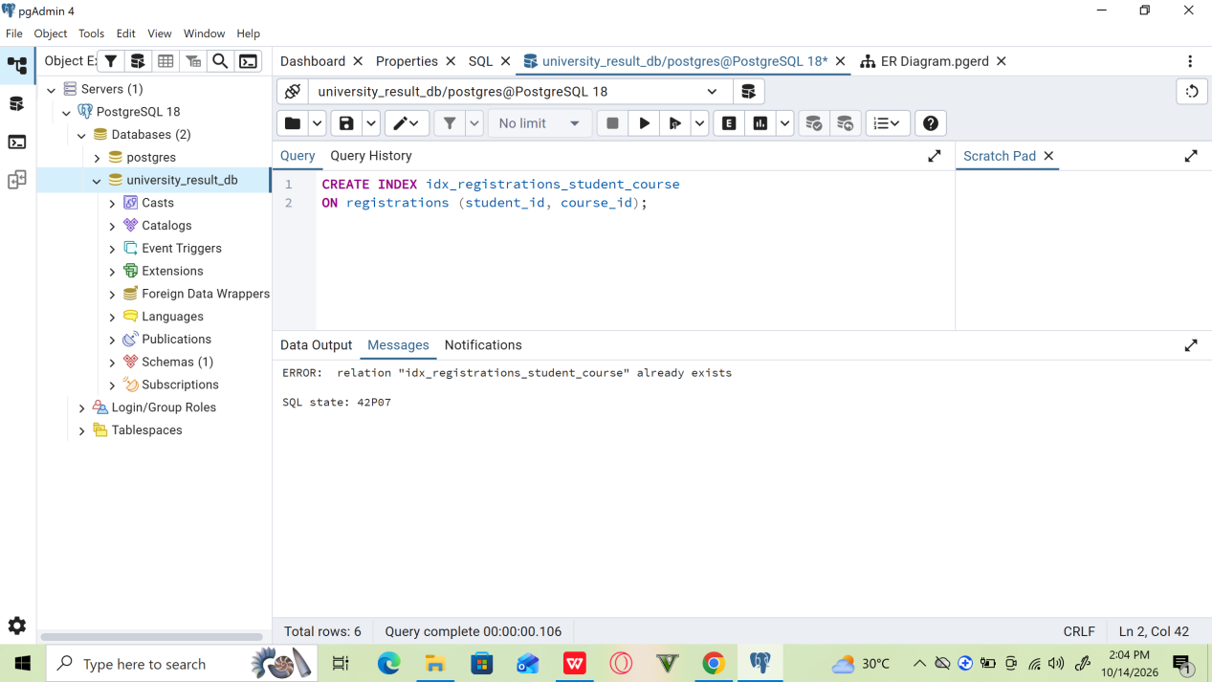
Figure 7: Creation of a composite index on student_id and course_id.

5.8 Examination of Filtering and Sorting Operations
The next experiment investigated a query that filters registrations by student identifier and sorts the matching records by course identifier.
The following SQL statement was executed:
EXPLAIN ANALYZE
SELECT *
FROM registrations
WHERE student_id = 1
ORDER BY course_id;

Explanation
The WHERE clause restricts the results to registrations associated with student identifier
The ORDER BY clause sorts the matching records by course identifier.
The execution plan showed how PostgreSQL combined these operations.

Result
The observed execution plan contained a Sort operation followed by a Sequential Scan on the Registrations table.
The plan indicated that:
PostgreSQL filtered records using student_id = 1.
Three rows were removed by the filter.
The matching result was sorted using quicksort.
The composite index was available but was not selected by the query planner.
The continued use of a Sequential Scan was reasonable because the table contained only four records.
This experiment demonstrated that PostgreSQL considers the estimated cost of alternative execution plans instead of automatically selecting an index whenever one exists.
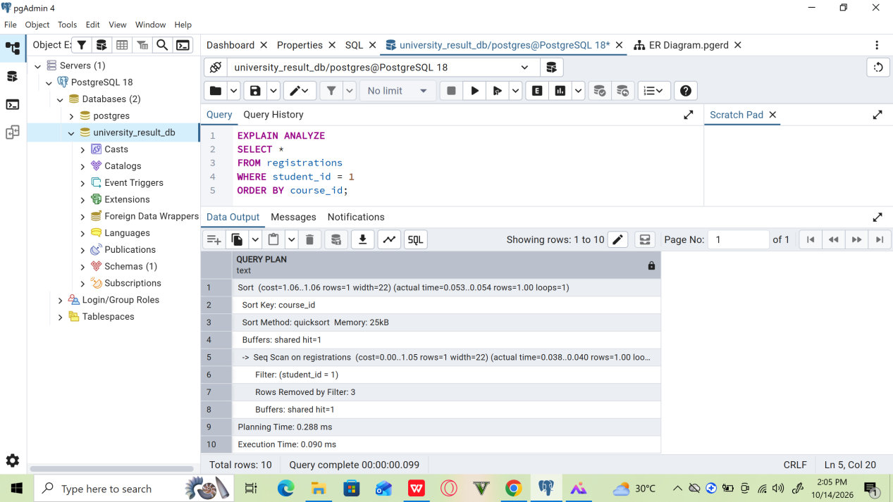
Figure 8: Execution plan showing filtering and sorting operations.

5.9 Updating Database Statistics
The PostgreSQL ANALYZE command was executed on the Registrations table.
The command used was:
ANALYZE registrations;

Explanation
PostgreSQL uses statistical information about tables and columns to estimate the number of rows that queries will process and to compare possible execution strategies.
The ANALYZE command collects and updates these statistics.
Accurate statistics help the query planner make informed decisions when selecting scan and join operations.

Result
The command executed successfully.
This experiment demonstrated the role of database statistics in query optimization.
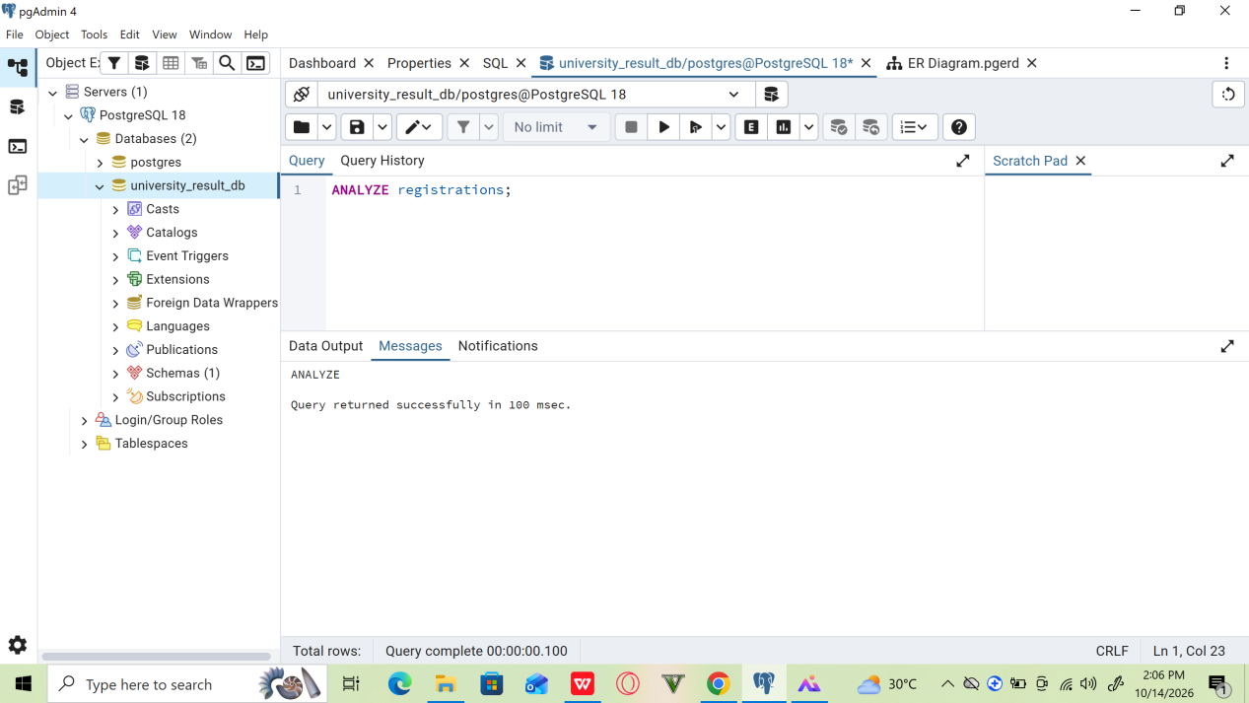
Figure 9: Updating query-planner statistics for the Registrations table.

5.10 Examination of the Execution Plan After ANALYZE
After updating the statistics, the filtering and sorting query was executed again.
EXPLAIN ANALYZE
SELECT *
FROM registrations
WHERE student_id = 1
ORDER BY course_id;

Explanation
The purpose of this experiment was to determine whether updating the table statistics would change the execution plan.
The resulting plan was compared with the plan observed before running ANALYZE.

Result
The execution plan remained unchanged. PostgreSQL continued to use a Sequential Scan followed by a Sort operation.
This result was expected for a table containing only four records. Updating statistics does not necessarily change the execution plan; it provides the planner with information that may help it select an appropriate strategy.
The experiment demonstrated that query optimization depends on several factors, including table size, data distribution, query conditions, indexes, and estimated execution costs.
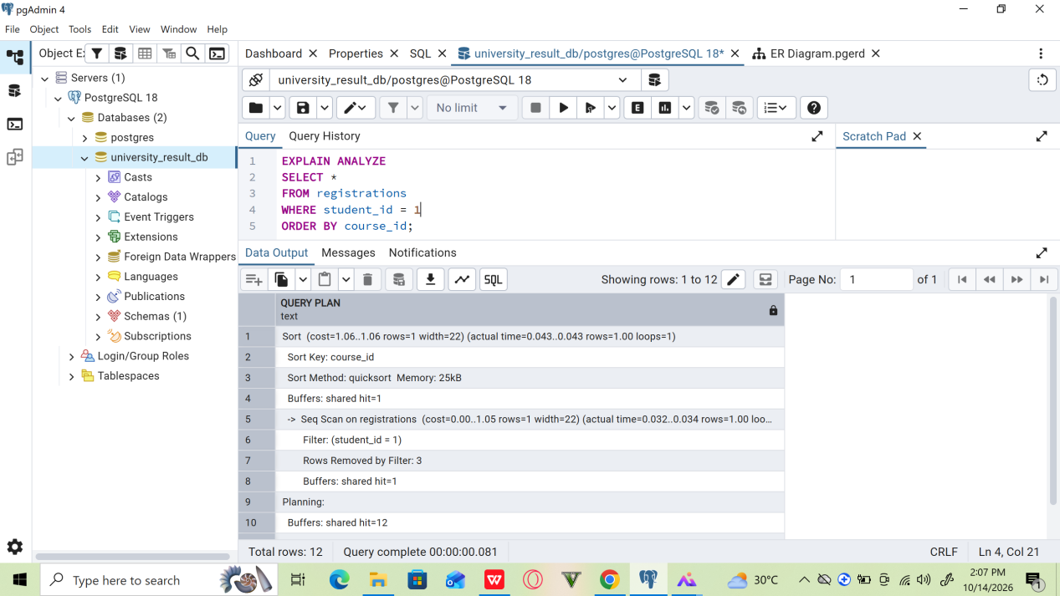
Figure 10: Execution plan after updating database statistics.

6.0 SUMMARY OF EXPERIMENTAL FINDINGS
The practical experiments produced the following findings.
Experiment | Observation | Interpretation
Basic SQL query | Course records were retrieved and sorted successfully. | SQL supports structured data retrieval and ordering.
Multi-table JOIN | Student and course information were combined successfully. | JOIN operations retrieve related information from multiple tables.
Initial execution plan | PostgreSQL generated a plan for the multi-table query. | Execution plans help explain how queries are processed.
Single-column index | The index was created and verified. | Indexes can be added to support selected query conditions.
Query after index creation | PostgreSQL used a Sequential Scan. | An index is not always the least expensive execution strategy.
Composite index | The index was created successfully. | Multiple columns can be covered by one index.
Filtering and sorting | PostgreSQL used a Sequential Scan and Sort operation. | The planner evaluates the cost of filtering, scanning, and sorting.
ANALYZE | Table statistics were updated. | Statistics help PostgreSQL estimate query costs.
Final execution plan | The plan remained unchanged. | Updating statistics does not necessarily alter a plan when the existing strategy remains appropriate.

7.0 DISCUSSION
The experiments demonstrated several important concepts in database query processing and optimization.
First, basic SQL statements and JOIN operations provide mechanisms for retrieving information from individual tables and combining related information across multiple tables.
Second, EXPLAIN ANALYZE provides information about the execution plan and the actual performance of a query. It allows database developers to examine scan operations, join strategies, filtering, sorting, and execution times.
Third, indexes can support efficient data retrieval, but their effectiveness depends on the characteristics of the query and the database. In this experiment, PostgreSQL continued to use Sequential Scans even after indexes were created. This was reasonable because the Registrations table contained only four records.
Fourth, composite indexes can support queries involving multiple columns. However, an index's presence does not prove that it has improved query performance. Performance improvements must be evaluated through appropriate comparisons using representative data.
Finally, updating database statistics with ANALYZE helps PostgreSQL estimate query costs. However, the command does not guarantee that the query execution plan will change.
Overall, the experiments showed that query optimization is a cost-based process in which PostgreSQL selects an execution strategy according to its estimates and the characteristics of the database.

RECOMMENDATIONS
Based on the practical work, the following recommendations are made:
Use EXPLAIN ANALYZE when investigating the execution behaviour of important queries.
Create indexes on columns that are frequently used in selective filtering and JOIN conditions when the expected benefit justifies the additional storage and maintenance costs.
Evaluate composite indexes according to the actual query patterns and the order of the indexed columns.
Maintain accurate database statistics by allowing PostgreSQL's automatic statistics collection to operate and running ANALYZE when appropriate.
Avoid creating unnecessary indexes because they consume storage and add overhead to data modifications.
Test query performance with representative datasets before drawing conclusions about optimization effectiveness.
Compare execution plans and timings under consistent conditions rather than assuming that one plan is always faster than another.
Record the actual results of experiments and distinguish observed performance from theoretical expectations.

CONCLUSION
This portfolio investigated query processing and optimization using PostgreSQL and the University Student Result Management System.
The practical work covered basic SQL queries, multi-table JOIN operations, query execution plans, index creation, composite indexes, filtering, sorting, and database statistics.
The experiments demonstrated that PostgreSQL uses a cost-based query planner to choose execution strategies. The planner may select a Sequential Scan even when an appropriate index exists, particularly when the table is very small.
The results also showed that updating database statistics does not necessarily change an execution plan. Instead, statistics provide information that helps PostgreSQL estimate costs and select appropriate strategies.
The portfolio provided practical experience in examining query behaviour and understanding the factors that influence database performance. These skills are useful when designing, maintaining, and optimizing relational database systems.

