PORTFOLIO 4: NOSQL AND ADVANCED DATA MODELS
Course Code: MIT 8103
Course Title: Advanced Database Systems
Project Title: University Student Result Management System Using MongoDB
Name: Agbo Gad-David Oyioche
Matriculation Number: 2026/A/MIT/0495
Programme: Master of Information Technology

INTRODUCTION
Modern database systems are designed to store, organize, retrieve, and manage large amounts of information efficiently. Traditional relational databases, such as PostgreSQL, organize data into tables with rows and columns. However, NoSQL databases provide alternative data models that can accommodate flexible and nested data structures.
MongoDB is a document-oriented NoSQL database that stores records as BSON documents in collections. It supports embedded documents and arrays, making it suitable for applications that manage related information, such as student profiles and course results.
This portfolio demonstrates the application of MongoDB to a University Student Result Management System. It covers database creation, document insertion, embedded course information, data filtering, and a comparison between MongoDB and PostgreSQL.

AIM AND OBJECTIVES

Aim
To demonstrate the use of MongoDB and NoSQL data modelling techniques for managing student information and academic results.

Objectives
The objectives of this portfolio are to:
Create a MongoDB database and collection using MongoDB Atlas.
Insert student records as BSON documents.
Represent course information using embedded documents and arrays.
retrieve student records using MongoDB queries.
Filter students by department and course performance.
Count student records and retrieve selected fields.
Compare relational data modelling in PostgreSQL with document-based modelling in MongoDB.

TOOLS AND TECHNOLOGIES
The following tools and technologies were used:
MongoDB Atlas: A cloud-based platform used to host and manage the MongoDB database.
MongoDB Data Explorer: The browser-based interface used to create collections, insert documents, and execute queries.
MongoDB Query Language (MQL): Used to retrieve and filter documents.
Microsoft Word: Used to prepare the portfolio report.

DATABASE DESIGN AND IMPLEMENTATION

Database Creation
A database named university_result_db was created in MongoDB Atlas. Within the database, a collection named student_records was created to store student information and their academic results.
Unlike a traditional relational database, MongoDB stores related information as documents within collections.

Document Structure
Each student document contains the following fields:
Field | Description
studentId | Unique identifier assigned to a student
name | Student's name
department | Student's department
academicSession | Academic session
level | Student's academic level
courses | Array containing course details and scores
The courses field contains embedded documents. Each embedded course document includes the course code, course name, credit units, and score.

Sample Student Document
The following is an example of the document structure used:
{
"studentId": "STU001",
"name": "David Okafor",
"department": "Computer Science",
"academicSession": "2026/2027",
"level": 800,
"courses": [
{
"courseCode": "MIT8103",
"courseName": "Advanced Database Systems",
"credits": 3,
"score": 78
},
{
"courseCode": "MIT8105",
"courseName": "Network Architecture and Protocols",
"credits": 2,
"score": 82
}
]
}
This structure demonstrates how a student's course information can be stored inside the student's main document without requiring a separate collection for every course record.

Student Records
Three sample student documents were inserted into the student_records collection. The records represent students from Computer Science and Information Technology departments, with their respective course information and scores.
The collection was verified to contain three student documents.

QUERYING AND DATA RETRIEVAL
MongoDB queries were used to retrieve all student records and filter documents according to specific requirements.

Retrieve All Student Records
Query:
db.student_records.find({});
Purpose: Retrieves all documents in the student_records collection.
Result: The collection displayed the three inserted student records.

Filter Students by Department
Query:
db.student_records.find({
department: "Computer Science"
});
Purpose: Retrieves students whose department is Computer Science.
Result: Two student documents matched the filter.

Find Students Registered for MIT8103
Query:
db.student_records.find({
"courses.courseCode": "MIT8103"
});
Purpose: Searches the embedded courses array for a course with the code MIT8103.
Result: All three student documents matched because each student has MIT8103 in their course list.

Filter Students by Course and Score
Query:
db.student_records.find({
courses: {
$elemMatch: {
courseCode: "MIT8103",
score: { $gte: 80 }
}
}
});
Purpose: Finds students with a score of at least 80 in MIT8103. The $elemMatch operator ensures that the course code and score conditions match within the same embedded course document.
Result: One student document matched the filter: STU002, who scored 85 in MIT8103.

Count Student Records
Query:
db.student_records.countDocuments({});
Purpose: Counts all documents in the collection.
Expected result: Three documents.

Retrieve Selected Fields
Query:
db.student_records.find(
{},
{ _id: 0, name: 1, department: 1 }
);
Purpose: Retrieves only each student's name and department while excluding MongoDB's default _id field.
This query demonstrates projection, which allows an application to retrieve only the fields needed for a particular operation.

COMPARISON BETWEEN POSTGRESQL AND MONGODB
PostgreSQL and MongoDB use different data models and provide different approaches to storing related information.
Feature | PostgreSQL | MongoDB
Database model | Relational | Document-oriented NoSQL
Main data structure | Tables, rows, and columns | Collections and documents
Data format | Relational records | BSON documents
Relationships | Foreign keys and joins | Embedded documents or references
Schema | Defined table structure | Flexible document structure
Query language | SQL | MongoDB Query Language
Related course data | Commonly stored in separate tables | Can be embedded within student documents
Transactions | Supports ACID transactions | Supports transactions, including multi-document transactions
Typical strength | Structured data, constraints, and complex relational queries | Flexible document structures and application-oriented data access
Both databases can support a student result management system. The appropriate choice depends on application requirements, data relationships, integrity needs, and query patterns.

ADVANTAGES OF MONGODB IN THE PROJECT
The implementation demonstrates several benefits of MongoDB:
Flexible data structure: Student documents can accommodate different numbers of courses.
Embedded data: Course information can be stored within a student document.
Convenient retrieval: Related student and course information can often be retrieved in one query.
Field projection: Queries can return only the information needed by an application.
Cloud accessibility: MongoDB Atlas makes it possible to manage the database through a web browser.

LIMITATIONS AND CONSIDERATIONS
Although MongoDB provides flexible data modelling, some considerations remain important:
Repeated course information across many student documents can lead to duplication.
Data consistency must be considered when information is duplicated or embedded.
Validation rules and suitable indexes may be necessary as the dataset grows.
Complex relationships and reporting requirements may be easier to manage with a relational model in some applications.
A small sample dataset is sufficient for demonstrating queries but is not enough to establish performance advantages over PostgreSQL.

SCREENSHOTS AND EVIDENCE
The following screenshots document the implementation and testing of the MongoDB database:
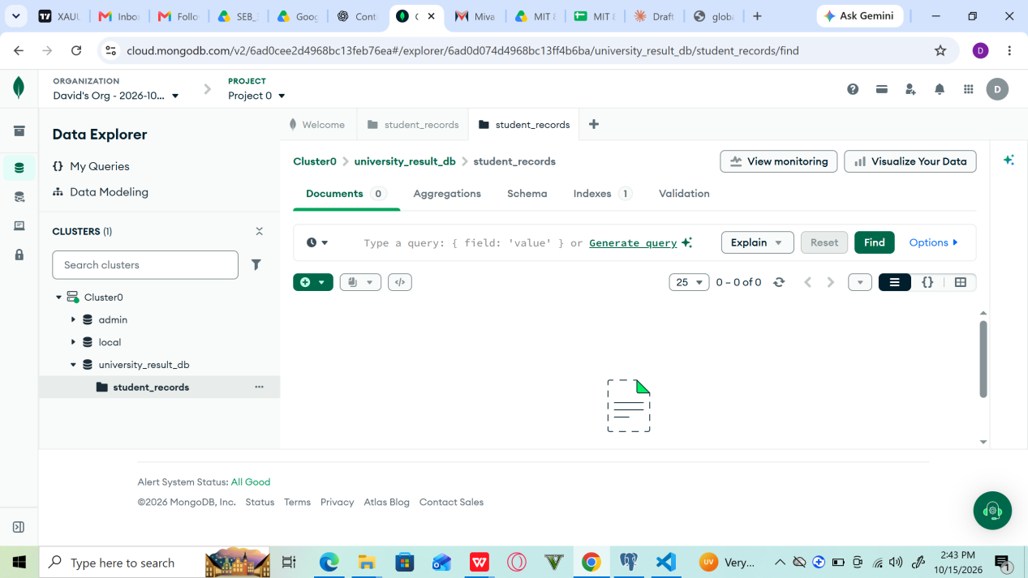
Fig 1 Database and collection creation.
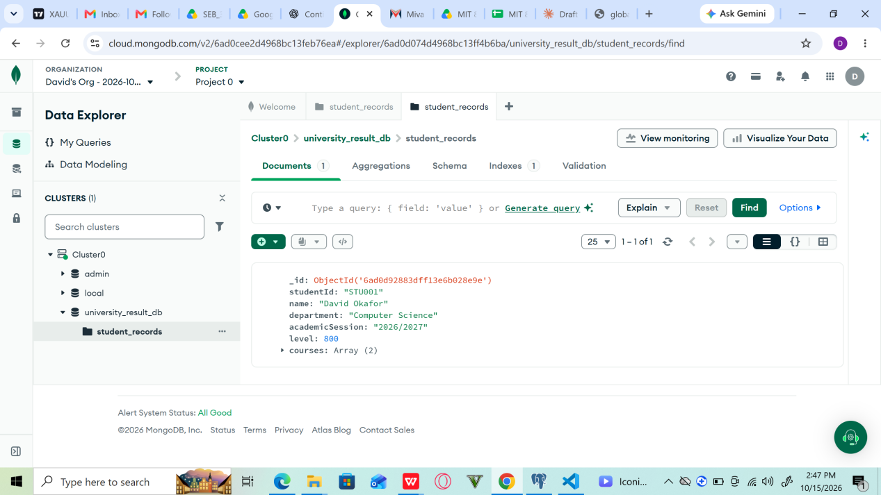
Fig 2 Inserting a student document.
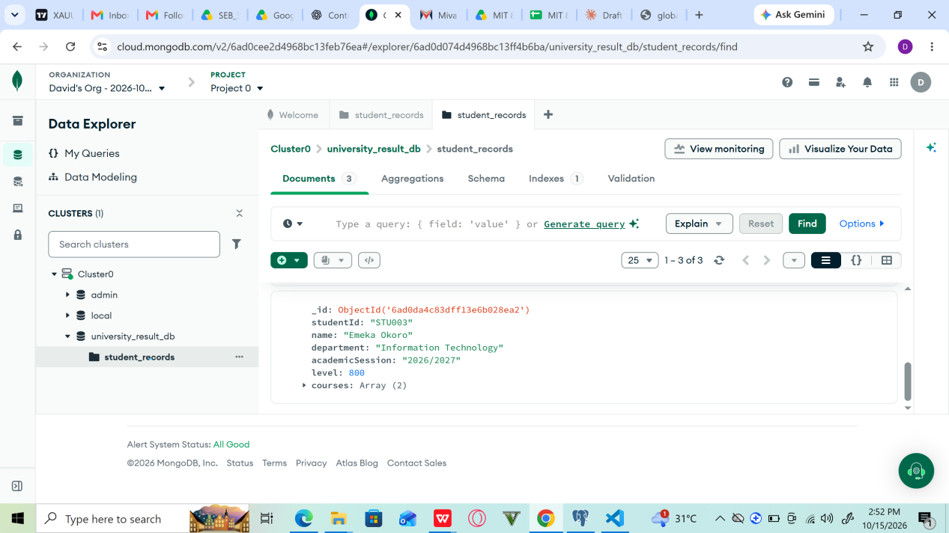
Fig 3 Display of student records.
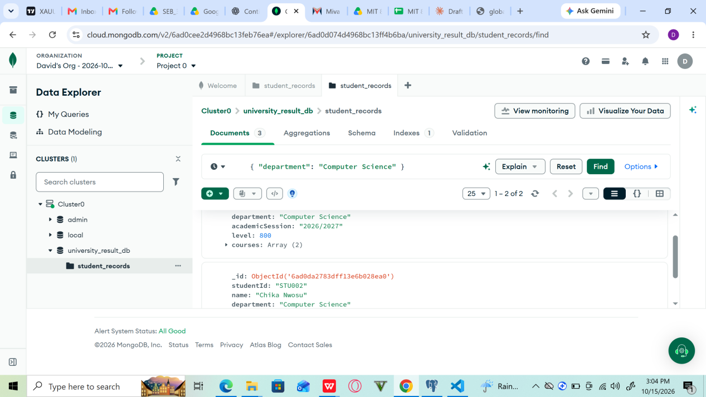
Fig 4 Filtering students by department.
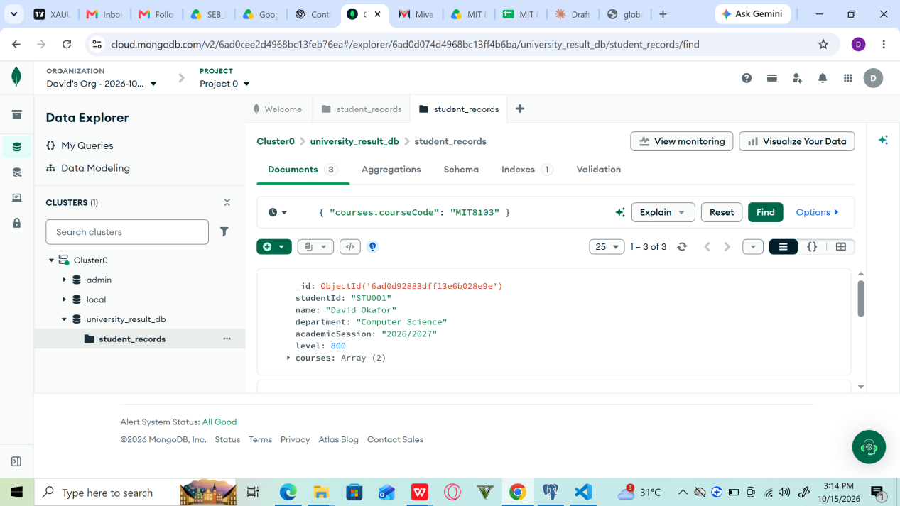
Fig 5 Querying embedded course information.
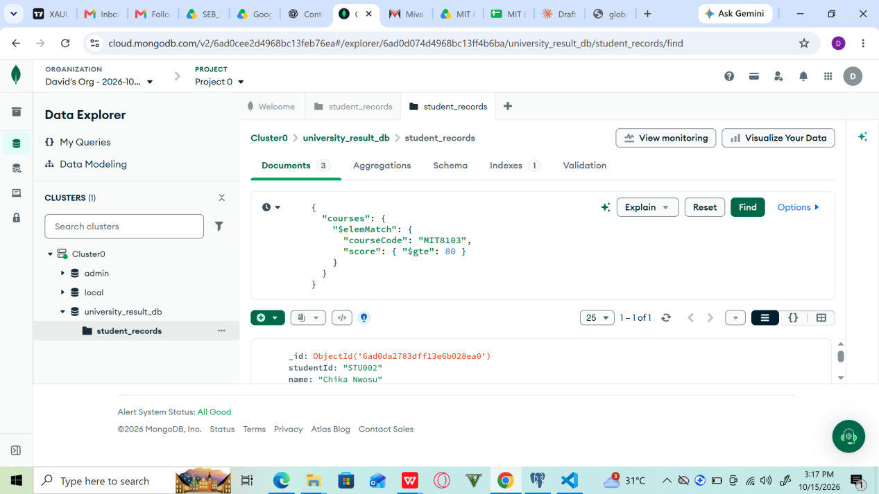
Fig 6 Filtering by course code and score.
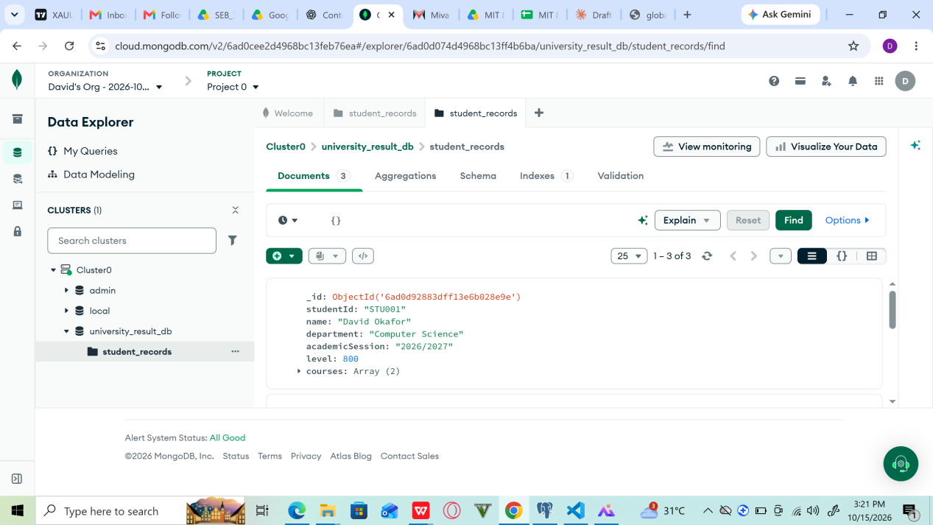
Fig 7 Verification of all student documents.
The screenshots should be placed in the Screenshots folder and included in this section of the report where required by the lecturer. Each image should have a caption explaining what it demonstrates.

CONCLUSION
This portfolio demonstrated the implementation of a document-oriented database using MongoDB Atlas for a University Student Result Management System. A database and collection were created, three student documents were inserted, and queries were used to retrieve records by department, course registration, and academic score.
The project also demonstrated embedded documents, field projection, and document counting. The comparison with PostgreSQL showed that relational and document-oriented databases offer different approaches to data storage and retrieval. MongoDB is suitable for flexible document structures, while PostgreSQL provides strong relational modelling capabilities.
In conclusion, the exercise improved practical understanding of NoSQL database design and showed how MongoDB can be used to manage student information and academic results.

REFERENCES
MongoDB, Inc. MongoDB Manual. https://www.mongodb.com/docs/manual/
MongoDB, Inc. MongoDB Atlas Documentation. https://www.mongodb.com/docs/atlas/
PostgreSQL Global Development Group. PostgreSQL Documentation. https://www.postgresql.org/docs/

