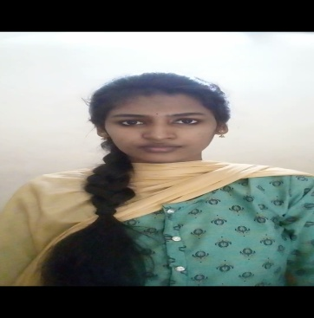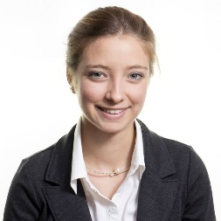**DONKA PRAMEELA**

**Email :** donkaprameela@gmail.com

**Contact** : +91-9052270903

**LinkedIn** : https://www.linkedin.com/in/donka-prameela-b46938281/

**GitHub** :https://www.github.com/D-prameela

**OBJECTIVE**

Aspiring for a challenging job at a reputable firm that will allow me to grasp the field of overall quality management of projects while also contributing to the organization’s growth and development.

**ACADEMIC QUALIFICATIONS**

|  |  |  |  |
| --- | --- | --- | --- |
| Academic Qualification | University/Board | Year | Percentage /CGPA |
| B.Tech. (IT) | JNTUGV | 2025 | 7.96 CGPA |
| Intermediate | Board of Intermediate Education, AP | 2021 | 8.3 |
| SSC | Board of Secondary Education, AP | 2019 | 9.3 |

**TECHNICAL SKILLS**

**Programming :** Python, Java, C

**Development :** HTML

**Database :** MySQL

**Operating Systems :** Windows

**PROJECT EXPERIENCE**

**AUTOMATED TELLER MACHINE**

Automated Teller Machine is a software application is designed in such a way that the user has to enter card and pin number. Once verified, he had to enter the option provided in the menu.

**CERTIFICATIONS**

**Data Analysis using Python certification organised by APSSDC**

**BASICS OF PYTHON CERTIFICATION**

Issued by : Infosys | Springboard

**CERTIFICATE OF ACHIEVEMENT-HTML**

Issued by : Mindluster

**CO CURRICULAR ACTIVITIES**

• Participated in Data Analysis Using python Organized by APSSDC.

• Completed a Course on Basics of Python provided by Infosys Springboard.

• Completed a Course on Html Provided by Mindluster

• Participated in Query Designing Organised by Aditya Institute of Technology And Management, Tekkali.

• Completed a course on Django and done a project on “REGISTRATION WITH GOOGLE

APPLICATION BY USING DJANGO” under the guidance of APSSDC.

• Solving problems on HackerRank.

**EXTRA CURRICULAR ACTIVITIES**

* Performed stage acting in Youth festivals.
* Volunteered for a workshop conducted on industrial training on Android.
* An active member of Digital marketing Club.
* An active member of NSS.

**PERSONAL DETAILS**

**Father Name :** Donka Shankar Rao

**Date of Birth :** 27 September 2003

**Languages Known :** English, Telugu

**Hobbies/Interests :** Blogging, Traveling, Reading books

**Address         :**  D/no- 13-2-118,Tilak Nagar, Kasibugga (Post)

                            Palasa (Mandal), Srikakulam (District),

                            Andhra Pradesh (State), Pin code: 532222.

**Date:** 02/07/2023 Donka Prameela

**Place:** Tekkali Signature