**A PROJECT REPORT ON**

**“Development and Operations”**

Submitted in the partial fulfillment of the record for the award of the degree

**“BACHELOR OF SCIENCE IN COMPUTERS”**

Submitted by

**D.SUBHASH- K2237440**

Under the Guidance of

**Ms. G.MADHURI MCA**

Submitted to

DEPARTMENT OF COMPUTER SCIENCE & APPLICATIONS



**KAKARAPARTI BHAVANARAYANA**

**COLLEGE**

**(AUTONOMOUS)**

(Sponsored by S.K.P.V.V Hindu High Schools Committee) Kothapeta, Vijayawada - 520001.

# Affiliated to KRISHNA UNIVERSITY

**1**

**PROGRAM BOOK FOR**

# SHORT-TERM INTERNSHIP

**(Onsite/Virtual)**

Name of the Student:D.SUBHASH

Name of the College: **Kakaraparti Bhavanarayana College**

Registration Number: **K2237440**

Period of Internship: From: 24-03-2025 To:22-05-2025

Name & Address of The Intern Organization:Quality Thoughts Pvt. Ltd,

Vijayawada.

**Krishna University**

**YEAR: 2023 to 2027**

2

## An Internship Report on

DEVELOPMENT AND OPERATIONS

*Submitted in accordance with the requirement for the degree of*

**BACHELOR OF SCIENCE IN COMPUTERS**

Under the Faculty Guide ship of

**Ms. G.MADHURI MCA**

**Department of**

### Computer Science & Applications, KBN College (Autonomous)

**Submitted by:**

**D.SUBHASH**

**Reg.No: K2237440**

**Department of Computer Science &**

**Applications**

**Kakaraparti Bhavanarayana College**

**(Autonomous)**

**Affiliated to KRISHNA UNIVERSITY**

**3**

## Student’s Declaration

**I’m D.SUBHASH** student of **BACHELOR OF SCIENCE IN COMPUTERS** Program, Reg. No. **K2237440** of theDepartment of **Computer Science & Applications** at **Kakaraparti Bhavanarayana College** do hereby declare that I have completed the mandatory internship from **24-03-2025** to **22-05-2025** in **DevOps** in Vijayawada under the Faculty Guide ship of Honorable **Ms.G.MADHURI**, Department of **Computers Science And Applications**, **Kakaraparti Bhavanarayana College (Autonomous).**

*(Signature and Date)*

4

Official Certification

This is to certify that **D.SUBHASH**  Reg. No: **K2237440** has completed his/her Internship in DevOps onUsing ubuntu, github, docker etc.,under my supervision as a part of partial fulfillment of the requirement for the Degree of **BACHELOR OF SCIENCE IN COMPUTERS** in the Department of **Computer Science & Applications** in **Kakaraparti Bhavanarayana College (Autonomous).**

This is accepted for evaluation.

*(Signatory with Date and Seal)*

**Endorsements**

*Faculty Guide*

*Head of the Department*

*Principal*

*5*

## Certificate from Intern Organization

**G R**

This is to certify that D.SUBHASHReg. No: **K2237440** of

### **Kakaraparti Bhavanarayana College (Autonomous).** Underwent internship in **DevOps** from **24-03-2025** to **22-05-2025**

The overall performance of the intern during his/her internship is found to be

(Satisfactory / Not Satisfactory).

*Authorized Signatory with Date and Seal*

6

### **Acknowledgements**

*My sincere thanks to* ***Mr. P. RAVINDRA, Head ,Dept. of Computer Science & Applications, KBN College, Vijayawada,*** *for providing an excellent environment .*

*I acknowledge with thanks the valuable guidance of* ***Ms*.*G.MADHURI,* *Dept.***

***of Computers Science & Applications*** *for their kind cooperation in times of need.*

*I am very thankful to the lab faculty who always readily solved the problems during development by giving their valuable suggestions. Their encouragement assisted me in making this project a success.*

*I express thanks to all the teaching and non-teaching staff members of* ***Dept. of Computers Science & Applications, KBN COLLEGE (Autonomous) in Vijayawada****.*

*I express thanks to all the teaching and non-teaching staff*

*members*

***DEVELOPMENT AND OPERATIONS***

*Last but not the least I also acknowledge with humble gratitude to my parents, my team members and my dearest friends who helped me to complete this project.*

**Submitted By**

**D.SUBHASH**

**7**

**Contents**

|  |  |  |
| --- | --- | --- |
| **S.No** | **INDEX** | **Page No.** |
| 1 | **Chapter – 1**  Executive Summary  1.Introduction of the power BI | 8  9 - 10 |
| 2 | **Chapter – 2**  Overview of the Organization  2.1 Vision and Mission of the Organization  2.2 Policy and Structure of the Organization  2.3 Roles and Responsibilities  2.4 Future planes of the Organization | 11 - 15 |
| 3 | **Chapter – 3** Internship Part | 16 - 56 |
| 4 | **Chapter – 4**  Outcomes Description  3.1 project documentation | 57 - 63  64 - 87 |
| 5 | Student Self Evaluation of the ShortTerm Internship | 88 - 89 |
| 6 | Photos & Videos | 90 |
| 7 | Evaluation | 91 – 93 |
| 8 | Marks Statement | 94 - 96 |

**8**

**CHAPTER 1: EXECUTIVE SUMMARY**

### ***Introduction Microsoft Power BI***

Power BI is a collection of software services, apps, and connectors that work together to turn your unrelated sources of data into coherent, visually immersive, and interactive insights. Your data might be an Excel spreadsheet, or a collection of cloud-based and onpremises hybrid data warehouses. Power BI lets you easily connect to your data sources, visualize and discover what's important, and share that with anyone or everyone you want

The parts of Power BI Power BI consists of several elements that all work together, starting with these three basics:

* A Windows desktop application called Power BI Desktop.
* An online software as a service (SaaS) service called the Power BI service.
* Power BI Mobile apps for Windows, IOS, and Android devices

These three elements—Power BI Desktop, the service, and the mobile apps—are designed to let you create, share, and consume business insights in the way that serves you and your role most effectively.

Power BI Desktop is free applications you install on your local computer that lets you connect to, transform, and visualize your data. With Power BI Desktop, you can connect to multiple different sources of data, and combine them (often called modeling) into a data model. This data model lets you build visuals, and collections of visuals you can share as reports, with other people inside your organization. Most users who work on business intelligence projects use Power BI Desktop to create reports, and then use the Power BI service to share their reports with others.

**Minimum Requirements:** The following list provides the minimum requirements to run Power BI Desktop:

* Windows 8.1 or Windows Server 2012 R2 or later.NET 4.6.2 or later.
* Internet Explorer 11 or later.
* Memory (RAM): At least 2 GB available, 4 GB or more recommended.

Display: At least 1440x900 or 1600x900 (16:9) required. Lower resolutions such as

1024x768 or 1280x800 aren't supported because some controls (such as closing the startup screens) display beyond those resolutions.

* Windows display settings: If you set your display to change the size of text, apps, and other items to more than 100%, you won't see some dialogs that you must interact with to continue using Power BI Desktop. If you encounter this issue, check your display settings in Windows by going to Settings > System > Display, and use the slider to return display settings to 100%.
* CPU: 1 gigahertz (GHz) 64-bit (x64) processor or better recommended.
* WebView2: If WebView2 wasn't automatically installed with Power

9

* BI Desktop or if it was uninstalled, download and run the installer for WebView2.

How to Download Power BI Desktop: There are 3 Ways to Download of Power BI Desktop Latest version of the Market.

1. Open a browser and go directly to the Power BI Desktop page of the Microsoft Store. From the Power BI service, in the upper right corner, select the Download icon and then choose Power BI DesktoP to the Power BI Desktop Desktop executable from the Download Center, select Download from the

3.To download the Power BI Desktop executable from the Download Center, select Download from the

Download Center page.

Then specify the 32-bit or 64-bit installation file to download. Open Power BI Desktop:

We can open the power bi desktop are on following ways on the computer are:

1. Click on Button & search on power bi desktop Click on it.
2. Double click on the power bi desktop icon
3. Right click on the power bi desktop icon, Select open on it

**Learning Objective:**

Power BI has changed the BI landscape forever, enabling BI professionals and regular Excel users alike to work with big data and build insightful dashboards.

Learn to use this powerful business intelligence solution from the ground up. Navigate the intuitive user interface and explore the ecosystem of data modeling tools. Discover outsidethe-box visualizations and broadcast your insights to colleagues in the Power BI Service.

This Course gives you a solid foundation to begin your Power BI journey.

On completing this Course, as Learning Objective:

* Identify the primary components of the Power BI interface: reports, data, and model views
* Import Excel data and build basic visuals
* Publish a desktop report to the Power BI Service
* Identify common challenges in Power BI data models, implement smart solutions, and avoid common mistakes

10

This Power BI training course will help you get the most out of Microsoft’s Power BI, a suite of tools that lets you build interactive dashboards for analyzing data and extracting business insights. This course will help you master the development of dashboards from published reports, discover greater insights from your data with Quick Insights, and learn practical applications for Power BI tasks, such as gathering and analyzing data. You will also learn valuable Power BI troubleshooting tips.

Understand Power BI concepts like Microsoft Power BI desktop layouts, BI reports, dashboards, and Power BI DAX commands and function.

11

Gain a competitive edge in creating customized visuals and deliver a reliable analysis of vast amount of data using Power BI

Learn how to experiment, fix, prepare and present data quickly and easily create a sales analysis report and a project management report

Form relationships in your data model and learn data visualization best practices

**OUTCOMES OBJECTIVES:**

Our curriculum-based approach features hands-on labs and personal guidance to help new Power BI users how to integrate data and build stunning visualizations in Power BI for rapid, valuable insights. As part of the training cost, the organization will receive a copy of all materials for internal use.

* Create and share compelling data visualizations.
* Find and integrate data from multiple data sources.
* Enrich data with calculations and other features available in Power BI.
* Explore data acquisition, modeling, and security.
* Review Data Analysis Expressions (DAX) business logic and calculation.

12

#### CHAPTER 2: OVERVIEW OF THE ORGANIZATION



**Quality Management Training, Corporate Training Providers**

Quality Thought Technologies provides ultimate software training. Our group technical savvier who are dedicated to brings difference in the way people are trained in software tools & technologies. We focus on practical approach with welldefined process & framework that perfectly transforms the academics to professionals. We believe in Practical Approach than Theoretical Approach.

In Quality Thought we change each penny of yours to figure up. Accompanied by a motive to furnish extreme branch of subject knowledge to every individual trainee of ours, Quality Thought, a pioneer in the IT training sector higher up than a decade experienced in training and placements. Our team follows excessive dedication and motivation, we persuade quality of excellence and accomplished fulfillment in our training programs. Quality Thought is the gate way to a blazing future in IT sector. We market leaders in IT training space and are pioneer's in introducing brand new courses, products and services. Accompanied specialization in IOT and Data Science, numerous programs in future.

We are always maintaining our ascendance by being the first to introduce brand new products and services in the industry. We are mainly specializing in career training in the area off software quality assurance. We make the trainee dream into reality.

13

Quality Thought educational and professional development organization that has been founded to advance the software test and quality assurance profession by promoting and recognizing professionalism through education, consulting Service**At Quality Thought you get:**

Amplify your profession in Quality Thought.

* Experience Training of Excellence from our bureaucrats.
* Modernize persistently in Learning New Skills which presents You Beneficial

Utility.

* Accessibility of a unique training in magnificent ambience.
* Obtainability of our faculty members for perpetual timing for assistance. • Premier direction and prop up by our HR-Team members in placing our trainees in foremost organizations.

Quality Mission Statement

Quality Mission Statement

To furnish a training quality of excellence, career orientation and to attain the goal of bagging opportunities in IT sector. Quality Thought fulfills its Mission through a disciplined approach. It provides only real time services to its customers through its Real time faculty. As Part of Its Mission and Vision Quality Thought:-

Quality Thought vision is to bring new insights in your individual and organizational search & transform your career. Our mission is to provide the best services to all with value addition and cutting edge in your job search, thereby saving your precious time.

* It Promotes and Provides education of software testing professionals around the world.
* It creates a pool of qualified software testing professionals to meet the needs of testing organizations.t
* Provides assistance and guidance to members, both corporate and individuals, performing testing of all types of software systems.
* It provides a framework for assessing organizational testing practices and procedures.

14

* + IIt Provides services, methods, and tools supporting the discipline of software testing.
  + Provide an open forum for discussing different testing issues.

##### Quality Vision Statement

―Quality Thought, persistently focuses on spotting advanced and emerging technologies and assembles programs for forthcoming requisites‖.

Quality Thought vision is to bring new insights in your individual and organizational search

& transform your career. Our mission is to provide the best services to all with value

addition and cutting edge in your job search, thereby saving your precious time. It Promote and Provides education of software testing professionals around the world. It creates a pool of qualified software testing professionals to meet the needs of testing organizations. It Provides assistance and guidance to members, both corporate and individuals, performing testing of all types of software systems. It provides a framework for assessing organizational testing practices and procedures. It Provides services, methods, and tools supporting the discipline of software testing. Provide an open forum for discussing different testing issues.

**Quality Policy**

Quality Thought educational and professional development organization that has been founded to advance the software test and quality assurance profession by promoting and recognizing professionalism through education, consulting Services. Quality Thought fulfills its Mission through a disciplined approach. It provides only real time services to its customers through its real time faculty.

Quality Thought provides the best in industry classroom driven training programs with live trainings conducted by subject matter experts. At QT we have excellent class room infrastructure for a conductive face-to-face training programs to be conducted. Our classroom programs are well planned with optimal batch sizes and individual attention on every participant in a well-mannered environment ensuring a healthy learning platform for all our students. Fresh graduates as well as working professional can enroll our multitude of classroom training programs and achieve their professional career goals. 15

#### CHAPTER 3: INTERNSHIP PART

**Activities/Responsibilities in the Intern Organization during Internship**

Microsoft Power BI is a collection of applications, software services and connectors that work to gather to turn your unrelated sources of data into clear, visually immersive, and interactive insights. It is a business analytics interactive service provided by Microsoft that helps you to connect easily with your data sources, and visualize.

With the help of Power BI, individuals can get data from a wide range of systems in the cloud and create dashboards that will track the metrics they care the most. With this technology, enterprises can see their business performance more closely and get immediate results with real- time dashboards available for every device. By taking our Microsoft Power BI training course, anyone can become a competent data analyst. All the topics and units are broken down in an easy to learn manner, making the course extremely enjoyable and our friendly instructors delight all our learners to use Power BI successfully. The user-friendly Power BI reporting application has been designed to help users, of all experiential levels, produce insightful data analysis - hence our interactive and highly engaging BI training course helps candidates across departments communicate performance-related data in a visually understandable manner.

Power BI is a business analytics solution owned by Microsoft. Analysts use it for data visualization, draw insights from it, and share the dashboards and visual reports across the organization. Moreover, one can access these reports sitting at their workplace or any where through Power BI apps offered by Microsoft.

**Getting Data**

Getting Data is the first experience of **working with Power BI**. You can connect to many data sources on-premises or on cloud. For some data sources you can have a live or direct connection, for some connection works offline. For some connections you need a gateway or connector to be installed.

**Power Query for Data Transformation**

Data analysis and BI (Business Intelligence) world starts from data extraction and transformation. Power Query is the data transformation engine of Microsoft Power BI.

Power Query comes as part of Excel 2016 or as an add-in for Excel 2013 and 2010.

16

Power Query is used to transform the data to consolidate it like Merging, Appending,

Creating Custom Columns, Creating Conditional Columns, and Applying Aggregations, sorting if required and removing unwanted data. To work on Power Query, make sure, you should be connected to SOURCE else you can get data into Power Query.

**Data Modeling and Data Analysis Expression (DAX)**

Power Pivot is velocity in-memory data modeling engine of the Power BI. Modeling effectively is the key of high performance BI solution. Data Modeling is used to create relationships, and calculated members, as well as advanced best practices and **DAX expressions**. DAX is Data Analytical Expression language. DAX has similar structure to excel functions, but it is different. You will learn basic functions as well as complex functions and scenarios of using them in real world challenges.

**Data Visualization - Reports**

Data Visualization is the front end of any BI application; this is the user viewpoint of your system. It is critical to visualize measures and dimensions effectively so the BI system could tell the story of the data clearly. We will be trained conceptual best practices of data visualizations which is valid through all data visualization tools. We will be trained Power View and Power Map skills. Power View is the interactive data visualization tool and Power Map is 3D geo- spatial data visualization tool. We will be learning how to create effective charts, and dashboards using these tools as well as best practices for working with these tools

17

**CHAPTER 4:**

**ACTIVITY LOG FOR THE FIRST WEEK**

|  |  |  |  |
| --- | --- | --- | --- |
| **Day**  **&**  **Dat e** | **Brief description of the daily activity** | **Learning Outcome** | **Person In- Charge**  **Signature** |
| **12-07-23 Wednesday** | Introduction to power BI  Uses of power BI  Types of power BI  Latest version of power BI | The power BI is used to convert raw data in to visual graphs .The power BI is mostly use in business sector and in companies sector |  |
| **13-07-23 Thursday** | What is power BI  What is business Intelligence  History of power BI  Power BI desktop | Power BI is a data  visualization and intelligences Which helps to convert data  from different data source |  |
| **14-07-23**  **Friday** | Process of installing power BI desktop How to convert Raw data in to graphical representation | The raw data has converted in to graphical representation |  |
| **15-07-23 Saturday** | how to represent visual graphs by using data | By using data the graphs was create |  |
| **17-07-23**  **Monday** | Explain about visual tool and how to use it  Explain about general tool and how to use it | Learn how to create stacked bar graphs by using visual and general tool |  |
| **18-07-23**  **Tuesday** | Explain about power BI filters tool Types of filters | There are three level of filters Visual level, filter on this page, filter on all page |  |

18

##### WEEKLY REPORT

**WEEK – 1 (From Dt 12-07-23to Dt 18-07-23)**

**Objective of the Activity Done:**

**Detailed Report:**

This week we learned about the introduction of power bi. And on the first day we know about where the power bi will be used. And the power bi will be used mostly in business fields and companies. On the second day we learned about what is power bi and business intelligence. The power bi is a data visualization and business intelligence tool which helps to connect data from different data sources into an interactive dashboard and bi report. The business intelligence is a collection of methods and tools that analysis raw data

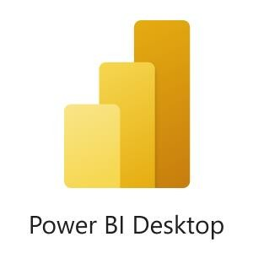On the third and fourth day we learned about installing a

power bi desktop app. The process for installing power bi desktop is

1. search “power bi desktop install” on the internet
2. click on the “download free” option to install power bi desktop
3. click on the “get” option and the power bi desktop setup will get download on your computer
4. once the power bi desktop is download click on the install option

In fifth and sixth day we learn about power bi filters and stacked bar chart the filters have three level

1. filter on visual page
2. filters on this page
3. filters on all the page

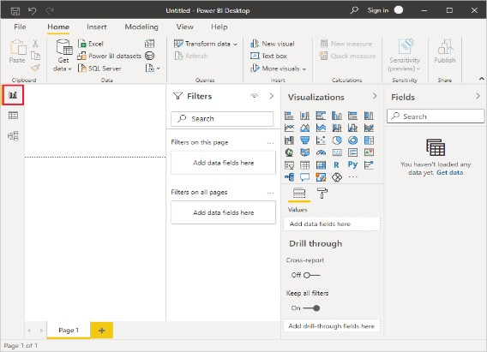

19

**ACTIVITY LOG FOR THE SECOND WEEK**

|  |  |  |  |
| --- | --- | --- | --- |
| **Day**  **&**  **Dat e** | **Brief description of the daily activity** | **Learning Outcome** | **Person In- Charge**  **Signature** |
| 19-07-23 wednesday | How to use clustered bar chart Process to open clustered bar chart in power bi | Discussion on clustered bar chart it can compare data, grouping data e.t.c |  |
| 20-07-23  Thursday | How to use 100% stacked bar chart and how the data will shown in 100%  stacked bar chart | In a 100% stacked bar chart the data will be shown in percentage. It is a straightforward process |  |
| 21-07-23  Friday | How to use pie chart in power bi desktop and how the data will show in pie chart | In the pie chart the data will be shown in slices. |  |
| 22-07-23  Saturday | What is transfer data  How to rectify error in transform data | The error rectify by using column profile column distribution column quality |  |
| 24-07-23  Monday | How to use clustered column chart in power bi  and how the data will show in clustered column chart  In transfer data how to choose column, row and how to remove column,row | by clicking on home option we can choose and remove rows and column |  |
| 25-07-23  Tuesday | Discuss about performance analyze data | This performance analyze start recording and refresh and duration values DAX process of query in power bi |  |

20

**WEEKLY REPORT**

**WEEK – 2 (From Dt 19-07-23to Dt 25-07-23) Objective of the Activity Done:**

**Detailed Report:**

In these week the first day we learn about clustered bar chart

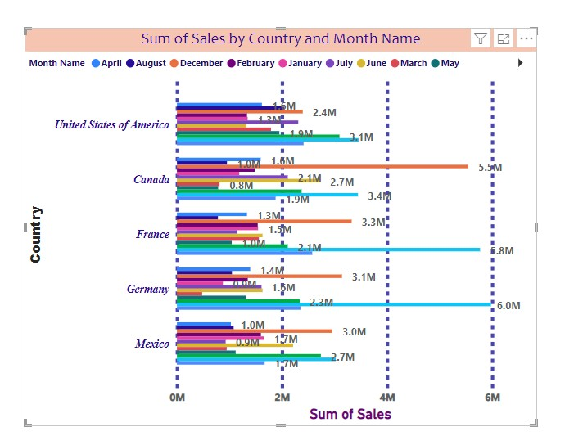

Clustered bar chart: The clustered bar chart is useful to visual and compare data across different categories.A clustered bar chart display multiple bars side by side

Open power bi desktop and connect your data source

Drag and drop the fields that represent the categories you want to compare to the axis fields well in the visual pane

Drag and drop the fields that represent the values you want to measure to the values field well in the visualization pane

The second day we learn about 100% stacked bar chart

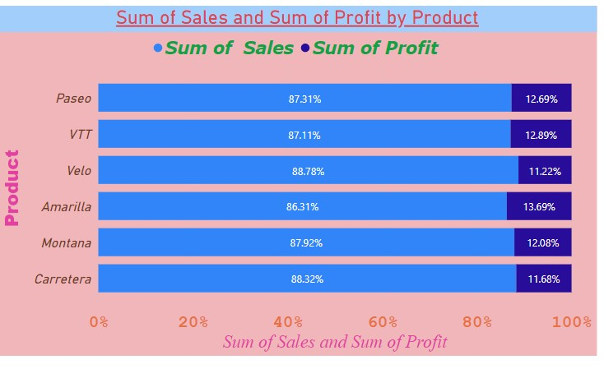

21

100%stacked bar chart: In a 100% stacked bar chart in power bi is a straightforward process. before processing ensure you have the necessary data load into your power bi

. It represent in percentage form open power bi desktop and load your data

In the visual pane on the right side select the 100% stacked bar chart option

These will create a regular stacked bar chart

Drag the fields you want show on the x-axis to the axis will of the visualization pane

Drag the fields you want stacked on the y-axis to the values well of the visualization pane The third day we learn about pie chart

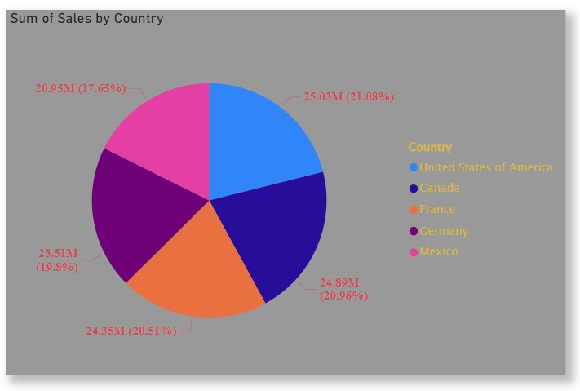

Pie Chart: Creating a pie chart in power bi is straightforward. power bi is a powerful data visualization tool that allows you to connect to different data source transfer and model data and then can create visualization like pie chart

Open power bi desktop. click on get data from the home tab choose the data sources you want to connect

follow the terms to connect your data and load it in power bi prepare your data ensure your data in structure for pie chart

The fourth day we learn about transfer data

Transfer data : In transfer data we can know about column quality, column distribution, column performance it will show the options in view. we can rectify error in transfer data in that we have distinct values and unique values also

The fifth and sixth day we learn about clustered column chart data analysis

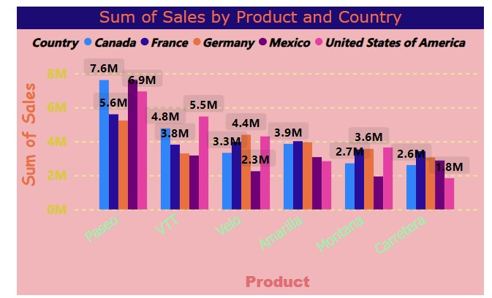 22

clustered column chart : In clustered column chart we have to follow some steps the are

connect to your data source, prepare the data, create the clustered column chart, clustered the columns, adjust the visualization the performance analyze the data by start recording and it will record and refresh it

##### ACTIVITY LOG FOR THE THIRD WEEK

|  |  |  |  |
| --- | --- | --- | --- |
| **Day &**  **Date** | **Brief description of the daily activity** | **Learning Outcome** | **Person InCharge**  **Signature** |
| 26-07-23  Wednesday | Discuss about how to use card by using different charts | A card is a components of a dashed board that display data or text |  |
| 27-07-23  Thursday | we learn about multiple cards in power bi | How to use multiple bar cards in power bi |  |
| 28-07-23  Friday | Today we learn about line chart in power bi | How to create line chart in power bi and it’s uses |  |
| 31-07-23  Monday | Today we learn about area chart in power bi and use of area chart in power bi | In power bi the area charts in power bi have various  practical uses that can provide  value insight and helping in decision making |  |
| 01-08-23  Tuesday | discuss about ribbon chart in power bi and learn about how to create ribbon chart in power bi | The uses of ribbon chart in power bi |  |
| 02-08-23 wednesday | Discuss about to create row level security with power can be used to restrict data | Row level security with power bi can be used to Filter restrict data access at the row level |  |

23

**WEEKLY REPORT**

**WEEK – 3 (From Dt 26-07-23 to Dt 02-08-23) Objective of the Activity Done:**

**Detailed Report:**

Line chart:

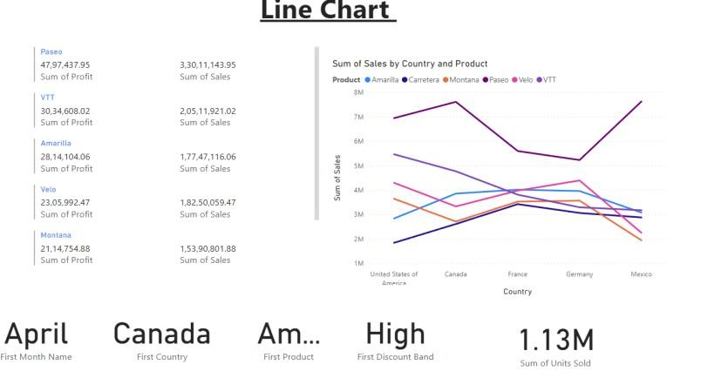

First, ensure that you have your data in a table format, with the columns that you want to use for the x and y-axis. Then, go to the Power BI Desktop, click on the Visualization tab, and select Line Chart from the visualizations pane.The use of line chart are time series analysis, performance tracking, forecasting and predictive analysis Card chart:

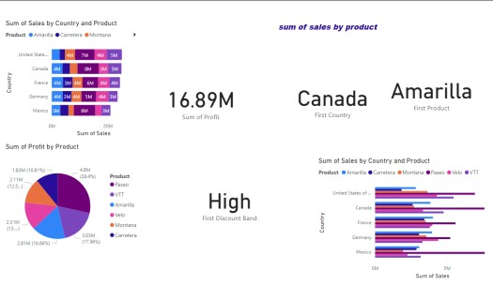

24

To start building a visual, you have three options: 1) insert a new visual from the ribbon and add fields, 2) right-click on the canvas and select “add visual”, or 3) check or drag fields from the data pane and then select the new card from the on-object dialog.

**Area chart:**

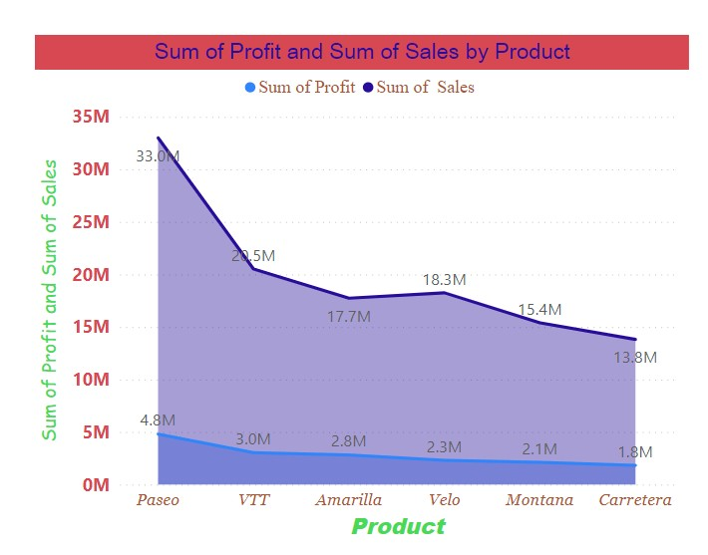

Area charts emphasize the magnitude of change over time, and can be used to draw attention to the total value across a trend. For example, data that represents profit over time can be plotted in an area chart to emphasize the total profit.

Ribbon chart:

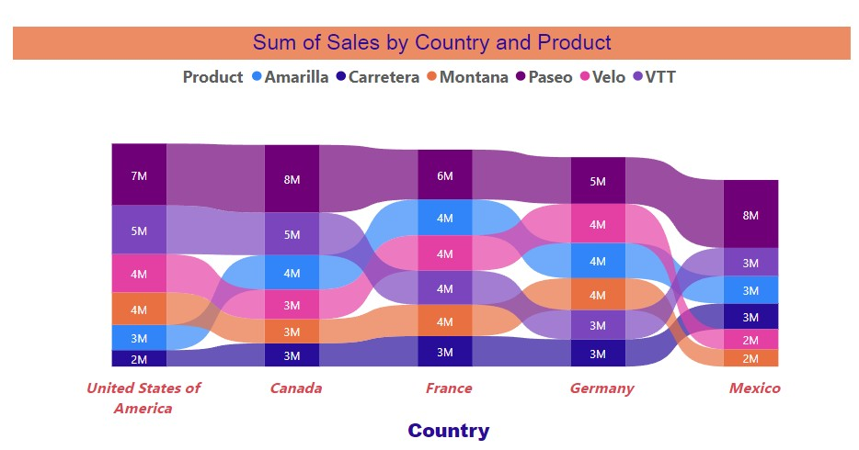

Ribbon Charts are a powerful visualization tool in Power BI, allowing analysts to examine data through a unique and engaging perspective. In this article, we will explore the Ribbon Chart in detail, from its benefits to its creation and customization.

25

**ACTIVITY LOG FOR THE FOURTH WEEK**

|  |  |  |  |
| --- | --- | --- | --- |
| **Day**  **&**  **Dat e** | **Brief description of the daily activity** | **Learning Outcome** | **Person In- Charge**  **Signature** |
| 03-08-23  Thursday | Discuss about types row level security in power bi | we learn about types of row level security in power bi they are two types i)static  ii) dynamic |  |
| 04-08-23  Friday | Discuss about to create combo chart in power bi and types of combo charts in power bi | A combo chart is a single visualization that combines a line chart and a column chart. |  |
| 05-08-23 saturday | Discuss about waterfall chart in powerbi and what is the use of waterfall in power bi | Today we learn about how to represent waterfall chart |  |
| 07-08-23  Monday | Today we learn about funnel and scatter charts in power bi | Today we learn about uses of funnel and scatter charts in power bi and how to represent the funnel and scatter charts in power bi |  |
| 08-08-23  Tuesday | what is parameter and explain about parameter in power bi | Power bi to selected modeling option click on new parameter there are two types numeric and fields range |  |
| 09-08-23 wednesday | Discuss about parameters used to calculated columns and measures & groups in power bi | The fields parameters features allows you to change columns and measures dynamically |  |

26

##### WEEKLY REPORT

**WEEK – 4 (From Dt 03-08-23 to Dt 09-08-23)**

**Objective of the Activity Done:**

**Detailed Report:**

Row level security (RLS):

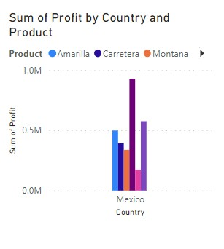

Today we learn about row level security in power bi it can be used to filter the restricted data access at row level . Row-level security (RLS) with Power BI can be used to restrict data access for given users. Filters restrict data access at the row level, and you can define filters within roles.we can use clustered column chart and stacked column chart for low level security.

Types of row level security in power bi :

In power bi we have two types of row level security they are :i) static

ii) dynamic

1. Static : RLS is Row Level security means restriction of data accessing for a particular user. Filters restrict the data at a row level. We can configure RLS for a dataset that we have imported into the Power BI desktop and can configure RLS in Power BI Service by defining the roles in the Power BI desktop.
2. Dynamic : By dynamic row-level security, I mean the definition of security is beside the user account information in the data source.

27

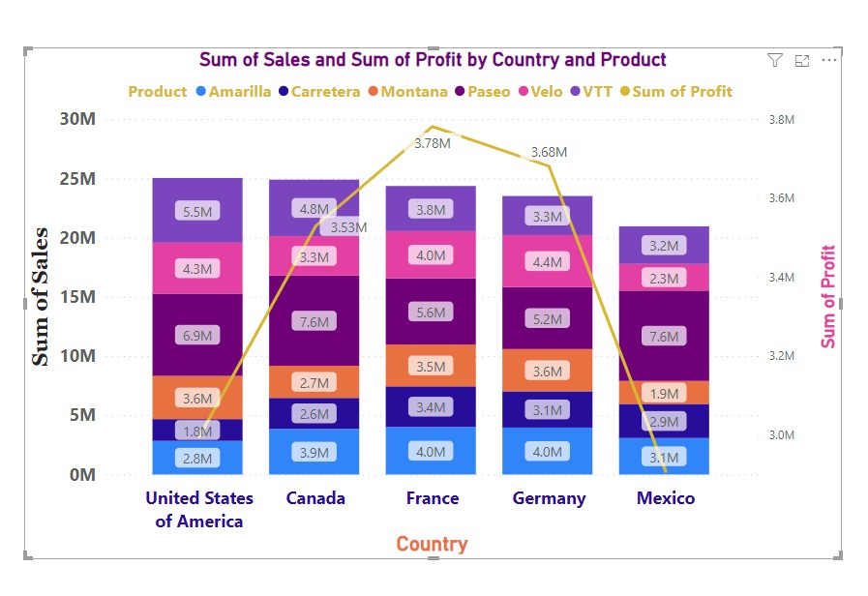

**combo chart:**

In Power BI, a combo chart is a single visualization that combines a line chart and a column chart. Combining the two charts into one lets you make a quicker comparison of the data. Instead of using two charts we can combine the line chart and column chart for presentation. In these combo we taken country in X -axis and in Y -axis we take sum of sales in secondary Y axis we have taken sum of profits and in legend we have taken products Waterfall chart:

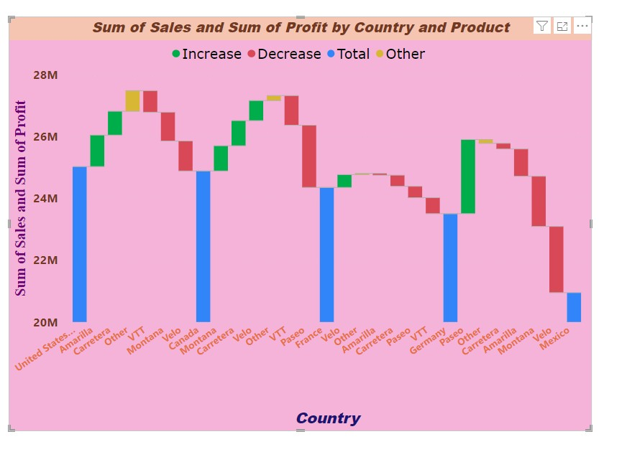

To create a waterfall chart it is used to process step by step process and table format visualization pane. This chart is used for breakdown in each contribution section in the visualization pane; one data pane selects the positive and negative values. Check the box values are select each contribution used to waterfall chart in power bi

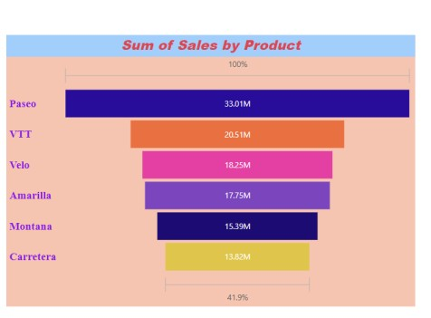Funnel chart:

28

To create a funnel chart. This chart helps lowest and highest values in contribution. Funnel chart helps you visualize connected stages. A funnel chart is a specialized chart type that demonstrates the flow of users through a business or sales process.

**Scatter Chart:** To Create a Scatter Chart This Chart Helps To Adding to the two Numeric Columns Sales and revenue from Animation Values in power bi Desktop used with visualization bi. Scatter Chart To visualization into two X,Y Axis Vertical and Horizontal visualize in this Scatter Chart Also called Scatter plot . Chart is

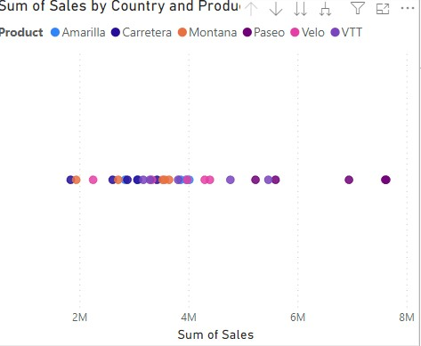Relationship between into Two

Variables and this power full Chart.

**Parameters:**  To Create a power Bi Desktop Adding a Parameters To visual and Report into The option click on DAX Data Analysis Expression To Act as a Variables Reports and readers Can use slicers To adjust

the Inputs and Different outcomes.There Are Two Types of the Parameters

* Numeric Rang
* 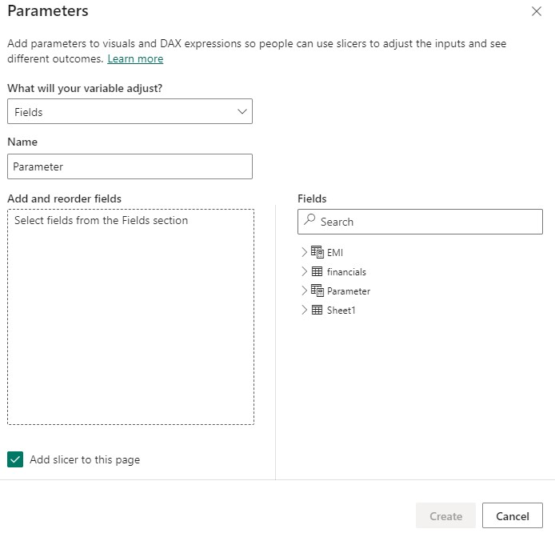Fields

**Numeric Rang:**  To

Create a Power Bi

Desktop Adjust into

Numeric Values Used as Inputs For Visualize or DAX To create a Numeric range

Parameter, go to

Modeling Ribbon >

New Parameter > Numeric range.

29

* A Parameters pop-up box will appear.

* Create a calculated column.
* Create measures.
* Using the rectangle visual, place the field.
* Click Measure Conditional formatting – Background color. ➔ Enter the Background color interface.

30

**ACTIVITY LOG FOR THE FIFTH WEEK**

|  |  |  |  |
| --- | --- | --- | --- |
| **Day**  **&**  **Date** | **Brief description of the daily activity** | **Learning Outcome** | **Person In- Charge**  **Signature** |
| 10-08-23  Thursday | Discuss about donut chart in power bi And discuss about uses of donut chart in power bi  And how to present donut chart in power bi | Donut charts are used to show the proportions of categorical data, with the size of each piece representing the proportion of each category |  |
| 11-08-23  Friday | Discuss about treemap chart in power bi And discuss about uses of treemap chart in power bi  And how to present treemap chart in power bi | Treemaps display hierarchical data as a set of nested rectangles. Each level of the hierarchy is represented by a colored rectangle called a branch node. |  |
| 12-08-23  Saturday | Discuss about create a KPI chart and gauge chart & slicer in power bi desktop | KPI means key performance indicator to create a reach to get data. and gauge chart used progress forward the values and slicer to use change default values easy visual |  |
| 14-08-23  Monday | Explain about server reporting services that can host power bi report | Power bi report server. there are two types:  i.Physical Machine ii.Virtual Machine |  |
| 16-08-2023  Wednesday | Power bi reports based to Clouds server How to use Server | These server used to rental purpose of the Server in power bi. |  |
| 17-08-2023  Thursday | Discuss about to create a table data to convert matrix table and decomposition  tree in power bi | To create a table to convert matrix table data visualization select the decomposition tree  icon from the visualizations  pane |  |

31

##### WEEKLY REPORT

**WEEK – 5 (From Dt 10-08-23 to Dt 19-08-23) Objective of the Activity Done:**

**Detailed Report:**

**Parameters Fields:** In Power BI, the x-axis of the visual can be changed using a feature called 'Field Parameter. The Field Parameters feature is not supported for implicit measures i.e. the default summarisation of the columns Field parameters allow users to dynamically change the measures or dimensions being analyzed within a report. an essential feature meant to make work easy.

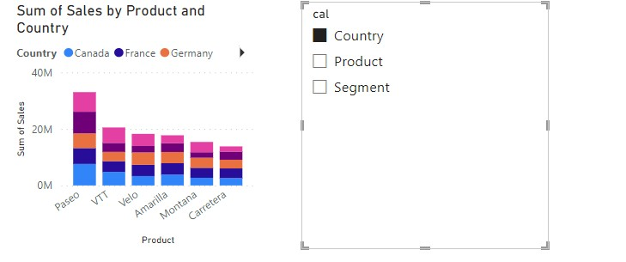

Donut chart :

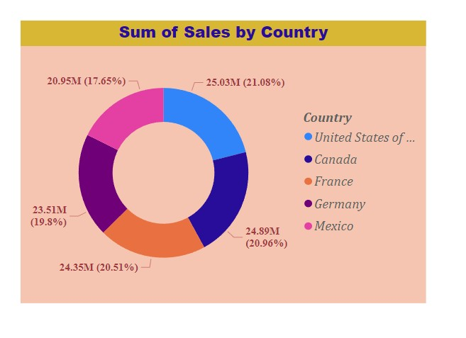

**Donut charts** :are used to show the proportions of categorical data, with the size of each piece representing the proportion of each category. A donut chart is created using a string field and a count of features, number, or rate/ratio field.

32

**Treemap Chart:**

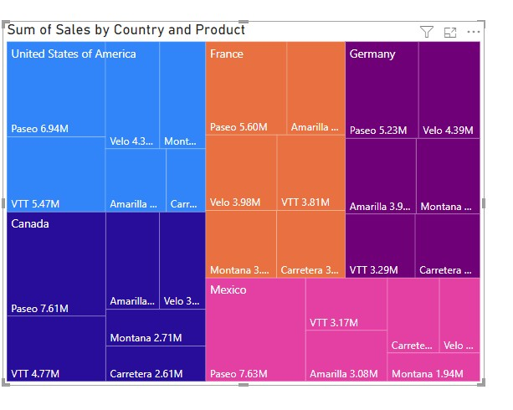

A treemap is a visual method for displaying hierarchical data that uses nested rectangles to represent the branches of a tree diagram. Each rectangle has an area proportional to the amount of data it represents. Network administrators often use treemaps to analyze disk space use.

**KPI(KEY PERFORMANCE INDICATOR):**

* Step 1: Adding KPI Indicators from the Fields Pane.
* Step 2: Adding the KPI Trends.
* Step 3: Check Whether the Columns are Sorted in Power BI.
* Step 4: Converting the Visual into a KPI.
* Step 5: Adding Goals and Formatting the KPI.

Key performance indicators are new columns of performance over time for specific strategic objectives. Modern KPI dashboards allow any user to easily explore the data.

**Gauge chart in Power BI:**

* Open your power bi desktop.
* Load the data using get data from the ribbon. ★ Select the Gauge chart from the visualization.
* In the field formatting section, under the values drag and drop the Gross sales from the Field pane in power bi desktop.

**Slicer Chart:**Adding a slicer to your Power BI report is quick and easy, here's how it's done: Open your report and select the visual to which you want to add the slicer. You can add a slicer to any visual in Power BI. Click on the "Visualizations" pane in the Power BI ribbon and select the "Slicer" icon.

33

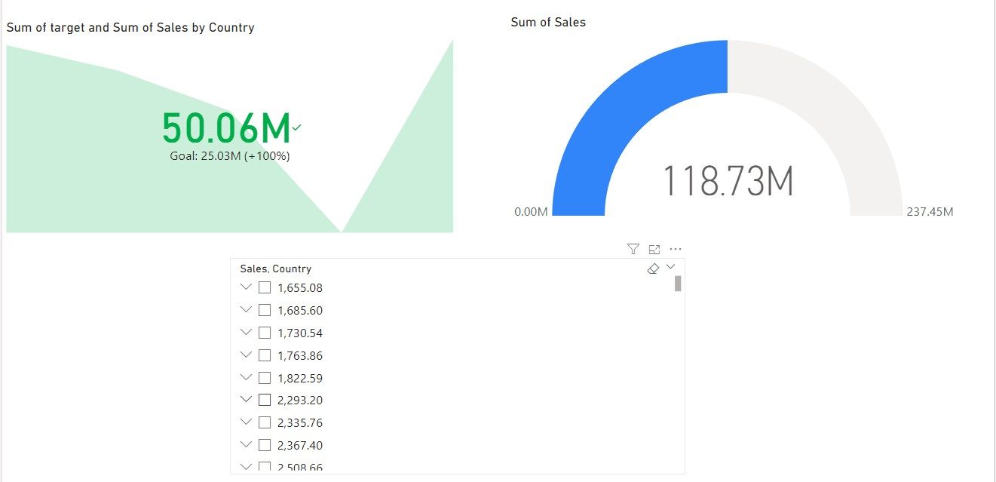

**Power Bi Server Report:**  Power BI Report Server, has you covered with a complete solution. Power BI Premium provides dedicated capacity in the cloud performance

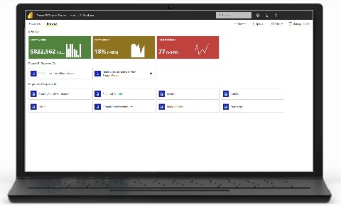And Physical And Virtual Machines Used To Servers.

**Physical Machine:**

Power BI Report Server is available through two different licenses: Power BI Premium and SQL Server Enterprise Edition with Software Assurance Power BI Premium license, you can create a Developing cloud and on-premises.

**Virtual Machine:** A virtual machine, commonly shortened to just VM, is no different than any other physical computer like a laptop, smart phone, or server. It has a CPU, memory, disks to store your files, and can connect to the internet if needed.

34

**ACTIVITY LOG FOR THE SIXTH WEEK**

|  |  |  |  |
| --- | --- | --- | --- |
| **Day**  **&**  **Dat e** | **Brief description of the daily activity** | **Learning Outcome** | **Person In- Charge**  **Signature** |
| 18-08-2023  Friday | Discuss about key influence in power bi tools. | Key influencers show you the top  contributors And matric values changed. |  |
| 19-08-2023  Saturday | Discuss about matrix Table | The ordinary table in  Power BI is only twodimensional. |  |
| 21-08-2023  Monday | Discuss about decomposition  tree | Power bi visualize data across multiple dimensions. |  |
| 22-08-2023  Tuesday | Allocated data sets for main Project | Analyze the data sets |  |
| 23-08-2023    Wednesday | Data Allocated for main Project | Analyze the data sets & to be started Main Project |  |
| 24-08-2023  Thursday | Discussed About main Project | Creating Charts For Main Project |  |

35

##### WEEKLY REPORT

**WEEK – 6 (From Dt 18-08-23 to Dt 24-08-2023 )**

**Objective of the Activity Done:**

**Detailed Report:**

**Matrix Table:**

The ordinary table in Power BI is only two-dimensional. The data shown are flat and duplicate values are displayed, not aggregated. A matrix table supports multiple dimensions, a stepped layout, aggregates data, and has a drill-down functionality. Like the ordinary table, creating a matrix table in Power BI is super easy.

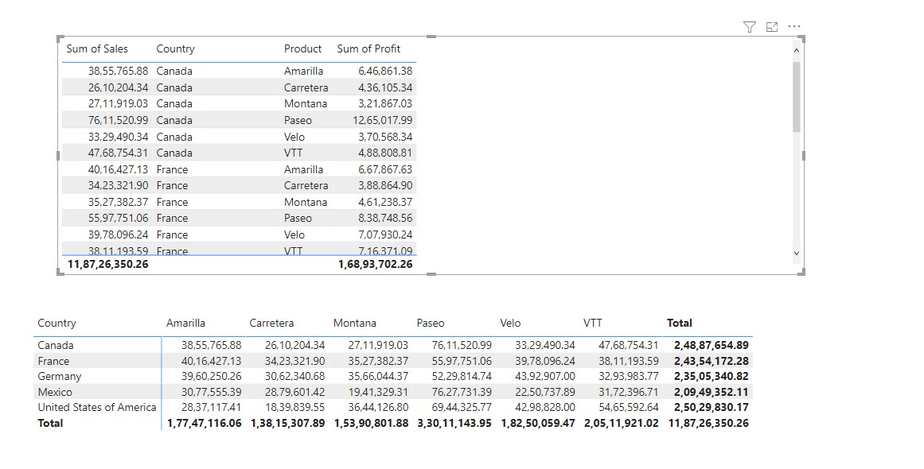

**Decomposition Tree:** The decomposition tree visual in Power BI lets you visualize data across multiple dimensions. It automatically aggregates data Used to This Chart.

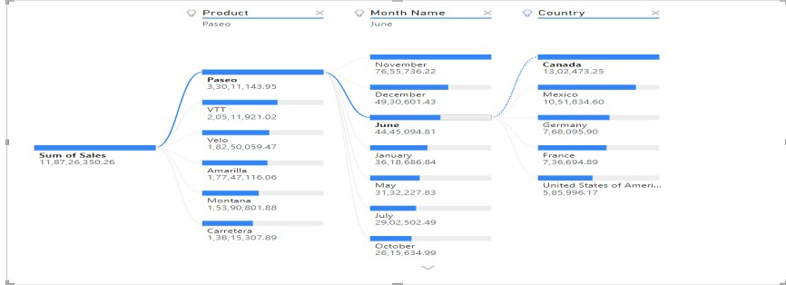

36

**Key influencers:**Key influencers show you the top contributors to the selected metric value. Top segments show you the top segments that contribute to the selected metric value. A segment is made up of a combination of values.

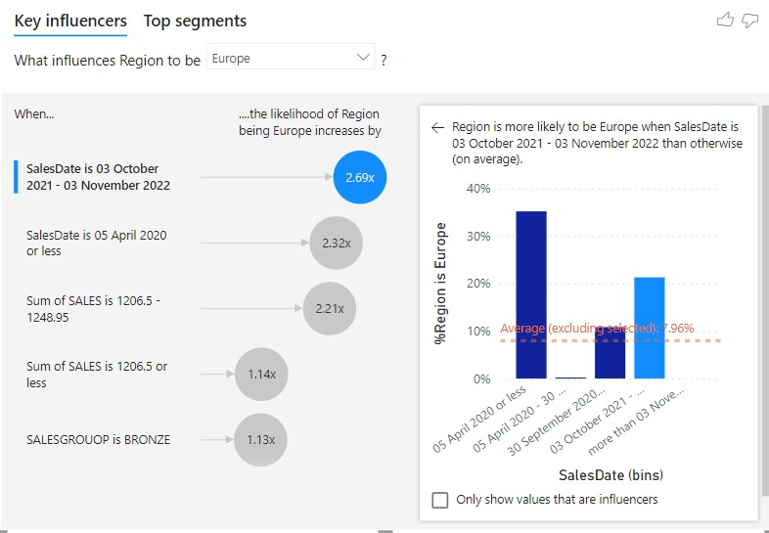

37

**ACTIVITY LOG FOR THE SEVENTH WEEK**

|  |  |  |  |
| --- | --- | --- | --- |
| **Day**  **&**  **Dat e** | **Brief description of the daily activity** | **Learning Outcome** | **Person In- Charge**  **Signature** |
| 25-08-2023  Friday | Documentation | Documentation |  |
| 26-08-2023  Saturday | Documentation | Documentation |  |
| 28-08-2023  Monday | Documentation | Documentation |  |
| 29-08-2023  Tuesday | Documentation | Documentation |  |
| 30-08-2023  Wednesday | Documentation | Documentation |  |
| 31-08-2023  Thursday | Documentation | Documentation |  |

###### 38

**CHAPTER 5: OUTCOMES DESCRIPTION**

**Work environment I have experienced**

A unique teaching style to help aspiring learners to master the art of managing data and creating powerful dashboards to make intelligent business decisions. Working together to turn your unrelated sources of data into clear, visually immersive, and interactive insights.

Individually getting data from a wide range of systems in the cloud and create dashboards that will track the metrics they care the most. With this technology, enterprises can see their business performance more closely and get immediate results with real-time dashboards available for every device.

All the topics and units are broken down in an easy to learn manner, making the course extremely enjoyable and our friendly instructors delight all our learners to use Power BI successfully. The trainers will help you understand how to use Power BI to analyze data, identify trends and make better decisions. They helped learn how to create reports, dashboards, and interactive visuals with Power BI. Helped us get the most out of Power BI and make it work for your business.

Interactive and highly engaging BI training course helps candidates across departments communicate performance-related data in a visually understandable manner.

Exploring the different types of testing, preparing, and presenting data quickly and easily. Learn how to turn data into powerful insights that direct and drive informed business decisions - giving your business the edge over competitors.

Learnt about DAX data computation, creating tables, binned tables, data drill down and drill up, Power Q&A, and many more advanced topics.

learn how to create and customize reports, work with advanced analytics,

39

*realtime technical skills I have acquired*

The Power BI Developer will have an advantage if they are well-versed in the

Microsoft Business Intelligence stack, which includes Power Pivot, SSRS,

SSIS, and SSAS. Since most companies use Microsoft services and goods, a Power BI Developer with a good scope of knowledge is an asset to the company.

Additionally, we can connect to cloud databases like Amazon Redshift, cloud applications like Sales force, and warehouses. Power BI can connect to any type of data we can imagine. In addition, Power BI has a Web Data Connector that can connect any desired data source by pulling API directly from the web.

Business users with access to Power BI can quickly and easily find valuable data in their sizable Adopt data sets. With this software, users no longer need to be familiar with query languages, making it easier for stakeholders to interact with big data.

Power BI is a business intelligence tool with excellent prospects for the foreseeable future. Its benefits and uses are significantly higher than any doubt that it might go off the market.

Data analysis involves the process of transforming raw data into useful information. It is a process applied to various industries. Power BI can connect to such sources as Google Analytics.

It is easier to understand all the different kinds of reports available in the product as we understand the architecture and components of Power BI. We can create our data models and business rules.

* Proficient with using various visualization tools for this.

* Interactive visualizations of data from various sources. You'll gain

* Familiarity with the various Power BI visualizations available as a result

* Find the KPIs with the appropriate objectives

* Use current and historical data for better decision making

* Technical publications can be derived from business requirements

* Data models that are multi-dimensional. 40

*Managerial skills I have acquired*

Planning is a vital aspect within an organization. Process of formulating a set of actions or one or more strategies to pursue and achieve certain goals or objectives with the available resources. Process includes identifying and setting achievable goals, developing necessary strategies, and outlining the tasks and schedules on how to achieve the set goals. Information shared throughout a team, ensuring that the group acts as a unified workforce. Flow of information within the organization, whether formal or informal, verbal or written, vertical or horizontal, and it facilitates the smooth functioning of the organization. Making proper and right decisions results in the success of the organization, while poor or bad decisions may lead to failure or poor performance. **negotiate the terms of a contract or something discussed**

Avoiding wastage of time, optimizes productivity, and ensures responsibility and accountability on the part. Ability to tackle and solve the frequent problems that can arise in a typical workday. Involves identifying a certain problem or situation and then finding the best way to handle the problem and get the best solution.

###### creating a safe and positive environment

Exhibit flexibility in their approaches to fast-paced work environments where change is inevitable and welcome. This includes being open to updating processes and applications to meet current industry trends and taking on additional tasks or responsibilities in order to accommodate schedule changes, short- or long-term work overloads, or other needs.

Demonstrating time management skills because it shows that even when handling multiple projects or responsibilities, work gets done, deadlines are met, and everyone’s ducks are in neat little rows. Creating a schedule, stick to it, and maintain a perfect work-life balance, they’re looking at a prime candidate.

*listening* supersedes speaking. We usually hear of ―good‖ listening being a key takeaway, but proper listening should be more than good. It should be *active*. Active listening requires the

―listener‖ to concentrate on what’s being said rather than listening for the sake of responding. glazing over larger concerns embedded into an team’s complaint or inquiry.

Motivation helps bring forth a desired behavior or response from certain stakeholders depending on characteristics such as company and team culture, team personalities, and more. A collection of abilities that include things such as business planning, decision-making, problem-solving, communication, delegation, and time management.

41

*How I could improve my communication skills*

Being able to convey complex, technical concepts to others – not just through their Power BI dashboards and reports, but via face-to-face communication, too. Keeping the communication concise without compromising on the importance of it. This applies to both written and verbal communication. For written communication, proofread, and for verbal communication, practice saying only what is important to the conversation.

Gauge what type of communication they are going to understand. For example, if you are communicating with a colleague or a senior, obviously informal language should not be used.

Also, if you use acronyms, you cannot assume that the other person will immediately understand. So, know your listener.

The language you use in your communication should be assertive and active. This form of language instantly grabs the attention of the listener or reader. They will latch on to your every word and the right message will be passed on.

Keeping a positive body language like an open stance and eye contact. This is subconsciously read by the other person, and their body language also becomes positive.

Proofread what you have written once or twice before sending. One tip is that do not proofread immediately after writing. It’s harder to spot errors. Take a small break, give rest to your eyes, and then proofread.

Making sure that you are in the right frame of mind. Tiredness, frustration, sadness, and anger, among other range of emotions, can hamper what we want to communicate. Just making sure we are positive or at least neutral.

Directly communicate with the person we mean to. In many organizations, communication channels are created with many needless people passing on the messages.

Communication is something that has a substantial impact on our personal and professional life. It has to be taken seriously. And always remembering some of the most successful and happy people in life are great communicators.*Describe how could you could enhance your abilities in group discussions, participation in teams, contribution as a team member, leading a team/a*

Problem-solving skills: Candidates should be able to evaluate complex situations, analyze data, and reach intelligent conclusions in order to deliver effective solutions.

Good attention to detail: As they say, the devil is in the detail. Candidates will be expected to work with large volumes of data, and they must have a keen eye for smaller details, errors, and flaws in the data to make sure your business is working with only the cleanest, most accurate data.

42

―No man is an island‖. So the saying goes. Increasingly in the workplace, we all have to work with others in order to complete a project. Be it working in a team, or dealing with clients or suppliers, interpersonal abilities is a definite advantage and something employers always look for.The ability to build relationships with those around you under any circumstances, and the ability to inspire them to do what needs to be done is essential.

Theoretically, when someone is offered a job, there is a job description included in thecontract. In reality however, employees are not expected to stick to only what is under their job description.On the contrary, they are expected to get involved in other areas of the business, understand all the different steps, and offer help where necessary. At the end of the day, employers look for someone willing to try out different things, and wear multiple hats at the same time, deal with different projects and individuals, and provide more than one sole contribution at a time to the company.

Being self-confident exudes an aura that can convince those you work for (or with) that you know what you are doing. If you do not believe in yourself, your skills and abilities, then you cannot expect anyone else to believe in you. You need to be confident with yourself and ensure everyone sees you as someone that has the ability to pull through whatever situation comes your way.

Public speaking is a very crucial skill to have, which requires a lot of self-confidence, practice, and analysing of your audience. Even though it comes naturally to some people, it is definitely a skill that can be acquired, and it is a skill sought after by employers.

No matter how much you believe you are right about something, or that it may be more useful for your colleague to know exactly what you think, realise that not everyone reacts the same way to different styles of confrontation.It is important for individuals to know how and when to deal with various issues that may crop up in the working environment, whether they are dealing with clients, colleagues, or supervisors.

Integrity and well-founded moral values should be highly-respected in the work place.

43

though many scandals appear with black sheep here and there, it is essential for employees to maintain their values and integrity at all costs. Honesty and sticking to your values will definitely repay in the long run. An untainted reputation after all is what will help you move up the career ladder. Employers always look for employees that are passionate about what they do and are very committed to their assignments. They need to be assured that their employees will keep at a problem until it is solved, and they will do what is necessary to complete all tasks.

Arriving at work on time and willingness to work and take responsibility are basic indicators of an employee’s commitment. These factors can show whether an employee is cut out for a specific role.

If a person demonstrates an attitude that is appreciative of feedback, it can be deduced that he/she is willing to learn. Irrespective of age and experience, everyone is constantly learning at the workplace, and one should always remain open to new information that can enhance their skills and abilities.

Jobs are constantly changing and evolving, and employees of all ranks should show that they are open to growing and learning, either by experiencing new situations, by training, or even by listening and learning from criticism.

Even if your job has nothing to do with mathematics, arithmetic, geometry, algebra, calculus, and statistics, basic knowledge of these may become necessary at some stage.

Refreshing your knowledge of mathematics often is an essential part of keeping your competitive advantage in the job market. Statistics in particular may come in handy, as manya time you might need to produce some graphs and figures by analyzing quantitative data.

Being analytical, but also having strong research skills, differentiates one employee from the other. It demonstrates your determination, your ability to assess different scenarios, and your commitment to be 100% sure before giving an answer to your employer. It could mean the difference between a badly thought out idea and something that may gain the company a huge profit. As much as you think a question/problem presented to you is a piece of cake, be very wary of giving a rushed answer. Take the time to analyze the situation, think of all possible scenarios, and if possible ask for some time to go and do some research to find out more.

***44***

***Power BI for the Technology Industry Convert*** *Data into Insights with help of Power BI*

Access your data easily on any device and get a 360-degree view of the health of your company. Power BI is a complete package of solutions tailored for the digital business world. From better team collaboration to interactive reports, data management, and predictive analysis – Power BI is the perfect intelligence tool for your business. The augmented growth of data in today’s business landscape undoubtedly demands a reliable tool to manage heaps of data and reports efficiently. Power BI reconstructs the process instances step-by-step, even if they are from multiple sources, and helps you cut out unnecessary steps, get accurate results to interpret and act on, and reduce costs.

Power BI’s advanced business intelligence and data modeling capabilities offer businesses the power of predictive analytics to compete in today’s digital world. With features to generate historical data (past) and analyze current market trends and financial graphs, enterprises could easily prepare for the future.

Power BI’s

Predictive analytics – use of historical data, patterns, and ML techniques to predict future outcomes and



Prescriptive analytics – uses data and goes in-depth into the potential results of specific actions capabilities have significantly helped enterprises to arrive at better business decisions.



Connect to Data

*Bring in your data from different Data Sources- be it on-premise or cloud data.*

Hundreds of Database Connectors

Data Sources added on regular basis

Transform, Shape & Model Data

*Get the connected data from various sources to work together without the need to flatten data.*

Data Transformation

Connects various Data Sources

Data Model Optimization

Reports

*Gain deeper insights into your data with rich interactive and meaningful reports.*

Data Visualization

Quick Business insights

Drill down functionality

Real-time Goal Monitoring

***45***

**QUALITY THOUGHT**

# NYKAA SALES

**POWER BI**

**N.Ramakrishna-B.com Computers 2-214250-K2110850**

**46**

## NYKAA SALES ANALYSIS

**Objective:** The Power Bi Desktop Report on the project title of NYKAA SALES ANALYSIS support during the data collection process and active participation in project activities .

### **Visualization Of The Data**

To start analyzing the data we need a power bi dashboard for the visualization.

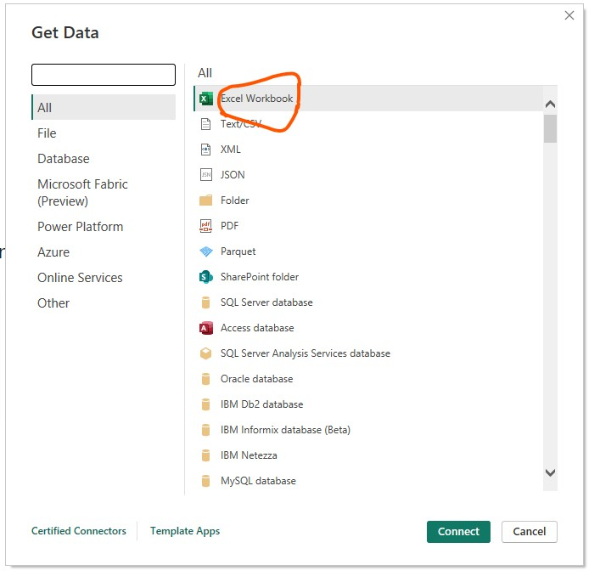

To get the data I have selected the “excel workbook” and loaded the data from the “excel sheet “ .

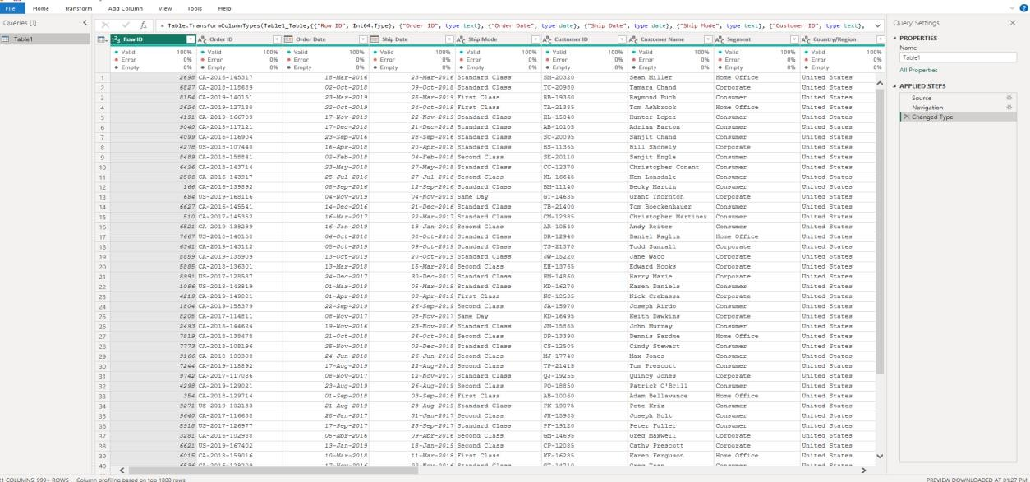

47

There is the data about “NYKAA SALES ANALYSIS”

After selecting the data go to the ‘HOME’ and select the option “transform data” then it will take to the power query.

After changing there is an option in ‘HOME’, “close and apply” click on it.

Then the Canvas Background is opened, then we can select our own color to design it.

Now we can create an impressive dashboard with the help of data .

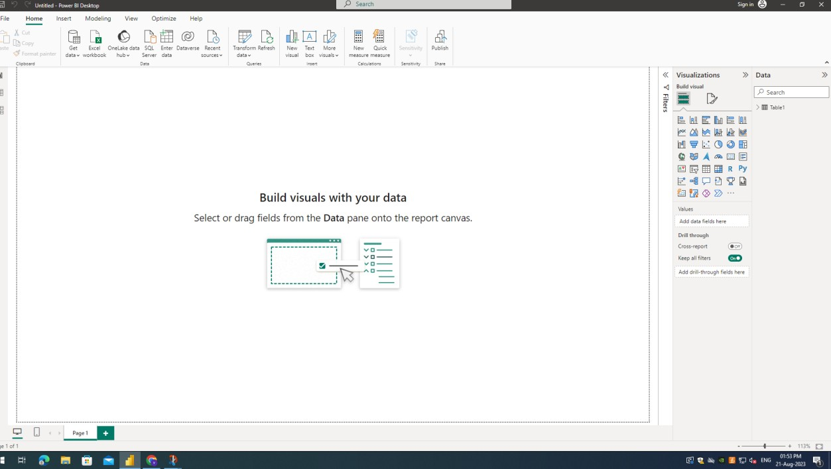

Here I have selected it as shown in the fig above

So here I am having the data as per my information, now I will create a dashboard .

48

### **WATERFALL CHART**

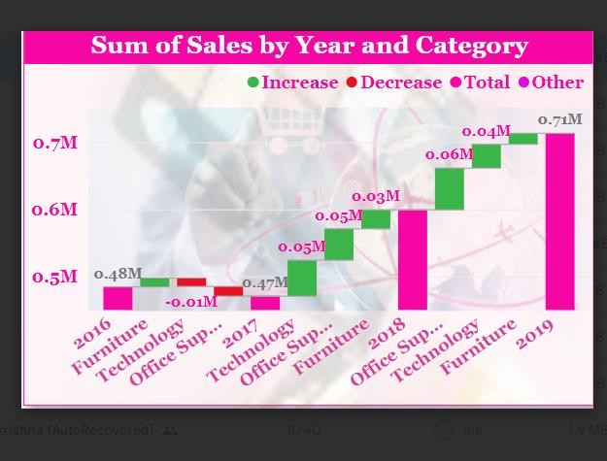

I have use waterfall chart to represent the sum of sales by year and category on X-axis year and category was taken and it show year and category sales and it was shown bar if the sales increase it show the bar in green color and if the sales was decrease it show in red color and others shown in pink color

YLINE CHART

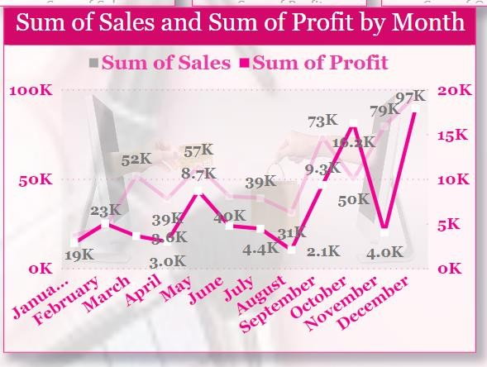

49

I have used a line chart to show sales, profit by month wise on x- axis months was taken. And on y-axis sales and on another y-axis profit was taken by using these segments. I have shown the sum of sales and sum of profit by month in line chart

CARDS CHART



In my dashboard the cards chart was used to show the total sales, total profit, total quantity, total customers, total orders, total product. And I have used a slicer chart when the slicer chart is used the values will change as per region, year, month. Then the total sales, total profit, total quantity, total customers, total orders and total products value will change in cards chart

GAUGE CHART

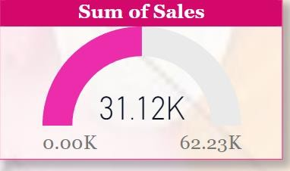

50

In gauge chart the target was fixed for sales by using the gauge chart the target was shown for sales by month wise, year wise and by region wise also

MULTI ROW CARD

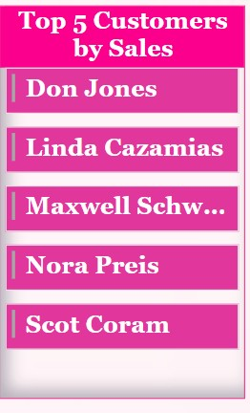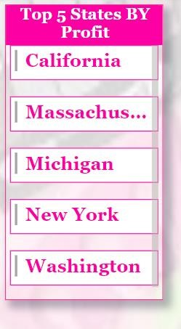

By using a multi row card. I have taken the top five states by profit and top five customers by sales was shown in multi row card

51

SLICER CHART

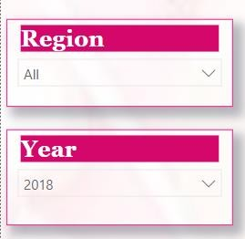

The slicer chart was taken to show two elements one is region and another one is year. In region the total sales, quantity, customers, products was in when we click on region it displays the option like east, west, north like that when click on any one it shows the total sales, quantity, customers, products was shown. Like that only again i have taken another slicer and in that slicer chart i have taken four years 2016-20019 by clicking on that it will displays option if we select any one option it will display the total sales, quantity, product,target also

52

SLICER CHART

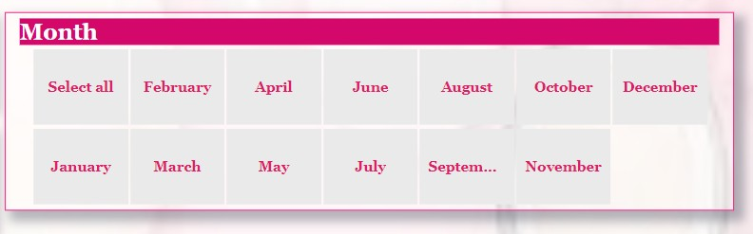

By using Slicer Chart I have selected month element by clicking on the any month it will display total sales, Quantity , Products , Customers and Target

***53***

***Student Self Evaluation of the Short-Term Internship***

**Student Name: D.SUBHASH Registration No:K2237440**

**Term of Internship: From: 12-07-2023 To :31-08-2023**

**Date of Evaluation:31-08-2023**

**Organization Name & Address: Quality thought Pvt.Ltd, Vijayawada.**

**Please rate your performance in the following areas:**

**Rating Scale: Letter grade of CGPA calculation to be provided**

|  |  |  |  |  |  |  |
| --- | --- | --- | --- | --- | --- | --- |
| 1 | Oral communication | 1 | 2 | 3 | 4 | 5 |
| 2 | Written communication | 1 | 2 | 3 | 4 | 5 |
| 4 | Interaction ability with community | 1 | 2 | 3 | 4 | 5 |
| 5 | Positive Attitude | 1 | 2 | 3 | 4 | 5 |
| 6 | Self-confidence | 1 | 2 | 3 | 4 | 5 |
| 7 | Ability to learn | 1 | 2 | 3 | 4 | 5 |
| 8 | Work Plan and organization | 1 | 2 | 3 | 4 | 5 |
| 9 | Professionalism | 1 | 2 | 3 | 4 | 5 |
| 10 | Creativity | 1 | 2 | 3 | 4 | 5 |
| 11 | Quality of work done | 1 | 2 | 3 | 4 | 5 |
| 12 | Time Management | 1 | 2 | 3 | 4 | 5 |
| 13 | Understanding the Community | 1 | 2 | 3 | 4 | 5 |
| 14 | Achievement of Desired Outcomes | 1 | 2 | 3 | 4 | 5 |
| **15** | **OVERALL PERFORMANCE** | **1** | **2** | **3** | **4** | **5** |

**Date: Signature of the Student**

54

***Evaluation by the Supervisor of the Intern Organization***

|  |
| --- |
| Student Name:D.SUBHASH Registration No:K2237440  Term of Internship: From: 12-07-2023 To :31-08-2023  Date of Evaluation: 31-08-2023  Organization Name & Address: Quality thought Pvt.Ltd, Vijayawada.  Name & Address of the Supervisor with Mobile Number :G.MADHURI MCA |

Please rate the student’s performance in the following areas:

Please note that your evaluation shall be done independent of the Student’s self- evaluation

Rating Scale: 1 is lowest and 5 is highest rank

|  |  |  |  |  |  |
| --- | --- | --- | --- | --- | --- |
| 1 Oral communication | 1 | 2 | 3 | 4 | 5 |
| 2 Written communication | 1 | 2 | 3 | 4 | 5 |
| 3 Proactiveness | 1 | 2 | 3 | 4 | 5 |
| 4 Interaction ability with community | 1 | 2 | 3 | 4 | 5 |
| 5 Positive Attitude | 1 | 2 | 3 | 4 | 5 |
| 6 Self-confidence | 1 | 2 | 3 | 4 | 5 |
| 7 Ability to learn | 1 | 2 | 3 | 4 | 5 |
| 8 Work Plan and organization | 1 | 2 | 3 | 4 | 5 |
| 9 Professionalism | 1 | 2 | 3 | 4 | 5 |
| 10 Creativity | 1 | 2 | 3 | 4 | 5 |
| 11 Quality of work done | 1 | 2 | 3 | 4 | 5 |
| 12 Time Management | 1 | 2 | 3 | 4 | 5 |
| 13 Understanding the Community | 1 | 2 | 3 | 4 | 5 |
| 14 Achievement of Desired Outcomes | 1 | 2 | 3 | 4 | 5 |
| **15 OVERALL PERFORMANCE** | **1** | **2** | **3** | **4** | **5** |

**Date: 55 Signature of the Supervisor**

**EVALUATION**

**Internal Evaluation for Short Term**

**Internship (On-site/Virtual)**

**Objectives:**

* To integrate theory and practice.
* To learn to appreciate work and its function towards the future.
* To develop work habits and attitudes necessary for job success.
* To develop communication, interpersonal and other critical skills in the future job.
* To acquire additional skills required for the world of work.

**Assessment Model:**

* There shall only be internal evaluation.
* The Faculty Guide assigned is in-charge of the learning activities of the students and for the comprehensive and continuous assessment of the students.
* The assessment is to be conducted for 100 marks.
* The number of credits assigned is 4. Later the marks shall be converted into grades and grade points to include finally in the SGPA and CGPA.
* The weightings shall be:
  + - Activity Log 25 marks
    - Internship Evaluation 50 marks
    - Oral Presentation 25 marks
* Activity Log is the record of the day-to-day activities. The Activity Log is assessed on an individual basis, thus allowing for individual members within groups to be assessed this way. The assessment will take into consideration the individual student’s involvement in the assigned work.
* While evaluating the student’s Activity Log, the following shall be considered –
  1. The individual student’s effort and commitment.
  2. The originality and quality of the work produced by the individual student.
  3. The student’s integration and co-operation with the work assigned.
  4. The completeness of the Activity Log.
* The Internship Evaluation shall include the following components and based on Weekly Reports and Outcomes Description a. Description of the Work Environment.

1. Real Time Technical Skills acquired.
2. Managerial Skills acquired.
3. Improvement of Communication Skills.
4. Team Dynamics
5. Technological Developments recorded.

**MARKS STATEMENT**

**(To be used by the Examiners)**

#### INTERNAL ASSESSMENT STATEMENT

**Name Of the Student: D.SUBHASH**

**Programme of Study: NYKAA SALES REPORT**

**Year of Study: 2021-2024**

**Group: II B.COM(COMPUTER’S)**

**Register No/H.T. No: K2237440**

##### Name of the College: KAKARAPARTI BHAVANARAYANA COLLEGE University: KRISHNA UNIVERSITY

|  |  |  |  |
| --- | --- | --- | --- |
| ***Sl.No*** | ***Evaluation Criterion*** | ***Maximum***  ***Marks*** | ***Marks Awarded*** |
| 1. | Activity Log | 25 |  |
| 2. | Internship Evaluation | 50 |  |
| 3. | Oral Presentation | 25 |  |
|  | GRAND TOTAL | 100 |  |

|  |  |
| --- | --- |
| Date: | **Signature of the Faculty Guide**  **Certified by** |
| Date: | **Signature of the Head of the Department/Principal** |

Seal: