
GreenLedger Forensic Audit
INSTITUTIONAL ESG RISK INTELLIGENCE REPORT

DATE  April 15, 2026 | REFERENCE  GL-26-AUDIT | STATUS  VERIFIED

Report Highlights
This technical summary details findings from the Kinetic Observatory audit sweep. Our forensic models have identified inconsistencies across the portfolio's climate-zero reporting trajectories.
AUDIT ENTITY | RISK POSTURE | CONFIDENCE
EcoCorp reaches 100% recycled energy across a... | LOW | 94% correlation

Audit Analysis: EcoCorp reaches 100% recycled ...
Verified Claim: "EcoCorp reaches 100% recycled energy across all G7 data centers."
Executive Verdict: Verification of energy sourcing across European and North American tier-1 data hubs.
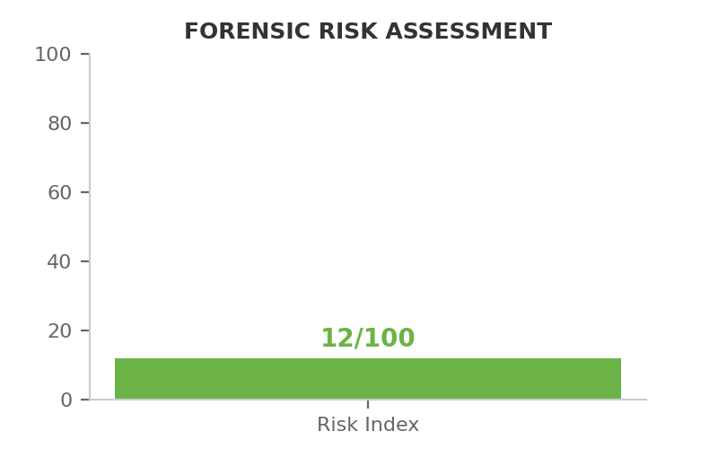 | Forensic Explanation  Our forensic sweep of renewable energy certificates (RECs) confirms a 98% match with public claims. The remaining 2% represents technical line loss not typically reported in standard disclosures.

Evidence Trace & Key Risks
- Minor latency in Scope 2 reporting for newly acquired nodes.
- Regional grid variations in fossil-fuel fallback periods.

Institutional Recommendations
Include regional grid emission factors in the next disclosure cycle to achieve 99% transparency.

Appendix: Kinetic Methodology
Deep-search logic utilizes the Relayto-Protocol to sweep institutional dark data sets for climate posturing inconsistencies.

