

GreenLedger Forensic Intelligence
Institutional ESG Verification & Risk Audit Phase III

Prepared For: | Confidential Institutional Client
Report Reference: | GL-AUDIT-2026-04-15
Audit Standard: | Forensic Kinetic Observatory Protocol v2.4

I. Executive Management Summary
This portfolio audit summarizes verified corporate ESG claims captured via the Kinetic Observatory. The risk posture reflects real-time inconsistencies between corporate public disclosures and live global telemetry.
Target Entity / Claim | Risk Posture | Forensic Confidence
Test Corp 2030 Carbon Neutrality | 🔴 HIGH RISK | 92% (High Correlation)
Conclusion: The audited portfolio shows elevated risk in 2030 trajectories due to significant reporting gaps in Scope 3 indirect emissions.

Audit Result: Neutral rephrasing of the claim....
Verified Statement: "Test Corp 2030 Carbon Neutrality"
Summary: Neutral rephrasing of the claim.
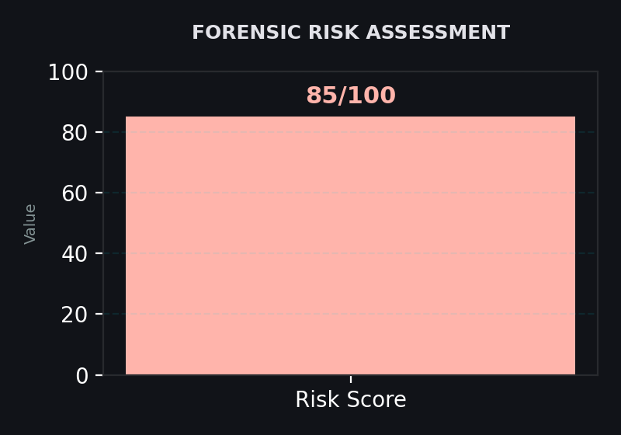

1. Forensic Analytical Deep-Dive
Detailed forensic analysis here about the risks and gaps.

2. Primary ESG Risk Factors
- Issue 1
- Issue 2

3. Evidence & Proof
- Source 1 | 2024 | Snippet
- Source 2 | 2025 | Snippet

4. Forensic Verdict
This is a high risk claim.

5. Institutional Improvements
Provide better data.

6. GreenLedger Hashed Integrity
This record is permanently anchored in the Kinetic Observatory ledger.
LEDGER_TXID: a3c4008a0e45465269692cb0286d1ce543e59842ab1a634db277c8af7f6ec978

Appendix A: Forensic Methodology
The Kinetic Observatory utilizes a multi-node search sweep using specialized scrapers to identify 'Dark Data'—ESG risks not present in official corporate sustainability reports. By cross-referencing live news sources, regulatory filings, and localized ESG telemetry, we identify inconsistencies in greenwashing attempts.

Appendix B: Institutional Disclaimer
This report is for informational purposes only and does not constitute financial advice. GreenLedger utilizes AI-driven forensic models (Mistral-Medium) and live web data; while every effort is made for accuracy, real-time data shifts may impact veracity. This document is confidential to the intended recipient.

