# Firebase

## Introduction

Firebase, a comprehensive app development platform by Google, offers various tools and services that assist developers in building high-quality applications. With features like cloud storage, authentication, real-time databases, and analytics, it has become a popular choice for mobile and web application development. This report discusses the pros and cons of Firebase and provides a step-by-step guide to setting up Firebase from start to finish.

## Pros of Firebase

* **Real-time Database**

Firebase provides a real-time database, enabling data to synchronize across all clients in real time. This feature is particularly advantageous for applications requiring live data updates, such as chat applications and collaborative platforms.

* **Authentication**

Firebase Authentication supports multiple methods, including email/password, Google, Facebook, and Twitter, simplifying user authentication management and providing a secure, reliable solution.

* **Cloud Firestore**

Cloud Firestore is a flexible, scalable database suitable for mobile, web, and server development. It offers real-time updates and rich querying capabilities, catering to a wide range of applications.

* **Analytics**

Firebase Analytics delivers free, unlimited reporting on up to 500 distinct events, aiding in understanding user behavior and measuring app performance effectively.

* **Hosting**

Firebase Hosting provides fast, secure, and reliable hosting for web apps, supporting both static and dynamic content, and integrates seamlessly with other Firebase services.

* **Cloud Functions**

Cloud Functions for Firebase enables running backend code in response to events triggered by Firebase features and HTTPS requests, allowing the extension of app functionality without server management.

* **Easy Integration**

Firebase integrates well with various third-party services and platforms, including Google Cloud, making it versatile and extendable.

## Cons of Firebase

* **Pricing**

While Firebase offers a generous free tier, costs can escalate quickly as the app scales, especially for database storage and network bandwidth.

* **Vendor Lock-In**

Heavy reliance on Firebase services can lead to vendor lock-in, making migration to other platforms challenging if needed.

* **Limited Querying**

Although Cloud Firestore offers improved querying capabilities compared to the real-time database, it still has limitations, particularly for complex queries.

* **Data Migration**

Migrating data to or from Firebase can be cumbersome, especially for large datasets.

* **Limited Customization**

Some Firebase services provide limited customization options, which may not meet the needs of all developers or applications.

## Setting Up Firebase: A Step-by-Step Guide

1. Create a Firebase Project
2. Visit the Firebase Console.
3. Click on "Add project."
4. Enter a project name and click "Continue."
5. (Optional) Enable Google Analytics for the project and configure the analytics settings.
6. Click "Create project."

# Commands for setting up

* Open visual studio code
* Drag the bottom of the visual studio up
* Click on terminal
* 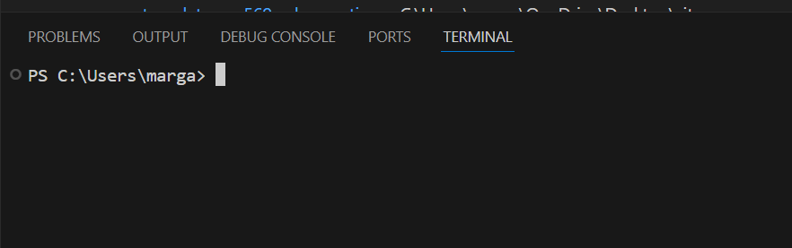go to this website and download it & install it
* after it is installed go back to your visual studio
* click on the terminal and type
* node -v
* then type npm -v
* then type npm install -g @ionic/cli@6.0 in the terminal

# Commands for creating your mobile application

Navigate to were you want to store your mobile application

**Now type:**

Ionic start (the name of your application) blank –type=angular

Let it start doing its thing when it is complete click on file and click on where you have the file created.

**

# Installing firebase in mobile application

In order to store the data you will need to install firebase in the application

* npm install firebase @angular/fire
* npm install firebase @angular/fire –save
* npm install firebase @angular/fire –legacy
* npm install firebase @angular/fire --legacy --deep

# References

Google. (n.d.). Firebase documentation. Retrieved June 23, 2024, from <https://firebase.google.com/docs>

Google. (n.d.). Firebase Realtime Database. Retrieved June 23, 2024, from <https://firebase.google.com/products/realtime-database>

Google. (n.d.). Firebase Authentication. Retrieved June 23, 2024, from <https://firebase.google.com/products/auth>

Google. (n.d.). Firebase Cloud Firestore. Retrieved June 23, 2024, from <https://firebase.google.com/products/firestore>

Google. (n.d.). Firebase Analytics. Retrieved June 23, 2024, from <https://firebase.google.com/products/analytics>

Google. (n.d.). Firebase Hosting. Retrieved June 23, 2024, from <https://firebase.google.com/products/hosting>

Google. (n.d.). Firebase Cloud Functions. Retrieved June 23, 2024, from <https://firebase.google.com/products/functions>