Configuration Manual

Hardware Requirements:
Processor: Intel Core i5 or equivalent (minimum)
RAM: 8GB
Storage: 2GB free disk space

Software Requirements:
Operating System: macOS Tahoe
Node.js: Version 20.x or later
npm: Version 20.x or later
MongoDB Atlas Account

Backend Setup:
1. Navigate to the server folder and install dependencies: npm install
2. Create a .env file and add the database connection string to it
3. Start the server: node index.js

Frontend Setup
1. Navigate to the client folder: cd client
2. Install dependencies: npm install
3. Start the application: npm run dev (or npm start)

Database Setup
1. Create an account on MongoDB Atlas, create the cluster
2. Create the database user and save the password
3. Copy the connection string and replace the password with the actual password
4. Paste the string into server/.env file as MONGODB_URDI value

Access Application
1. Open browser (port could be different): http://localhost:5173
2. Register a new account to get started

Home Page
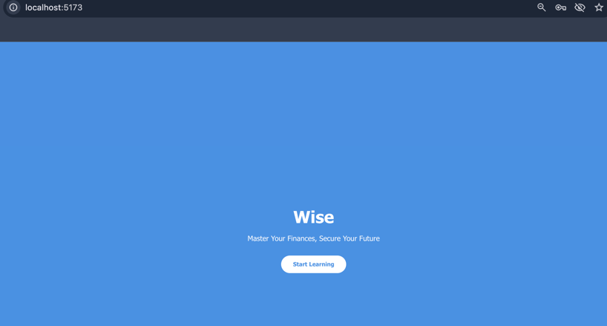

Registration and Login Page
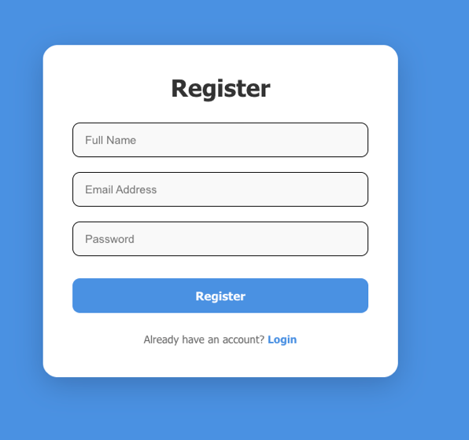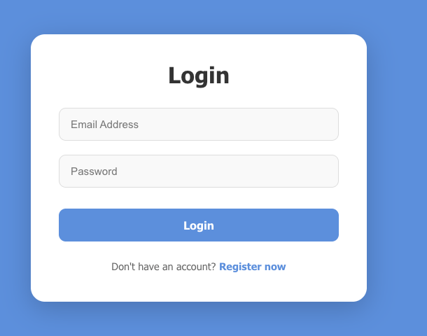
Lessons page
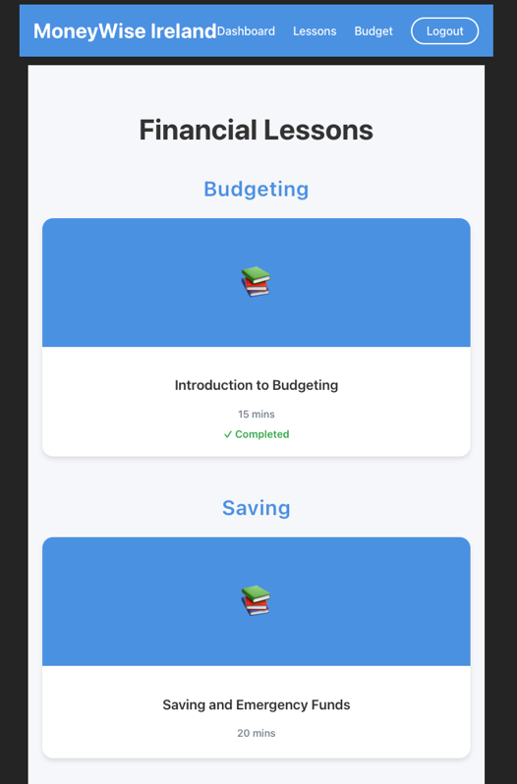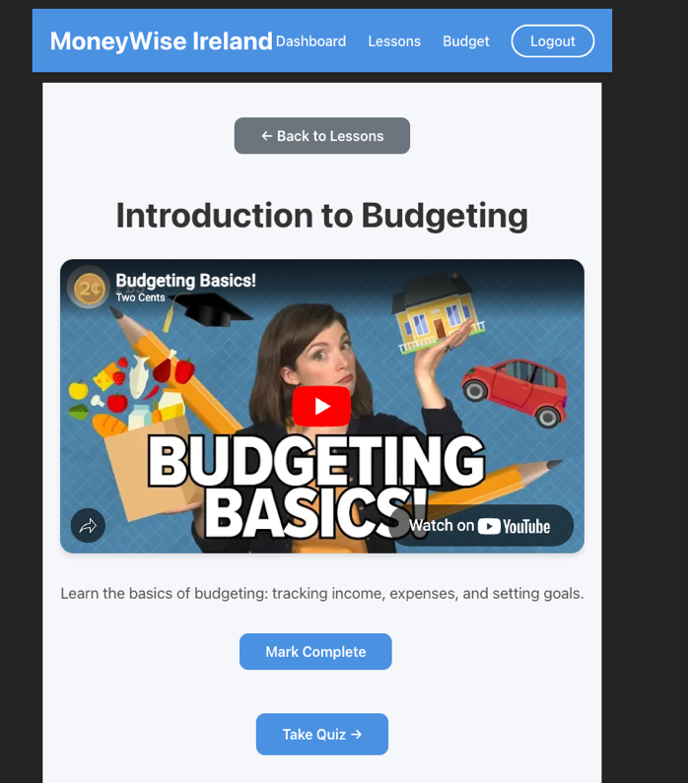
Quiz
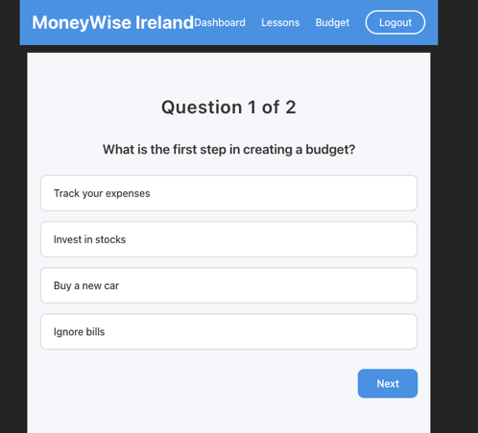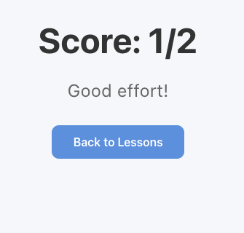

Dashboard
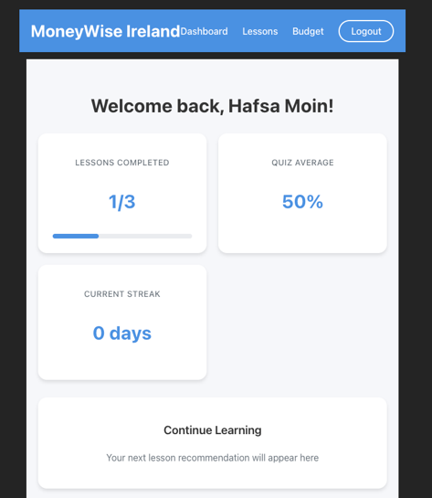
Budget Calculator
