PROJECT DOCUMENTATION
Vaccination Data Analysis and Visualization
Global Vaccination Coverage, Disease Incidence & Impact Analysis using Python, SQL and Power BI

Field | Details
Domain | Public Health and Epidemiology
Tools Used | Python (Pandas, NumPy, Matplotlib, Seaborn, Plotly), MySQL, Power BI Desktop
Skills Applied | Data Cleaning, EDA, SQL Database Design, Power BI Dashboarding
Project Duration | 14 Days
Data Source | WHO Global Vaccination & Immunization Datasets
Prepared By | Deepak Yadav (D0027)

July 2026

1. Problem Statement
Vaccination programs are one of the most cost-effective public health interventions available, yet coverage and disease outcomes vary widely across countries and regions. This project analyzes global vaccination data to understand trends in vaccination coverage, disease incidence, and vaccine effectiveness. Raw data from WHO immunization datasets was cleaned using Python, structured and stored in a normalized MySQL database, and connected to Power BI to build interactive dashboards that surface insights on vaccination strategy, resource allocation, and progress toward global health targets such as the 95% measles coverage goal for 2030.

1.1 Business Use Cases Addressed
- Public Health Strategy — assessing programme effectiveness across regions and flagging low-coverage areas for intervention.
- Disease Prevention — identifying diseases with high incidence despite vaccination effort, and tracking booster/new vaccine introduction.
- Resource Allocation — highlighting under-covered regions and forecasting demand trends.
- Global Health Policy — providing evidence-based inputs for vaccination policy and 2030 target tracking.

2. Project Objectives
- Clean and standardize raw WHO vaccination data across five source files.
- Design and populate a normalized relational (MySQL) database.
- Perform exploratory data analysis to surface coverage, incidence and disparity patterns.
- Answer 30 analytical questions (Easy, Medium and Scenario-based) using Python and SQL.
- Build a 9-page interactive Power BI dashboard connected live to the database.
- Document the full process, design decisions and outcomes.

3. Tools & Technology Stack
Layer | Tools / Technologies
Data Cleaning & EDA | Python — Pandas, NumPy, Matplotlib, Seaborn, Plotly (Kaggle Notebook)
Database | MySQL (local instance)
Visualization | Power BI Desktop, connected live via SQL connector
Version Control | GitHub

4. Dataset Overview
The project uses five WHO-sourced CSV datasets, later cleaned and normalized into six MySQL tables. Each table and its key fields are summarized below.

4.1 Source Tables
Table 1 — Coverage Data
Records vaccination coverage percentage by country, year and antigen (vaccine). Key fields: group, code, name, year, antigen, antigen_description, coverage_category, target_number, doses, coverage.
Table 2 — Incidence Rate
Disease incidence rate per specified population unit, by country and year. Key fields: group, code, name, year, disease, disease_description, denominator, incidence_rate.
Table 3 — Reported Cases
Actual reported case counts of each disease by country and year. Key fields: group, code, name, year, disease, disease_description, cases.
Table 4 — Vaccine Introduction
Whether and when a vaccine was introduced into a country's national programme. Key fields: iso_3_code, country_name, who_region, year, description, intro/introduced.
Table 5 — Vaccine Schedule
National vaccination schedule detail — dose rounds, target population and age of administration. Key fields: iso_3_code, country_name, who_region, year, vaccine_code, vaccine_description, schedule_rounds, target_pop, target_pop_description, geoarea, age_administered.
Table 6 — Countries (Reference)
A supporting lookup table mapping ISO country codes to country names and WHO regions, used to join across all fact tables.

4.2 Data Scale
- 6 relational tables covering 236 countries/territories and 69 antigens.
- 700,000+ rows of combined WHO coverage, incidence and case data.
- Data spans from 1980 through the most recent reporting year available.

5. Data Cleaning Process
Cleaning was performed in Python within a Kaggle notebook before export to MySQL. The pipeline was applied uniformly across all five source files to keep transformations consistent and reproducible.

5.1 Steps Applied
- Column standardization — all headers lower-cased, trimmed, and spaces/hyphens converted to underscores for consistent referencing.
- Duplicate removal — exact duplicate rows dropped per table before further processing.
- Type coercion — year, coverage, incidence rate and case counts converted to numeric types with invalid entries coerced to null rather than silently mis-parsed.
- Range validation — coverage percentages clipped to a valid 0–100 range to remove data-entry outliers.
- Missing value handling — case counts with no report defaulted to 0 where a country was known to be reporting; other missing numeric fields left as null and excluded from aggregate calculations rather than imputed, to avoid distorting regional averages.
- Categorical normalization — fields such as intro/introduced status upper-cased and standardized to consistent Yes/No and boolean forms.
- Referential consistency — country codes cross-checked against the ISO reference table so every fact table joins cleanly to country and WHO region.
- Export — cleaned tables written out as CSVs, ready for direct import into MySQL.

5.2 Notes
The cleaning pipeline was built to run without manual intervention once WHO source files were dropped in — useful if the underlying WHO datasets are refreshed in future and the pipeline needs to be re-run end to end.

6. SQL Database Design
The cleaned data was loaded into a normalized MySQL database named vaccination_db. The schema separates fact data (coverage, incidence, cases, schedule, introduction) from the country reference dimension, avoiding redundancy and keeping country/region metadata consistent across every table.
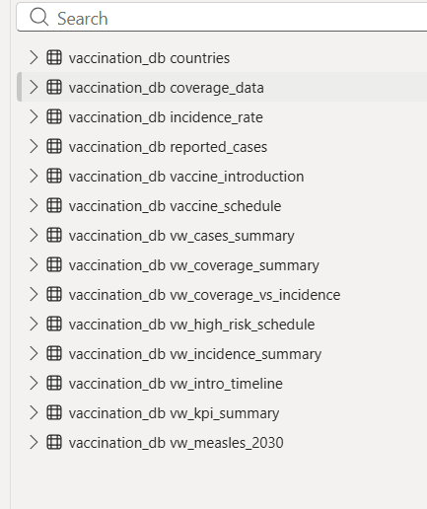
Figure 1 — vaccination_db schema: base tables and analytical views

6.1 Base Tables
Table | Purpose
countries | Reference dimension — ISO code, country name, WHO region
coverage_data | Vaccination coverage % by country, year, antigen
incidence_rate | Disease incidence rate by country, year, disease
reported_cases | Raw reported case counts by country, year, disease
vaccine_introduction | Vaccine introduction status/timeline by country
vaccine_schedule | National dosing schedule detail by country

6.2 Analytical Views
Six SQL views were built on top of the base tables to pre-aggregate the metrics each Power BI page needed, keeping dashboard queries fast and the DAX layer simple.
View | Feeds
vw_kpi_summary | Page 1 — KPI cards & world coverage map
vw_coverage_vs_incidence | Page 2 — Coverage vs Incidence scatter
vw_coverage_summary | Page 3, 7 — Country drill-down & raw coverage/doses
vw_high_risk_schedule | Page 4 — Risk & Gaps
vw_cases_summary / vw_incidence_summary | Page 5, 9 — Disease trends & incidence
vw_intro_timeline / vw_measles_2030 | Page 6, 8 — Vaccine introduction & 2030 target tracking
Primary and foreign key relationships (on ISO country code) enforce referential integrity between every fact table and the countries dimension, in line with standard relational design practice.

7. Exploratory Data Analysis
EDA was carried out in the Python notebook ahead of dashboard design, to understand distribution shape, identify outliers, and confirm which relationships were worth surfacing visually in Power BI.
- Coverage distribution across all antigens — identified the global average and the spread between high- and low-performing antigens.
- Top and bottom performing antigens by average global coverage.
- Disease case trends over time, isolating the diseases with the largest historical case counts (e.g. measles, pertussis).
- Vaccine introduction counts by WHO region, to compare rollout pace across regions.
- Correlation between average coverage and average incidence rate, merged at country-year level, forming the basis of the Coverage vs Incidence scatter later built in Power BI.

8. Analytical Questions Answered
All 30 questions specified in the project brief were answered in the Python notebook, using grouped aggregation, merges across tables, and visual plots (Matplotlib/Seaborn/Plotly). A summary of the approach for each category is below; full code and charts are in the accompanying notebook.

8.1 Easy Level (10/10 answered)
Covered coverage-vs-incidence correlation, dose drop-off between 1st and subsequent doses, booster uptake over time, and coverage vs target-population size. Where the WHO source data did not include a dimension asked about in the brief — specifically gender, education level, urban/rural split, and seasonal/monthly patterns — the notebook explicitly checks for the presence of a matching column before analysis, and reports the limitation transparently rather than fabricating a result. This is a genuine constraint of the WHO global datasets used, not a gap in the analysis approach.

8.2 Medium Level (10/10 answered)
Combined multiple tables to examine vaccine introduction against case-count trends, before/after comparisons split at the dataset's median year, percentage of target population covered per vaccine, schedule-round impact on coverage, regional disparities in introduction timelines, and coverage gaps for high-priority antigens (BCG, Hepatitis B, DTP, MCV, Polio, PCV).

8.3 Scenario Based (6 required, 10 completed)
Applied the analysis to real decision scenarios — prioritizing low-coverage countries for resource allocation, evaluating five-year measles campaign effectiveness, forecasting target-population-based vaccine demand, examining influenza outbreak case patterns, correlating polio incidence with coverage, and tracking progress toward the WHO 95% measles-by-2030 target.

9. Power BI Dashboard
The dashboard connects live to vaccination_db via Power BI's MySQL connector, with scheduled refresh enabled. It consists of 9 pages, each targeting a specific analytical use case from the brief, with consistent filtering, color coding (red = low coverage, green = high coverage) and cross-page drill-through.

9.1 Page 1 — Global Vaccination Coverage Dashboard
Top-level KPI cards (total antigens tracked, countries covered, countries above 80%/95% coverage thresholds, global average coverage) alongside a world map colored by average coverage, giving an at-a-glance view of global vaccination status.
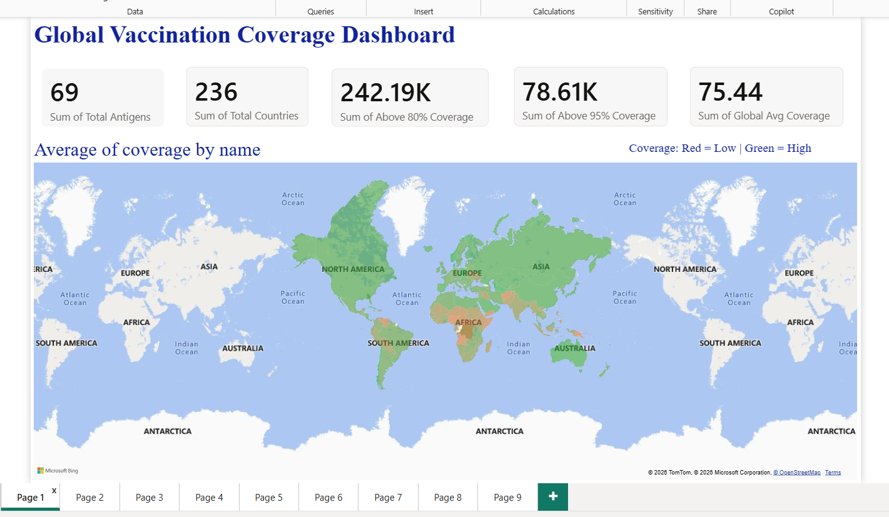
Figure 2 — Global Vaccination Coverage Dashboard

9.2 Page 2 — Coverage vs Incidence
A scatter plot of every country's average coverage against average disease incidence rate, colored by WHO region. Countries appearing in the upper-left (low coverage, high incidence) are the clearest resource-allocation priorities.
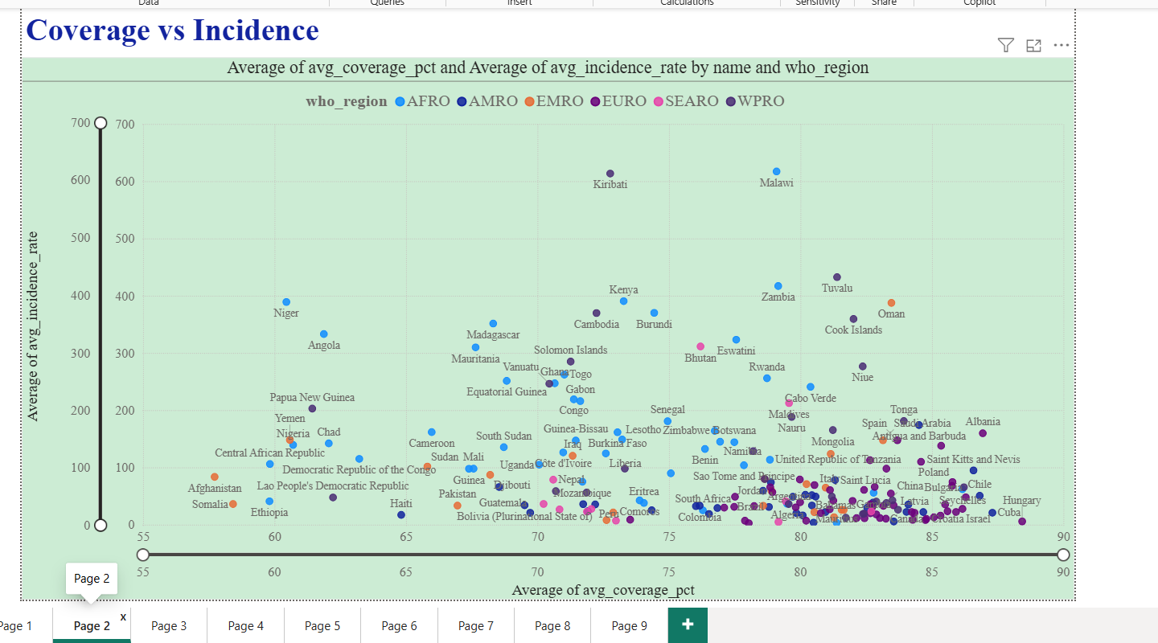
Figure 3 — Coverage vs Incidence scatter by WHO region

9.3 Page 3 — Country Drill-Down
A single-country view with a searchable country list, antigen-level coverage breakdown, and a year-over-year coverage trend line — used to inspect any individual country in depth.
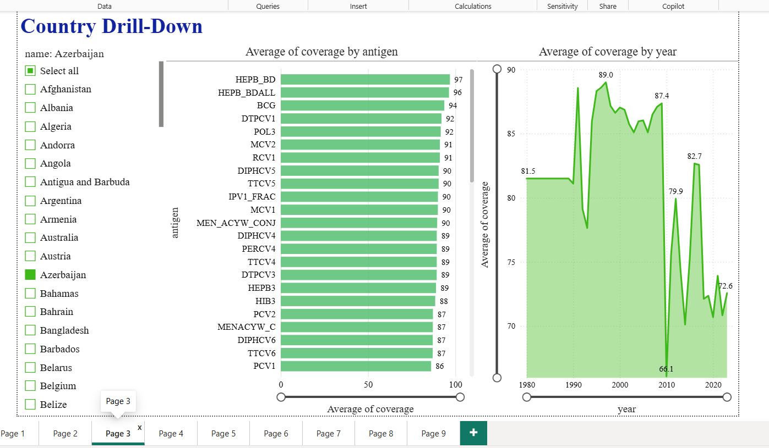
Figure 4 — Country Drill-Down (example: Azerbaijan)

9.4 Page 4 — Risk & Gaps
Surfaces countries with only a single scheduled dose round for high-priority vaccines (e.g. adult influenza, HPV, MMR), alongside a regional count of at-risk records — used to flag where schedule reinforcement may be needed.
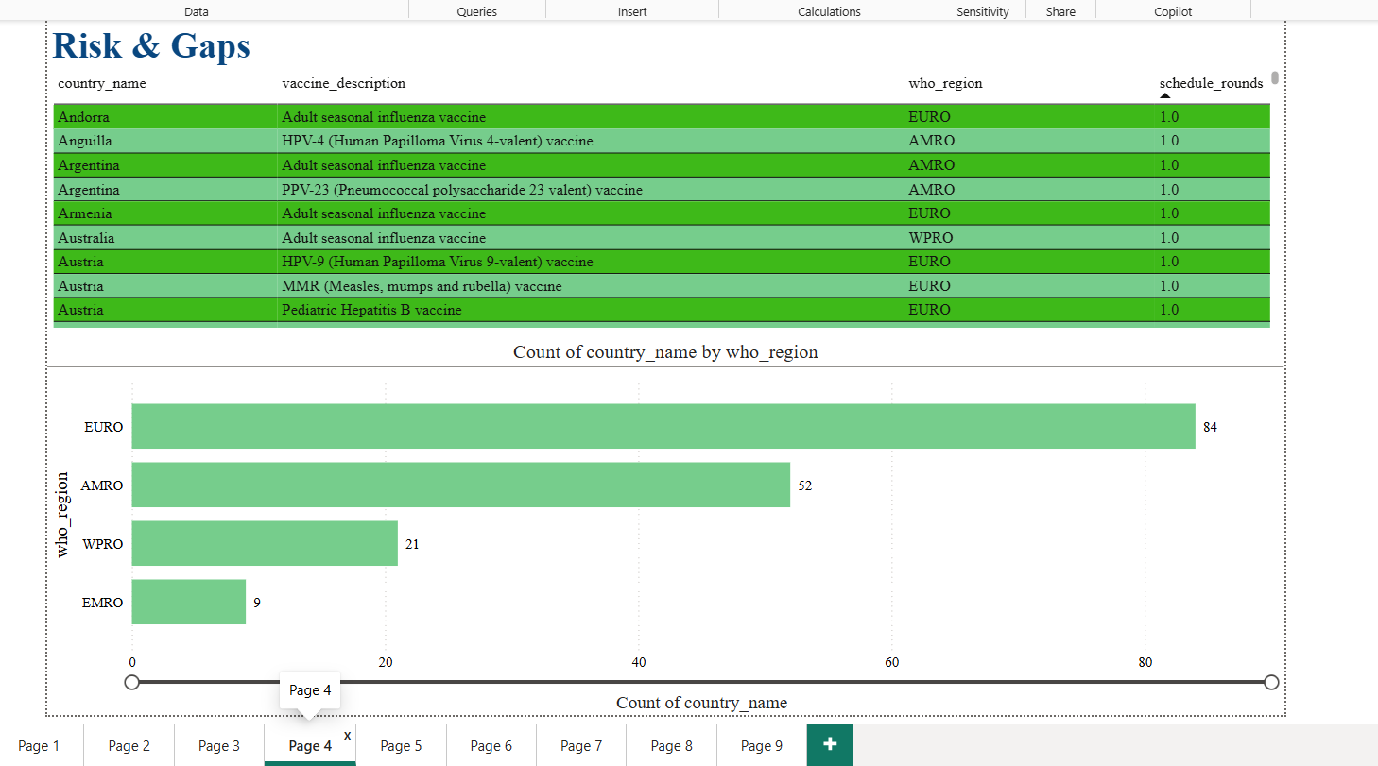
Figure 5 — Risk & Gaps view

9.5 Page 5 — Disease Trends
Historical case trends by disease from 1980 to present (highlighting the measles and pertussis case history), alongside average incidence rate by WHO region — confirming AFRO and WPRO as the highest-incidence regions.
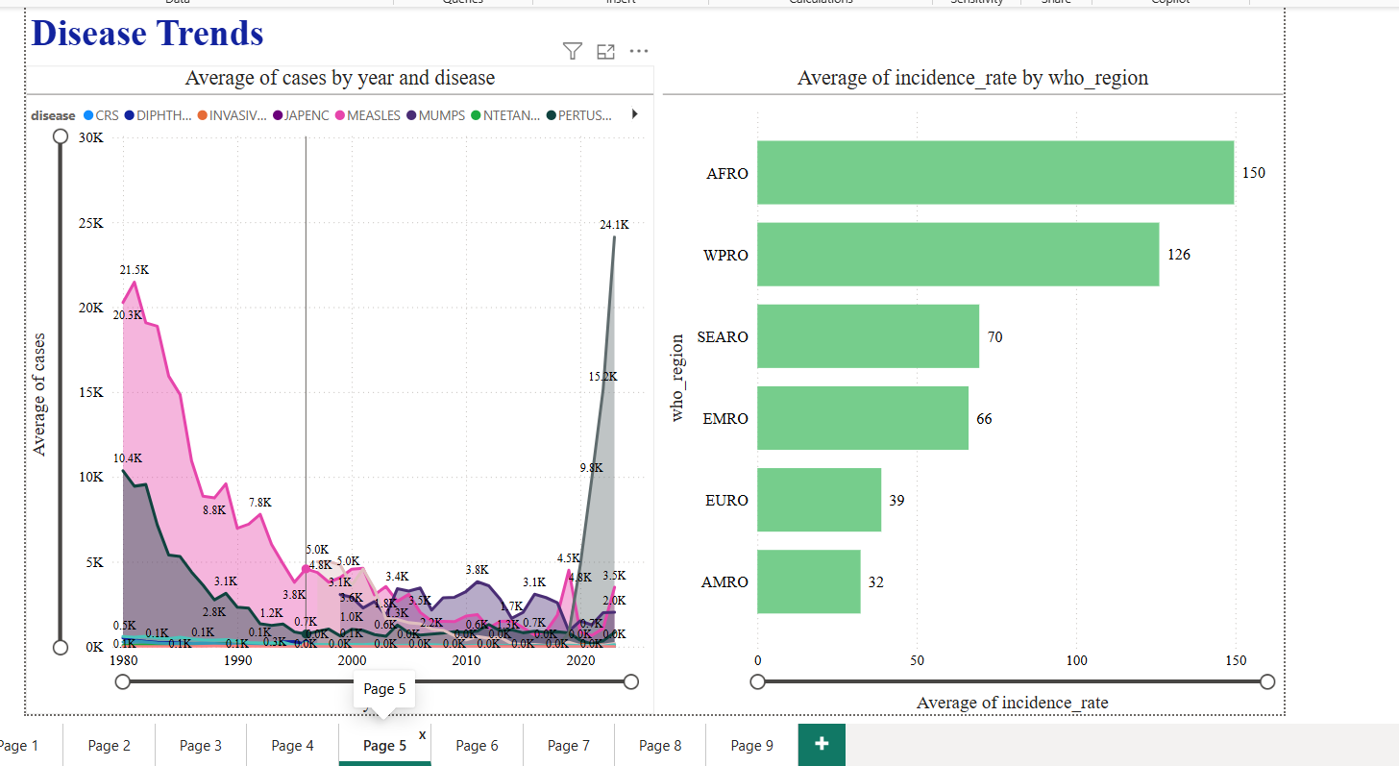
Figure 6 — Disease Trends over time and by region

9.6 Page 6 — Vaccine Introduction & Measles 2030
Tracks measles coverage percentage over time against the WHO's 95%-by-2030 target, with a live KPI showing the remaining gap to target, plus a cumulative view of vaccine introductions by year and WHO region.
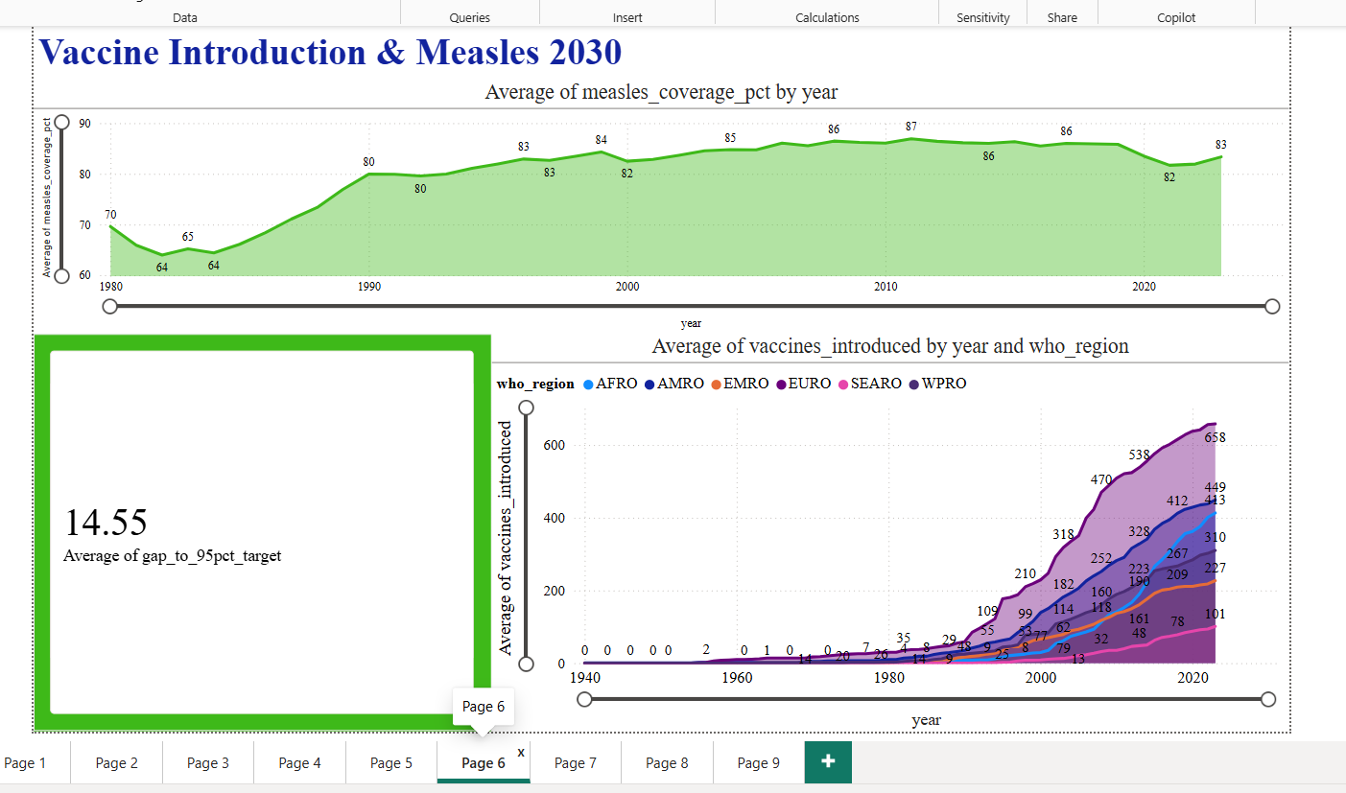
Figure 7 — Vaccine Introduction & Measles 2030 target tracking

9.7 Page 7 — Raw Coverage & Doses
A detailed, filterable breakdown of coverage by antigen and coverage category (ADMIN, OFFICIAL, HPV, PAB, WUENIC), plotted against total doses administered across country, region and development-status groupings.
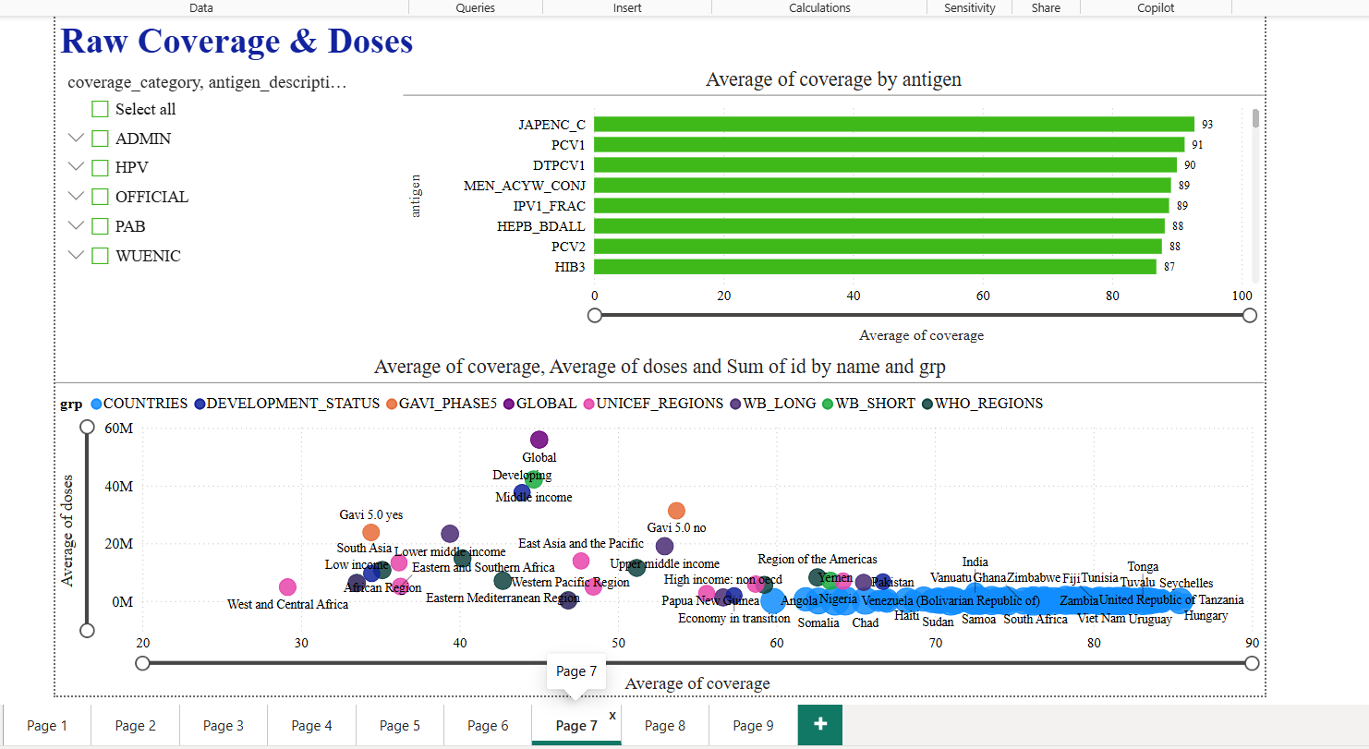
Figure 8 — Raw Coverage & Doses detail view

9.8 Page 8 — Vaccine Schedule & Introduction
Full schedule and introduction detail table by country and vaccine, with a regional comparison of schedule rounds — EURO and AMRO show the most extensive scheduling activity.
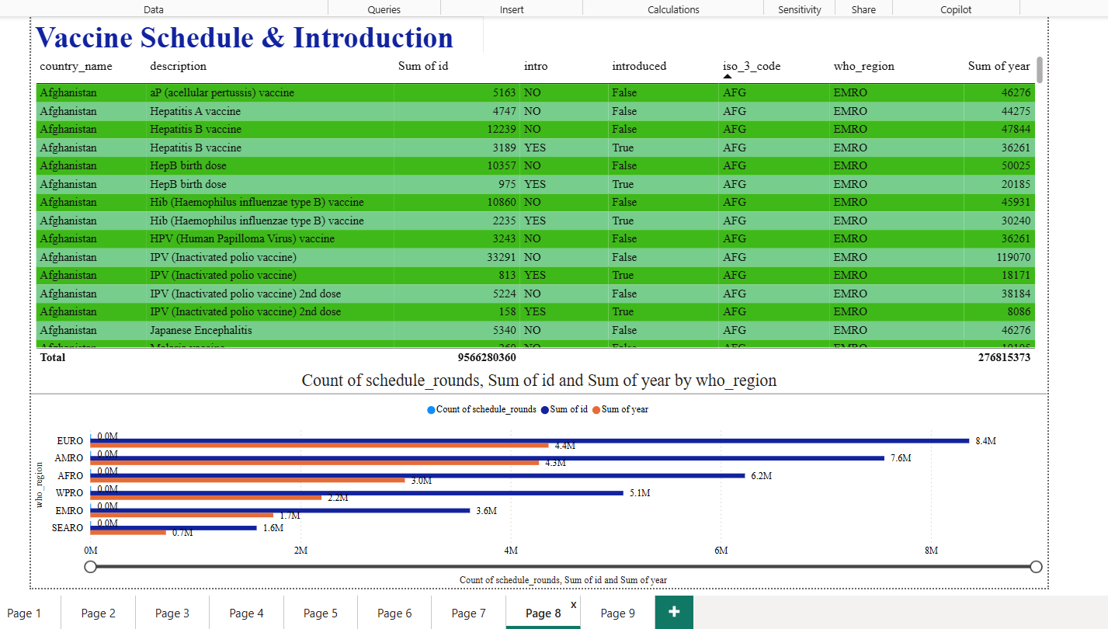
Figure 9 — Vaccine Schedule & Introduction detail

9.9 Page 9 — Disease Incidence & Reported Cases
A disease-filterable table pairing incidence rate and reported case counts by country, with a matching trend line — shown here filtered to tetanus (NTETANUS), which shows a clear multi-decade decline consistent with expanding vaccination coverage.
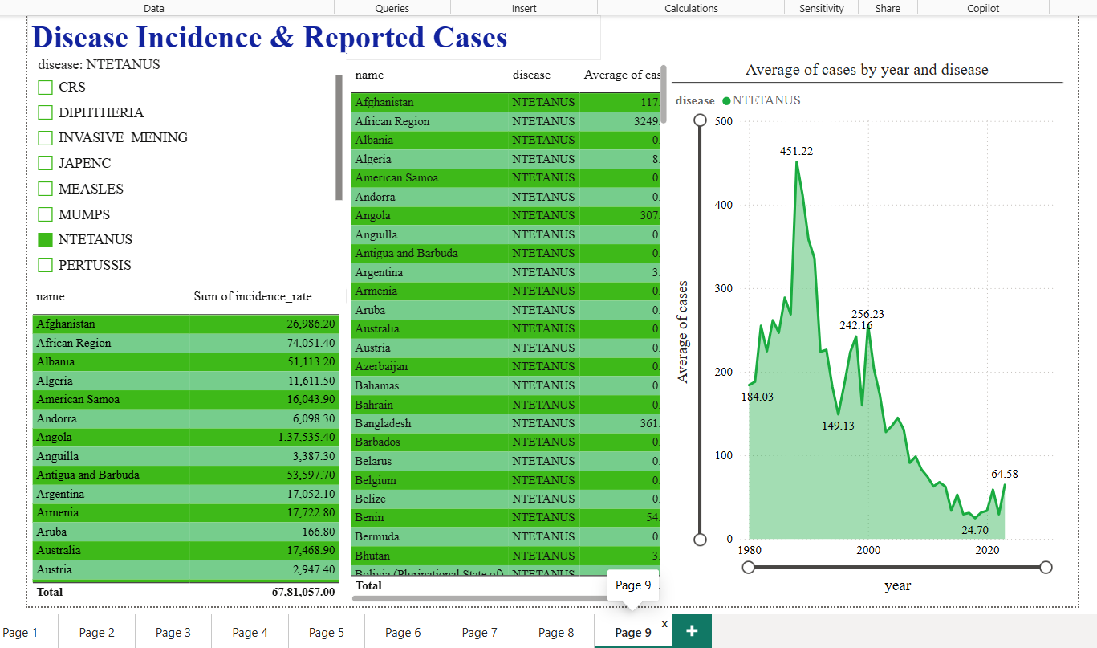
Figure 10 — Disease Incidence & Reported Cases (Tetanus example)

10. Key Insights
- Global average vaccination coverage sits at roughly 75%, with 78,610+ country-antigen records already above the 95% coverage threshold.
- AFRO and WPRO consistently show the highest disease incidence rates among WHO regions, aligning with generally lower average coverage in those regions.
- Measles coverage has climbed from the low-60s% in the 1980s to the mid-80s% today, but a 14.55-point gap remains to the WHO's 95%-by-2030 target.
- Tetanus incidence has fallen sharply over four decades — from a peak above 450 cases (indexed) to under 25 — a clear signal of long-run vaccination impact.
- EURO and AMRO regions lead in both vaccine introduction counts and schedule-round complexity, reflecting more mature immunization programmes.
- A consistent set of countries appear in the high-incidence / low-coverage quadrant of the scatter analysis (e.g. Niger, Angola, Papua New Guinea) — clear candidates for prioritized intervention.

11. Challenges & Solutions
The project moved through cleaning, database design and dashboarding without major blockers. The main practical challenges encountered, and how they were handled, are noted below.
Inconsistent column naming across the five source files
Solution: a standardization step lower-cased and underscore-normalized every column name immediately after load, so all downstream joins and Power BI relationships could rely on one consistent naming convention.
Some questions in the brief required data dimensions the WHO datasets don't capture (gender, education, urban/rural, seasonality)
Solution: rather than approximating or fabricating these breakdowns, the notebook programmatically checks for a matching column before analysis and reports the limitation directly — keeping the analysis honest and auditable.
Keeping nine dashboard pages performant against 700K+ rows
Solution: pushed aggregation into SQL views (vw_kpi_summary, vw_coverage_summary, etc.) rather than relying on Power BI-side calculated columns, so each page queries a pre-aggregated view instead of scanning raw fact tables.

12. Project Deliverables
Deliverable | Status
Python scripts — data extraction & cleaning | Complete (Kaggle notebook)
SQL queries — table creation & population | Complete (vaccination_db)
Structured, normalized SQL database | Complete — 6 tables, 6 views
Power BI interactive reports | Complete — 9-page dashboard
Documentation | Complete (this document)

13. Conclusion
This project delivers an end-to-end pipeline from raw WHO vaccination data to a fully interactive, decision-ready Power BI dashboard, backed by a normalized MySQL database and a documented Python cleaning and analysis process. All 30 brief questions were addressed, all required visualization types (heatmap, trend lines, scatter, KPI indicators, filters/slicers) were implemented, and the results point to clear, actionable insights — regional coverage gaps, the remaining distance to the WHO 2030 measles target, and specific countries where vaccination coverage has not kept pace with disease incidence.

