Ministerul Educației, Culturii și Cercetării al Republicii Moldova
IP Centrul de Excelență în Informatică și Tehnologii Informaționale

RAPORTUL
STAGIULUI DE PRACTICĂ

Elevul: Tilipeț Dumitru
Grupa: P-2422
Specialitatea: Programarea și testarea produselor program
Baza de practică: IP CEITI

Conducătorul stagiului de practică
de la unitatea economică

Frunză Olga

Conducătorul stagiului de practică
Chişinău 2026

de la Centrul de Excelență

Nicșan Adrian

CUPRINS

1. INTRODUCERE 2
2. CONȚINUTUL ACTIVITĂȚILOR ȘI SARCINILOR DE LUCRU 3
2.1 Descrierea sistemului AirBook 3
2.2 Structura bazei de date 3
2.3 Schema bloc generală a algoritmului elaborat 4
2.4 Listingul programului 4
2.4.1 Main.java – Punctul de intrare Java 4
2.4.2 AppUI.java – Clasa principală JavaFX 4
2.5 Rezultatele testării subprogramelor și registrului de calcul tabelar 4
2.5.1 Datele de intrare 4
2.5.2 Datele de ieșire 4
3. CONCLUZII 4
4. BIBLIOGRAFIE 4
5. ANEXE 4
Anexa 1 – Structura proiectului 4
Anexa 2 – Comenzi de compilare și execuție 4
Anexa 3 – Configurare SQL Server pentru conexiunea JDBC 4

1. INTRODUCERE
Prezentul raport descrie rezultatele stagiului de practică de inițiere, în cadrul căruia a fost elaborat un sistem informatic de rezervare a biletelor de avion, denumit AirBook. Aplicația a fost dezvoltată utilizând limbajul de programare Java, tehnologia JavaFX 17 pentru interfața grafică utilizator și Microsoft SQL Server drept sistem de gestiune a bazelor de date relaționale.
Scopul principal al proiectului a constat în crearea unei aplicații desktop funcționale care să permită gestionarea integrală a procesului de rezervare a biletelor de avion: administrarea zborurilor, pasagerilor, biletelor, plăților, aeroporturilor și flotei de avioane, inclusiv generarea de rapoarte statistice și exportul datelor în formate CSV/TXT.
Structura raportului urmează cerințele metodologice impuse: prezentarea schemei bloc generale, listingul codului sursă, spații rezervate pentru capturile de ecran ale testelor, concluzii și bibliografie.

2. CONȚINUTUL ACTIVITĂȚILOR ȘI SARCINILOR DE LUCRU

2.1 Descrierea sistemului AirBook
AirBook este o aplicație desktop de tip CRUD (Create, Read, Update, Delete) pentru gestiunea rezervărilor de bilete de avion. Arhitectura aplicației urmează un model stratificat (Layered Architecture), cu separarea clară a responsabilităților între straturi:
Strat | Pachete / Clase | Responsabilitate
Prezentare (UI) | ui.AppUI, ui.css | Interfața grafică JavaFX, navigare, formulare, tabele
Acces date (DAO) | dao.*DAO | Interogări SQL, mapare obiecte Java ↔ tabele BD
Model (Entity) | model.*, model.enums | Clasele POJO: Zbor, Pasager, Bilet, Plata etc.
Infrastructură | database.DatabaseConnection | Conexiunea JDBC la MS SQL Server (port 1433)

Aplicația folosește un ExecutorService cu un singur thread dedicat operațiunilor cu baza de date, evitând blocarea thread-ului JavaFX și asigurând o interfață responsivă pe tot parcursul operațiunilor de tip I/O.

2.2 Structura bazei de date
Baza de date Rezervare_bilete_avion este implementată în Microsoft SQL Server și conține 8 tabele interconectate prin chei externe (FOREIGN KEY). Schema relațională este prezentată în tabelul următor:

Tabel | Câmpuri principale | Relații
Aeroporturi | IdAeroport, Nume, Oras, Tara, CodIATA (UNIQUE) | Referit de: Zboruri (plecare/sosire)
Avioane | IdAvion, Model, Capacitate | Referit de: Zboruri, Locuri
Locuri | IdLoc, IdAvion, NumarLoc, Clasa (Economy/Business) | FK → Avioane
Zboruri | IdZbor, NumarZbor, IdAeroportPlecare, IdAeroportSosire, IdAvion, DataPlecare, DataSosire | FK → Aeroporturi (x2), Avioane
Pasageri | IdPasager, Nume, Prenume, Email, Telefon | Referit de: Bilete
Rezervari | IdRezervare, CodRezervare (UNIQUE), DataRezervare | Referit de: Bilete, Plati
Bilete | IdBilet, IdRezervare, IdPasager, IdZbor, IdLoc, Pret, Status | FK → Rezervari, Pasageri, Zboruri, Locuri
Plati | IdPlata, IdRezervare, Suma, Metoda, Status, DataPlata | FK → Rezervari

2.3 Schema bloc generală a algoritmului elaborat
Fluxul general de execuție al aplicației AirBook urmează pașii descriși în schema bloc de mai jos. La pornire, clasa Main.java inițiază motorul JavaFX prin apelul Application.launch(). Clasa AppUI, care extinde Application, preia controlul în metoda start(), construind interfața și declanșând încărcarea asincronă a datelor din baza de date.
Pas | Acțiune | Observații
1 | main() → Application.launch(AppUI.class) | Punct de intrare Java standard
2 | AppUI.start(Stage) | Construire UI: topBar, sidebar, content
3 | loadAllAsync(true) | Executat pe thread-ul BD dedicat (daemon)
4 | DAO.findAll() pentru fiecare entitate | JDBC → SQL Server → obiecte Java
5 | applyData(DataSnapshot) | Populare ObservableList → TableView actualizat automat
6 | Interacțiune utilizator (CRUD) | Dialog → validare → DAO.create/update/delete → refresh
7 | Generare rapoarte / Export CSV | Interogări SQL agregate → TableView sau fișier local
8 | AppUI.stop() | Shutdown executor la închiderea ferestrei

2.4 Listingul programului

2.4.1 Main.java – Punctul de intrare Java
Fișierul Main.java reprezintă punctul de intrare standard al aplicației Java. El delegă controlul clasei AppUI, care extinde javafx.application.Application, prin intermediul metodei statice Application.launch().

import javafx.application.Application;
import ui.AppUI;

public class Main {
public static void main(String[] args) {
Application.launch(AppUI.class, args);
}
}

2.4.2 AppUI.java – Clasa principală JavaFX
Clasa AppUI extinde Application și constituie nucleul întregii interfețe grafice. Sunt prezentate secțiunile esențiale: importurile, constantele de stil, declararea DAO-urilor și a colecțiilor observabile, precum și metodele start() și stop() – echivalentul JavaFX al metodei main().
package ui;

import dao.*;
import database.DatabaseConnection;
import java.io.BufferedWriter;
import java.io.File;
import java.io.FileWriter;
import java.io.IOException;
import java.sql.Connection;
import java.sql.PreparedStatement;
import java.sql.ResultSet;
import java.sql.ResultSetMetaData;
import java.sql.SQLException;
import java.time.LocalDate;
import java.time.LocalDateTime;
import java.time.LocalTime;
import java.time.format.DateTimeFormatter;
import java.time.format.DateTimeParseException;
import java.util.ArrayList;
import java.util.LinkedHashMap;
import java.util.List;
import java.util.Locale;
import java.util.Map;
import java.util.concurrent.ExecutorService;
import java.util.concurrent.Executors;
import java.util.function.Predicate;
import java.util.regex.Pattern;
import java.util.stream.Collectors;
import javafx.application.Application;
import javafx.beans.property.SimpleStringProperty;
import javafx.collections.FXCollections;
import javafx.collections.ObservableList;
import javafx.collections.transformation.FilteredList;
import javafx.event.ActionEvent;
import javafx.geometry.Insets;
import javafx.geometry.Pos;
import javafx.scene.Node;
import javafx.scene.Scene;
import javafx.scene.control.*;
import javafx.concurrent.Task;
import javafx.scene.image.Image;
import javafx.scene.layout.*;
import javafx.scene.paint.Color;
import javafx.scene.shape.Circle;
import javafx.stage.FileChooser;
import javafx.stage.Stage;
import model.*;
import model.enums.MetodaPlata;
import model.enums.StatusBilet;
import model.enums.StatusPlata;

public class AppUI extends Application {
private static final String BG = "#0b1017";
private static final String SIDEBAR = "#111827";
private static final String PANEL = "#161d2a";
private static final String CARD = "#1c2535";
private static final String BORDER = "#253047";
private static final String TEXT = "#f8fafc";
private static final String MUTED = "#89a0c0";
private static final String ACCENT = "#f59e0b";
private static final String BLUE = "#3b82f6";
private static final String GREEN = "#10b981";
private static final String RED = "#ef4444";
private static final Pattern NAME_PATTERN = Pattern.compile("^[A-Za-z]+(?:[ -][A-Za-z]+)*$");
private static final Pattern PHONE_PATTERN = Pattern.compile("^[0-9+()\\-\\s]{6,20}$");
private static final Pattern EMAIL_PATTERN = Pattern.compile("^[A-Za-z0-9+_.-]+@[A-Za-z0-9.-]+$");

private final PasagerDAO pasagerDAO = new PasagerDAO();
private final ZborDAO zborDAO = new ZborDAO();
private final RezervareDAO rezervareDAO = new RezervareDAO();
private final BiletDAO biletDAO = new BiletDAO();
private final PlataDAO plataDAO = new PlataDAO();
private final AeroportDAO aeroportDAO = new AeroportDAO();
private final AvionDAO avionDAO = new AvionDAO();
private final LocDAO locDAO = new LocDAO();

private final ObservableList<Pasager> pasageri = FXCollections.observableArrayList();
private final ObservableList<Zbor> zboruri = FXCollections.observableArrayList();
private final ObservableList<Rezervare> rezervari = FXCollections.observableArrayList();
private final ObservableList<Bilet> bilete = FXCollections.observableArrayList();
private final ObservableList<Plata> plati = FXCollections.observableArrayList();
private final ObservableList<Aeroport> aeroporturi = FXCollections.observableArrayList();
private final ObservableList<Avion> avioane = FXCollections.observableArrayList();
private final ObservableList<Loc> locuri = FXCollections.observableArrayList();
private final ExecutorService dbExecutor = Executors.newSingleThreadExecutor(r -> {
Thread thread = new Thread(r, "airbook-db-worker");
thread.setDaemon(true);
return thread;
});

private final List<Button> navButtons = new ArrayList<>();
private final Map<String, String> navIcons = new LinkedHashMap<>();
private BorderPane root;
private BorderPane content;
private Label dbStatus;
private Stage stage;
private String activeScreen = "Dashboard";
private String lastReportTitle = "Raport";
private String lastReportText = "";

@Override
public void start(Stage primaryStage) {
Locale.setDefault(Locale.US);
stage = primaryStage;
stage.setTitle("AirBook - Rezervare Bilete Avion");
stage.setMinWidth(1280);
stage.setMinHeight(780);
stage.getIcons().add(new Image(new File("ui/Logo.png").toURI().toString()));

navIcons.put("Dashboard", "");
navIcons.put("Zboruri", "");
navIcons.put("Pasageri", "");
navIcons.put("Rezervari", "");
navIcons.put("Bilete", "");
navIcons.put("Plati", "");
navIcons.put("Aeroporturi", "");
navIcons.put("Avioane", "");
navIcons.put("Rapoarte", "");
navIcons.put("Export", "");

root = new BorderPane();
root.setTop(topBar());
root.setLeft(sidebar());
content = new BorderPane();
content.getStyleClass().add("app-bg");
root.setCenter(content);

Scene scene = new Scene(root, 1450, 860);
scene.getStylesheets().add(new File("ui/css/style.css").toURI().toString());
stage.setScene(scene);
stage.show();

showDashboard();
loadAllAsync(true);
}

@Override
public void stop() {
dbExecutor.shutdownNow();
}

private Node topBar() {
HBox bar = new HBox(16);
bar.getStyleClass().add("topbar");
bar.setAlignment(Pos.CENTER_LEFT);

Label logo = new Label("AirBook");
logo.getStyleClass().add("topbar-logo");
Label version = new Label("Rezervare Bilete Avion");
version.getStyleClass().add("topbar-subtitle");
Region spacer = new Region();
HBox.setHgrow(spacer, Priority.ALWAYS);
Circle dot = new Circle(4, Color.web(GREEN));
dbStatus = new Label("Rezervare_bilete_avion - SQL Server");
dbStatus.getStyleClass().add("db-online");
bar.getChildren().addAll(logo, divider(), version, spacer, dot, dbStatus);
return bar;
}

private Node sidebar() {
VBox side = new VBox(6);
side.getStyleClass().add("sidebar");
side.getChildren().addAll(section("Principal"), nav("Dashboard", this::showDashboard));
side.getChildren().addAll(section("Management"), nav("Zboruri", this::showZboruri), nav("Pasageri", this::showPasageri),
nav("Rezervari", this::showRezervari), nav("Bilete", this::showBilete), nav("Plati", this::showPlati));
side.getChildren().addAll(section("Date"), nav("Aeroporturi", this::showAeroporturi), nav("Avioane", this::showAvioane));
side.getChildren().addAll(section("Analitica"), nav("Rapoarte", this::showRapoarte), nav("Export", this::showExport));
Region spacer = new Region();
VBox.setVgrow(spacer, Priority.ALWAYS);
VBox status = new VBox(2);
status.getStyleClass().add("db-card");
status.getChildren().addAll(label("SQL Server", "db-title"), label("localhost:1433 - online", "db-sub"));
side.getChildren().addAll(spacer, status);
return side;
}

private Label section(String text) {
Label label = new Label(text.toUpperCase());
label.getStyleClass().add("nav-section");
return label;
}

private Button nav(String text, Runnable action) {
Button b = new Button(text + badgeText(text));
b.getStyleClass().add("nav-button");
b.setMaxWidth(Double.MAX_VALUE);
b.setAlignment(Pos.CENTER_LEFT);
b.setOnAction(e -> {
try {
activeScreen = text;
action.run();
} catch (RuntimeException ex) {
showError("Eroare aplicatie", rootMessage(ex));
}
});
navButtons.add(b);
return b;
}

private String badgeText(String text) {
if ("Zboruri".equals(text) || "Pasageri".equals(text) || "Rezervari".equals(text) || "Bilete".equals(text)) {
return " " + countFor(text);
}
return "";
}

private int countFor(String text) {
if ("Zboruri".equals(text)) return zboruri.size();
if ("Pasageri".equals(text)) return pasageri.size();
if ("Rezervari".equals(text)) return rezervari.size();
if ("Bilete".equals(text)) return bilete.size();
return 0;
}

private void markActive() {
for (Button b : navButtons) {
b.getStyleClass().remove("active-nav");
if (b.getText().contains(activeScreen)) {
b.getStyleClass().add("active-nav");
}
}
}

private DataSnapshot loadAll() {
try {
return new DataSnapshot(
aeroportDAO.findAll(),
avionDAO.findAll(),
locDAO.findAll(),
pasagerDAO.findAll(),
zborDAO.findAll(),
rezervareDAO.findAll(),
biletDAO.findAll(),
plataDAO.findAll());
} catch (RuntimeException ex) {
throw ex;
}
}

private void loadAllAsync(boolean renderAfter) {
setDbStatus("Se incarca datele...", "db-loading");
Task<DataSnapshot> task = new Task<>() {
@Override
protected DataSnapshot call() {
return loadAll();
}
};
task.setOnSucceeded(e -> {
applyData(task.getValue());
setDbStatus("Rezervare_bilete_avion - SQL Server", "db-online");
updateNavLabels();
if (renderAfter) renderActiveScreen();
});
task.setOnFailed(e -> {
setDbStatus("Eroare conectare SQL Server", "db-error");
showError("Conectare BD", rootMessage(task.getException()));
});
dbExecutor.submit(task);
}

private void applyData(DataSnapshot data) {
aeroporturi.setAll(data.aeroporturi);
avioane.setAll(data.avioane);
locuri.setAll(data.locuri);
pasageri.setAll(data.pasageri);
zboruri.setAll(data.zboruri);
rezervari.setAll(data.rezervari);
bilete.setAll(data.bilete);
plati.setAll(data.plati);
}

private void setDbStatus(String text, String styleClass) {
if (dbStatus == null) return;
dbStatus.setText(text);
dbStatus.getStyleClass().setAll(styleClass);
}

private void updateNavLabels() {
for (Button button : navButtons) {
for (String name : navIcons.keySet()) {
if (button.getText().contains(name)) {
button.setText(name + badgeText(name));
break;
}
}
}
}

private void refreshCurrent() {
loadAllAsync(true);
}

private void renderActiveScreen() {
if ("Zboruri".equals(activeScreen)) showZboruri();
else if ("Pasageri".equals(activeScreen)) showPasageri();
else if ("Rezervari".equals(activeScreen)) showRezervari();
else if ("Bilete".equals(activeScreen)) showBilete();
else if ("Plati".equals(activeScreen)) showPlati();
else if ("Aeroporturi".equals(activeScreen)) showAeroporturi();
else if ("Avioane".equals(activeScreen)) showAvioane();
else if ("Rapoarte".equals(activeScreen)) showRapoarte();
else if ("Export".equals(activeScreen)) showExport();
else showDashboard();
}

private void setScreen(String icon, String title, String subtitle, Node toolbar, Node body, Node footer) {
markActive();
BorderPane screen = new BorderPane();
screen.getStyleClass().add("screen");
screen.setTop(screenTop(icon, title, subtitle, toolbar));
screen.setCenter(body);
if (footer != null) screen.setBottom(footer);
content.setCenter(screen);
}

private Node screenTop(String icon, String title, String subtitle, Node toolbar) {
VBox top = new VBox();
VBox header = new VBox(3);
header.getStyleClass().add("screen-header");
Label t = new Label(icon == null || icon.isBlank() ? title : icon + " " + title);
t.getStyleClass().add("screen-title");
Label sub = new Label(subtitle);
sub.getStyleClass().add("screen-subtitle");
header.getChildren().addAll(t, sub);
top.getChildren().add(header);
if (toolbar != null) top.getChildren().add(toolbar);
return top;
}

private HBox toolbar() {
HBox box = new HBox(8);
box.getStyleClass().add("toolbar");
box.setAlignment(Pos.CENTER_LEFT);
return box;
}

private VBox body() {
VBox body = new VBox(14);
body.getStyleClass().add("body");
VBox.setVgrow(body, Priority.ALWAYS);
return body;
}

private HBox footer(String text) {
HBox footer = new HBox(8);
footer.getStyleClass().add("footer");
footer.setAlignment(Pos.CENTER_LEFT);
footer.getChildren().addAll(pageButton("1", true), pageButton("2", false), pageButton("3", false), pageButton("Next", false));
Region spacer = new Region();
HBox.setHgrow(spacer, Priority.ALWAYS);
footer.getChildren().addAll(spacer, label(text, "footer-text"));
return footer;
}

private Button pageButton(String text, boolean active) {
Button button = new Button(text);
button.getStyleClass().add(active ? "page-button-active" : "page-button");
return button;
}

private void showDashboard() {
activeScreen = "Dashboard";
VBox main = body();
HBox stats = new HBox(12);
stats.getChildren().addAll(statCard("Zboruri", String.valueOf(zboruri.size()), "Zboruri active", "+3 astazi", ACCENT),
statCard("Pasageri", String.valueOf(pasageri.size()), "Pasageri inregistrati", "+2 astazi", BLUE),
statCard("Bilete", String.valueOf(bilete.size()), "Bilete vandute", "+8 saptamana asta", GREEN),
statCard("Venit", money(totalVenit()), "Venit total (MDL)", "+15.2%", RED));

GridPane grid = new GridPane();
grid.setHgap(14);
grid.setVgap(14);
ColumnConstraints c1 = new ColumnConstraints();
c1.setPercentWidth(58);
ColumnConstraints c2 = new ColumnConstraints();
c2.setPercentWidth(42);
grid.getColumnConstraints().addAll(c1, c2);
grid.add(panel("Zboruri Recente", recentFlights()), 0, 0);
grid.add(panel("Statistici", statisticsPanel()), 1, 0);
VBox.setVgrow(grid, Priority.ALWAYS);
main.getChildren().addAll(stats, grid);
setScreen("", "Dashboard", "Vedere generala a sistemului de rezervare", null, main, null);
}

private VBox statCard(String icon, String value, String label, String change, String color) {
VBox card = new VBox(7);
card.getStyleClass().add("stat-card");
card.setStyle("-fx-border-color: " + color + " " + BORDER + " " + BORDER + " " + BORDER + "; -fx-border-width: 2 1 1 1;");
HBox.setHgrow(card, Priority.ALWAYS);
Label v = label(value, "stat-value");
Label l = label(label, "stat-label");
Label c = label(change, "stat-change");
if (icon != null && !icon.isBlank()) {
card.getChildren().add(label(icon, "stat-icon"));
}
card.getChildren().addAll(v, l, c);
return card;
}

private Node recentFlights() {
VBox list = new VBox(0);
for (Zbor zbor : zboruri.stream().limit(7).collect(Collectors.toList())) {
HBox row = new HBox(14);
row.getStyleClass().add("flight-row");
row.setAlignment(Pos.CENTER_LEFT);
Label numar = label(zbor.getNumarZbor(), "code");
Label plane = label("-", "muted");
VBox route = new VBox(2);
route.getChildren().addAll(label(zbor.getPlecare().getCodIata() + " -> " + zbor.getSosire().getCodIata(), "route"),
label(date(zbor.getDataPlecare()) + " - " + time(zbor.getDataPlecare()) + " - " + time(zbor.getDataSosire()), "mono-muted"));
Region spacer = new Region();
HBox.setHgrow(spacer, Priority.ALWAYS);
row.getChildren().addAll(numar, plane, route, spacer, badge(statusForFlight(zbor), statusColor(statusForFlight(zbor))));
list.getChildren().add(row);
}
return list;
}

private Node statisticsPanel() {
VBox box = new VBox(14);
box.getChildren().add(barChart());
box.getChildren().addAll(miniStat("Rata confirmare", confirmationRate() + "%", GREEN),
miniStat("Aeroporturi active", String.valueOf(aeroporturi.size()), TEXT),
miniStat("Avioane disponibile", String.valueOf(avioane.size()), TEXT),
miniStat("Plati card", paymentCardRate() + "%", BLUE));
return box;
}

private Node barChart() {
HBox bars = new HBox(10);
bars.setAlignment(Pos.BOTTOM_CENTER);
bars.getStyleClass().add("bar-chart");
int[] values = {6, 9, 5, 11, 8, 12, 7};
String[] labels = {"L", "Ma", "Mi", "J", "V", "S", "D"};
for (int i = 0; i < values.length; i++) {
VBox col = new VBox(4);
col.setAlignment(Pos.BOTTOM_CENTER);
Label val = label(String.valueOf(values[i]), "bar-val");
Region bar = new Region();
bar.getStyleClass().add(i == 5 ? "bar-highlight" : "bar");
bar.setPrefSize(66, values[i] * 7);
Label lab = label(labels[i], "mono-muted");
col.getChildren().addAll(val, bar, lab);
HBox.setHgrow(col, Priority.ALWAYS);
bars.getChildren().add(col);
}
return bars;
}

private HBox miniStat(String label, String value, String color) {
HBox row = new HBox();
row.getStyleClass().add("mini-stat");
Label l = label(label, "muted");
Label v = label(value, "mini-value");
v.setStyle("-fx-text-fill: " + color + ";");
Region spacer = new Region();
HBox.setHgrow(spacer, Priority.ALWAYS);
row.getChildren().addAll(l, spacer, v);
return row;
}

private void showZboruri() {
activeScreen = "Zboruri";
TableView<Zbor> table = table();
table.getColumns().addAll(col("#", z -> String.valueOf(z.getIdZbor()), 55),
col("NR. ZBOR", Zbor::getNumarZbor, 110), col("PLECARE", z -> z.getPlecare().getCodIata() + " - " + z.getPlecare().getOras(), 210),
col("SOSIRE", z -> z.getSosire().getCodIata() + " - " + z.getSosire().getOras(), 210),
col("AVION", z -> z.getAvion().getModel(), 180), col("DATA PLECARE", z -> fmt(z.getDataPlecare()), 170),
col("DATA SOSIRE", z -> fmt(z.getDataSosire()), 170), col("STATUS", z -> statusForFlight(z), 120));
FilteredList<Zbor> filtered = new FilteredList<>(zboruri, z -> true);
table.setItems(filtered);

TextField search = search("Cauta numar zbor, aeroport...");
ComboBox<String> status = filter("Toate zborurile", "Active", "Programate", "Boarding");
ComboBox<String> destinatie = filter("Toate destinatiile");
aeroporturi.stream().map(Aeroport::getOras).distinct().sorted().forEach(destinatie.getItems()::add);
Runnable apply = () -> filtered.setPredicate(z -> match(search, z.getNumarZbor(), z.getPlecare().toString(), z.getSosire().toString(), z.getAvion().toString())
&& ("Toate zborurile".equals(status.getValue()) || statusForFlight(z).equals(status.getValue()))
&& ("Toate destinatiile".equals(destinatie.getValue()) || z.getSosire().getOras().equals(destinatie.getValue())));
wireFilters(apply, search, status, destinatie);

HBox tb = toolbar();
tb.getChildren().addAll(button("Zbor nou", ACCENT, () -> zborDialog(null)), button("Actualizare", CARD, this::refreshCurrent),
button("Editeaza", BLUE, () -> zborDialog(table.getSelectionModel().getSelectedItem())),
button("Sterge", RED, () -> deleteSelected(table.getSelectionModel().getSelectedItem(), "zbor", z -> zborDAO.delete(z.getIdZbor()))),
spacer(), search, destinatie, status);
setScreen("", "Zboruri", "Gestionarea tuturor zborurilor din sistem", tb, wrapTable(table), footer(zboruri.size() + " inregistrari - Pagina 1 din 7"));
}

private void showPasageri() {
activeScreen = "Pasageri";
TableView<Pasager> table = table();
table.getColumns().addAll(col("#", p -> String.valueOf(p.getIdPasager()), 70), col("NUME", Pasager::getNume, 190),
col("PRENUME", Pasager::getPrenume, 190), col("EMAIL", Pasager::getEmail, 330), col("TELEFON", Pasager::getTelefon, 190),
col("REZERVARI", p -> String.valueOf(countTicketsForPassenger(p.getIdPasager())), 120));
FilteredList<Pasager> filtered = new FilteredList<>(pasageri, p -> true);
table.setItems(filtered);
TextField search = search("Cauta dupa nume, email, tel...");
ComboBox<String> filter = filter("Toti pasagerii", "Cu rezervari", "Fara rezervari");
Runnable apply = () -> filtered.setPredicate(p -> match(search, p.getNume(), p.getPrenume(), p.getEmail(), p.getTelefon())
&& ("Toti pasagerii".equals(filter.getValue())
|| ("Cu rezervari".equals(filter.getValue()) && countTicketsForPassenger(p.getIdPasager()) > 0)
|| ("Fara rezervari".equals(filter.getValue()) && countTicketsForPassenger(p.getIdPasager()) == 0)));
wireFilters(apply, search, filter);
HBox tb = toolbar();
tb.getChildren().addAll(button("Pasager nou", ACCENT, () -> pasagerDialog(null)), button("Actualizare", CARD, this::refreshCurrent),
button("Editeaza", BLUE, () -> pasagerDialog(table.getSelectionModel().getSelectedItem())),
button("Sterge", RED, () -> deleteSelected(table.getSelectionModel().getSelectedItem(), "pasager", p -> pasagerDAO.delete(p.getIdPasager()))),
spacer(), search, filter);
setScreen("", "Pasageri", "Baza de date a pasagerilor inregistrati", tb, wrapTable(table), footer(pasageri.size() + " inregistrari - Pagina 1 din 7"));
}

private void showRezervari() {
activeScreen = "Rezervari";
TableView<Rezervare> table = table();
table.getColumns().addAll(col("#", r -> String.valueOf(r.getIdRezervare()), 70), col("COD REZERVARE", Rezervare::getCodRezervare, 170),
col("DATA REZERVARE", r -> date(r.getDataRezervare()), 170), col("PASAGER", this::ticketPassenger, 220),
col("ZBOR", this::ticketFlight, 120), col("LOC", this::ticketSeat, 90),
col("PRET (MDL)", r -> money(ticketPrice(r)), 140), col("STATUS BILET", this::ticketStatus, 150),
col("PLATA", r -> paymentStatus(r.getIdRezervare()), 120));
FilteredList<Rezervare> filtered = new FilteredList<>(rezervari, r -> true);
table.setItems(filtered);
TextField search = search("Cauta cod rezervare...");
ComboBox<String> filter = filter("Toate", "Confirmate", "Anulate", "Platite", "Refuzate");
Runnable apply = () -> filtered.setPredicate(r -> match(search, r.getCodRezervare(), ticketPassenger(r), ticketFlight(r))
&& ("Toate".equals(filter.getValue())
|| ("Confirmate".equals(filter.getValue()) && "CONFIRMAT".equals(ticketStatus(r)))
|| ("Anulate".equals(filter.getValue()) && "ANULAT".equals(ticketStatus(r)))
|| ("Platite".equals(filter.getValue()) && paymentStatus(r.getIdRezervare()).contains("PLATIT"))
|| ("Refuzate".equals(filter.getValue()) && paymentStatus(r.getIdRezervare()).contains("REFUZAT"))));
wireFilters(apply, search, filter);
HBox tb = toolbar();
tb.getChildren().addAll(button("Rezervare noua", ACCENT, () -> rezervareDialog(null)), button("Actualizare", CARD, this::refreshCurrent),
button("Editeaza", BLUE, () -> rezervareDialog(table.getSelectionModel().getSelectedItem())),
button("Sterge", RED, () -> deleteSelected(table.getSelectionModel().getSelectedItem(), "rezervare", r -> rezervareDAO.delete(r.getIdRezervare()))),
spacer(), search, filter);
setScreen("", "Rezervari", "Managementul rezervarilor de bilete", tb, wrapTable(table), footer(rezervari.size() + " inregistrari - Pagina 1 din 7"));
}

private void showBilete() {
activeScreen = "Bilete";
TableView<Bilet> table = table();
table.getColumns().addAll(col("#", b -> String.valueOf(b.getIdBilet()), 70), col("REZERVARE", b -> b.getRezervare().getCodRezervare(), 150),
col("PASAGER", b -> b.getPasager().getNumeComplet(), 250), col("ZBOR", b -> b.getZbor().getNumarZbor(), 130),
col("LOC", b -> b.getLoc().getNumarLoc(), 100), col("CLASA", b -> b.getLoc().getClasaLoc().name(), 130),
col("PRET", b -> money(b.getPret()), 130), col("STATUS", b -> b.getStatus().name(), 150));
FilteredList<Bilet> filtered = new FilteredList<>(bilete, b -> true);
table.setItems(filtered);
TextField search = search("Cauta bilet, pasager, zbor...");
ComboBox<String> clasa = filter("Toate clasele", "ECONOMY", "BUSINESS");
ComboBox<String> status = filter("Toate statusurile", "CONFIRMAT", "ANULAT", "IN_ASTEPTARE");
Runnable apply = () -> filtered.setPredicate(b -> match(search, b.getRezervare().getCodRezervare(), b.getPasager().getNumeComplet(), b.getZbor().getNumarZbor())
&& ("Toate clasele".equals(clasa.getValue()) || b.getLoc().getClasaLoc().name().equals(clasa.getValue()))
&& ("Toate statusurile".equals(status.getValue()) || b.getStatus().name().equals(status.getValue())));
wireFilters(apply, search, clasa, status);
HBox tb = toolbar();
tb.getChildren().addAll(button("Bilet nou", ACCENT, () -> biletDialog(null)), button("Actualizare", CARD, this::refreshCurrent),
button("Export CSV", BLUE, () -> exportLines("bilete.csv", "Id,Rezervare,Pasager,Zbor,Loc,Pret,Status\n", bilete.stream().map(Bilet::toCSV).collect(Collectors.toList()))),
button("Editeaza", BLUE, () -> biletDialog(table.getSelectionModel().getSelectedItem())),
button("Sterge", RED, () -> deleteSelected(table.getSelectionModel().getSelectedItem(), "bilet", b -> biletDAO.delete(b.getIdBilet()))),
spacer(), search, clasa, status);
setScreen("", "Bilete", "Vizualizare si gestionare bilete de avion", tb, wrapTable(table), footer(bilete.size() + " inregistrari - Pagina 1 din 7"));
}

private void showPlati() {
activeScreen = "Plati";
TableView<Plata> table = table();
table.getColumns().addAll(col("#", p -> String.valueOf(p.getIdPlata()), 80), col("REZERVARE", p -> p.getRezervare().getCodRezervare(), 220),
col("SUMA (MDL)", p -> money(p.getSuma()), 200), col("METODA", p -> p.getMetoda().name(), 180),
col("STATUS", p -> p.getStatus().name(), 180), col("DATA PLATA", p -> fmt(p.getDataPlata()), 220));
FilteredList<Plata> filtered = new FilteredList<>(plati, p -> true);
table.setItems(filtered);
TextField search = search("Cauta rezervare...");
ComboBox<String> metoda = filter("Toate metodele", "CARD", "CASH", "TRANSFER");
ComboBox<String> status = filter("Toate statusurile", "PLATIT", "REFUZAT", "IN_ASTEPTARE");
Runnable apply = () -> filtered.setPredicate(p -> match(search, p.getRezervare().getCodRezervare(), p.getMetoda().name(), p.getStatus().name())
&& ("Toate metodele".equals(metoda.getValue()) || p.getMetoda().name().equals(metoda.getValue()))
&& ("Toate statusurile".equals(status.getValue()) || p.getStatus().name().equals(status.getValue())));
wireFilters(apply, search, metoda, status);
HBox tb = toolbar();
tb.getChildren().addAll(button("Plata noua", ACCENT, () -> plataDialog(null)), button("Actualizare", CARD, this::refreshCurrent),
button("Editeaza", BLUE, () -> plataDialog(table.getSelectionModel().getSelectedItem())),
button("Sterge", RED, () -> deleteSelected(table.getSelectionModel().getSelectedItem(), "plata", p -> plataDAO.delete(p.getIdPlata()))),
spacer(), search, metoda, status);
setScreen("", "Plati", "Evidenta platilor si tranzactiilor", tb, wrapTable(table), footer(plati.size() + " inregistrari - Pagina 1 din 7"));
}

private void showAeroporturi() {
activeScreen = "Aeroporturi";
TableView<Aeroport> table = table();
table.getColumns().addAll(col("#", a -> String.valueOf(a.getIdAeroport()), 70), col("COD IATA", Aeroport::getCodIata, 140),
col("NUME AEROPORT", Aeroport::getNume, 430), col("ORAS", Aeroport::getOras, 220), col("TARA", Aeroport::getTara, 220),
col("ZBORURI", a -> String.valueOf(countFlightsForAirport(a.getIdAeroport())), 120));
FilteredList<Aeroport> filtered = new FilteredList<>(aeroporturi, a -> true);
table.setItems(filtered);
TextField search = search("Cauta dupa nume, cod IATA...");
ComboBox<String> tara = filter("Toate tarile");
aeroporturi.stream().map(Aeroport::getTara).distinct().sorted().forEach(tara.getItems()::add);
Runnable apply = () -> filtered.setPredicate(a -> match(search, a.getNume(), a.getCodIata(), a.getOras(), a.getTara())
&& ("Toate tarile".equals(tara.getValue()) || a.getTara().equals(tara.getValue())));
wireFilters(apply, search, tara);
HBox tb = toolbar();
tb.getChildren().addAll(button("Aeroport nou", ACCENT, () -> aeroportDialog(null)), button("Actualizare", CARD, this::refreshCurrent),
button("Editeaza", BLUE, () -> aeroportDialog(table.getSelectionModel().getSelectedItem())),
button("Sterge", RED, () -> deleteSelected(table.getSelectionModel().getSelectedItem(), "aeroport", a -> aeroportDAO.delete(a.getIdAeroport()))),
spacer(), search, tara);
setScreen("", "Aeroporturi", "Lista tuturor aeroporturilor din sistem", tb, wrapTable(table), footer(aeroporturi.size() + " inregistrari"));
}

private void showAvioane() {
activeScreen = "Avioane";
TableView<Avion> table = table();
table.getColumns().addAll(col("#", a -> String.valueOf(a.getIdAvion()), 70), col("MODEL", Avion::getModel, 320),
col("CAPACITATE", a -> a.getCapacitate() + " pasageri", 220), col("LOCURI DISPONIBILE", a -> freeSeatsText(a), 260),
col("ZBORURI", a -> String.valueOf(countFlightsForPlane(a.getIdAvion())), 120));
FilteredList<Avion> filtered = new FilteredList<>(avioane, a -> true);
table.setItems(filtered);
TextField search = search("Cauta model avion...");
ComboBox<String> cap = filter("Toate", "Sub 100 locuri", "100-200 locuri", "Peste 200 locuri");
Runnable apply = () -> filtered.setPredicate(a -> match(search, a.getModel())
&& ("Toate".equals(cap.getValue())
|| ("Sub 100 locuri".equals(cap.getValue()) && a.getCapacitate() < 100)
|| ("100-200 locuri".equals(cap.getValue()) && a.getCapacitate() >= 100 && a.getCapacitate() <= 200)
|| ("Peste 200 locuri".equals(cap.getValue()) && a.getCapacitate() > 200)));
wireFilters(apply, search, cap);
HBox tb = toolbar();
tb.getChildren().addAll(button("Avion nou", ACCENT, () -> avionDialog(null)), button("Actualizare", CARD, this::refreshCurrent),
button("Editeaza", BLUE, () -> avionDialog(table.getSelectionModel().getSelectedItem())),
button("Sterge", RED, () -> deleteSelected(table.getSelectionModel().getSelectedItem(), "avion", a -> avionDAO.delete(a.getIdAvion()))),
spacer(), search, cap);
setScreen("", "Avioane", "Flota de avioane inregistrata in sistem", tb, wrapTable(table), footer(avioane.size() + " inregistrari"));
}

private void showRapoarte() {
activeScreen = "Rapoarte";
VBox main = body();
GridPane cards = new GridPane();
cards.setHgap(14);
cards.setVgap(14);
for (int i = 0; i < 3; i++) {
ColumnConstraints c = new ColumnConstraints();
c.setPercentWidth(33.33);
cards.getColumnConstraints().add(c);
}
cards.add(reportCard("", "Raport Zboruri", "Lista zborurilor cu bilete vandute, locuri libere si venituri generate.", "zbor pasageri venit", () -> runReport("Raport Zboruri", reportFlightsSql())), 0, 0);
cards.add(reportCard("", "Raport Pasageri", "Statistici despre pasageri: rezervari, total cheltuit si frecventa zboruri.", "pasager rezervare total", () -> runReport("Raport Pasageri", reportPassengersSql())), 1, 0);
cards.add(reportCard("", "Raport Financiar", "Analiza veniturilor pe metoda de plata si statusul platilor.", "venituri plati metoda", () -> runReport("Raport Financiar", reportFinanceSql())), 2, 0);
cards.add(reportCard("", "Raport Destinatii", "Cele mai populare destinatii si numarul de zboruri pe oras.", "destinatie ruta popularitate", () -> runReport("Raport Destinatii", reportDestinationsSql())), 0, 1);
cards.add(reportCard("", "Raport Rezervari Lunare", "Evolutia rezervarilor grupata pe luna calendaristica.", "luna trend comparatie", () -> runReport("Raport Rezervari Lunare", reportMonthlySql())), 1, 1);
cards.add(reportCard("", "Raport Flota", "Utilizarea avioanelor, numar zboruri si venituri per avion.", "avion utilizare eficienta", () -> runReport("Raport Flota", reportFleetSql())), 2, 1);
VBox result = new VBox(10);
result.getStyleClass().add("report-result");
Label title = label("Selecteaza un raport pentru afisare", "report-title");
TableView<ReportRow> table = reportTable(new ReportData(new ArrayList<>(), new ArrayList<>()));
result.getChildren().addAll(title, table);
VBox.setVgrow(table, Priority.ALWAYS);
main.getChildren().addAll(cards, result);
setScreen("", "Rapoarte", "Generare rapoarte statistice si analitice", null, main, null);
}

private Node reportCard(String icon, String title, String desc, String tag, Runnable action) {
VBox card = new VBox(10);
card.getStyleClass().add("report-card");
card.setOnMouseClicked(e -> {
try {
action.run();
} catch (RuntimeException ex) {
showError("Eroare raport", rootMessage(ex));
}
});
if (icon != null && !icon.isBlank()) {
card.getChildren().add(label(icon, "report-icon"));
}
card.getChildren().addAll(label(title, "report-card-title"), label(desc, "report-desc"), label(tag, "report-tag"));
return card;
}

private void runReport(String title, String sql) {
setDbStatus("Se genereaza raportul...", "db-loading");
Task<ReportData> task = new Task<>() {
@Override
protected ReportData call() {
return queryReportData(sql);
}
};
task.setOnSucceeded(e -> {
setDbStatus("Rezervare_bilete_avion - SQL Server", "db-online");
renderReport(title, task.getValue());
});
task.setOnFailed(e -> {
setDbStatus("Eroare SQL Server", "db-error");
showError("Eroare raport", rootMessage(task.getException()));
});
dbExecutor.submit(task);
}

private void renderReport(String title, ReportData data) {
lastReportTitle = title;
lastReportText = reportToText(data);
VBox main = body();
GridPane cards = new GridPane();
cards.setHgap(14);
cards.setVgap(14);
for (int i = 0; i < 3; i++) {
ColumnConstraints c = new ColumnConstraints();
c.setPercentWidth(33.33);
cards.getColumnConstraints().add(c);
}
cards.add(reportCard("", "Raport Zboruri", "Lista zborurilor cu bilete vandute, locuri libere si venituri generate.", "zbor pasageri venit", () -> runReport("Raport Zboruri", reportFlightsSql())), 0, 0);
cards.add(reportCard("", "Raport Pasageri", "Statistici despre pasageri: rezervari, total cheltuit si frecventa zboruri.", "pasager rezervare total", () -> runReport("Raport Pasageri", reportPassengersSql())), 1, 0);
cards.add(reportCard("", "Raport Financiar", "Analiza veniturilor pe metoda de plata si statusul platilor.", "venituri plati metoda", () -> runReport("Raport Financiar", reportFinanceSql())), 2, 0);
cards.add(reportCard("", "Raport Destinatii", "Cele mai populare destinatii si numarul de zboruri pe oras.", "destinatie ruta popularitate", () -> runReport("Raport Destinatii", reportDestinationsSql())), 0, 1);
cards.add(reportCard("", "Raport Rezervari Lunare", "Evolutia rezervarilor grupata pe luna calendaristica.", "luna trend comparatie", () -> runReport("Raport Rezervari Lunare", reportMonthlySql())), 1, 1);
cards.add(reportCard("", "Raport Flota", "Utilizarea avioanelor, numar zboruri si venituri per avion.", "avion utilizare eficienta", () -> runReport("Raport Flota", reportFleetSql())), 2, 1);
HBox resultHeader = new HBox(8);
resultHeader.setAlignment(Pos.CENTER_LEFT);
resultHeader.getChildren().addAll(label(title + " - " + LocalDate.now().format(DateTimeFormatter.ofPattern("dd.MM.yyyy")), "report-title"),
spacer(), button("Export CSV", BLUE, () -> exportText(slug(title) + ".csv", lastReportText)),
button("Export TXT", CARD, () -> exportText(slug(title) + ".txt", lastReportText)));
VBox result = new VBox(8);
result.getStyleClass().add("report-result");
TableView<ReportRow> table = reportTable(data);
VBox.setVgrow(table, Priority.ALWAYS);
result.getChildren().addAll(resultHeader, table);
main.getChildren().addAll(cards, result);
setScreen("", "Rapoarte", "Generare rapoarte statistice si analitice", null, main, null);
}

private TableView<ReportRow> reportTable(ReportData data) {
TableView<ReportRow> table = table();
int index = 0;
for (String columnName : data.columns) {
final int columnIndex = index;
table.getColumns().add(col(columnName.toUpperCase(), row -> row.value(columnIndex), 180));
index++;
}
table.setItems(FXCollections.observableArrayList(data.rows));
table.setMinHeight(240);
return table;
}

private void showExport() {
activeScreen = "Export";
VBox main = body();
GridPane grid = new GridPane();
grid.setHgap(14);
grid.setVgap(14);
VBox config = new VBox(12);
config.getStyleClass().add("export-card");
ComboBox<String> table = filter("Bilete (cu detalii zbor si pasager)", "Pasageri", "Zboruri", "Rezervari", "Plati", "Aeroporturi", "Avioane");
ComboBox<String> format = filter("CSV", "TXT");
ComboBox<String> separator = filter("Virgula (,)", "Punct si virgula (;)", "Tab");
DatePicker from = new DatePicker(LocalDate.now().minusDays(7));
DatePicker to = new DatePicker(LocalDate.now());
from.getStyleClass().add("input");
to.getStyleClass().add("input");
Button export = button("Exporta Acum", ACCENT, () -> exportSelected(table.getValue(), format.getValue()));
config.getChildren().addAll(label("Configurare Export", "report-title"), formLabel("TABEL DE EXPORTAT"), table,
formLabel("FORMAT FISIER"), format, formLabel("DE LA DATA"), from, formLabel("PANA LA DATA"), to,
formLabel("SEPARATOR (CSV)"), separator, export);
VBox recent = new VBox(12);
recent.getStyleClass().add("export-card");
recent.getChildren().addAll(label("Exporturi Recente", "report-title"), exportRecent("", "bilete_all_07052026.csv", "50 randuri - 4.2 KB - 07.05.2026"),
exportRecent("", "raport_zboruri_05052026.txt", "50 randuri - 2.8 KB - 05.05.2026"),
exportRecent("", "pasageri_03052026.csv", "50 randuri - 3.1 KB - 03.05.2026"));
VBox preview = new VBox(10);
preview.getStyleClass().add("export-card");
TextArea area = new TextArea("IdBilet,CodRezervare,Pasager,Zbor,Loc,Pret,Status\n1,RES1001,Achirus Constantin,MD101,5A,189.00,Confirmat\n2,RES1002,Batitchi Nicolae,MD103,7B,245.00,Confirmat\n3,RES1003,Besliu Dan,MD105,12C,110.00,Anulat");
area.getStyleClass().add("report");
preview.getChildren().addAll(label("Previzualizare CSV", "report-title"), area);
grid.add(config, 0, 0, 1, 2);
grid.add(recent, 1, 0);
grid.add(preview, 1, 1);
main.getChildren().add(grid);
setScreen("", "Export Date", "Exportati datele sistemului in format CSV sau TXT", null, main, null);
}

private Node exportRecent(String icon, String file, String sub) {
HBox row = new HBox(10);
row.getStyleClass().add("export-row");
row.setAlignment(Pos.CENTER_LEFT);
VBox text = new VBox(2);
text.getChildren().addAll(label(file, "route"), label(sub, "mono-muted"));
if (icon != null && !icon.isBlank()) {
row.getChildren().add(label(icon, "report-icon"));
}
row.getChildren().addAll(text, spacer(), button("Descarca", CARD, () -> {}));
return row;
}

private void exportSelected(String selectedTable, String format) {
String name = selectedTable.toLowerCase().replace(" ", "_").replace("(", "").replace(")", "");
boolean csv = "CSV".equals(format);
if (selectedTable.startsWith("Bilete")) exportLines("bilete." + (csv ? "csv" : "txt"), csv ? "Id,Rezervare,Pasager,Zbor,Loc,Pret,Status\n" : "", bilete.stream().map(csv ? Bilet::toCSV : Bilet::toTXT).collect(Collectors.toList()));
else if ("Pasageri".equals(selectedTable)) exportLines("pasageri." + (csv ? "csv" : "txt"), csv ? "Id,Nume,Prenume,Email,Telefon\n" : "", pasageri.stream().map(csv ? Pasager::toCSV : Pasager::toTXT).collect(Collectors.toList()));
else if ("Rezervari".equals(selectedTable)) exportLines("rezervari." + (csv ? "csv" : "txt"), csv ? "Id,Cod,Data,Total,Bilete\n" : "", rezervari.stream().map(csv ? Rezervare::toCSV : Rezervare::toTXT).collect(Collectors.toList()));
else if ("Plati".equals(selectedTable)) exportLines("plati." + (csv ? "csv" : "txt"), csv ? "Id,Rezervare,Suma,Metoda,Status,Data\n" : "", plati.stream().map(csv ? Plata::toCSV : Plata::toTXT).collect(Collectors.toList()));
else exportText(name + "." + (csv ? "csv" : "txt"), selectedTable + System.lineSeparator() + "Export generat: " + LocalDateTime.now());
}

private void pasagerDialog(Pasager selected) {
Dialog<Pasager> dialog = baseDialog(selected == null ? "Adaugare Pasager" : "Editare Pasager");
GridPane form = form();
TextField nume = input(selected == null ? "" : selected.getNume());
TextField prenume = input(selected == null ? "" : selected.getPrenume());
TextField email = input(selected == null ? "" : selected.getEmail());
TextField telefon = input(selected == null ? "" : selected.getTelefon());
addRow(form, 0, "Nume *", nume, "Prenume *", prenume);
addRow(form, 1, "Email *", email, "Telefon *", telefon);
dialog.getDialogPane().setContent(form);
Button okButton = (Button) dialog.getDialogPane().lookupButton(ButtonType.OK);
okButton.addEventFilter(ActionEvent.ACTION, e -> {
List<String> errors = new ArrayList<>();
try {
requireName(nume, "Numele");
} catch (IllegalArgumentException ex) {
errors.add(ex.getMessage());
}
try {
requireName(prenume, "Prenumele");
} catch (IllegalArgumentException ex) {
errors.add(ex.getMessage());
}
try {
requireEmail(email);
} catch (IllegalArgumentException ex) {
errors.add(ex.getMessage());
}
try {
requirePhone(telefon, "Telefonul");
} catch (IllegalArgumentException ex) {
errors.add(ex.getMessage());
}
if (!errors.isEmpty()) {
showError("Date invalide", String.join(System.lineSeparator(), errors));
e.consume();
}
});
dialog.setResultConverter(btn -> btn == ButtonType.OK
? new Pasager(selected == null ? 0 : selected.getIdPasager(),
requireName(nume, "Numele"),
requireName(prenume, "Prenumele"),
requireEmail(email),
requirePhone(telefon, "Telefonul"))
: null);
saveDialog(dialog, p -> { if (selected == null) pasagerDAO.create(p); else pasagerDAO.update(p); });
}

private void zborDialog(Zbor selected) {
Dialog<Zbor> dialog = baseDialog(selected == null ? "Adaugare Zbor Nou" : "Editare Zbor");
GridPane form = form();
TextField numar = input(selected == null ? "" : selected.getNumarZbor());
ComboBox<Avion> avion = combo(avioane);
ComboBox<Aeroport> plecare = combo(aeroporturi);
ComboBox<Aeroport> sosire = combo(aeroporturi);
DatePicker dataP = datePicker(selected == null ? LocalDate.now().plusDays(1) : selected.getDataPlecare().toLocalDate());
DatePicker dataS = datePicker(selected == null ? LocalDate.now().plusDays(1) : selected.getDataSosire().toLocalDate());
TextField oraP = input(selected == null ? "08:00" : time(selected.getDataPlecare()));
TextField oraS = input(selected == null ? "10:00" : time(selected.getDataSosire()));
if (selected == null) {
avion.getSelectionModel().selectFirst();
plecare.getSelectionModel().selectFirst();
if (aeroporturi.size() > 1) sosire.getSelectionModel().select(1);
} else {
selectById(avion, selected.getAvion().getIdAvion(), Avion::getIdAvion);
selectById(plecare, selected.getPlecare().getIdAeroport(), Aeroport::getIdAeroport);
selectById(sosire, selected.getSosire().getIdAeroport(), Aeroport::getIdAeroport);
}
addRow(form, 0, "Numar Zbor *", numar, "Avion *", avion);
addRow(form, 1, "Aeroport Plecare *", plecare, "Aeroport Sosire *", sosire);
addRow(form, 2, "Data Plecarii *", dataP, "Ora Plecarii *", oraP);
addRow(form, 3, "Data Sosirii *", dataS, "Ora Sosirii *", oraS);
dialog.getDialogPane().setContent(form);
dialog.setResultConverter(btn -> {
if (btn != ButtonType.OK) return null;
return new Zbor(selected == null ? 0 : selected.getIdZbor(), numar.getText(), plecare.getValue(), sosire.getValue(), avion.getValue(),
readDateTime(dataP, oraP, "Data/Ora plecarii"),
readDateTime(dataS, oraS, "Data/Ora sosirii"));
});
saveDialog(dialog, z -> { if (selected == null) zborDAO.create(z); else zborDAO.update(z); });
}

private void rezervareDialog(Rezervare selected) {
Dialog<Rezervare> dialog = baseDialog(selected == null ? "Rezervare Noua" : "Editare Rezervare");
GridPane form = form();
TextField cod = input(selected == null ? "RES" + System.currentTimeMillis() % 100000 : selected.getCodRezervare());
DatePicker data = datePicker(selected == null ? LocalDate.now() : selected.getDataRezervare().toLocalDate());
TextField ora = input(selected == null ? "12:00" : time(selected.getDataRezervare()));
addRow(form, 0, "Cod Rezervare *", cod, "Data *", data);
addRow(form, 1, "Ora *", ora, "", label("", "muted"));
dialog.getDialogPane().setContent(form);
dialog.setResultConverter(btn -> btn == ButtonType.OK ? new Rezervare(selected == null ? 0 : selected.getIdRezervare(), cod.getText(), readDateTime(data, ora, "Data/Ora rezervarii")) : null);
saveDialog(dialog, r -> { if (selected == null) rezervareDAO.create(r); else rezervareDAO.update(r); });
}

private void biletDialog(Bilet selected) {
Dialog<Bilet> dialog = baseDialog(selected == null ? "Bilet Nou" : "Editare Bilet");
GridPane form = form();
ComboBox<Rezervare> rezervare = combo(rezervari);
ComboBox<Pasager> pasager = combo(pasageri);
ComboBox<Zbor> zbor = combo(zboruri);
ComboBox<Loc> loc = combo(FXCollections.observableArrayList());
TextField pret = input(selected == null ? "" : String.format(Locale.US, "%.2f", selected.getPret()));
ComboBox<StatusBilet> status = combo(FXCollections.observableArrayList(StatusBilet.values()));
zbor.setOnAction(e -> {
try {
loc.getItems().clear();
if (zbor.getValue() != null) loc.getItems().setAll(locuri.stream()
.filter(item -> item.getIdAvion() == zbor.getValue().getAvion().getIdAvion())
.collect(Collectors.toList()));
loc.getSelectionModel().selectFirst();
} catch (RuntimeException ex) {
showError("Eroare incarcare locuri", rootMessage(ex));
}
});
if (selected == null) {
rezervare.getSelectionModel().selectFirst();
pasager.getSelectionModel().selectFirst();
zbor.getSelectionModel().selectFirst();
status.getSelectionModel().select(StatusBilet.CONFIRMAT);
} else {
selectById(rezervare, selected.getRezervare().getIdRezervare(), Rezervare::getIdRezervare);
selectById(pasager, selected.getPasager().getIdPasager(), Pasager::getIdPasager);
selectById(zbor, selected.getZbor().getIdZbor(), Zbor::getIdZbor);
loc.getItems().setAll(locuri.stream()
.filter(item -> item.getIdAvion() == selected.getZbor().getAvion().getIdAvion())
.collect(Collectors.toList()));
selectById(loc, selected.getLoc().getIdLoc(), Loc::getIdLoc);
status.getSelectionModel().select(selected.getStatus());
}
addRow(form, 0, "Rezervare *", rezervare, "Pasager *", pasager);
addRow(form, 1, "Zbor *", zbor, "Loc *", loc);
addRow(form, 2, "Pret (MDL) *", pret, "Status *", status);
dialog.getDialogPane().setContent(form);
dialog.setResultConverter(btn -> btn == ButtonType.OK ? new Bilet(selected == null ? 0 : selected.getIdBilet(), requiredCombo(rezervare, "Rezervarea"), requiredCombo(pasager, "Pasagerul"), requiredCombo(zbor, "Zborul"), requiredCombo(loc, "Locul"), parseNonNegativeDouble(pret, "Pretul"), requiredCombo(status, "Statusul")) : null);
saveDialog(dialog, b -> { if (selected == null) biletDAO.create(b); else biletDAO.update(b); });
}

private void plataDialog(Plata selected) {
Dialog<Plata> dialog = baseDialog(selected == null ? "Plata Noua" : "Editare Plata");
GridPane form = form();
ComboBox<Rezervare> rezervare = combo(rezervari);
TextField suma = input(selected == null ? "" : String.format(Locale.US, "%.2f", selected.getSuma()));
ComboBox<MetodaPlata> metoda = combo(FXCollections.observableArrayList(MetodaPlata.values()));
ComboBox<StatusPlata> status = combo(FXCollections.observableArrayList(StatusPlata.values()));
if (selected == null) {
rezervare.getSelectionModel().selectFirst();
metoda.getSelectionModel().select(MetodaPlata.CARD);
status.getSelectionModel().select(StatusPlata.PLATIT);
} else {
selectById(rezervare, selected.getRezervare().getIdRezervare(), Rezervare::getIdRezervare);
metoda.getSelectionModel().select(selected.getMetoda());
status.getSelectionModel().select(selected.getStatus());
}
addRow(form, 0, "Rezervare *", rezervare, "Suma *", suma);
addRow(form, 1, "Metoda *", metoda, "Status *", status);
dialog.getDialogPane().setContent(form);
dialog.setResultConverter(btn -> btn == ButtonType.OK ? new Plata(selected == null ? 0 : selected.getIdPlata(), requiredCombo(rezervare, "Rezervarea"), parseNonNegativeDouble(suma, "Suma"), requiredCombo(metoda, "Metoda de plata"), requiredCombo(status, "Statusul platii"), LocalDateTime.now()) : null);
saveDialog(dialog, p -> { if (selected == null) plataDAO.create(p); else plataDAO.update(p); });
}

private void aeroportDialog(Aeroport selected) {
Dialog<Aeroport> dialog = baseDialog(selected == null ? "Aeroport Nou" : "Editare Aeroport");
GridPane form = form();
TextField nume = input(selected == null ? "" : selected.getNume());
TextField cod = input(selected == null ? "" : selected.getCodIata());
TextField oras = input(selected == null ? "" : selected.getOras());
TextField tara = input(selected == null ? "" : selected.getTara());
addRow(form, 0, "Nume Aeroport *", nume, "Cod IATA *", cod);
addRow(form, 1, "Oras *", oras, "Tara *", tara);
dialog.getDialogPane().setContent(form);
dialog.setResultConverter(btn -> btn == ButtonType.OK ? new Aeroport(selected == null ? 0 : selected.getIdAeroport(), nume.getText(), oras.getText(), tara.getText(), cod.getText()) : null);
saveDialog(dialog, a -> { if (selected == null) aeroportDAO.create(a); else aeroportDAO.update(a); });
}

private void avionDialog(Avion selected) {
Dialog<Avion> dialog = baseDialog(selected == null ? "Avion Nou" : "Editare Avion");
GridPane form = form();
TextField model = input(selected == null ? "" : selected.getModel());
TextField capacitate = input(selected == null ? "" : String.valueOf(selected.getCapacitate()));
DatePicker data = datePicker(LocalDate.now());
addRow(form, 0, "Model avion *", model, "Capacitate *", capacitate);
addRow(form, 1, "Data inregistrarii", data, "", label("Informativa pentru formular", "muted"));
dialog.getDialogPane().setContent(form);
dialog.setResultConverter(btn -> btn == ButtonType.OK ? new Avion(selected == null ? 0 : selected.getIdAvion(), model.getText(), parsePositiveInt(capacitate, "Capacitatea")) : null);
saveDialog(dialog, a -> { if (selected == null) avionDAO.create(a); else avionDAO.update(a); });
}

private <T> TableView<T> table() {
TableView<T> table = new TableView<>();
table.getStyleClass().add("air-table");
table.setColumnResizePolicy(TableView.CONSTRAINED_RESIZE_POLICY);
return table;
}

private Node wrapTable(TableView<?> table) {
VBox box = body();
box.getChildren().add(table);
VBox.setVgrow(table, Priority.ALWAYS);
return box;
}

private <T> TableColumn<T, String> col(String title, Value<T> value, int width) {
TableColumn<T, String> c = new TableColumn<>(title);
c.setCellValueFactory(data -> new SimpleStringProperty(value.get(data.getValue())));
c.setPrefWidth(width);
return c;
}

private TextField search(String prompt) {
TextField field = new TextField();
field.getStyleClass().add("input");
field.setPromptText(prompt);
field.setMinWidth(230);
return field;
}

private ComboBox<String> filter(String first, String... values) {
ComboBox<String> combo = new ComboBox<>();
combo.getStyleClass().add("input");
combo.getItems().add(first);
combo.getItems().addAll(values);
combo.getSelectionModel().selectFirst();
combo.setMinWidth(145);
return combo;
}

private void wireFilters(Runnable apply, TextField search, ComboBox<?>... combos) {
search.textProperty().addListener((obs, old, value) -> apply.run());
for (ComboBox<?> combo : combos) combo.setOnAction(e -> apply.run());
}

private boolean match(TextField field, String... values) {
String query = field.getText() == null ? "" : field.getText().trim().toLowerCase();
if (query.isEmpty()) return true;
for (String value : values) {
if (value != null && value.toLowerCase().contains(query)) return true;
}
return false;
}

private Button button(String text, String color, Runnable action) {
Button b = new Button(text);
b.getStyleClass().add("action-button");
b.setStyle("-fx-background-color: " + color + "; -fx-text-fill: " + (ACCENT.equals(color) ? "#111827" : TEXT) + ";");
b.setOnAction(e -> {
try {
action.run();
} catch (RuntimeException ex) {
showError("Eroare aplicatie", rootMessage(ex));
}
});
return b;
}

private Region spacer() {
Region spacer = new Region();
HBox.setHgrow(spacer, Priority.ALWAYS);
return spacer;
}

private Label label(String text, String styleClass) {
Label label = new Label(text);
label.getStyleClass().add(styleClass);
return label;
}

private Node divider() {
Region r = new Region();
r.getStyleClass().add("divider");
return r;
}

private Node panel(String title, Node content) {
VBox box = new VBox(10);
box.getStyleClass().add("panel");
Label label = label(title, "panel-title");
box.getChildren().addAll(label, content);
VBox.setVgrow(content, Priority.ALWAYS);
return box;
}

private Badge badge(String text, String color) {
return new Badge(text, color);
}

private String statusColor(String status) {
if ("Active".equals(status)) return GREEN;
if ("Boarding".equals(status)) return ACCENT;
if ("Anulat".equals(status)) return RED;
return BLUE;
}

private String statusForFlight(Zbor zbor) {
if (zbor.getDataPlecare().isBefore(LocalDateTime.now())) return "Active";
if (zbor.getDataPlecare().toLocalDate().equals(LocalDate.now().plusDays(1))) return "Boarding";
return "Programate";
}

private DatePicker datePicker(LocalDate date) {
DatePicker picker = new DatePicker(date);
picker.getStyleClass().add("input");
return picker;
}

private LocalDateTime readDateTime(DatePicker datePicker, TextField timeField, String fieldName) {
if (datePicker.getValue() == null) {
throw new IllegalArgumentException(fieldName + " este obligatorie.");
}
try {
return LocalDateTime.of(datePicker.getValue(), LocalTime.parse(requiredText(timeField, fieldName)));
} catch (DateTimeParseException ex) {
throw new IllegalArgumentException(fieldName + " trebuie sa aiba ora in format HH:mm.");
}
}

private int parsePositiveInt(TextField field, String fieldName) {
try {
int value = Integer.parseInt(requiredText(field, fieldName));
if (value <= 0) throw new IllegalArgumentException(fieldName + " trebuie sa fie un numar pozitiv.");
return value;
} catch (NumberFormatException ex) {
throw new IllegalArgumentException(fieldName + " trebuie sa fie un numar intreg valid.");
}
}

private double parseNonNegativeDouble(TextField field, String fieldName) {
try {
double value = Double.parseDouble(requiredText(field, fieldName).replace(',', '.'));
if (value < 0) throw new IllegalArgumentException(fieldName + " nu poate fi negativ.");
return value;
} catch (NumberFormatException ex) {
throw new IllegalArgumentException(fieldName + " trebuie sa fie un numar valid.");
}
}

private String requiredText(TextField field, String fieldName) {
String value = field.getText();
if (value == null || value.trim().isEmpty()) {
throw new IllegalArgumentException(fieldName + " este obligatoriu.");
}
return value.trim();
}

private String requireName(TextField field, String fieldName) {
String value = requiredText(field, fieldName);
if (!NAME_PATTERN.matcher(value).matches()) {
throw new IllegalArgumentException(fieldName + " trebuie sa contina doar litere, spatii sau cratime.");
}
return value;
}

private String requireEmail(TextField field) {
String value = requiredText(field, "Emailul");
if (!value.contains("@")) {
throw new IllegalArgumentException("Emailul trebuie sa contina caracterul @.");
}
if (!EMAIL_PATTERN.matcher(value).matches()) {
throw new IllegalArgumentException("Format email invalid.");
}
return value;
}

private String requirePhone(TextField field, String fieldName) {
String value = requiredText(field, fieldName);
if (!PHONE_PATTERN.matcher(value).matches()) {
throw new IllegalArgumentException(fieldName + " trebuie sa contina doar cifre si simboluri uzuale (+, -, spatiu).");
}
int digits = value.replaceAll("\\D", "").length();
if (digits < 6) {
throw new IllegalArgumentException(fieldName + " trebuie sa aiba cel putin 6 cifre.");
}
return value;
}

private <T> T requiredCombo(ComboBox<T> combo, String fieldName) {
T value = combo.getValue();
if (value == null) {
throw new IllegalArgumentException(fieldName + " este obligatoriu.");
}
return value;
}

private Label formLabel(String text) {
return label(text, "form-label");
}

private GridPane form() {
GridPane form = new GridPane();
form.setHgap(14);
form.setVgap(10);
form.getStyleClass().add("form-grid");
return form;
}

private void addRow(GridPane form, int row, String l1, Node n1, String l2, Node n2) {
form.add(formLabel(l1), 0, row * 2);
form.add(n1, 0, row * 2 + 1);
form.add(formLabel(l2), 1, row * 2);
form.add(n2, 1, row * 2 + 1);
}

private TextField input(String value) {
TextField input = new TextField(value);
input.getStyleClass().add("input");
return input;
}

private <T> ComboBox<T> combo(ObservableList<T> values) {
ComboBox<T> combo = new ComboBox<>(values);
combo.getStyleClass().add("input");
combo.setMinWidth(260);
return combo;
}

private <T> void selectById(ComboBox<T> combo, int id, IdGetter<T> getter) {
combo.getItems().stream().filter(item -> getter.getId(item) == id).findFirst().ifPresent(combo.getSelectionModel()::select);
}

private <T> Dialog<T> baseDialog(String text) {
Dialog<T> dialog = new Dialog<>();
dialog.setTitle(text);
dialog.getDialogPane().getButtonTypes().addAll(ButtonType.OK, ButtonType.CANCEL);
styleDialog(dialog);
return dialog;
}

private void styleDialog(Dialog<?> dialog) {
DialogPane pane = dialog.getDialogPane();
pane.getStylesheets().add(new File("ui/css/style.css").toURI().toString());
pane.getStyleClass().add("dialog-dark");
}

private <T> void saveDialog(Dialog<T> dialog, Saver<T> saver) {
try {
dialog.showAndWait().ifPresent(value -> {
runDbOperation("Se salveaza datele...", () -> {
saver.save(value);
}, "Operatie reusita", "Datele au fost salvate.", "Eroare salvare");
});
} catch (RuntimeException ex) {
showError("Date invalide", rootMessage(ex));
}
}

private <T> void deleteSelected(T selected, String name, Deleter<T> deleter) {
if (selected == null) {
showError("Selectie lipsa", "Selectati o inregistrare pentru stergere.");
return;
}
Alert confirm = new Alert(Alert.AlertType.CONFIRMATION, "Sigur doriti sa stergeti acest " + name + "?", ButtonType.YES, ButtonType.NO);
styleDialog(confirm);
confirm.showAndWait().filter(ButtonType.YES::equals).ifPresent(btn -> {
runDbOperation("Se sterge inregistrarea...", () -> {
deleter.delete(selected);
}, "Sters", "Inregistrarea a fost stearsa.", "Eroare stergere");
});
}

private void runDbOperation(String workingStatus, Runnable operation, String successHeader, String successMessage, String errorHeader) {
setDbStatus(workingStatus, "db-loading");
Task<Void> task = new Task<>() {
@Override
protected Void call() {
operation.run();
return null;
}
};
task.setOnSucceeded(e -> {
showInfo(successHeader, successMessage);
loadAllAsync(true);
});
task.setOnFailed(e -> {
setDbStatus("Eroare SQL Server", "db-error");
showError(errorHeader, rootMessage(task.getException()));
});
dbExecutor.submit(task);
}

private void showInfo(String header, String message) {
Alert a = new Alert(Alert.AlertType.INFORMATION, message, ButtonType.OK);
a.setHeaderText(header);
styleDialog(a);
a.showAndWait();
}

private void showError(String header, String message) {
Alert a = new Alert(Alert.AlertType.ERROR, message, ButtonType.OK);
a.setHeaderText(header);
styleDialog(a);
a.showAndWait();
}

private void exportLines(String defaultName, String header, List<String> rows) {
exportText(defaultName, header + String.join(System.lineSeparator(), rows));
}

private void exportText(String defaultName, String text) {
FileChooser chooser = new FileChooser();
chooser.setInitialFileName(defaultName);
chooser.getExtensionFilters().add(new FileChooser.ExtensionFilter("Text/CSV", "*.txt", "*.csv"));
File file = chooser.showSaveDialog(stage);
if (file == null) return;
try (BufferedWriter writer = new BufferedWriter(new FileWriter(file))) {
writer.write(text);
showInfo("Export reusit", "Fisier salvat: " + file.getAbsolutePath());
} catch (IOException ex) {
showError("Eroare export", ex.getMessage());
} catch (RuntimeException ex) {
showError("Eroare export", rootMessage(ex));
}
}

private ReportData queryReportData(String sql) {
List<String> columns = new ArrayList<>();
List<ReportRow> rows = new ArrayList<>();
try (Connection con = DatabaseConnection.getConnection(); PreparedStatement st = con.prepareStatement(sql); ResultSet rs = st.executeQuery()) {
ResultSetMetaData meta = rs.getMetaData();
for (int i = 1; i <= meta.getColumnCount(); i++) columns.add(meta.getColumnLabel(i));
while (rs.next()) {
List<String> values = new ArrayList<>();
for (int i = 1; i <= meta.getColumnCount(); i++) values.add(rs.getString(i));
rows.add(new ReportRow(values));
}
} catch (SQLException | RuntimeException ex) {
columns.add("Eroare");
rows.add(new ReportRow(FXCollections.observableArrayList(rootMessage(ex))));
}
return new ReportData(columns, rows);
}

private String reportToText(ReportData data) {
StringBuilder builder = new StringBuilder(lastReportTitle).append(System.lineSeparator());
builder.append(String.join(",", data.columns)).append(System.lineSeparator());
for (ReportRow row : data.rows) builder.append(String.join(",", row.values)).append(System.lineSeparator());
return builder.toString();
}

private Bilet firstTicket(Rezervare rezervare) {
return bilete.stream().filter(b -> b.getRezervare().getIdRezervare() == rezervare.getIdRezervare()).findFirst().orElse(null);
}

private String ticketPassenger(Rezervare rezervare) {
Bilet ticket = firstTicket(rezervare);
return ticket == null || ticket.getPasager() == null ? "Fara bilet" : ticket.getPasager().getNumeComplet();
}

private String ticketFlight(Rezervare rezervare) {
Bilet ticket = firstTicket(rezervare);
return ticket == null || ticket.getZbor() == null ? "-" : ticket.getZbor().getNumarZbor();
}

private String ticketSeat(Rezervare rezervare) {
Bilet ticket = firstTicket(rezervare);
return ticket == null || ticket.getLoc() == null ? "-" : ticket.getLoc().getNumarLoc();
}

private double ticketPrice(Rezervare rezervare) {
Bilet ticket = firstTicket(rezervare);
return ticket == null ? 0 : ticket.getPret();
}

private String ticketStatus(Rezervare rezervare) {
Bilet ticket = firstTicket(rezervare);
return ticket == null || ticket.getStatus() == null ? "FARA_BILET" : ticket.getStatus().name();
}

private String paymentStatus(int idRezervare) {
return plati.stream().filter(p -> p.getRezervare().getIdRezervare() == idRezervare).map(p -> p.getStatus().name()).findFirst().orElse("NEPLATIT");
}

private int countTicketsForPassenger(int idPasager) {
return (int) bilete.stream().filter(b -> b.getPasager().getIdPasager() == idPasager).count();
}

private int countFlightsForAirport(int idAeroport) {
return (int) zboruri.stream().filter(z -> z.getPlecare().getIdAeroport() == idAeroport || z.getSosire().getIdAeroport() == idAeroport).count();
}

private int countFlightsForPlane(int idAvion) {
return (int) zboruri.stream().filter(z -> z.getAvion().getIdAvion() == idAvion).count();
}

private String freeSeatsText(Avion avion) {
int sold = (int) bilete.stream().filter(b -> b.getZbor().getAvion().getIdAvion() == avion.getIdAvion() && b.getStatus() == StatusBilet.CONFIRMAT).count();
return Math.max(0, avion.getCapacitate() - sold) + " libere";
}

private double totalVenit() {
return bilete.stream().filter(b -> b.getStatus() == StatusBilet.CONFIRMAT).mapToDouble(Bilet::getPret).sum();
}

private int confirmationRate() {
if (bilete.isEmpty()) return 0;
return (int) Math.round(bilete.stream().filter(b -> b.getStatus() == StatusBilet.CONFIRMAT).count() * 100.0 / bilete.size());
}

private int paymentCardRate() {
if (plati.isEmpty()) return 0;
return (int) Math.round(plati.stream().filter(p -> p.getMetoda() == MetodaPlata.CARD).count() * 100.0 / plati.size());
}

private String fmt(LocalDateTime value) {
return value == null ? "" : value.format(DateTimeFormatter.ofPattern("dd.MM.yyyy HH:mm"));
}

private String date(LocalDateTime value) {
return value == null ? "" : value.format(DateTimeFormatter.ofPattern("dd.MM.yyyy"));
}

private String time(LocalDateTime value) {
return value == null ? "" : value.format(DateTimeFormatter.ofPattern("HH:mm"));
}

private String money(double value) {
return String.format(Locale.US, "%.2f", value);
}

private String rootMessage(Throwable ex) {
Throwable current = ex;
while (current.getCause() != null) current = current.getCause();
return current.getMessage() == null ? ex.getMessage() : current.getMessage();
}

private String slug(String value) {
return value.toLowerCase().replace(" ", "_").replace("", "a").replace("", "a").replace("", "i");
}

private String reportFlightsSql() {
return "SELECT z.NumarZbor AS Zbor, ap.CodIATA + ' -> ' + asr.CodIATA AS Ruta, CONVERT(varchar(10), z.DataPlecare, 104) AS Data, COUNT(b.IdBilet) AS Bilete, SUM(b.Pret) AS Venit FROM Zboruri z JOIN Aeroporturi ap ON z.IdAeroportPlecare = ap.IdAeroport JOIN Aeroporturi asr ON z.IdAeroportSosire = asr.IdAeroport LEFT JOIN Bilete b ON z.IdZbor = b.IdZbor GROUP BY z.NumarZbor, ap.CodIATA, asr.CodIATA, z.DataPlecare ORDER BY z.DataPlecare";
}

private String reportPassengersSql() {
return "SELECT TOP 20 p.Nume + ' ' + p.Prenume AS Pasager, COUNT(b.IdBilet) AS Bilete, ISNULL(SUM(b.Pret),0) AS Total, MAX(r.DataRezervare) AS UltimaRezervare FROM Pasageri p LEFT JOIN Bilete b ON p.IdPasager = b.IdPasager LEFT JOIN Rezervari r ON b.IdRezervare = r.IdRezervare GROUP BY p.Nume, p.Prenume ORDER BY Total DESC";
}

private String reportFinanceSql() {
return "SELECT Metoda, Status, COUNT(*) AS Tranzactii, SUM(Suma) AS Total FROM Plati GROUP BY Metoda, Status ORDER BY Total DESC";
}

private String reportDestinationsSql() {
return "SELECT TOP 20 a.Oras AS Destinatie, a.Tara, COUNT(z.IdZbor) AS Zboruri, COUNT(b.IdBilet) AS Bilete FROM Aeroporturi a JOIN Zboruri z ON a.IdAeroport = z.IdAeroportSosire LEFT JOIN Bilete b ON z.IdZbor = b.IdZbor GROUP BY a.Oras, a.Tara ORDER BY Zboruri DESC";
}

private String reportMonthlySql() {
return "SELECT FORMAT(DataRezervare, 'yyyy-MM') AS Luna, COUNT(*) AS Rezervari FROM Rezervari GROUP BY FORMAT(DataRezervare, 'yyyy-MM') ORDER BY Luna";
}

private String reportFleetSql() {
return "SELECT av.Model, av.Capacitate, COUNT(DISTINCT z.IdZbor) AS Zboruri, COUNT(b.IdBilet) AS Bilete, ISNULL(SUM(b.Pret),0) AS Venit FROM Avioane av LEFT JOIN Zboruri z ON av.IdAvion = z.IdAvion LEFT JOIN Bilete b ON z.IdZbor = b.IdZbor GROUP BY av.Model, av.Capacitate ORDER BY Venit DESC";
}

@FunctionalInterface private interface Value<T> { String get(T item); }
@FunctionalInterface private interface Saver<T> { void save(T item); }
@FunctionalInterface private interface Deleter<T> { void delete(T item); }
@FunctionalInterface private interface IdGetter<T> { int getId(T item); }

private static class DataSnapshot {
final List<Aeroport> aeroporturi;
final List<Avion> avioane;
final List<Loc> locuri;
final List<Pasager> pasageri;
final List<Zbor> zboruri;
final List<Rezervare> rezervari;
final List<Bilet> bilete;
final List<Plata> plati;

DataSnapshot(List<Aeroport> aeroporturi, List<Avion> avioane, List<Loc> locuri, List<Pasager> pasageri,
List<Zbor> zboruri, List<Rezervare> rezervari, List<Bilet> bilete, List<Plata> plati) {
this.aeroporturi = aeroporturi;
this.avioane = avioane;
this.locuri = locuri;
this.pasageri = pasageri;
this.zboruri = zboruri;
this.rezervari = rezervari;
this.bilete = bilete;
this.plati = plati;
}
}

private static class ReportData {
final List<String> columns;
final List<ReportRow> rows;
ReportData(List<String> columns, List<ReportRow> rows) {
this.columns = columns;
this.rows = rows;
}
}

private static class ReportRow {
final List<String> values;
ReportRow(List<String> values) {
this.values = values;
}
String value(int index) {
return index < values.size() ? values.get(index) : "";
}
}

private static class Badge extends Label {
Badge(String text, String color) {
super(text);
getStyleClass().add("badge");
setStyle("-fx-text-fill: " + color + "; -fx-background-color: rgba(16,185,129,0.13);");
}
}
}

2.5 Rezultatele testării subprogramelor și registrului de calcul tabelar

2.5.1 Datele de intrare
Mai jos sunt prezentate capturile de ecran cu datele de intrare introduse în sistem în cadrul sesiunilor de testare (adăugare zbor, pasager, rezervare, bilet și plată).
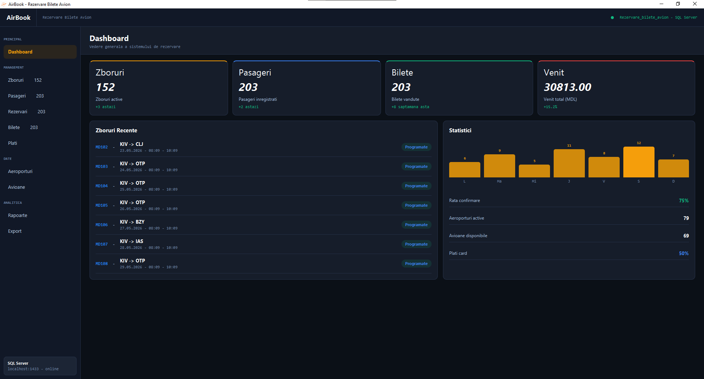

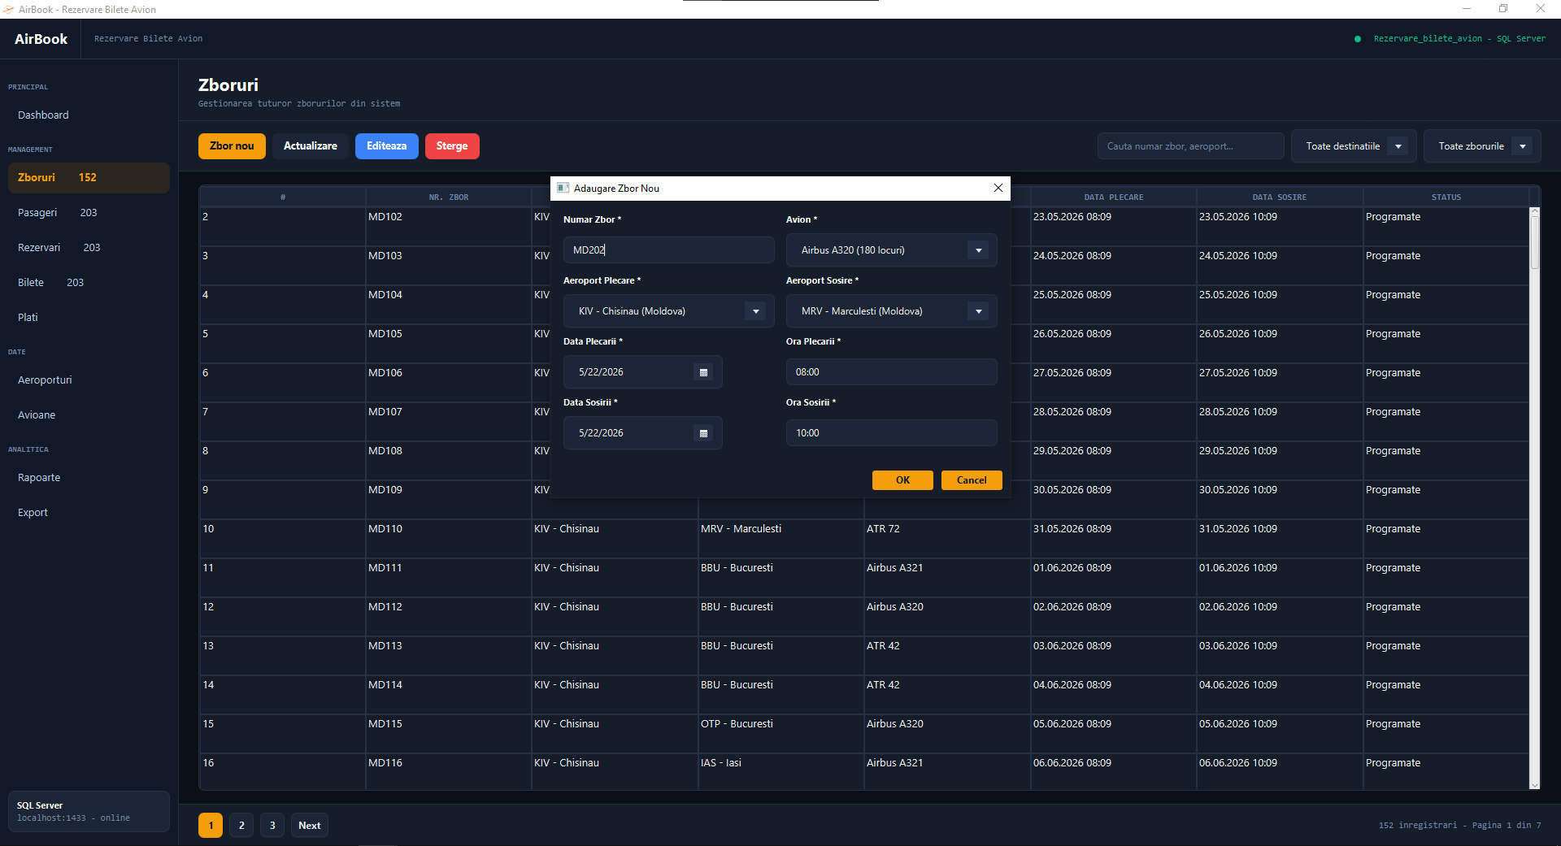
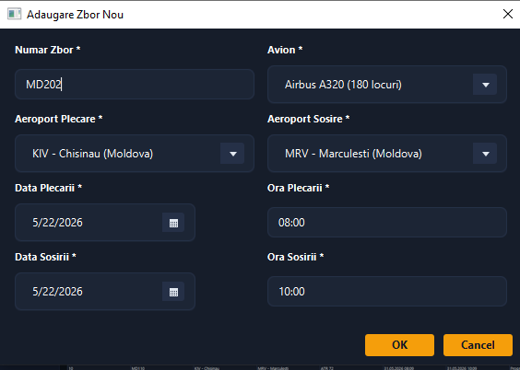

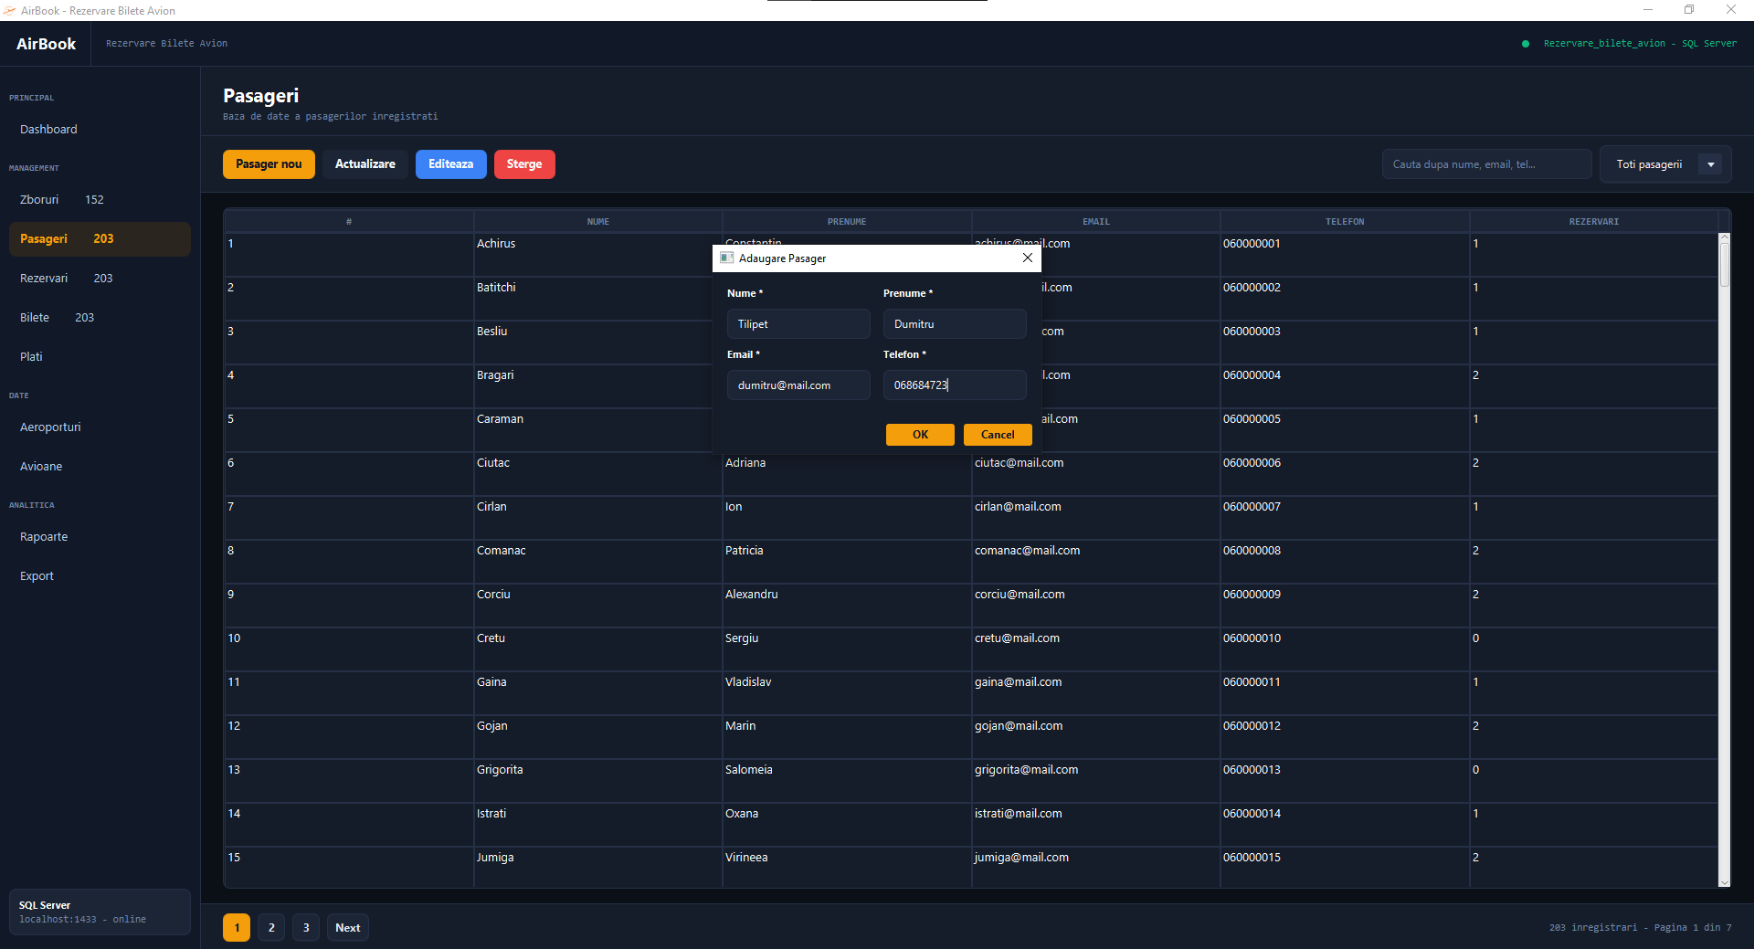
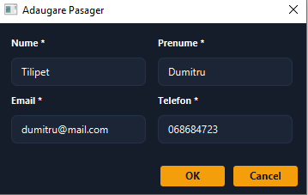

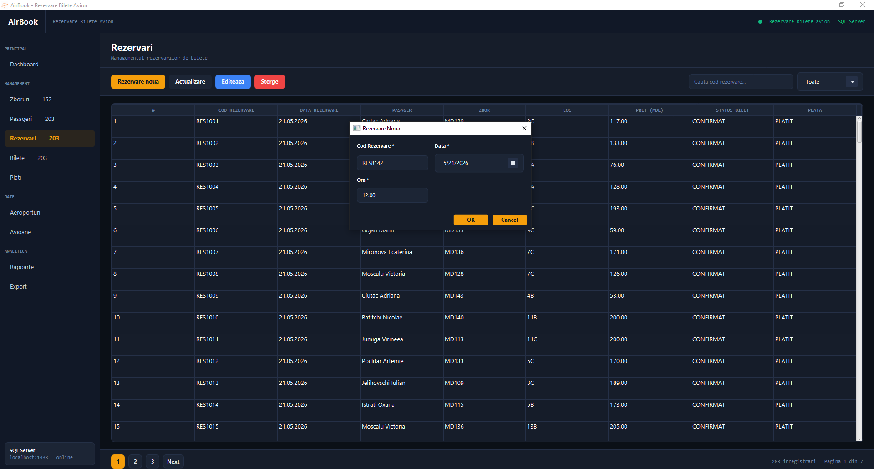
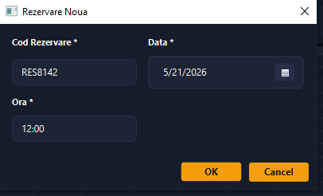

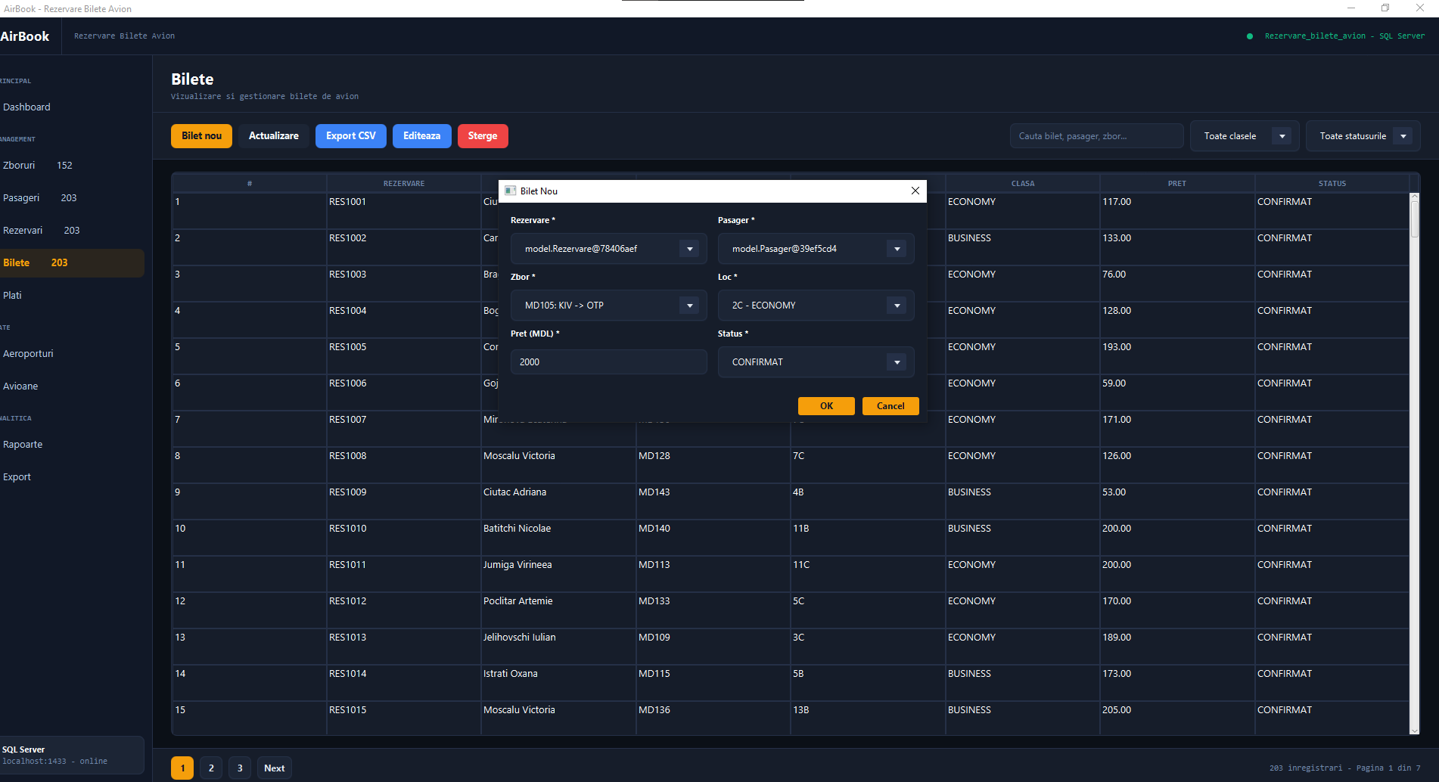
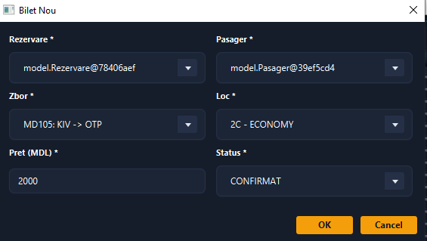

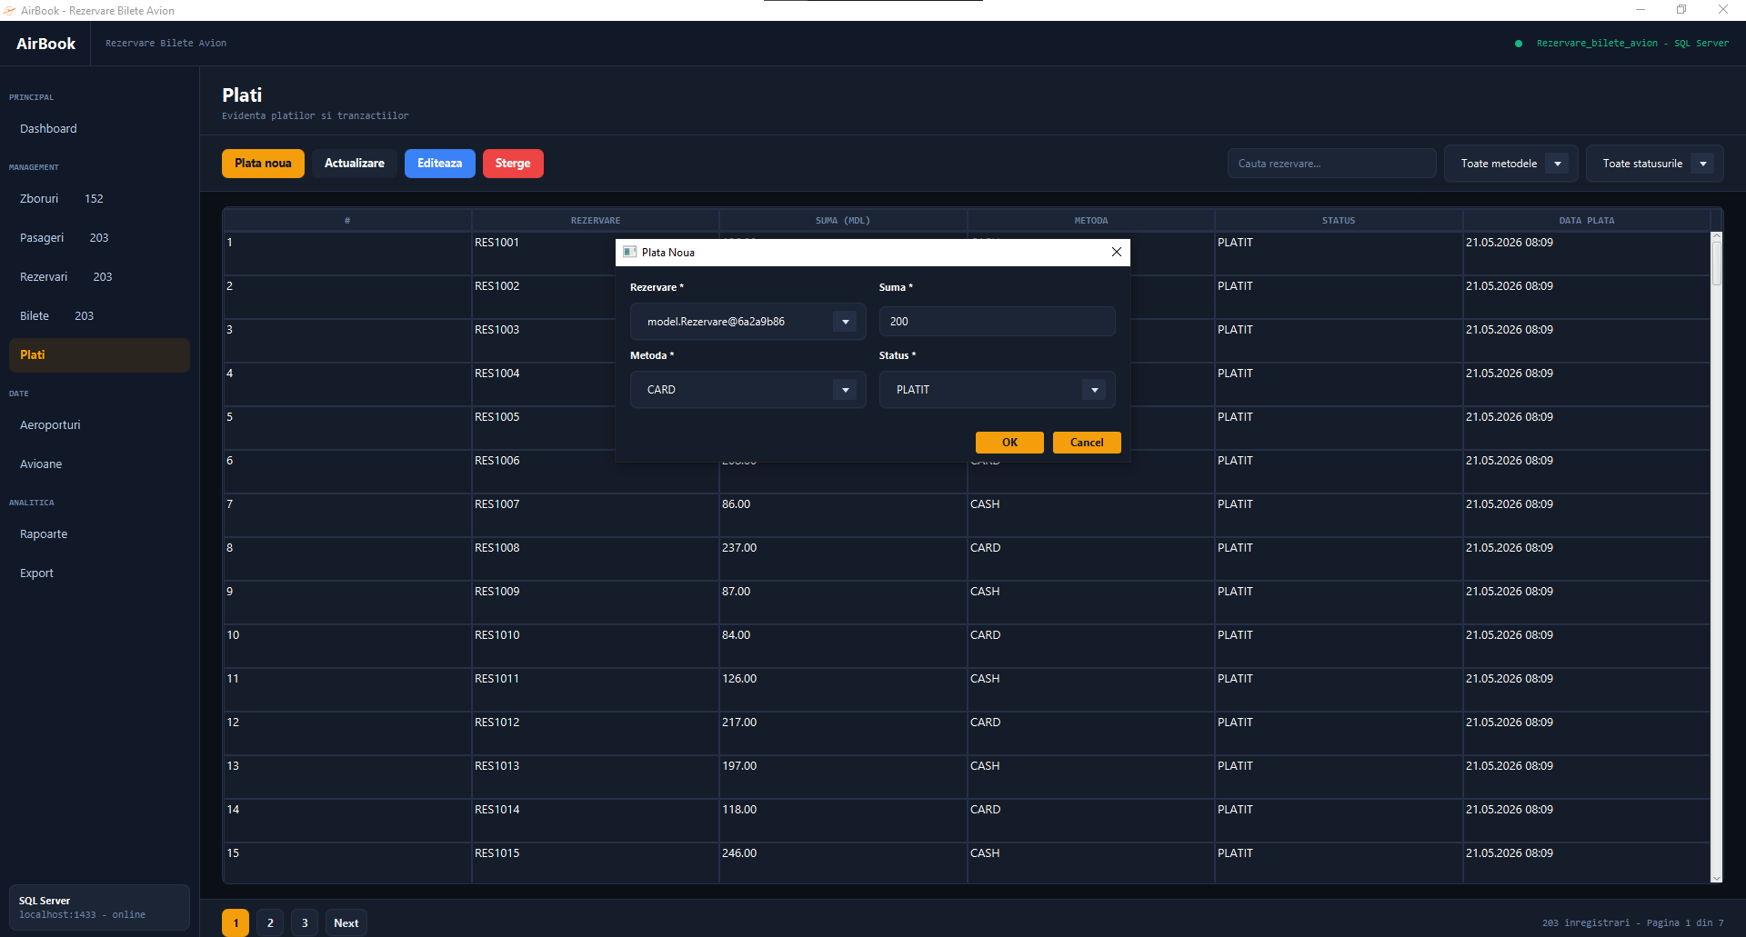
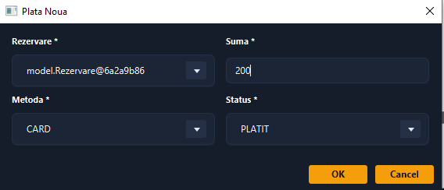

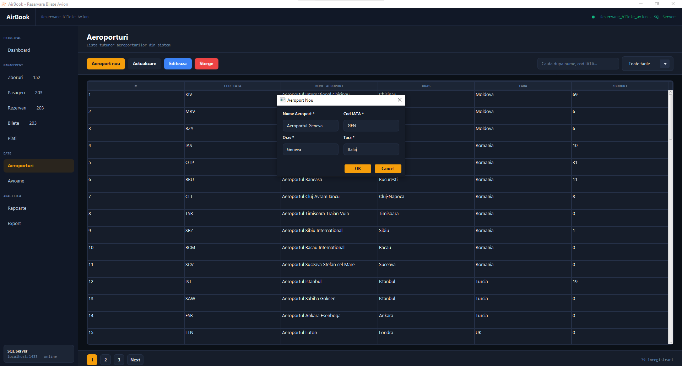
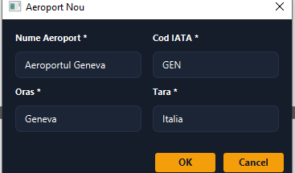

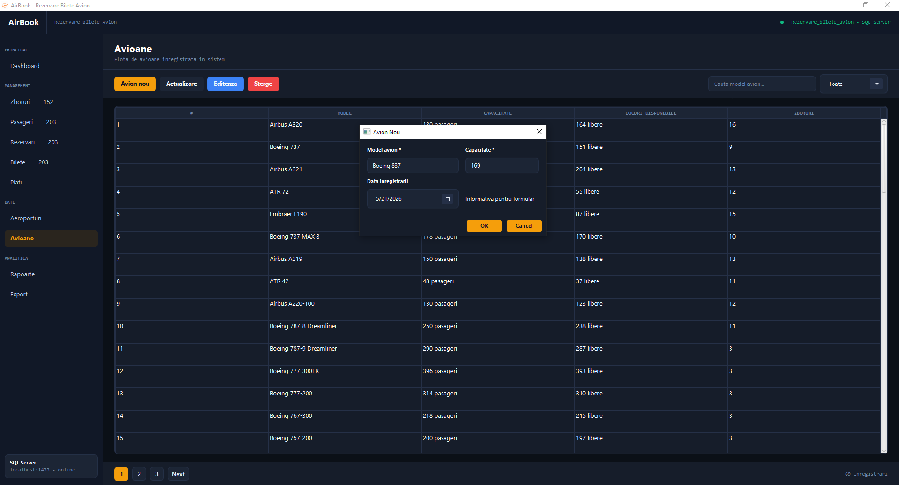
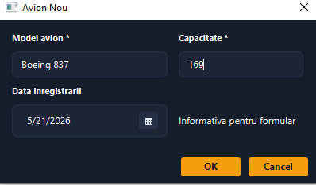

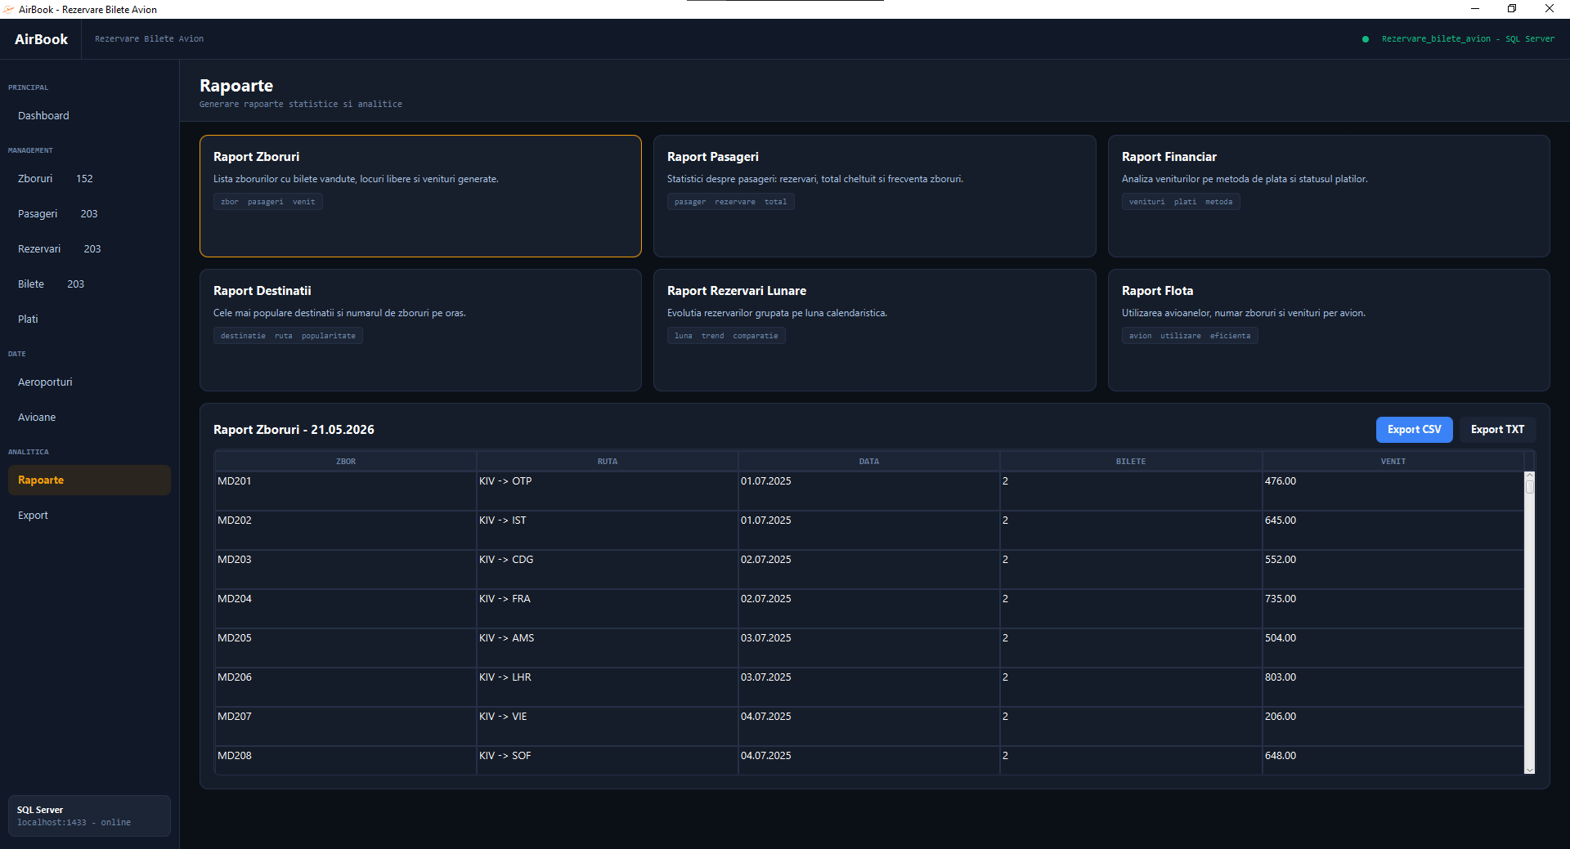

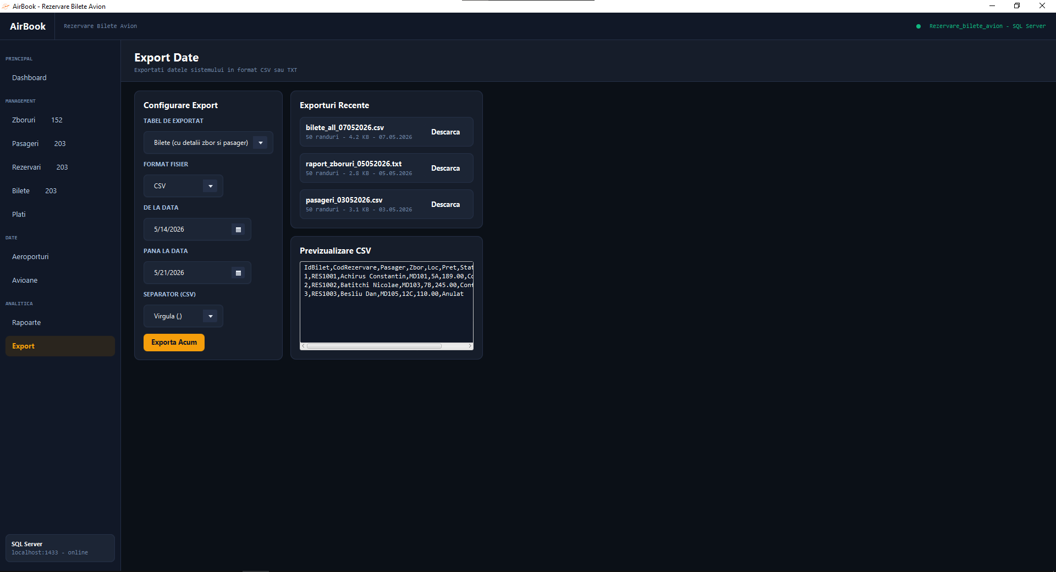

2.5.2 Datele de ieșire
Capturile de ecran de mai jos ilustrează datele de ieșire ale aplicației: tabele cu înregistrările salvate, rapoarte generate și fișierele CSV exportate, corespunzătoare datelor de intrare din secțiunea anterioară.
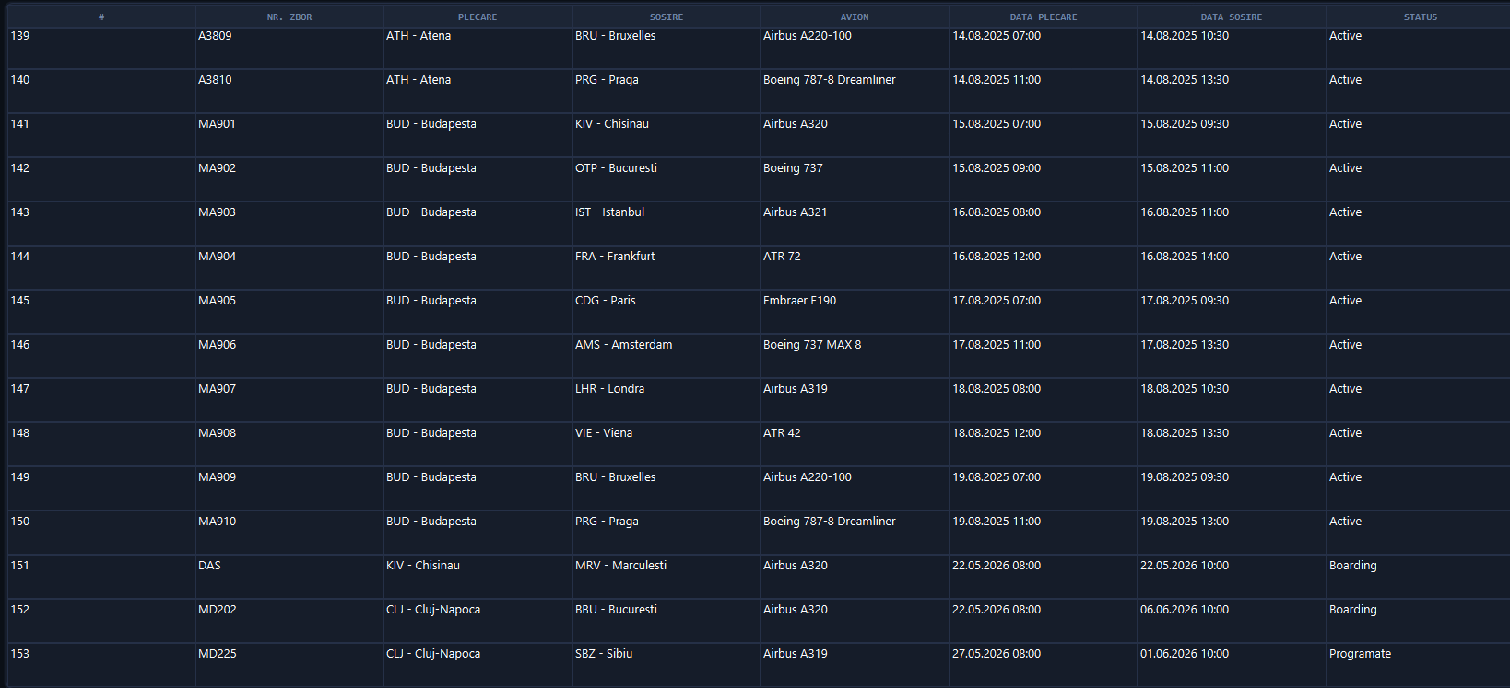

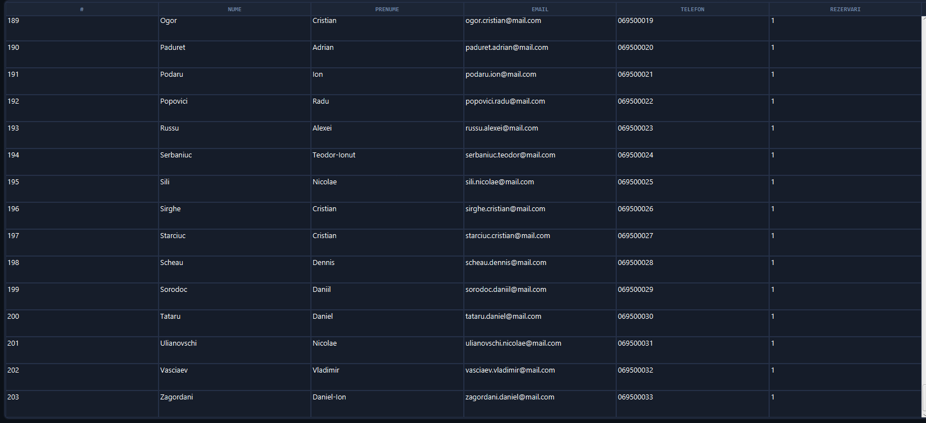
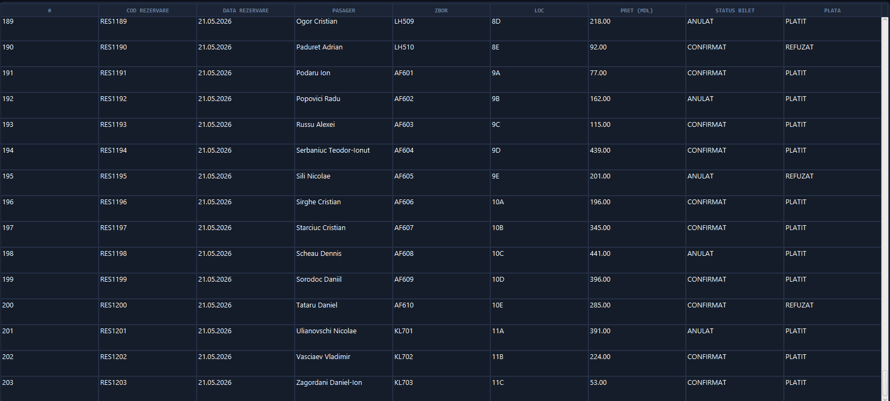

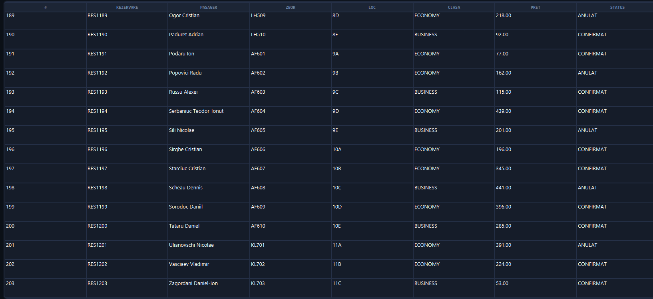

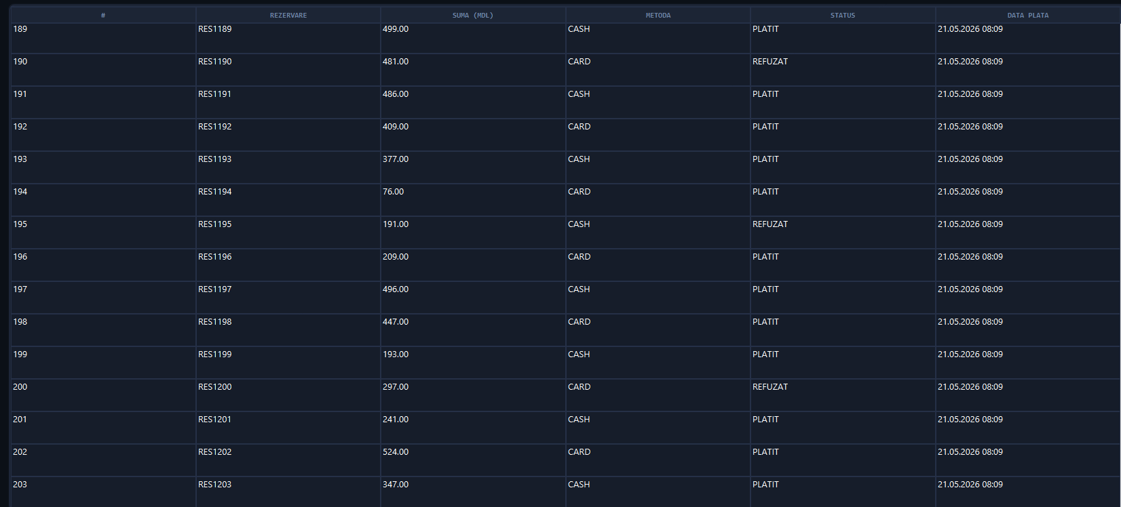

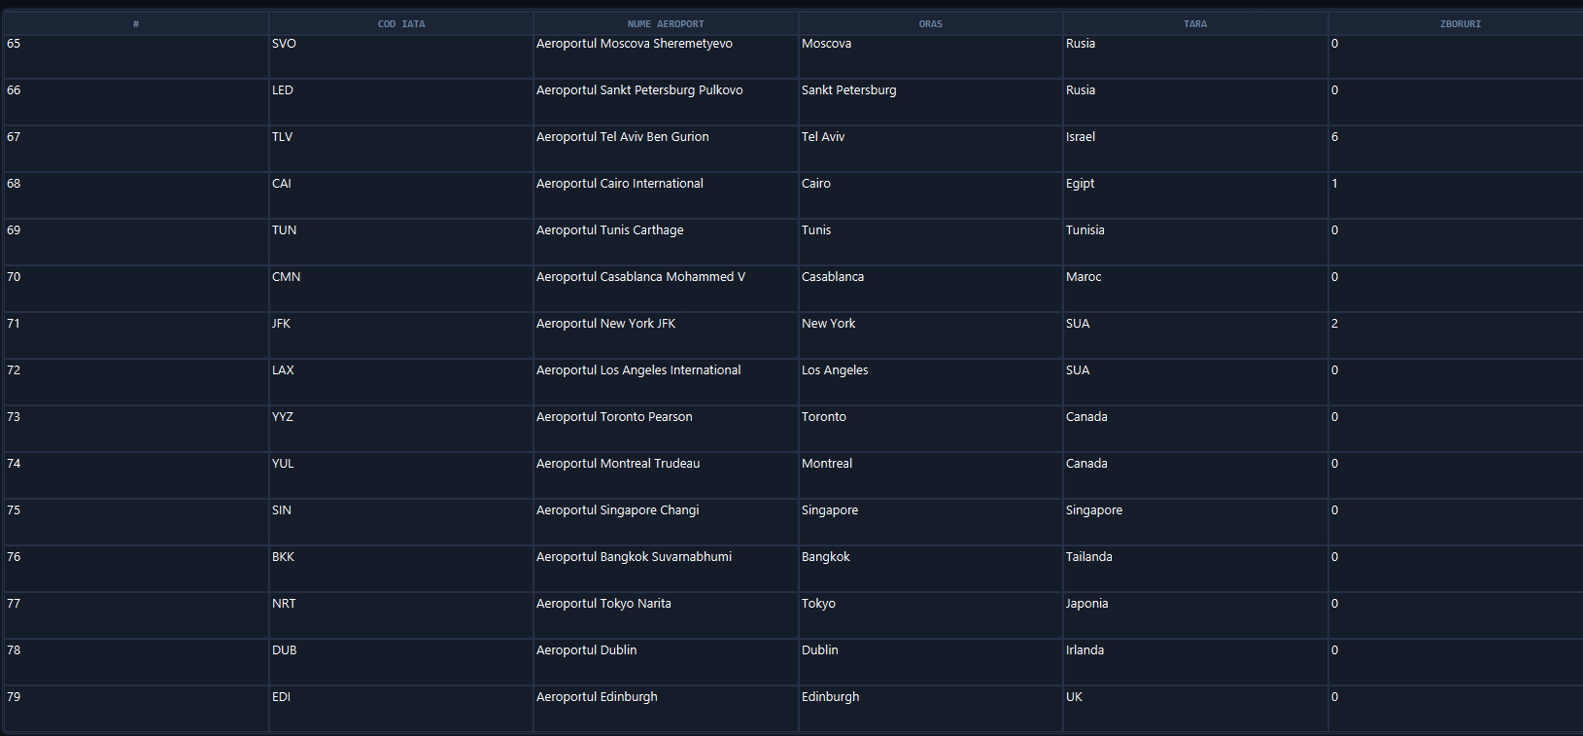

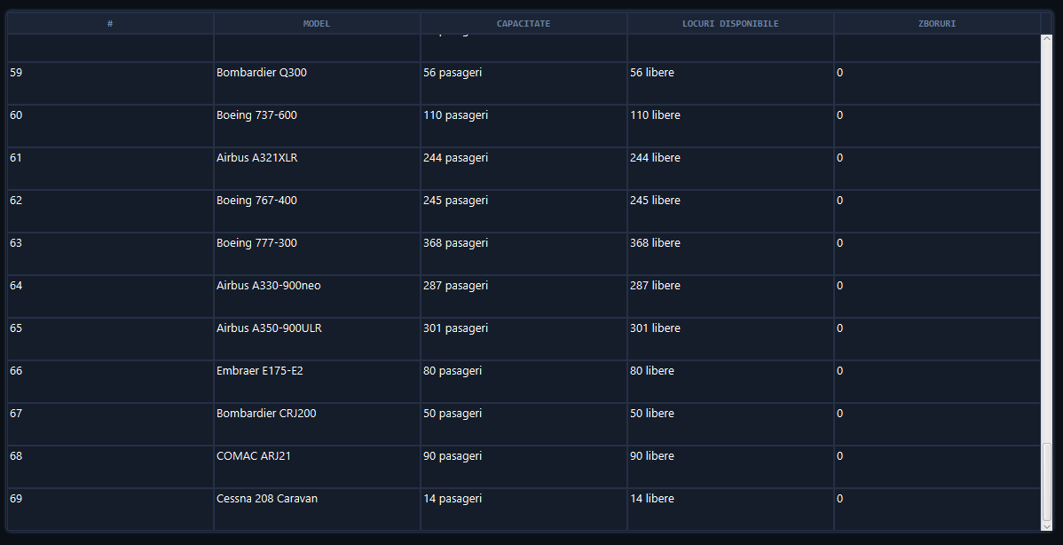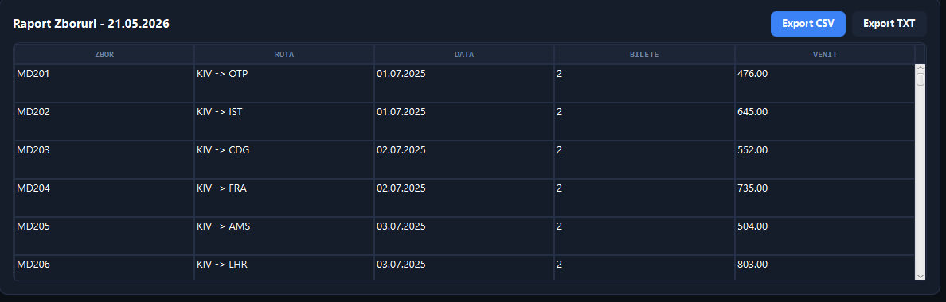

3. CONCLUZII
În urma realizării stagiului de practică de inițiere, a fost elaborat și testat sistemul AirBook – o aplicație desktop funcțională pentru rezervarea biletelor de avion, implementată în Java cu interfață grafică JavaFX 17 și bază de date Microsoft SQL Server. Rezultatele obținute demonstrează că tehnologiile alese sunt potrivite pentru dezvoltarea aplicațiilor desktop de gestiune a datelor la scară medie, asigurând performanță, stabilitate și o experiență vizuală modernă.
Cercetarea a implicat un grad ridicat de complexitate, vizibil în mai multe aspecte: arhitectura stratificată (DAO – Model – UI) a necesitat înțelegerea și aplicarea corectă a principiilor OOP și a design pattern-urilor; integrarea asincronă a operațiunilor cu baza de date (prin ExecutorService și Task JavaFX) a ridicat dificultăți legate de sincronizarea thread-urilor și actualizarea corectă a UI-ului; configurarea conexiunii JDBC la SQL Server (inclusiv autentificarea Windows Integrated și activarea TCP/IP pe portul 1433) a reprezentat o provocare practică semnificativă.
Există aspecte care pot fi perfecționate în cercetări viitoare: implementarea unui sistem de autentificare cu roluri distincte (administrator, agent, pasager); migrarea la o arhitectură client-server sau web (Spring Boot + REST API); adăugarea de validări mai stricte la nivel de bază de date prin TRIGGER-uri și proceduri stocate; implementarea unui modul de notificări (e-mail sau SMS) la confirmarea rezervării; și exportul rapoartelor în format PDF cu grafice vizuale.
Din perspectivă personală, obiectivele propuse la începutul stagiului – crearea unui sistem funcțional de rezervare cu interfață grafică intuitivă și bază de date relațională – au fost îndeplinite în integralitate. Proiectul a consolidat competențele de programare orientată pe obiecte în Java, a aprofundat cunoștințele despre JavaFX (scene graph, data binding, concurrență) și a oferit experiență practică valoroasă în proiectarea schemelor relaționale SQL Server. Dificultățile întâmpinate – în special cele legate de configurarea mediului de dezvoltare și integrarea JDBC – au constituit un exercițiu formativ esențial pentru activitatea de inginer software.

4. BIBLIOGRAFIE
[1] JavaFX 17 – Documentație oficială API – https://openjfx.io/javadoc/17/
[2] Getting Started with JavaFX – Ghid oficial de instalare și configurare – https://openjfx.io/openjfx-docs/
[3] JavaFX SDK 17 – Descărcare (Gluon) – https://gluonhq.com/products/javafx/
[4] Java SE 17 – Documentație oficială Oracle – https://docs.oracle.com/en/java/javase/17/
[5] Microsoft JDBC Driver for SQL Server – Documentație oficială – https://learn.microsoft.com/en-us/sql/connect/jdbc/microsoft-jdbc-driver-for-sql-server
[6] Download SQL Server Management Studio (SSMS) – https://learn.microsoft.com/en-us/sql/ssms/download-sql-server-management-studio-ssms
[7] JavaFX CSS Reference Guide – https://openjfx.io/javadoc/17/javafx.graphics/javafx/scene/doc-files/cssref.html
[8] Configuring TCP/IP for SQL Server – https://learn.microsoft.com/en-us/sql/database-engine/configure-windows/configure-a-server-to-listen-on-a-specific-tcp-port
[9] JavaFX Concurrency – Task și Service – https://openjfx.io/javadoc/17/javafx.graphics/javafx/concurrent/Task.html
[10] D0myyy/Practica-2 – Codul sursă al proiectului (GitHub) – https://github.com/D0myyy/Practica-2

5. ANEXE

Anexa 1 – Structura proiectului
Arborele de directoare al proiectului JAVA (AirBook):

JAVA/
├── app/
│ └── Main.java # Punct de intrare Java
├── ui/
│ ├── AppUI.java # Clasa principala JavaFX
│ ├── Logo.png # Icoana aplicatiei
│ └── css/
│ └── style.css # Foaie de stil JavaFX
├── dao/
│ ├── AeroportDAO.java
│ ├── AvionDAO.java
│ ├── BiletDAO.java
│ ├── LocDAO.java
│ ├── PasagerDAO.java
│ ├── PlataDAO.java
│ ├── RezervareDAO.java
│ └── ZborDAO.java
├── model/
│ ├── Aeroport.java
│ ├── Avion.java
│ ├── Bilet.java
│ ├── Loc.java
│ ├── Pasager.java
│ ├── Plata.java
│ ├── Rezervare.java
│ ├── Zbor.java
│ ├── enums/
│ │ ├── MetodaPlata.java
│ │ ├── StatusBilet.java
│ │ └── StatusPlata.java
│ └── interfaces/
├── database/
│ └── DatabaseConnection.java # Conexiune JDBC SQL Server
└── utils/
└── mssql-jdbc-13.4.0.jre11.jar

SQL/
├── BazaDeDate.sql # Script creare BD + date initiale
└── mssql-jdbc_auth-13.4.0.x64.dll # Driver autentificare Windows

Anexa 2 – Comenzi de compilare și execuție
Compilare aplicație JavaFX:
javac --module-path "..\javafx-sdk-17.0.19\lib" ^
--add-modules javafx.controls ^
-cp ".;utils\mssql-jdbc-13.4.0.jre11.jar" ^
app\Main.java ui\AppUI.java dao\*.java ^
database\*.java model\*.java ^
model\enums\*.java model\interfaces\*.java

Execuție aplicație:
java --module-path "..\javafx-sdk-17.0.19\lib" ^
--add-modules javafx.controls ^
-cp ".;utils\mssql-jdbc-13.4.0.jre11.jar;app" ^
Main

Anexa 3 – Configurare SQL Server pentru conexiunea JDBC
Setare | Valoare
Server | localhost
Port TCP/IP | 1433 (activat în SQL Server Configuration Manager)
Baza de date | Rezervare_bilete_avion
Autentificare | Windows Integrated Authentication
Driver DLL | mssql-jdbc_auth-13.4.0.x64.dll → C:\Program Files\Microsoft\jdk-11.0.12.7-hotspot\bin
Driver JDBC | mssql-jdbc-13.4.0.jre11.jar

