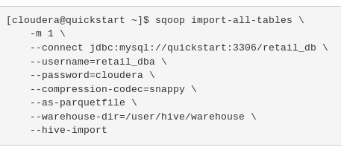

Replace *retail_db* by the name of the database in sql that you want to use

Replace *retail_dba* by root (or your sql username)

in impala