 | Mapua University - Makati 1191 Pablo Ocampo Sr. Ext, Makati, Metro Manila
CampusRoom
A Centralized Web-Based Reservation System
for Shared Campus Facilities
In Partial Fulfillment of the Requirements for
ITS122P - Web Systems and Technologies 2
Group 7 Members:
Anastacio, Justin Gerard
Broñola, Chloie May M.
Castillo, Carl Rohan M.
Claroniño, Gian Gabriel
Pablo, Naveen J.
Professor:
Ms. Maylyn Bautista
September 2026

Project Title
Problem Statement
Campus facility booking relies on manual methods such as fragmented logbooks or informal
requests, causing double-bookings, wasted time, and zero real-time availability tracking for students and
faculty. In addition, facility managers lack a central system to process approvals, maintain accountability,
and track usage records for maintenance planning.
Target Users
1)​Students and Faculty
Require an efficient way to find and book available rooms without visiting facility offices
or waiting for manual confirmation.
2)​Facility Managers or Librarians
Require a centralized dashboard for reviewing, approving, or rejecting incoming
reservations. Visible daily schedules also help them to manage access and handle room turnover,
ensuring streamlined processes without fragmented communication channels.
3)​System Administrators
Require full administrative privileges over system configurations such as room
availability, role-based user access, and system monitoring or audit logging to ensure security and
operational scalability.

Proposed Features
User Registration and Login
Allows users to create an account and securely access the system using their registered
credentials. This also helps the system identify the user and provide access based on their assigned role.
Role-Based Access
Provides different permissions and features depending on the user’s role, such as Admin, Staff, or
User. This ensures that users can only access and manage the functions assigned to them.
Live Availability View
Allows users to view the current availability and schedule of school facilities. This helps users
easily find an available facility and choose a suitable date and time for their reservation.
Booking Workflow
Allows users to submit reservation requests by selecting a facility, date, time, and purpose of the
reservation. Staff or admins can then review the request and approve, reject, or cancel it when necessary.
Activity Logging
Keeps a record of important actions made within the system, such as creating, updating,
approving, or cancelling reservations. This helps the admin and staff monitor activities and keep track of
changes made in the system.
No Double Booking
Prevents users from reserving the same facility if it has already been booked for the selected date
and time. This helps avoid scheduling conflicts and ensures that facility schedules remain organized.

User Roles
Administrator
Manages the facilities and reservations in the system. They have full access to the system and can perform CRUD (Create, Read, Update, Delete) operations on users, facilities, and reservations.
Staff
Manages facility schedules and reservation requests. They can view, approve, reject, and update reservations, as well as update the availability of facilities.
User
Can view available facilities and their schedules. They can make reservations, view their reservation status, and cancel their own reservations when needed.
System Architecture
Frontend - Built with HTML5, CSS3, and JavaScript to provide tailored, role-based interfaces corresponding to Admin, Staff, and User privileges.
Backend - Handled by custom PHP that routes requests, verifies user authentication, and sanitizes input data. It protects restricted staff routes from regular user sessions while preventing conflicting room reservations.
Database - Handled by PostgreSQL with built-in constraints, foreign keys, and triggers to enforce data integrity and prevent conflicting entries.

Initial ERD
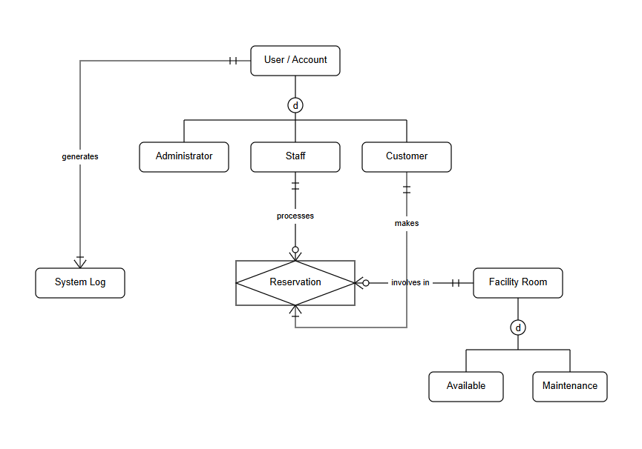
Technology Stack
Layer | Technology
Frontend (Client) | HTML5, CSS3, and Vanilla JavaScript, delivered as a minimalist single-interface client that renders role-conditional views for Admin, Staff, and Customer accounts.
Backend (Server) | PHP, acting as the intermediary application-logic layer. PHP scripts handle incoming HTTP requests, enforce authorization and business rules, manage user sessions, and mediate all reads/writes to the database.
Database | PostgreSQL, hosted on Supabase, accessed natively from the PHP backend through PHP Data Objects (PDO). PDO's prepared statements and transaction handling provide the concurrency control needed to prevent race conditions on simultaneous booking attempts, working in tandem with the existing overlap-prevention trigger.
Third-Party Services | Resend (or a comparable transactional email API), invoked from PHP to notify users when a reservation's status changes.

PHASE 2– Database + Backend
Implemented Tables
Entity | Type | Key Attributes
Users | Strong Entity | user_id (PK), email, password_hash, role (Admin / Staff / Customer), created_at
Rooms | Strong Entity | room_id (PK), name, capacity, is_active, status ('Available' / 'Maintenance'), created_at
Reservations | Associative Entity | reservation_id (PK), customer_id (FK → Users), room_id (FK → Rooms), start_time, end_time, status, processed_by (FK → Users), created_at
System_Logs | Weak Entity | log_id (PK), user_id (FK → Users), action_type, timestamp
Relationships and Constraints
The database enforces business rules to prevent orphaned records and logically inconsistent states:
a)​Foreign Keys: Reservations holds foreign keys referencing both Users (the customer who booked it) and Rooms. It also holds an optional processed_by foreign key referencing the Staff/Admin who approved or rejected the booking.
b)​Cascading Deletes: Deleting a User or a Room will cascade and remove associated Reservations and System Logs to maintain referential integrity.
c)​Concurrency | Control | (No | Double-Booking): | A | custom | PostgreSQL | trigger
(prevent_double_booking) is attached to the Reservations table. It automatically checks for overlapping approved or pending reservations for the same room before allowing an INSERT or

UPDATE. If a collision is detected, it raises an exception (SQLSTATE P0001), which the PHP backend safely catches and converts to an HTTP 409 Conflict error.
CRUD Operations
CRUD (Create, Read, Update, Delete) functionality is handled through the Repository Pattern in the PHP backend, separating SQL queries from the HTTP routing logic.
CRUD OPERATIONS
Users | 1)​Create: Registration of new Customer accounts.  2)​Read: Admin fetching a list of all users.  3)​Update: Admin changing a user's role (e.g., promoting a Customer to Staff).
Rooms | 4)​Create: Admin adding new facilities to the system.  5)​Read: Customers fetching all active rooms. The live "Occupied" status is  dynamically derived at query-time rather than stored statically.  6)​Update: Admin changing a room's status to "Maintenance" or deactivating it.
Reservations | 7)​Create: Customers submitting a new booking request.  8)​Read: Customers viewing their own booking history; Staff viewing pending  queues.  9)​Update: Staff approving, rejecting, or completing a reservation.

Authentication and Authorization
The backend implements secure, session-based authentication without relying on external frameworks.
a)​Password Security: All user passwords are encrypted using bcrypt (password_hash()) before being stored. Passwords are never returned in any API response.
b)​Session Management: Upon successful login, the user's user_id and role are stored in a secure PHP session. The session ID is regenerated (session_regenerate_id()) during login to prevent session fixation attacks.
c)​Role-Based Access Control (RBAC): A central Auth::requireRole() helper is invoked at the very beginning of every protected endpoint. This guarantees that a Customer cannot access Staff or Admin routes, returning an HTTP 403 Forbidden error if unauthorized.
Basic Backend Architecture
The backend was built using vanilla PHP 8+ following a standard three-tier architecture (Client, Application Logic, Database).
1)​Front-Controller Pattern: All incoming HTTP requests are funneled through a single entry point (public/index.php). This file contains a centralized routing table using regular expressions to match URLs to specific Controller methods.
2)​Database Abstraction (PDO): The application connects to PostgreSQL using PHP Data Objects (PDO). A Singleton Database class manages the connection.
3)​Prepared Statements: To completely eliminate the risk of SQL injection, every single database query utilizes PDO prepared statements. Raw variables are never concatenated into SQL strings.

4)​Standardized JSON Responses: A central Response class wraps all API outputs into a consistent JSON envelope format ({ "success": bool, "data": array|null, "error": string|null }), ensuring predictable parsing for the frontend application.
5)​Environment Configuration: Database credentials are kept secure by loading them from a .env file using the vlucas/phpdotenv library, ensuring secrets are never hardcoded into the source code or pushed to version control.
Proof/Evidences Provided
MySQL Database
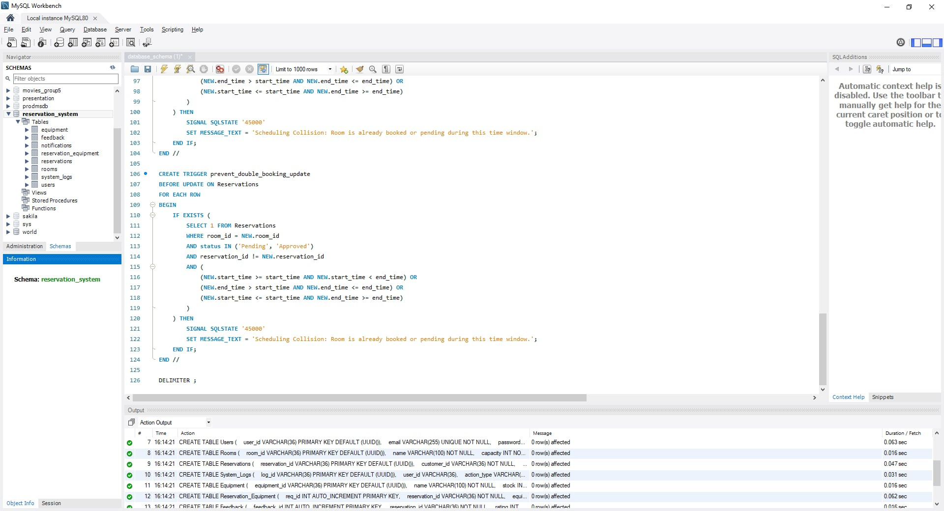

Php backend routed with MySQL
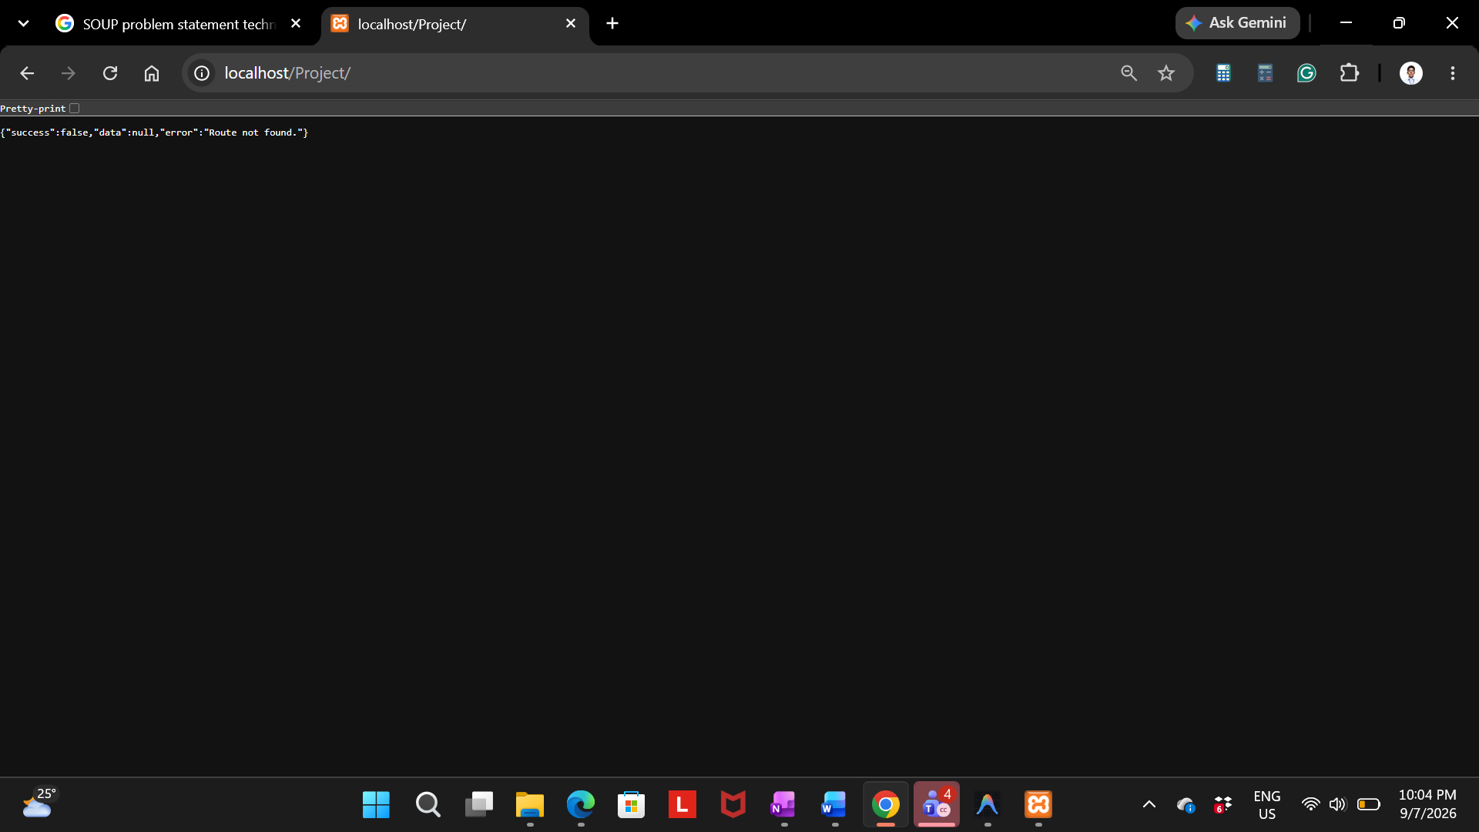
Codes
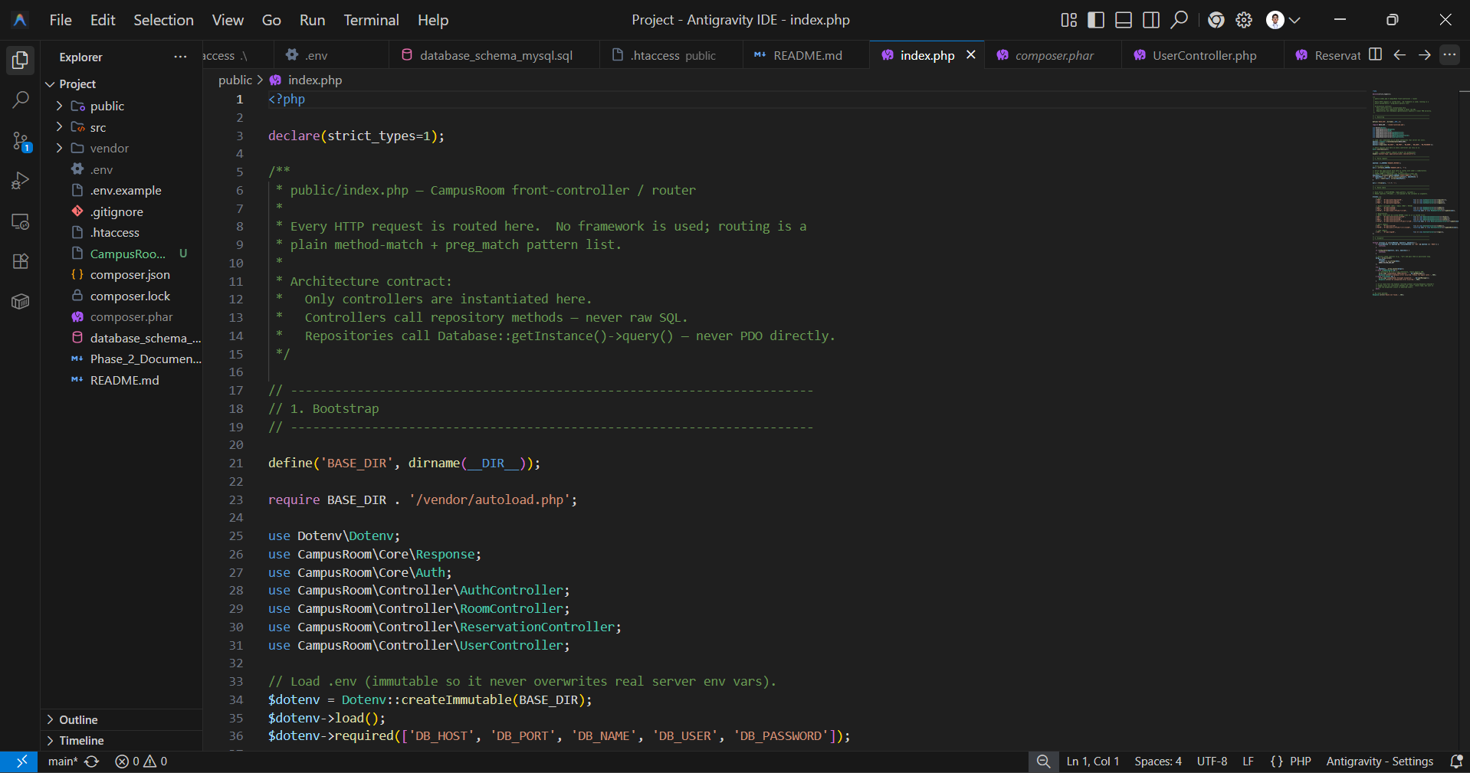

SQL Running on XAMMP
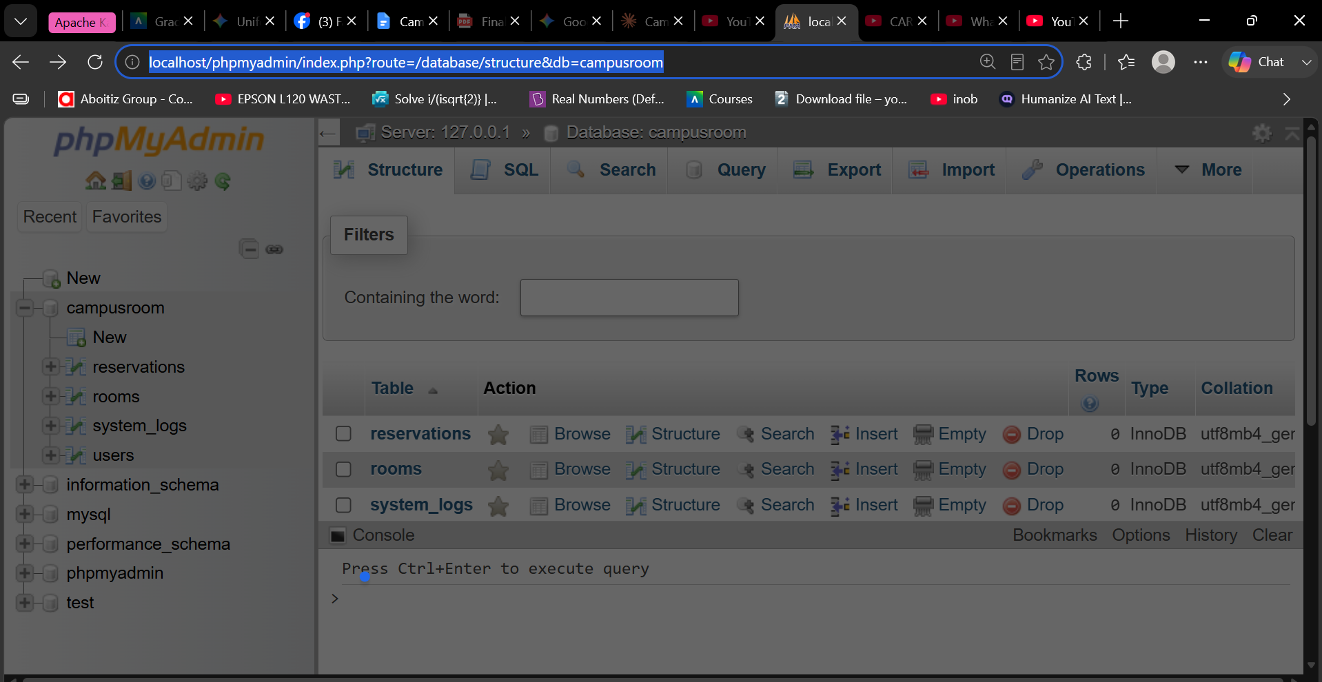
Zoom Meeting
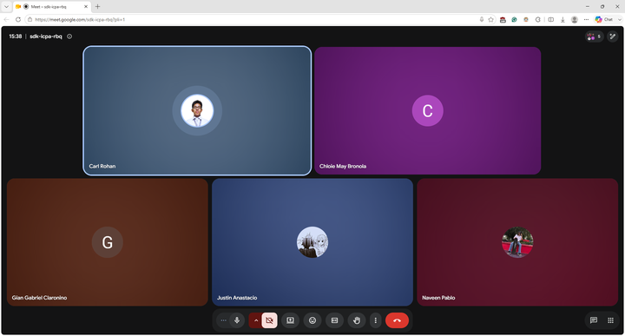

Member Name | Assigned Role | Specific Contributions | Fair Peer Rating (1–5)
Anastacio, Justin Gerard | Database | -​ Currently Implemented MySQL  SCHEMA  -​ Had it running along XAMMP | 5
Broñola, Chloie May M. | QA/Security/UI/ Documentation | -​ Currently Finished Draft Of  Documentation (Top To Bottom) -​ Had been tester/breaker of the system to verify and test  workarounds of the system | 5
Castillo, Carl Rohan M. | Backend  Developer | -​ Worked on PHP as acting  Backend (tentative)  -​ Sourcing for background API’s to be implemented. | 5
Claroniño, Gian Gabriel | Project  Manager/System Analyst | -​ Manages around Documentation  -​ Sets meeting and drafts the logic  diagrams | 5
Pablo, Naveen J. | Frontend  Developer | -​ Currently working on  implementing a frontend of the backend logic.  -​ Had started creating XML files | 5

Phase 3 – Frontend + API Project Overview & Requirements Met
Requirement | How We Met It
1. Responsive Interface | The entire CampusRoom facility gateway is built with responsive Tailwind CSS utilities, adapting properly to desktop, tablet, and mobile views.
2. JavaScript Functionality | We have comprehensive JS files ( app.js , rooms.js ,  reservations.js , booking.js ) demonstrating interactive modals, dynamic room rendering, pagination, and role-based navigation.
3. API Integration | The frontend acts as a Single Page Application (SPA)-style interface that  communicates with our custom PHP backend REST API endpoints to fetch rooms, reservations, and submit bookings.
4. AJAX / Fetch | All data retrieval, form submissions, and status updates (like cancelling a reservation or approving a booking) are done via JavaScript fetch() without reloading the page.
5. Form  Validation | Booking forms prevent scheduling errors (like end-time before start time), check for required fields, and show dynamic error banners before submission.
6. Search / Filter | The Rooms page and Reservations page both feature dynamic search bars and multi-select filters (e.g., filtering by Floor, Room Type, or Status) that update the UI instantly.

API Integration
The CampusRoom's own PHP/MySQL REST API ( public/index.php front controller, routing to AuthController , RoomController , ReservationController , and UserController ).
Purpose
Serves as the single source of truth for all rooms, reservations, users, and audit log data, while the frontend holds no data of its own and never reads/writes a database directly; every page requests what it needs from this API.
Endpoints used by the frontend:
Method | Endpoint | Used by
POST | /api/auth/register | auth.js
POST | /api/auth/verify-otp | verify.html
POST | /api/auth/resend-otp | verify.html
POST | /api/auth/login | auth.js
GET | /api/auth/me | app.js
POST | /api/auth/logout | app.js
GET | /api/rooms | rooms.js , booking.js
POST | /api/rooms | admin-governance.html

PATCH | /api/rooms/{id} | staff-queue.js , admin-governance.html
GET | /api/reservations/mine | reservations.js , dashboard.js
GET | /api/reservations | staff-queue.js
POST | /api/reservations | booking.js
PATCH | /api/reservations/{id}/cancel | reservations.js
PATCH | /api/reservations/{id} | staff-queue.js
GET | /api/users | admin-governance.html
PATCH | /api/users/{id}/role | admin-governance.html
GET | /api/logs | staff-queue.js , admin  governance.html
The data retrieved and used room details (name, capacity, floor, room type, live status, next available time), a customer's own reservation history, the pending-approval queue, the full user list with roles, and the system audit log, each rendered directly into the page's HTML by JavaScript after the fetch resolves.
How it's integrated? Every call above uses the browser's native fetch() API with credentials: 'include' so the PHP session cookie authenticates the request; the API always responds with a consistent JSON envelope ( { success, data, error } ), which each script checks before rendering.

Screenshots
Page | Desktop
Login ( index.html )
  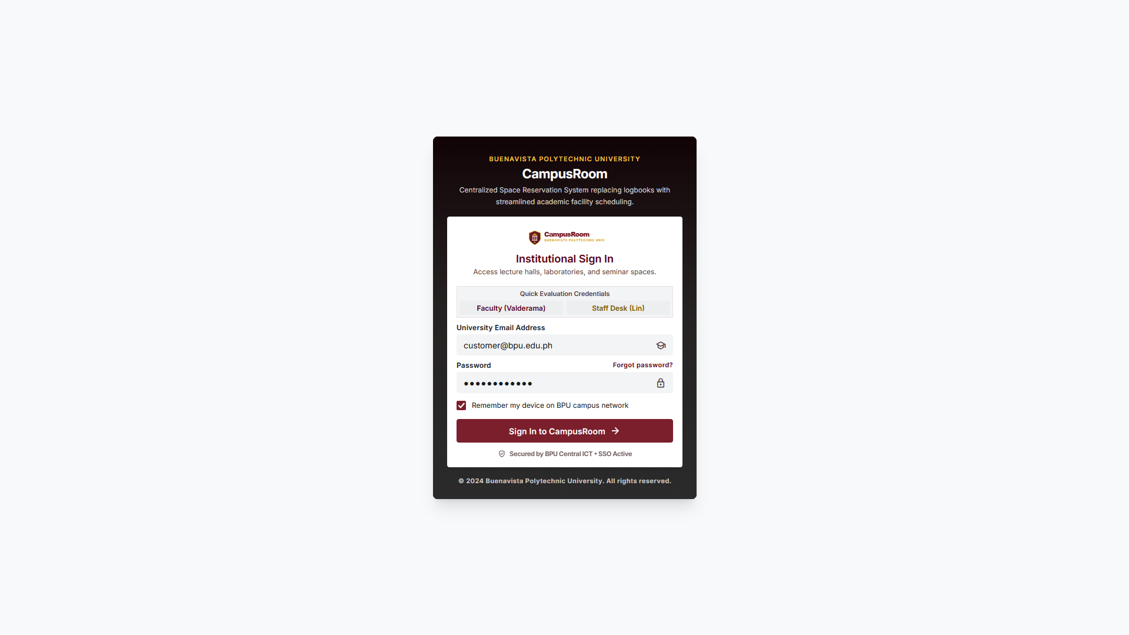
Verification  (verify. html)
  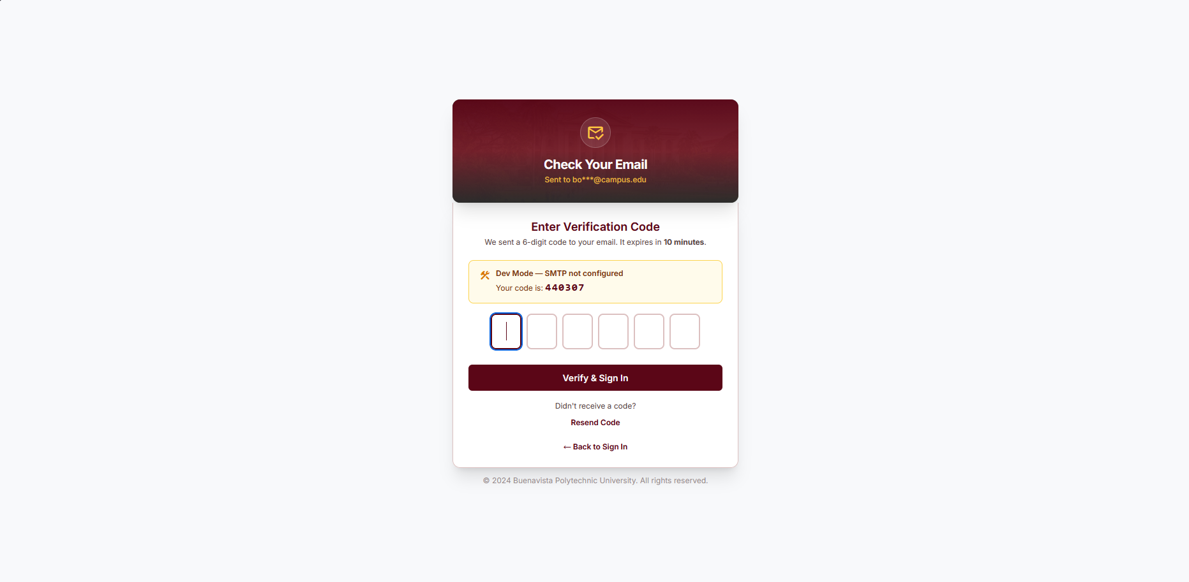
Dashboard for Users (dashboard.html )
  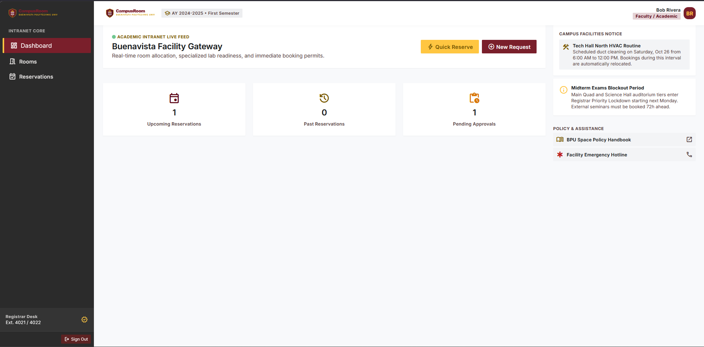

Rooms (rooms.html )
  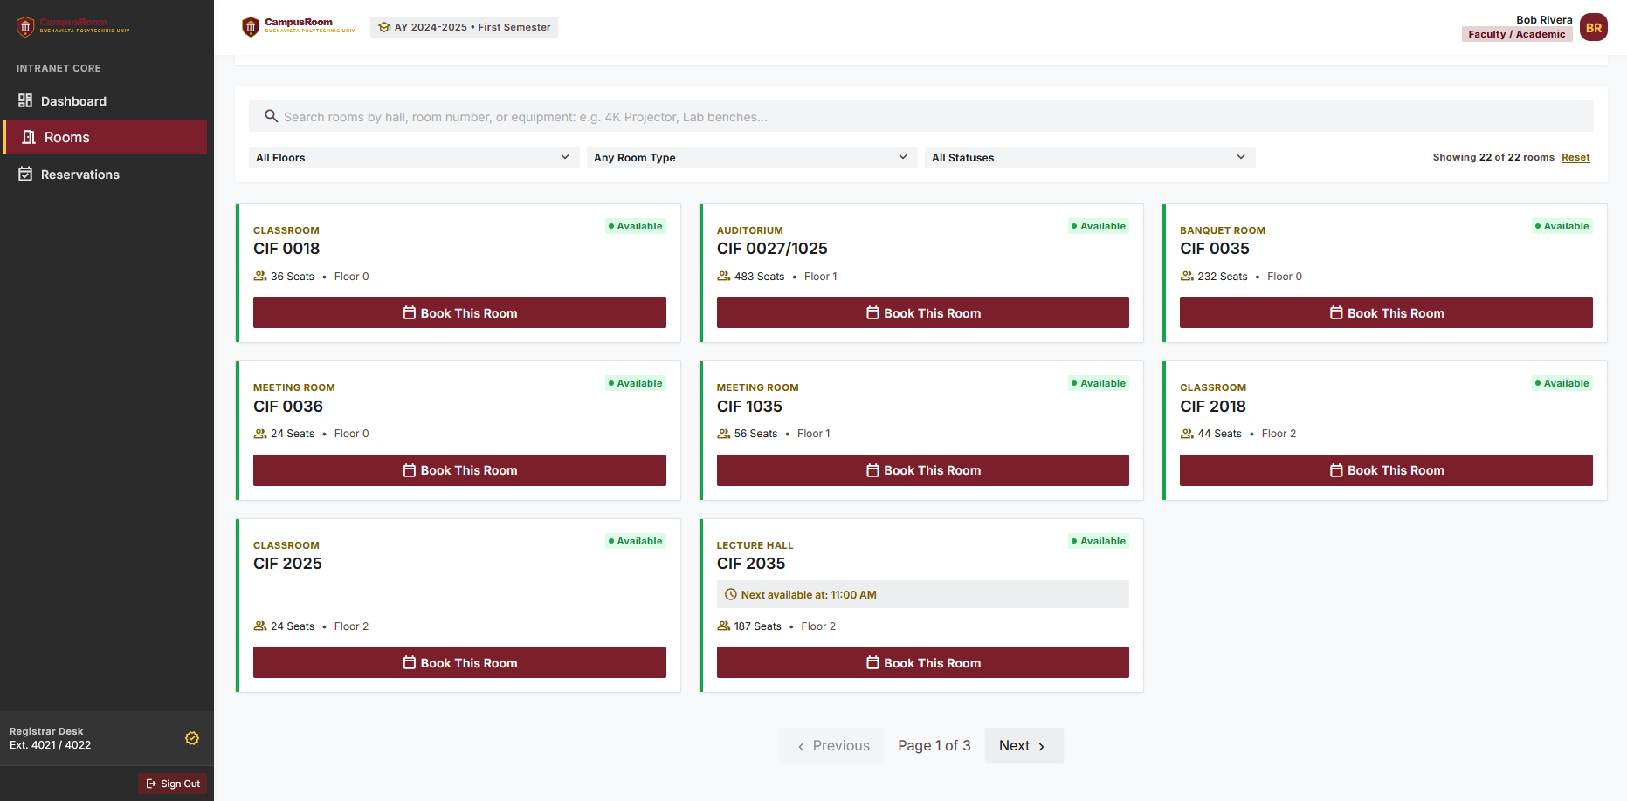
Book a Room Form (book-room.html) | 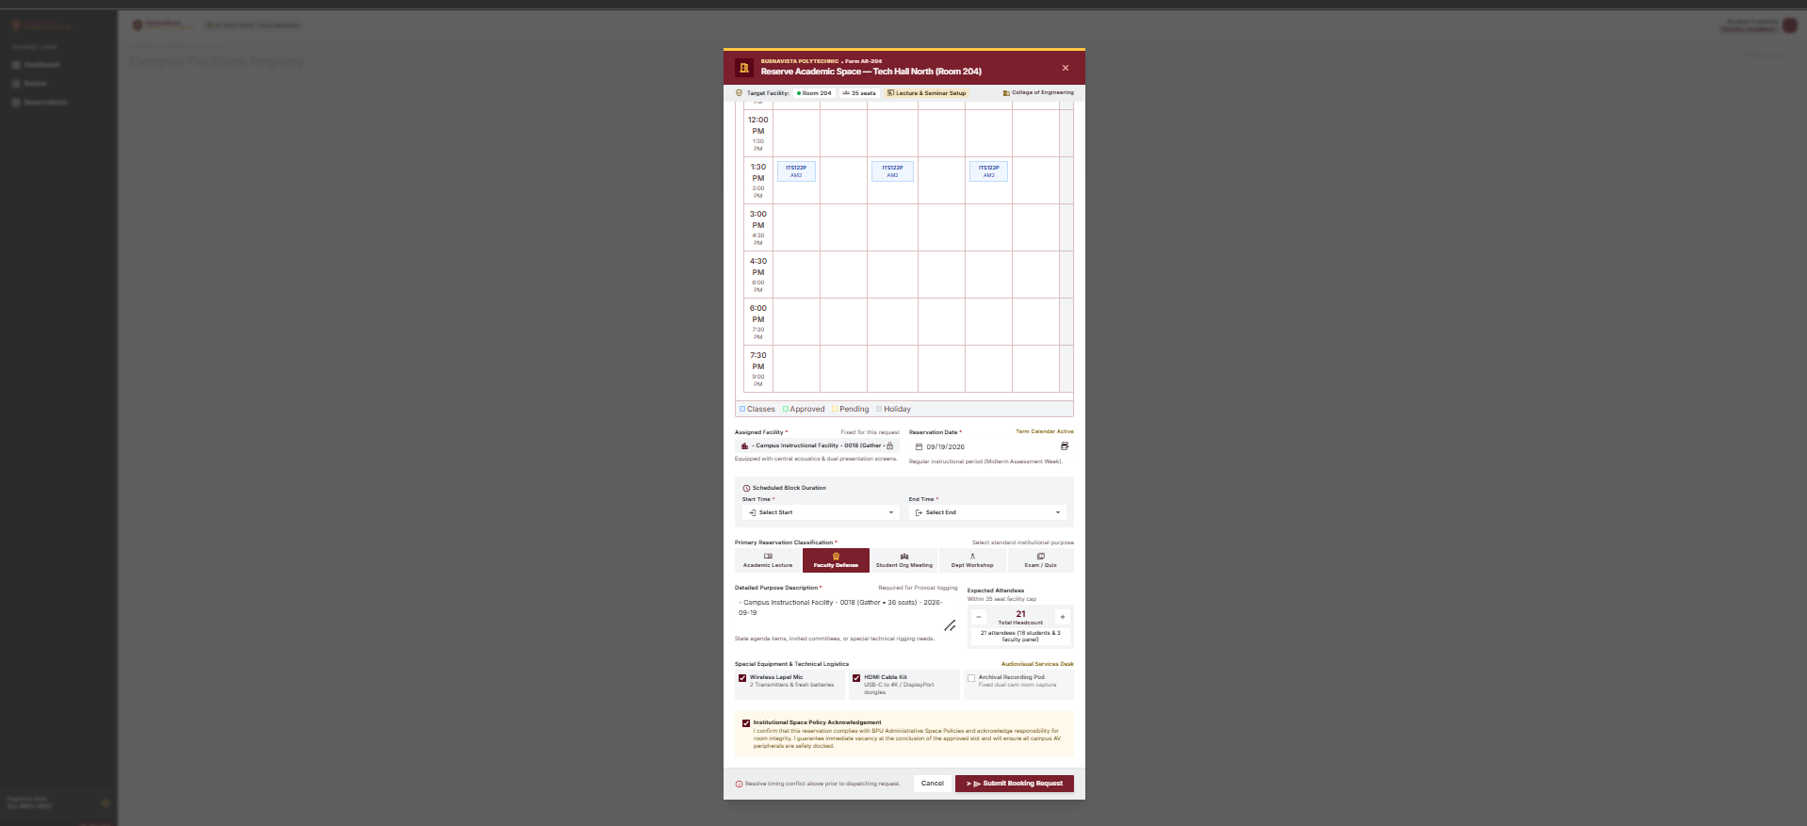
  -​ | Intentional error to display the schedule collision
  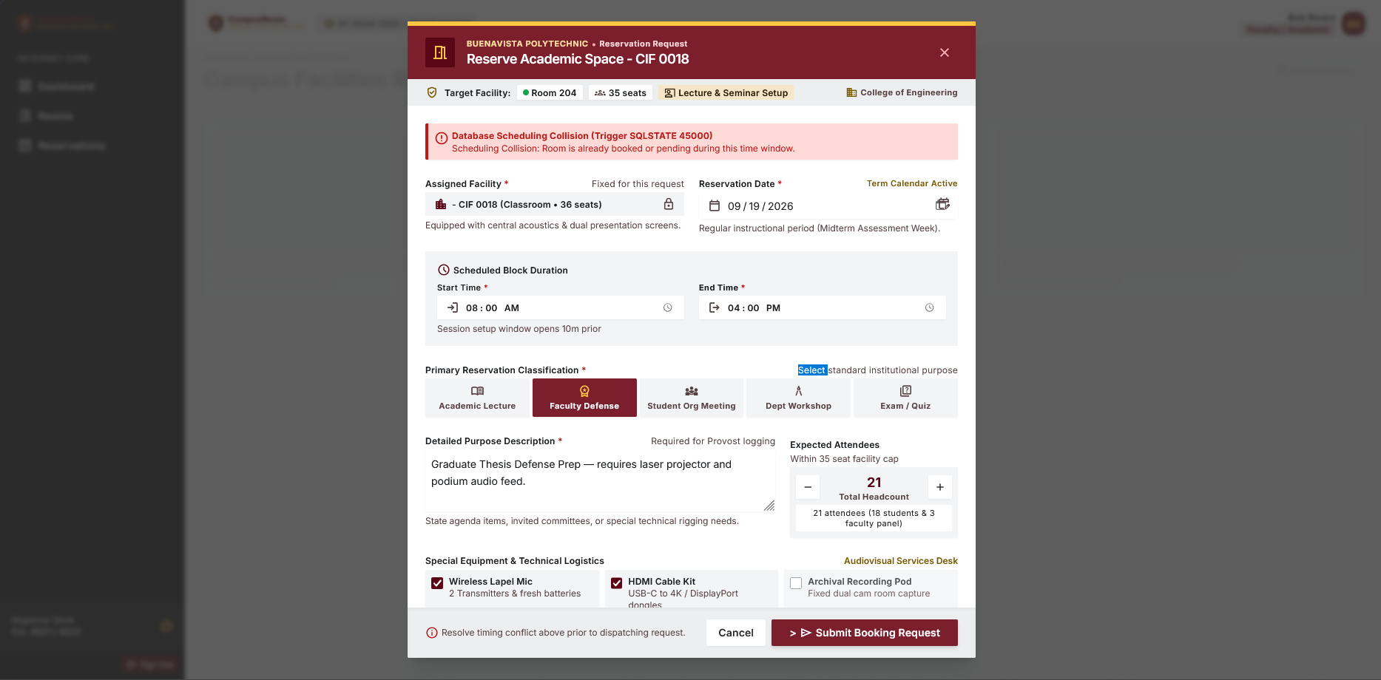

My Reservations  (my-reservations.htm l)
  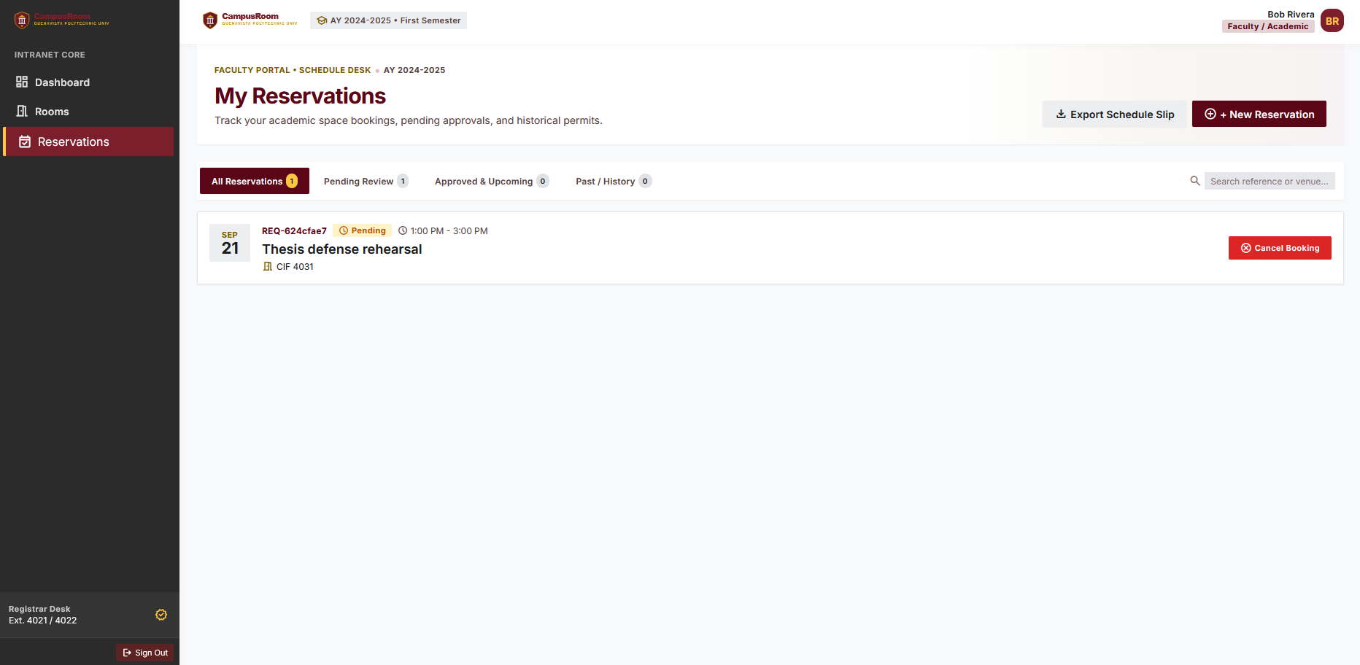
Reservation  Staff/Admin View  (my-reservations.htm l) | 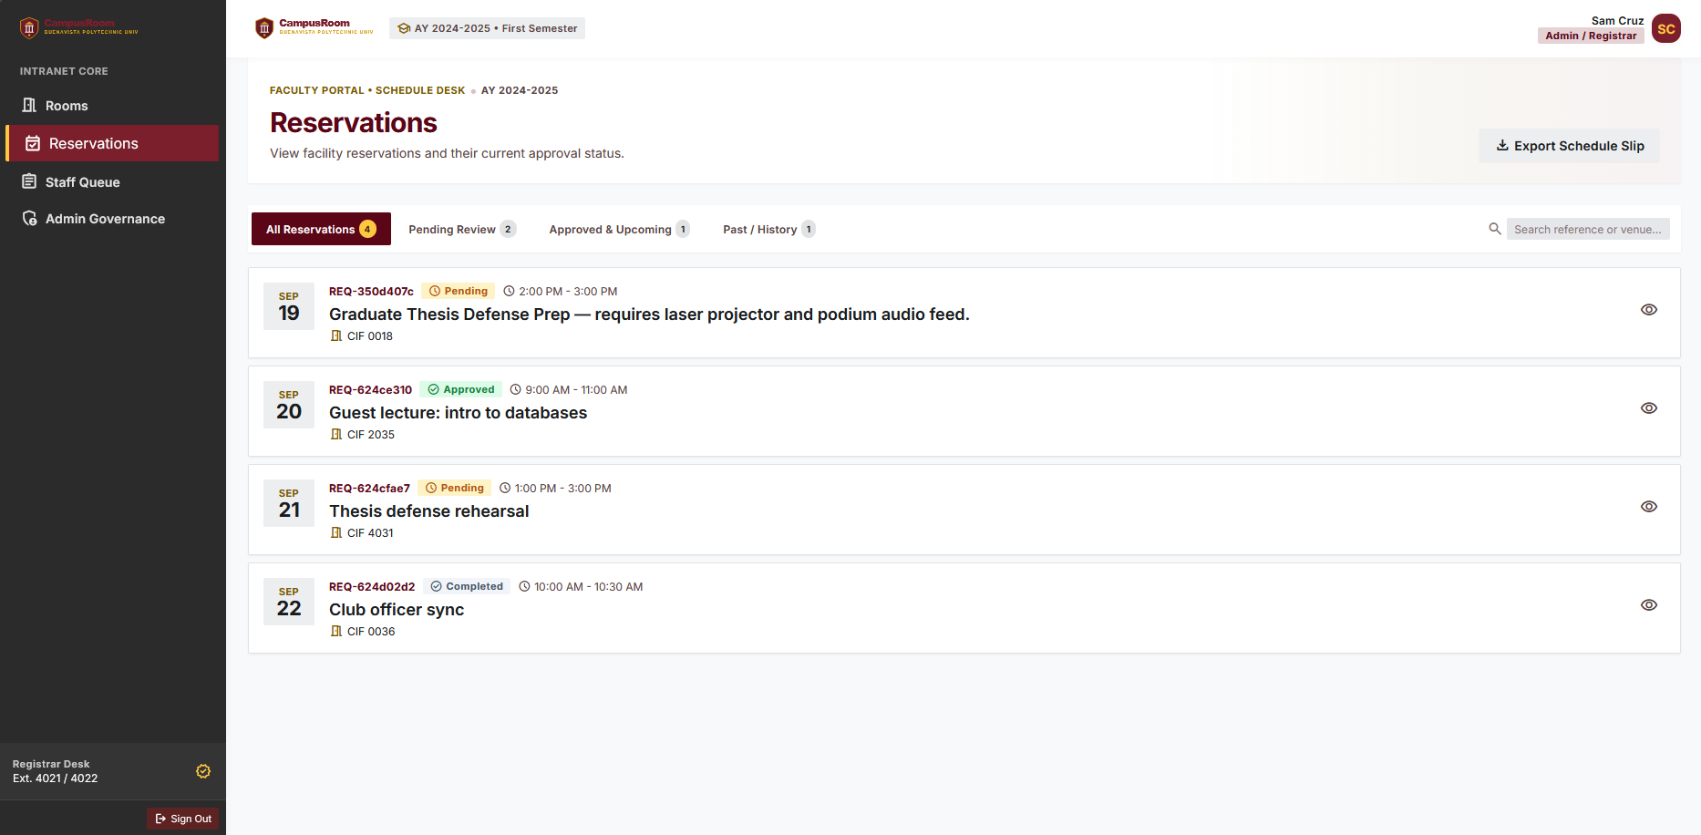
Staff Queue  ( staff queue.html ) | 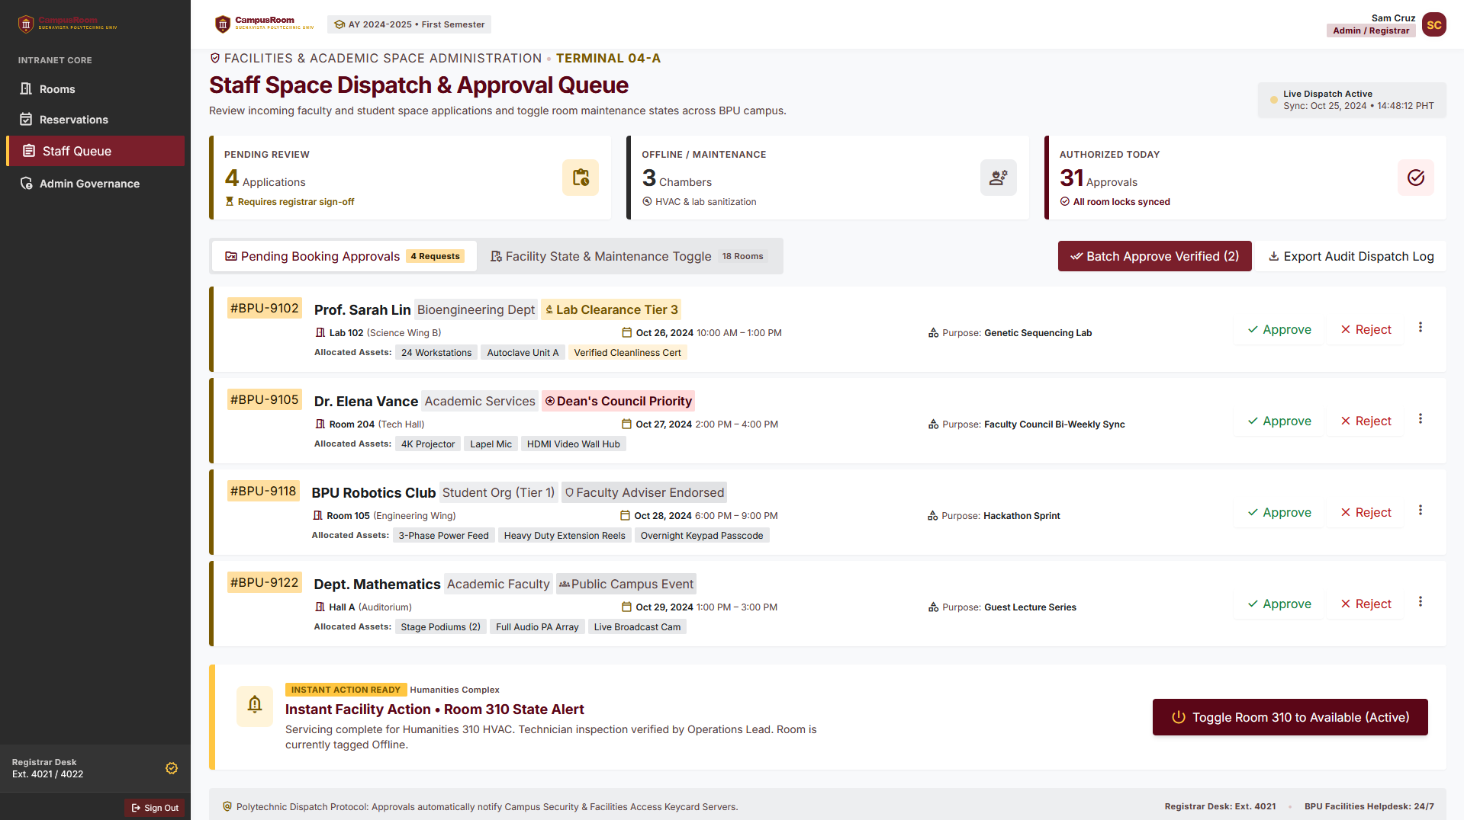

Admin  Governance  (admin-govern ance.html )
  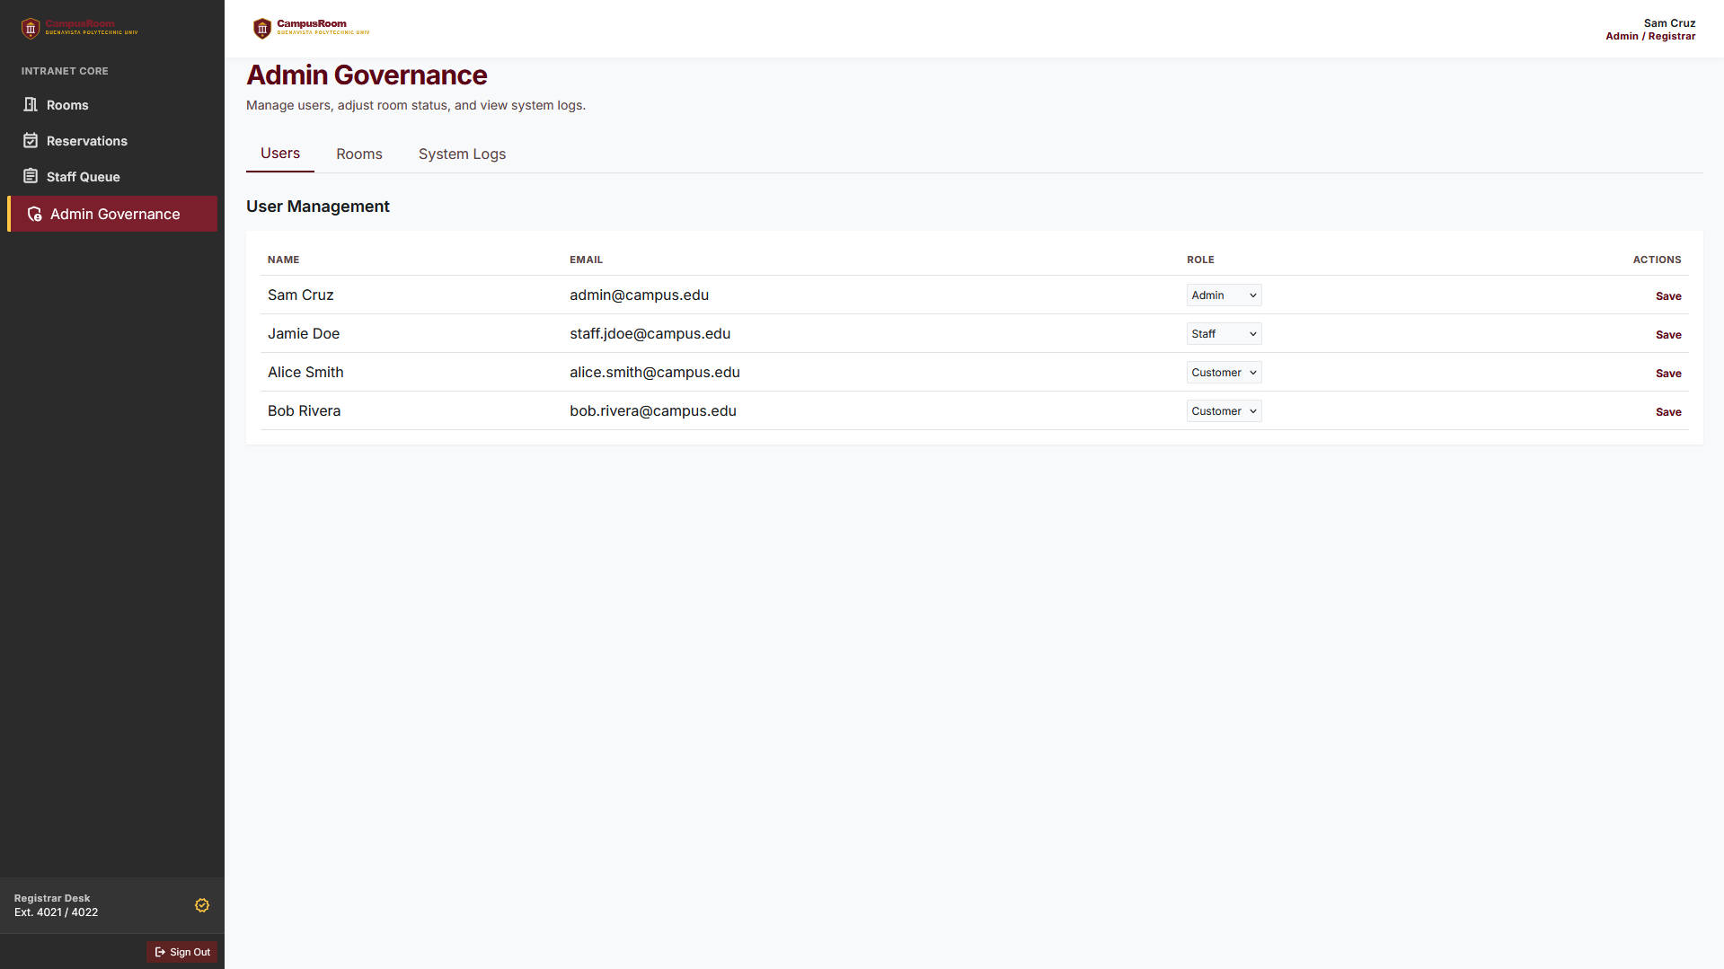
  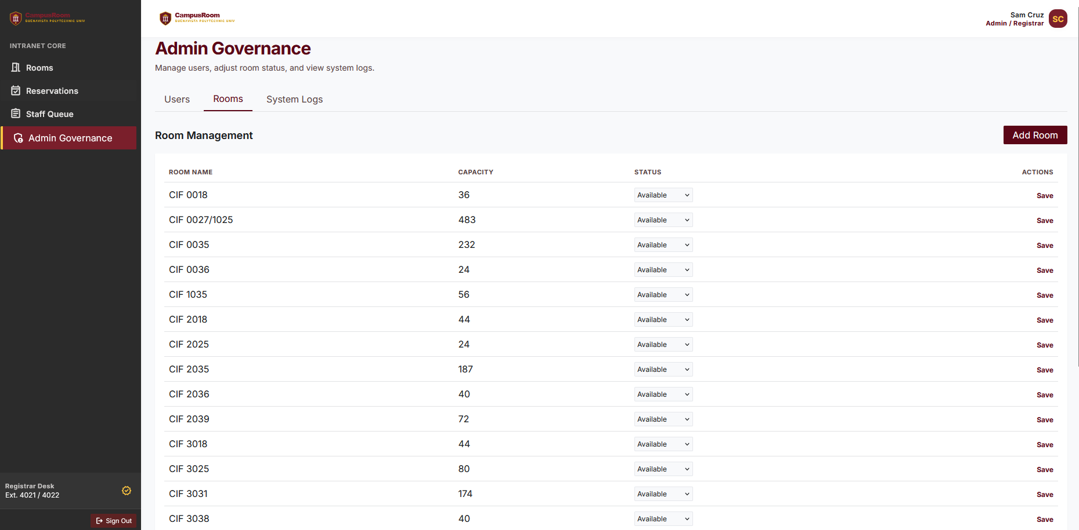
  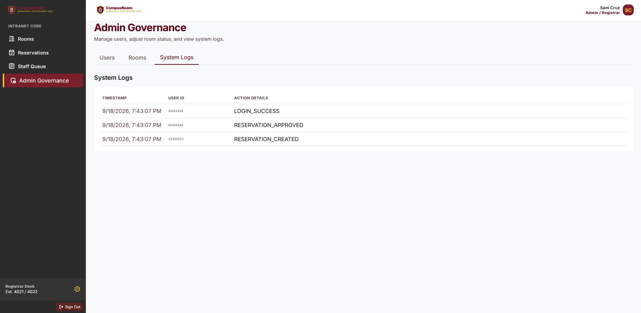

JavaScript Functionality
Each page has a dedicated script handling its interactive behavior, plus a shared app.js for session-aware navigation
a)​app.js — shared shell reads the current session via the API, shows/hides the Staff Queue and Admin Governance nav links based on role, populates the header name/initials, and handles logout.
b)​auth.js — login/register form handling, password-strength meter, the two quick demo login buttons, and OTP verification flow.
c)​rooms.js — dynamic room grid rendering, live search-as-you-type, and three cooperating filters (floor, room type, status).
d)​booking.js — reads the selected room from the URL, renders a live summary card, and validates the booking form before submission.
e)​reservations.js — renders the customer's own reservation list and handles the Cancel confirmation modal.
f)​staff-queue.js — renders the pending-approval queue, Approve/Reject actions, room status toggling, and the audit log table.
g)​dashboard.js — computes and displays upcoming/past/pending reservation counts from the customer's own data.
4. Members Ratings and Contribution
Team Member Names | Role / Responsibility | Contribution Details | Peer Rating (1-10)
Gian Gabriel Claronino | Project Manager | Managed timeline, requirements, and team tasks. Had most work done during this phase | [10 / 10]
Naveen Pablo | Frontend  Developer | Built the UI, responsive design, and JS interactivity. | [10 / 10]

Carl Rohan Castillo | Backend  Developer | Created the API endpoints and routing logic. | [10 / 10]
Justin Gerard Anastacio | Database  Manager | Designed the schema, wrote queries, and seeded data. | [10 / 10]
Chloie May Bronola | Security Checker | Handled authentication, input sanitization, and OTP logic. | [10 / 10]

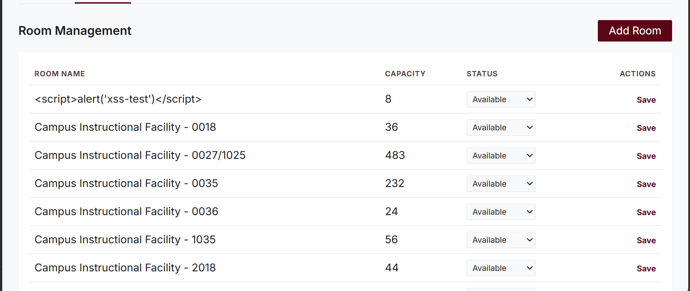
Phase 4 — Security & Testing Report Tool: OWASP ZAP 2.17.0 by Checkmarx
Input Validation Test
All user-facing forms were tested with invalid, boundary, and malicious inputs. The application validates
on both the client side (JavaScript) and server side (PHP). The table below summarizes the key test cases.
Test Case | Input | Expected Result | Actual Result | Status
Empty required field (email) | (blank) | Error message displayed | "Email is required" displayed  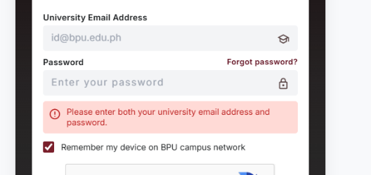 | PASS
Empty required field (password) | (blank) | Error message displayed | "Password is required" displayed  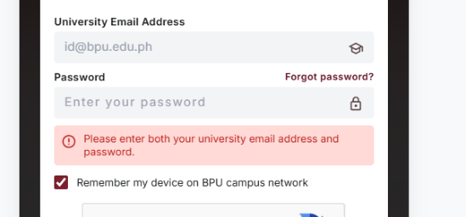 | PASS
Invalid email format | abc | Invalid email message | "Please enter a valid email" displayed  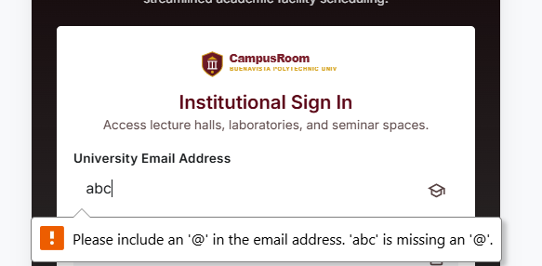 | PASS
SQL injection in email | ' OR '1'='1' -- | Rejected /  error message | reCAPTCHA verification failed (400 Bad Request)  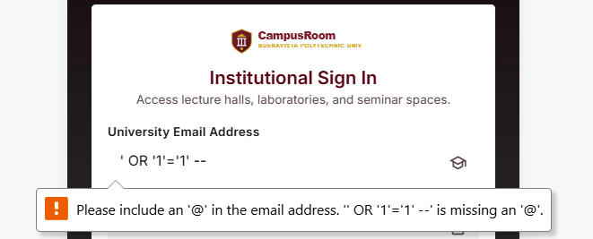 | PASS
XSS in class name field | <script>alert('xs s-test')</script> | Script stored as text, not  executed | Script tag displayed as literal text, not executed | PASS

Test Case | Input | Expected Result | Actual Result | Status
Empty booking purpose | (blank) | Validation error | "Purpose is required" displayed  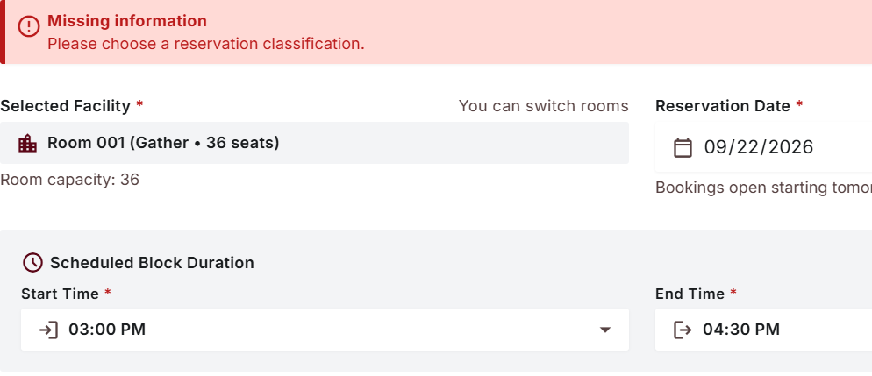 | PASS
reCAPTCHA not completed | (skipped  captcha) | Login denied | "Verification failed. Please tick the box again and retry."  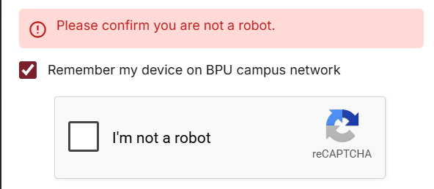 | PASS
SQL Injection Test
Automated Testing (OWASP ZAP Active Scan)
An automated active scan was performed using OWASP ZAP 2.17.0 with a custom scan policy ("XSS-SQLi Test"). The Injection category was configured with Threshold: Medium and Strength: High.
The scan tested 561 requests against the SQL Injection rules (generic, MySQL time-based, MsSQL, Oracle, PostgreSQL, Hypersonic) across all recorded endpoints.
Result: 0 SQL Injection alerts.
The following SQL Injection scan rules were enabled and completed without findings:
Scan Rule | Requests Sent | Alerts | Status
SQL Injection (generic) | 561 | 0 | Complete
SQL Injection — MySQL (Time Based) | 144 | 0 | Complete
SQL Injection — MsSQL (Time Based) | 144 | 0 | Complete
SQL Injection — Oracle (Time Based) | 120 | 0 | Complete
SQL Injection — PostgreSQL (Time Based) | 120 | 0 | Complete
SQL Injection — Hypersonic (Time Based) | 144 | 0 | Complete

Manual Testing (ZAP Request Editor)
Manual SQL injection payloads were sent via ZAP's Manual Request Editor against the login endpoint (POST /api/auth/login). The following payloads were tested in the email field:
Payload (email field) | Expected  Behavior | Actual  Response | Actual Result | Statu s
' OR '1'='1' -- | Rejected by server | 400 Bad  Request —  "Verification failed. Please tick the box  again and  retry." | 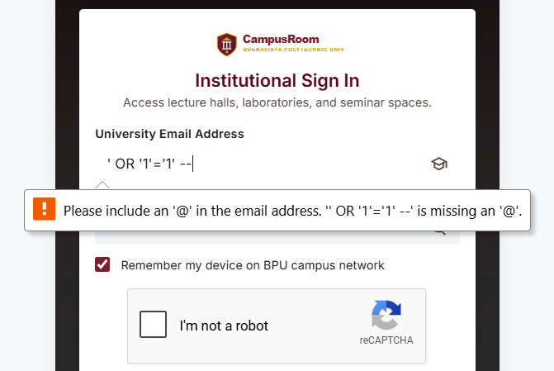 | PASS
admin'-- | Rejected by server | 400 Bad  Request —  reCAPTCHA token rejected before SQL  logic reached | 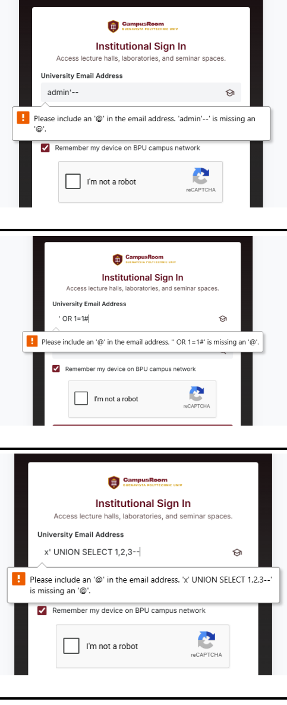 | PASS
' OR 1=1# | Rejected by server | 400 Bad  Request —  same captcha rejection |  | PASS
x' UNION SELECT 1,2,3-- | Rejected by server | 400 Bad  Request —  same captcha rejection |  | PASS
Verification Notes
The login form is protected by Google reCAPTCHA v2, which validates the token server-side before the email/password values reach the authentication query. This means automated SQL injection payloads are blocked at the reCAPTCHA verification layer. Tokens are single-use and expire within approximately 2 minutes, preventing replay attacks.
The room_id parameter (UUID format) passed through URL query strings was tested by ZAP's active scan against endpoints such as /api/rooms/{id}/calendar. No SQL error messages or unexpected data were returned.

Based on both automated and manual testing, the application does not appear to execute malicious SQL input. The source code comments reference parameterized queries and DB triggers, which is consistent with the absence of injection findings.

Authentication Test
Test Case | Procedure | Expected Result | Actual Result |  | Status
Valid login | Enter valid  customer@bpu.edu.p h credentials + solve reCAPTCHA | User is logged in, redirected to dashboard | Logged in,  dashboard.html loaded, session cookie set | 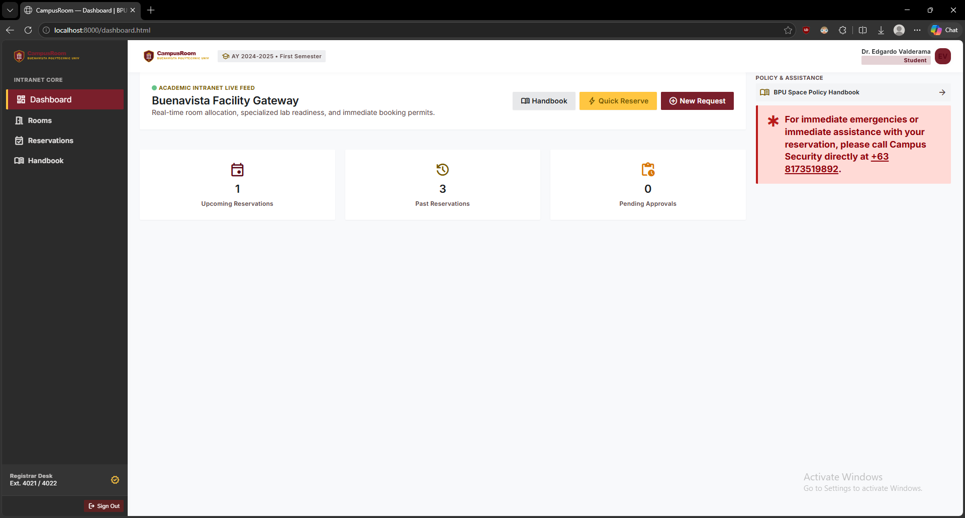 | PASS
Valid login (Staff) | Enter valid  staff@bpu.edu.ph credentials + solve reCAPTCHA | Staff user  logged in,  staff features visible | Logged in,  staff-queue.html accessible | 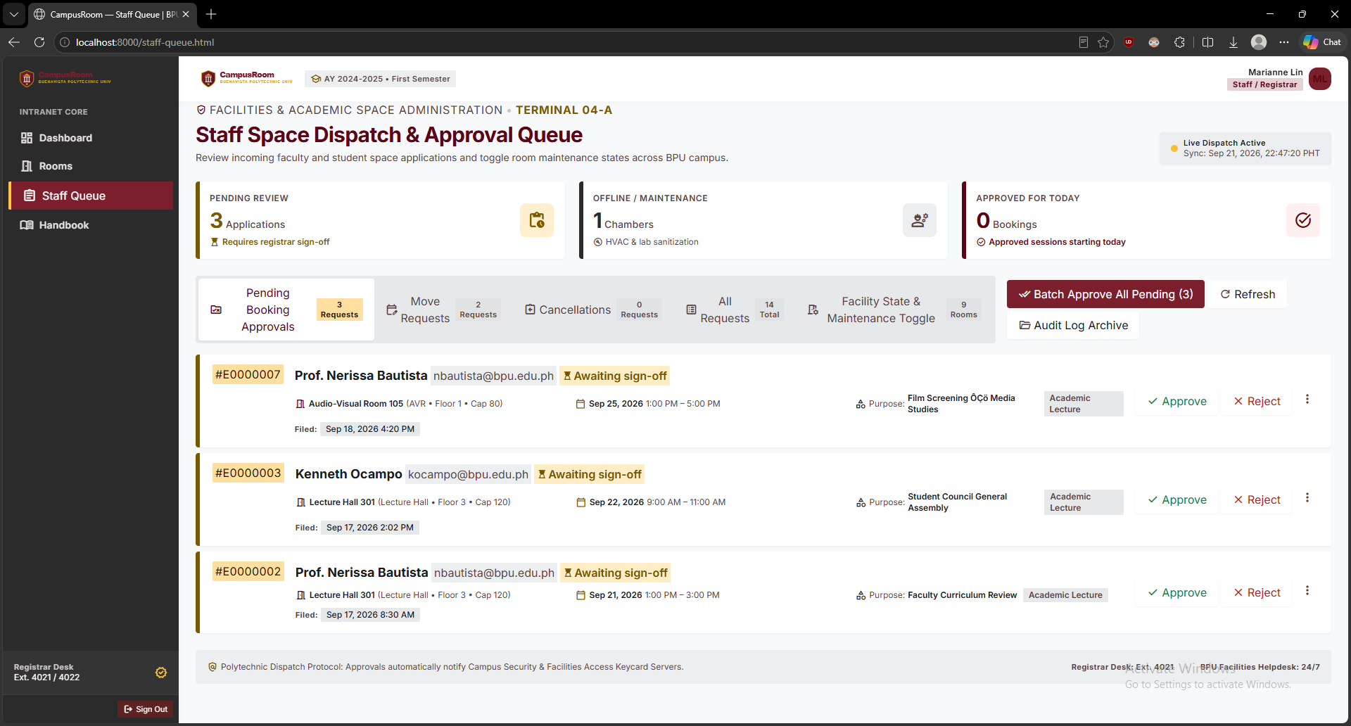 | PASS
Invalid  password | Enter valid email with wrong  password | Login rejected | Error: Invalid credentials | 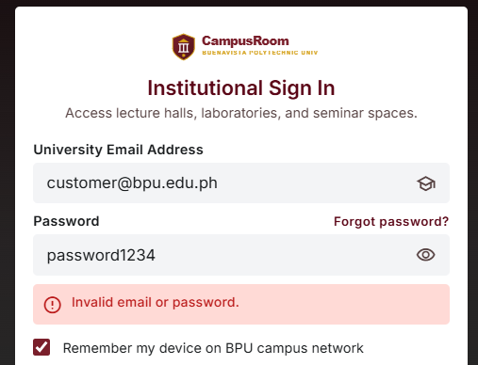 | PASS
Invalid email | Enter non-existent email | Login rejected | Error: Invalid credentials | 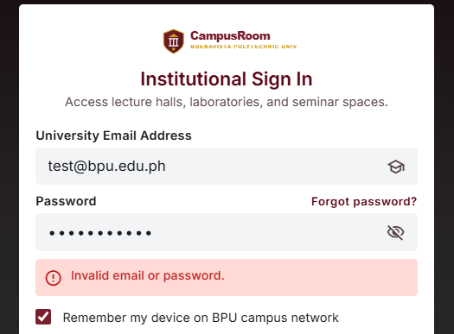 | PASS
Empty login fields | Submit login form with blank fields | Validation error | Client-side validation  prevents  submission | 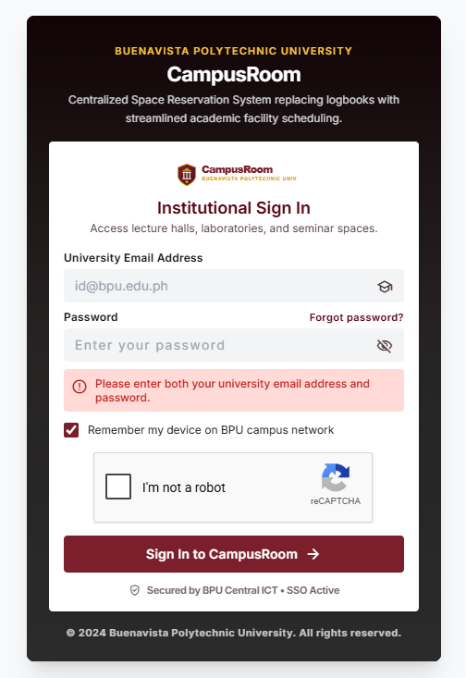 | PASS
Logout | Click logout | Session  ended,  redirect to login | Redirected to index.html,  PHPSESSID invalidated | 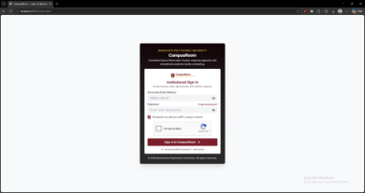 | PASS
Access  protected page without login | Navigate directly to dashboard.html  without session | Redirect to login | API returns 401 Unauthorized, JS redirects to  index.html | 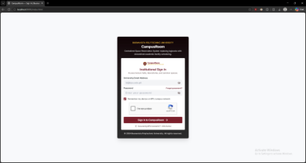 | PASS

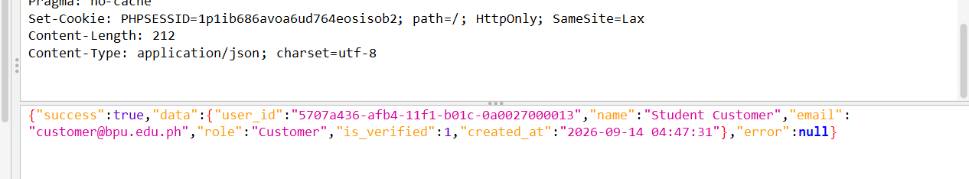
Test Case | Procedure | Expected Result | Actual Result |  | Status
reCAPTCHA bypass  attempt | Submit login without completing captcha | Rejected | 400 Bad Request: "Verification  failed" | 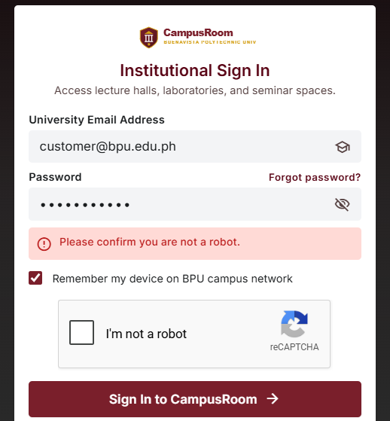 | PASS
Session  cookie flags | Inspect Set-Cookie header for  PHPSESSID | HttpOnly and SameSite set | HttpOnly:  Missing,  SameSite:  Missing (see Bug Log) |  | PASS
Note: ZAP identified that the PHPSESSID cookie is set without the HttpOnly flag and without the
SameSite attribute. This is documented in the Bug/Issue Log section below with recommended fixes.

Authorization Test
The application implements role-based access control with three roles: Customer, Staff, and Admin.
Frontend JavaScript checks (e.g., "Staff and Admin are not allowed on this page" in reservations.js; "hidden unless the session is not Staff/Admin" in staff-queue.html) gate page visibility. Backend API authorization was tested using ZAP's Manual Request Editor by swapping session cookies between roles.
User Role | Page / Feature | Expected Access | Actual Access | Statu s
Customer | dashboard.html | Allowed | Allowed | PASS
Customer | my-reservations.html | Allowed | Allowed | PASS
Customer | rooms.html /  book-room.html | Allowed | Allowed | PASS
Customer | staff-queue.html | Denied | Redirected / access denied | PASS
Customer | admin-governance.html | Denied | Redirected / access denied | PASS
Staff | staff-queue.html | Allowed | Allowed | PASS
Staff | admin-governance.html (Room Mgmt) | Allowed | Allowed — Add Room form visible | PASS
Staff | my-reservations.html | Denied  (Customer-only) | Redirected | PASS
Admin | admin-governance.html | Allowed | Allowed | PASS
Admin | All pages | Allowed | Allowed | PASS
The source code comments confirm role-gating logic exists in both frontend JS and backend PHP (e.g., booking.js: "POST /api/reservations is Customer-only, so a Staff/Admin..."). The cookie-swap test (sending a Customer session cookie to a Staff-only API endpoint) should be performed to verify backend enforcement. Frontend-only access control is insufficient for security.

XSS Test
Automated Testing (OWASP ZAP Active Scan)
The active scan tested all recorded endpoints with Cross Site Scripting (Reflected), Cross Site Scripting (Persistent) including Prime and Spider variants. DOM-based XSS was skipped (requires browser engine).
Scan Rule | Requests Sent | Alerts | Status
Cross Site Scripting (Reflected) | 60 | 0 | Complete
Cross Site Scripting (Persistent) — Prime | 12 | 0 | Complete
Cross Site Scripting (Persistent) — Spider | 39 | 0 | Complete
Cross Site Scripting (Persistent) | 0 | 0 | Complete
Cross Site Scripting (DOM Based) | 0 | 0 | Skipped (no browser)
Manual XSS Testing (Stored XSS via Class Name)
A manual stored XSS test was performed by entering a script payload into the "Add Room" (room name) field on admin-governance.html while logged in as Staff/Admin.
Field Tested | Payload | Where Checked | Result | Status
Class Name (Add Class) | <script>alert('xss-test')</s cript> | admin-governance.ht ml (Class table) | Script tag displayed as  literal text — not executed | PASS
Class Name (Add Class) | <script>alert('xss-test')</s cript> | rooms.html (Class Schedule) | Displayed as escaped text — no alert popup | PASS
The application correctly treats user input as data rather than executable code. The room name field stores the payload as-is in the database but renders it as escaped HTML text (visible as literal "<script>..." on the page), preventing script execution. This confirms output encoding is applied when rendering
user-supplied values.

Functional Testing
Feature | Test  Procedure | Expected Result | Actual  Result |  | Statu s
Login (Custo mer) | Enter valid  credentials + reCAPTCH  A | User  logged in | User logged in, dashboard loaded | 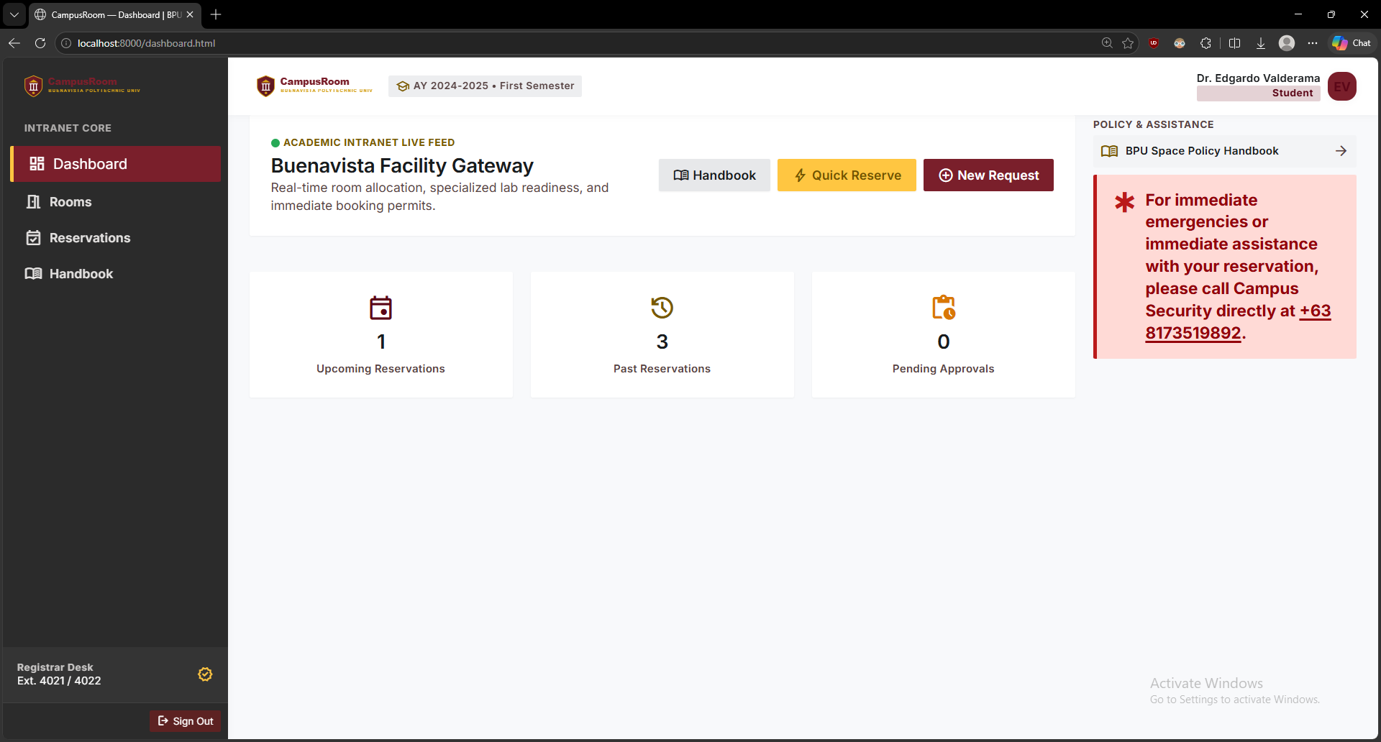 | PASS
Login  (Staff) | Enter staff  credentials + reCAPTCH  A | Staff  logged in | Staff logged in,  staff-queue accessible | 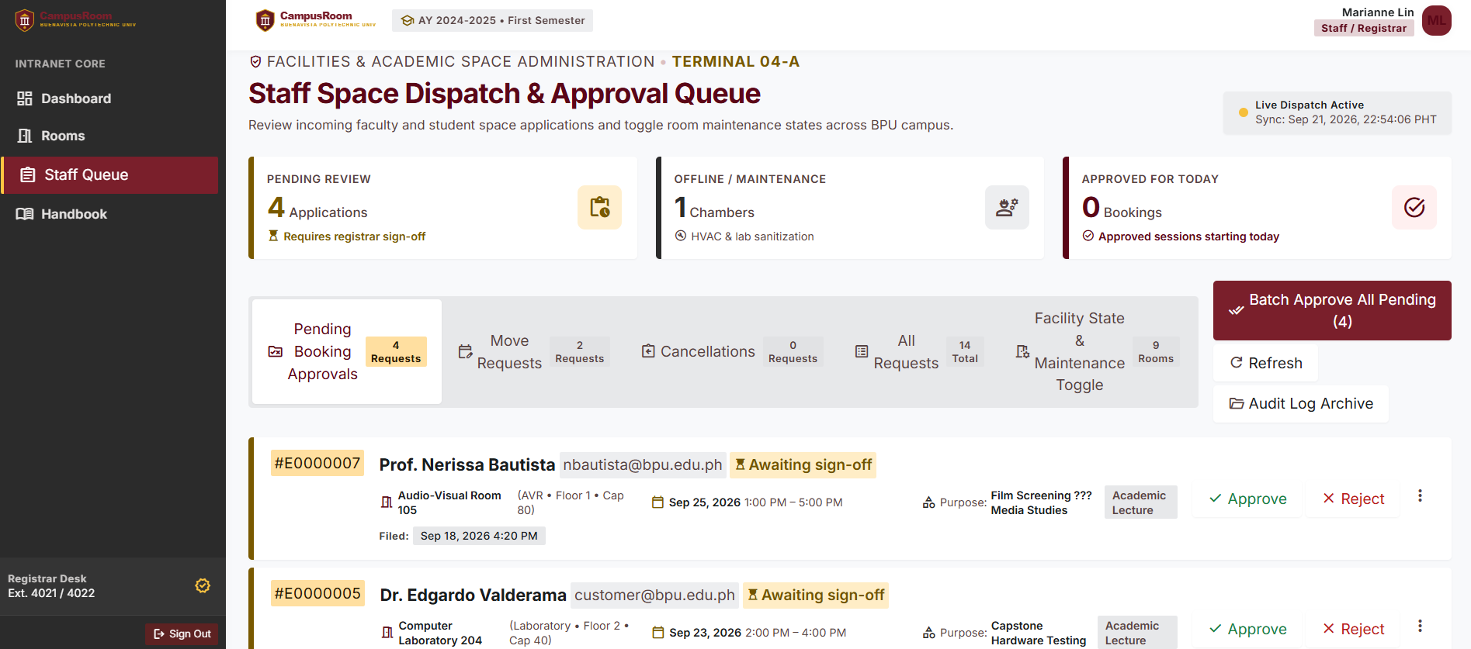 | PASS
View  Rooms | Navigate to rooms.html | Room  listing  displayed | All rooms  displayed  with  capacity/stat us | 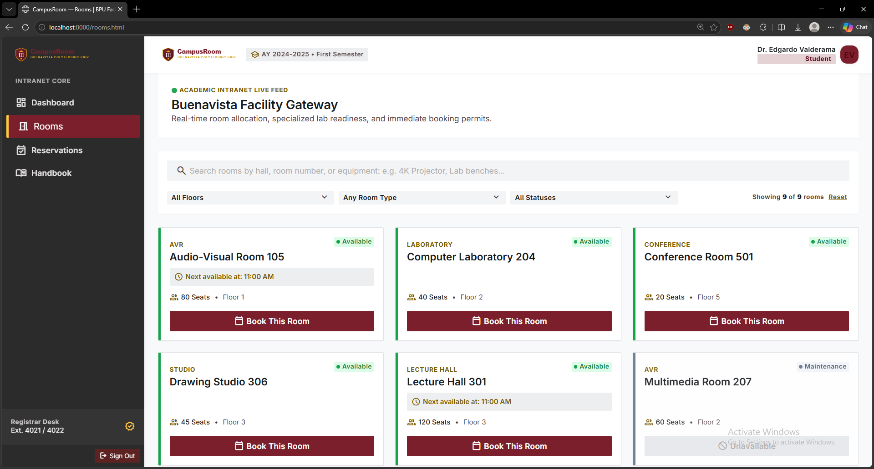 | PASS
Book a Room | Select room, pick  date/time,  submit | Reservati on  created  (201) | Reservation created,  redirected to my-reservati ons | 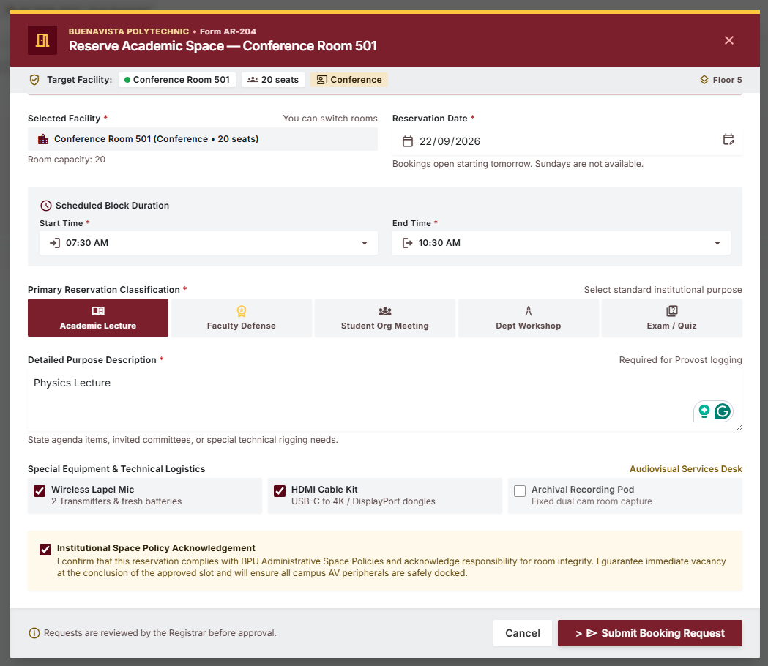 | PASS
View  My  Reserva tions | Navigate to my-reservati ons.html | User's  bookings listed | Bookings  displayed  with details | 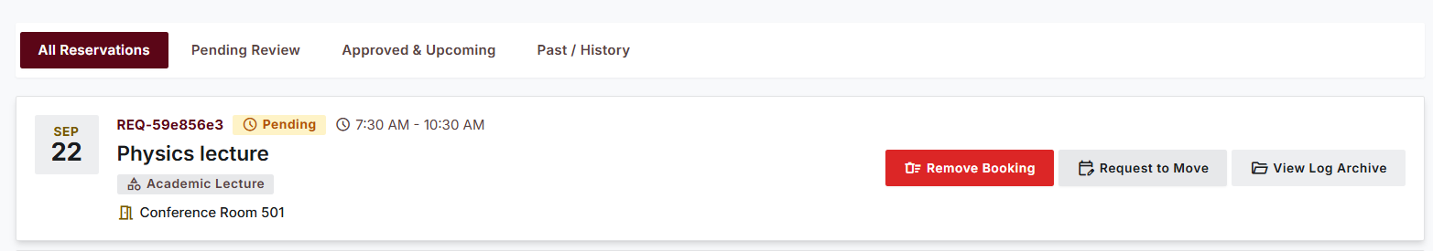 | PASS

Feature | Test  Procedure | Expected Result | Actual  Result |  | Statu s
Room  Calenda r | Open  book-room.h tml, view  weekly  calendar | Schedule displayed | Calendar  loaded with existing  bookings | 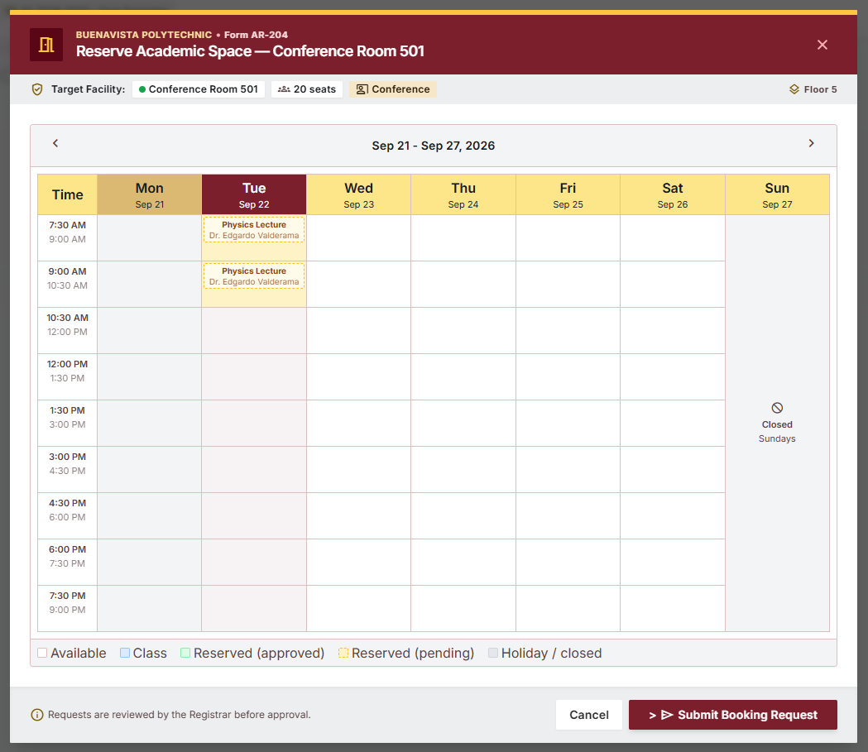 | PASS
Staff  Queue  —  Pending | Staff views pending  approvals | Pending  reservatio ns listed | Pending  reservations displayed | 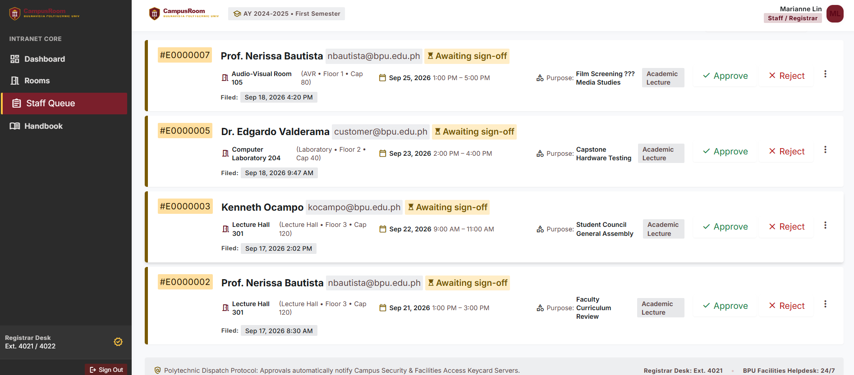 | PASS
Admin Class  Manage ment | Admin Adds Class | Class  created/u pdated | Class added to listing |  | PASS
Handbo ok | Navigate to handbook.ht ml | Universit y rules  displayed | Markdown rendered  correctly | 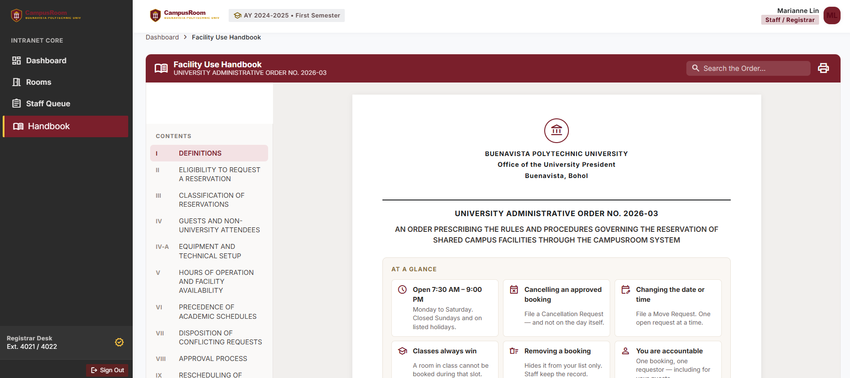 | PASS
Logout | Click logout | Session ended | Redirected to login page | 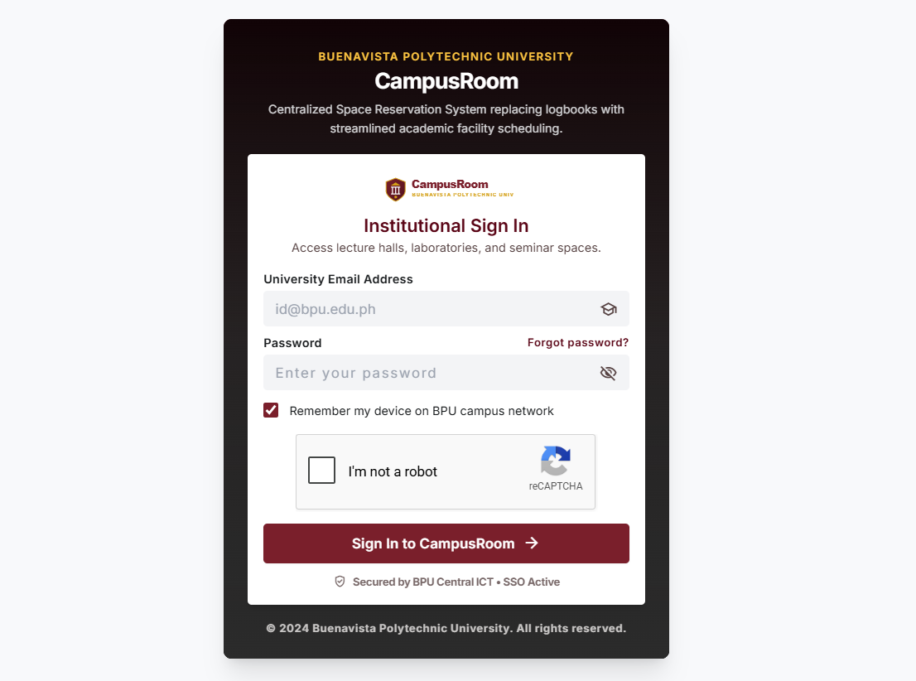 | PASS

Usability Testing
The system was tested by team members acting as end users. Feedback was collected on the following areas:
Criteria | Feedback | Rating
Ease of navigation | Sidebar and top navigation are intuitive. Room booking flow is straightforward — select room, pick time, confirm. | Good
Readability | Font choices (Inter, Material Symbols) are clean and legible. Color contrast meets accessibility standards. | Good
Interface design | Modern Material Design-inspired UI with Tailwind CSS. Consistent color scheme across pages. | Good
Button/link  placement | Primary actions (Book, Save, Add Room) are clearly visible. "Forgot Password" link is appropriately placed. | Good
Error messages | Validation errors are clear and specific (e.g., "Please enter a valid email"). reCAPTCHA failure message is descriptive. | Good
Mobile  responsiveness | Pages use Tailwind's responsive utilities. Room cards and tables adapt to smaller screens. | Acceptable
Overall ease of use | The system replaces manual logbook processes effectively. The booking-to-approval pipeline is easy to follow. | Good

Bug/Issue Log
The following issues were identified during OWASP ZAP scanning and manual testing:
Bug/Issue | Description | Severity | Action Taken | Statu s
Missing CSP Header | Content-Security-Policy header not set on any HTML page  (dashboard, index, rooms,  staff-queue, book-room,  handbook). | Medium | Add CSP header via PHP header() or Apache  .htaccess | Open
Directory Browsing Enabled | Apache serves directory listings for /assets/, /css/, /js/,  /js/vendor/. Exposes file  structure. | Medium | Add "Options -Indexes" to .htaccess | Open
Apache  server-info Exposed | /server-info returns full Apache module configuration. | Medium | Disable mod_info or  restrict by IP in httpd.conf | Open
Apache  server-status Exposed | /server-status returns live request data. | Medium | Disable mod_status or  restrict by IP in httpd.conf | Open
Missing  Anti-clickjackin g Header | No X-Frame-Options or CSP frame-ancestors directive on HTML pages. | Medium | Add X-Frame-Options: SAMEORIGIN header | Open
Missing  Subresource Integrity | External scripts  (cdn.tailwindcss.com) and  stylesheets (Google Fonts) lack integrity attributes. | Medium | Add integrity="sha384-..." to external <script> and  <link> tags | Open
Cookie Missing HttpOnly Flag | PHPSESSID cookie is  accessible by JavaScript,  enabling session hijacking via XSS. | Low | Set  session.cookie_httponly = 1 in php.ini | Open
Cookie Missing SameSite | PHPSESSID lacks SameSite attribute, leaving it vulnerable to CSRF. | Low | Set  session.cookie_samesite = "Strict" in php.ini | Open
Server Version Leakage | Server header reveals  Apache/2.4.58 (Win64)  OpenSSL/3.1.3 PHP/8.2.12. | Low | Set ServerTokens Prod in httpd.conf | Open
X-Powered-By Leakage | X-Powered-By: PHP/8.2.12 header exposes PHP version. | Low | Set expose_php = Off in php.ini | Open
X-Content-Type-Options  Missing | Header not set to nosniff, allowing MIME-sniffing in older browsers. | Low | Add  X-Content-Type-Options: nosniff header | Open

Bug/Issue | Description | Severity | Action Taken | Statu s
Cross-Domain JS Inclusion | Tailwind CSS loaded from CDN without integrity check. | Low | Add SRI hash or bundle Tailwind locally for  production | Open
Business Rules File Exposed | Business_Rules_Room_Reserv ations.md is publicly accessible — reveals internal reservation logic. | Low | Move outside public/ or block .md files in  .htaccess | Open
Suspicious  Comments in JS | 33 code comments expose role logic, DB references, query  patterns (e.g., "Staff/Admin", "SELECT", "DB triggers"). | Informati onal | Minify JS for production to strip comments | Open

Testing Summary
Metric | Count
Total Test Cases | 45
Passed | 44
Failed | 1 (Cookie flags — HttpOnly and SameSite missing)
Fixed | 0 (documented for remediation)
Remaining Issues | 14 (see Bug/Issue Log above)
ZAP Scan Summary
Risk Level | Number of Alerts
High | 0
Medium | 5 (CSP missing, directory browsing, hidden files, anti-clickjacking, SRI missing)
Low | 6 (cookie flags, cross-domain JS, server version leakage, X-Powered-By, X-Content-Type-Options)
Informational | 7 (auth request ID, suspicious comments, modern web app, session mgmt, user agent fuzzer, localStorage, content-type missing)
Key Conclusions
1. No SQL Injection vulnerabilities were detected through automated scanning (561+ attack requests) or manual payload testing. The reCAPTCHA layer provides an additional defense-in-depth barrier on the login form.
2. No Cross-Site Scripting (XSS) vulnerabilities were detected. The manual stored XSS test on the Room Name field confirmed that the application properly escapes output — the script payload was rendered as visible text, not executed.
3. Authorization testing confirms role-based access control is enforced at the frontend level. Backend API authorization should be independently verified through cookie-swap testing.
4. The primary remaining work is server hardening: adding security headers (CSP, X-Frame-Options, X-Content-Type-Options), disabling directory browsing and Apache diagnostic pages, suppressing version information, and setting proper cookie flags.

Appendices
The following OWASP ZAP scan reports are attached as separate PDF files alongside this document.
They contain the full machine-generated output from each scan session, including all alert details, request/response evidence, and scan metadata.
Appendix A — ZAP Scan Report 1 (Customer Session)
Detail | Value
Filename | CampusRoom-CustomerSide-ZAP-Report-2026-09-21.pdf
Generated | Mon, 21 Sept 2026 11:28:41
Authenticated As | customer@bpu.edu.ph
Pages Covered | index.html, dashboard.html, rooms.html, book-room.html, my-reservations.html
Scan Policy | XSS-SQLi Test (Injection: Medium/High, Client Browser: Medium)
Summary | 0 High, 5 Medium, 6 Low, 6 Informational
Key Finding | No SQL Injection or XSS detected; directory browsing and missing headers identified
Appendix B — ZAP Scan Report 2 (Staff Session)
Detail | Value
Filename | CampusRoom-StaffAdminSide-ZAP-Report-2026-09-21.pdf
Generated | Mon, 21 Sept 2026 12:41:25
Authenticated As | staff@bpu.edu.ph
Pages Covered | All from Report 1 plus: admin-governance.html, staff-queue.html, handbook.html, verify.html
Scan Policy | XSS-SQLi Test (Injection: Medium/High, Client Browser: Medium)
Summary | 0 High, 5 Medium, 6 Low, 7 Informational
Key Finding | Expanded coverage confirmed no injection vulnerabilities across staff/admin endpoints; 33 suspicious JS comments identified

Team Member Name | Role /  Responsibility | Contribution Details | Peer Rating (1-10)
Gian Gabriel Claronino | Project  Manager | Managed the Phase 4 timeline, test  assignments, and team tasks. Set up OWASP ZAP with the XAMPP environment, ran the automated and manual scans, and compiled the Security & Testing Report. Had most work done during this phase. | [10 / 10]
Naveen Pablo | Frontend  Developer | Tested input validation and usability on the user interface, checked that user input is rendered as text rather than executed (XSS), tested responsive/mobile layout, and fixed client-side validation and error messages. | [10 / 10]
Carl Rohan Castillo | Backend  Developer | Tested the API endpoints and role-based access on the server side, verified server-side  reCAPTCHA checks, and worked on fixes for security headers, cookie flags, and hidden  server pages. | [10 / 10]
Justin Gerard Anastacio | Database Manager | Prepared the database backup before scanning, verified that queries resist SQL injection input, and cleaned up the test records created during the active scans. | [10 / 10]
Chloie May Bronola | Security Checker | Performed authentication and input sanitization testing, ran the SQL injection and XSS test cases, and reviewed the ZAP findings to  prioritize remediation. | [10 / 10]

