D1_Nihar_84066

ASSIGNMENT 11

1. D1_nihar_84066>select * from ORDERS where cnum=(select cnum from CUSTOMERS where cname='Cisneros');
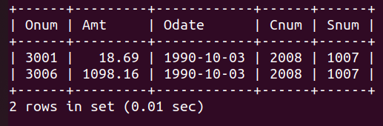

2. D1_nihar_84066>select Cname,Rating from CUSTOMERS where Cnum IN (select Cnum from ORDERS where Amt>(select avg(Amt) from ORDERS));

