D1_Nihar_84066
ASSIGNMENT 14

1. D1_nihar_84066>insert into SALESPEOPLE values(1100,'Blanco','San Jose', NULL);
Query OK, 1 row affected (0.01 sec)

D1_nihar_84066>select * from SALESPEOPLE;

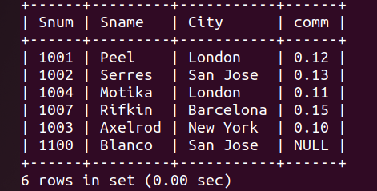

2. D1_nihar_84066>delete ORDERS from ORDERS,CUSTOMERS where CUSTOMERS.Cnum=ORDERS.Cnum and Cname='clemens';
Query OK, 2 rows affected (0.01 sec)

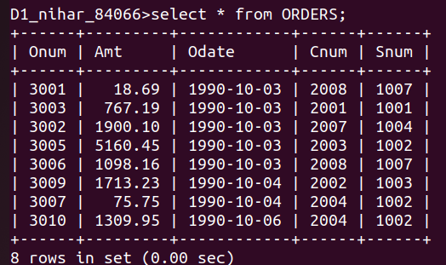

3. D1_nihar_84066>update CUSTOMERS set Rating=(Rating+100) where City='Rome';
Query OK, 2 rows affected (0.00 sec)
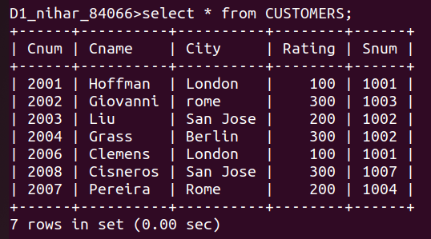

4. D1_nihar_84066>update CUSTOMERS set Snum=(select Snum from SALESPEOPLE where Sname='Motika') where Snum=(select Snum from SALESPEOPLE where Sname='Serres');
Query OK, 2 rows affected (0.00 sec)

