Linux Commands Assignments - II
1. List the directory contents date wise sorted. ( man ls).
Answer :
- Newest first (descending by time):
Bash : ls -lt
- Oldest first (ascending by time):
Bash: ls -ltr
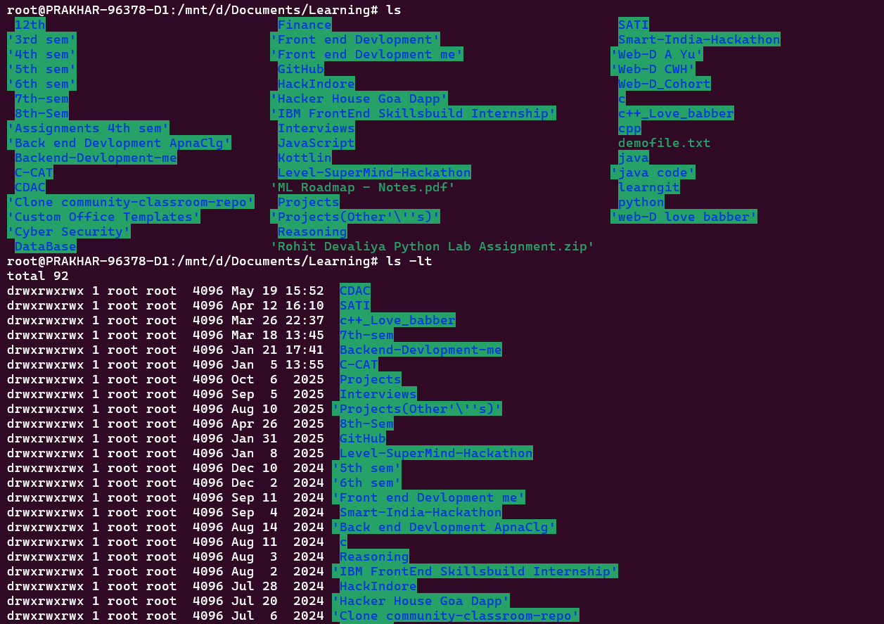
2. List the directory contents size wise sorted.(man ls).
Answer :
- Largest first (descending by size):
Bash : ls -lS
- Smallest first (ascending by size):
Bash : ls -lSr

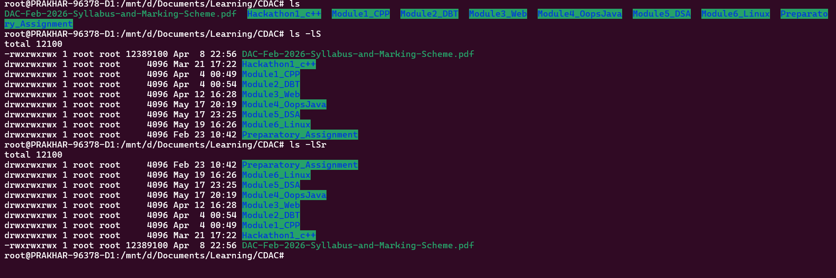

3. List directory contents along with their inode no. (man ls).
Answer: Bash : ls -li
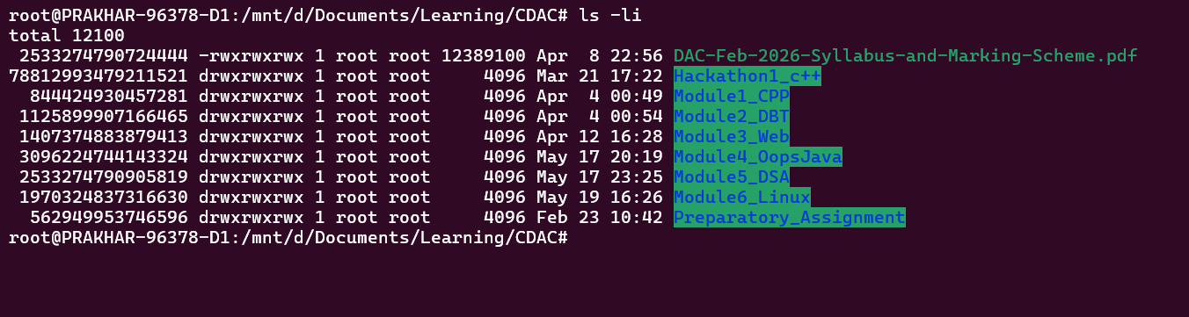

4. List the contents of the subdirectory.
Answer : ls subdirectory_name/
Bash : ls Module1_CPP/
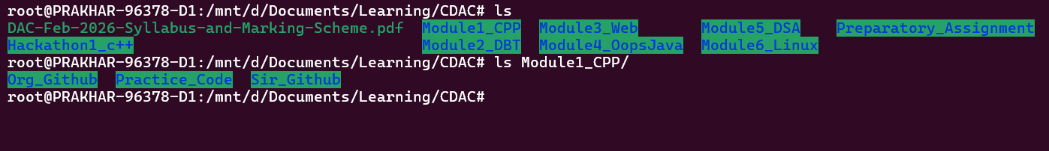
5.1 Create a file, write your surname and name in it and save.
Answer: Bash : touch myfile.txt
Bash : myfile.txt
Bash : cat myfile.txt
Prakhar Vishwakarma

5.2 : now open the same file and add your address in it and save.
Bash : echo "Indore, Madhya Pradesh" >> myfile.txt
5.3 : reopen the same file and check your name and address in it.
Bash : cat myfile.txt
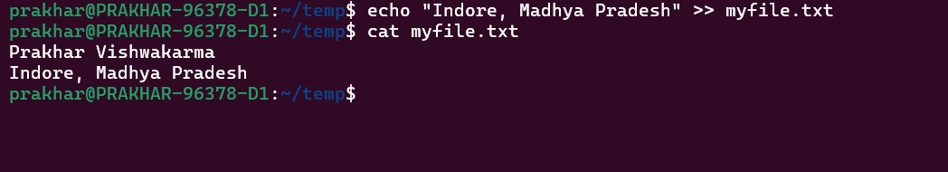

6. how to change the time stamp of file (man touch).
Answer : 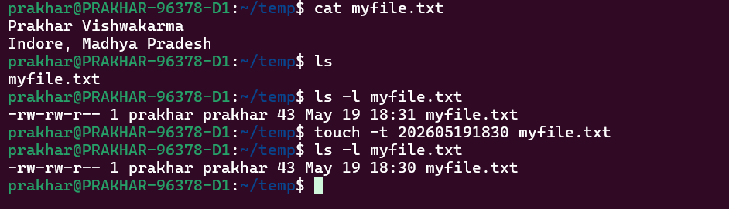

7. Create directory structure : Give following commands.
Answer:
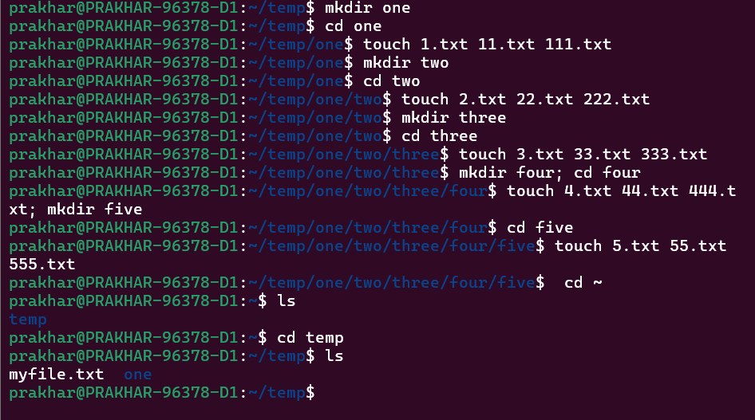

8. Considering above directory structure , Do following operations :
i.) list the directory contents of directory named "five" from current directory (i.e. home directory).
Answer : ls ~/temp/one/two/three/four/five
ii.) write your name in a file named "44.txt" of directory "four" from current directory.
Answer : echo "Prakhar Gupta" >> ~/temp/one/two/three/four/44.txt
cat ~/temp/one/two/three/four/44.txt

iii.) remove the file named "555.txt" from directory "five" from current directory.
Answer : rm ~/temp/one/two/three/four/five/555.txt
ls ~/temp/one/two/three/four/five

iv.) change directory to five ( i.e. cd one/two/three/four/five/ ).
Answer : cd ~/temp/one/two/three/four/five/

v.) write your course name in file named "3.txt" which resides in directory "three" from current directory (i.e. five).also read the same file.
Answr : echo "PGCP-AC (CDAC)" > ../../3.txt
cat ../../3.txt
vi.) list the contents of directory "two" from current directory (i.e. five).
Answer : ls ~/temp/one/two
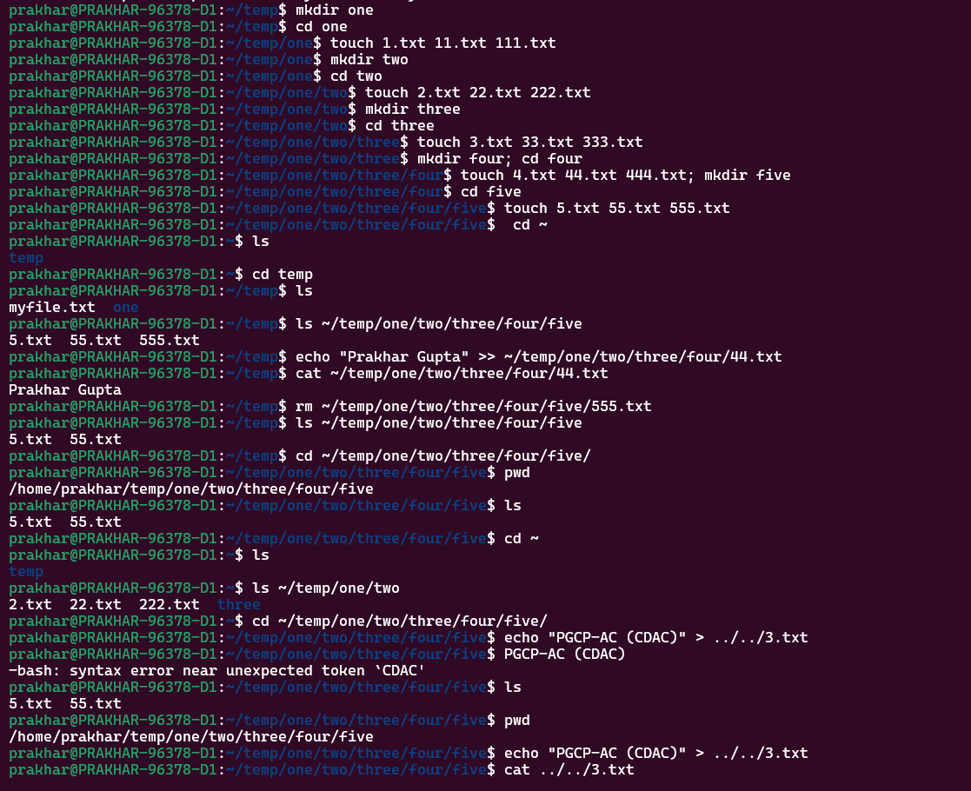

vii.) remove file named "222.txt" which belongs to directory "two" from current directory (i.e. five).
Answer: rm ../../../222.txt
ls ../../../

viii.) now change the directory to "one".
Answer: cd ../../../../

ix. remove all files only from directory named "five" from current directory (i.e. one).
Answer: rm ~/temp/one/two/three/four/five/*

x. remove directory named "five" from current directory (i.e. one)
Answer : rmdir ~/temp/one/two/three/four/five

xi. remove whole directory named "four" from current directory (i.e. one).
Answer: rm -r ~/temp/one/two/three/four

xii. change to your home directory.
Answer : cd ~
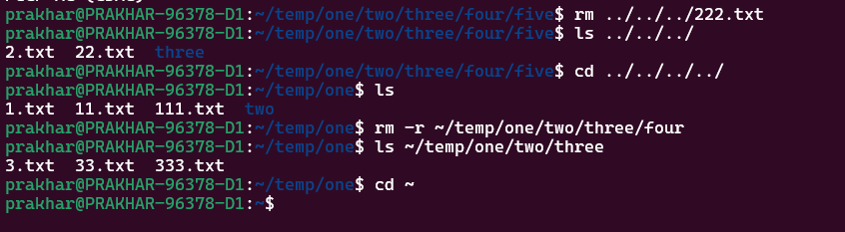
9. change the time stamp of file named "3.txt" which resides in directory named "three".(man touch) .
Answer : 