- Create an index that will enable a user to pull orders for ‘1990-10-03’ out of the Orders table quickly.
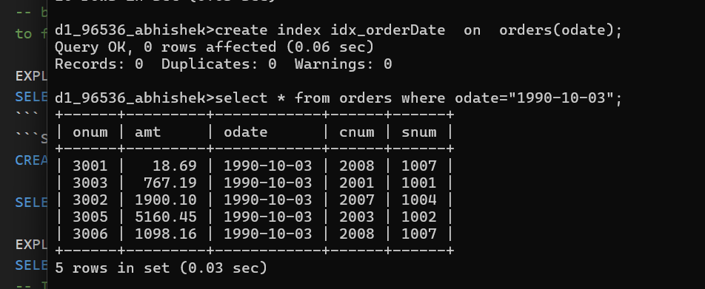
- 2. If the Orders table has already been created, how can you force the onum field to be unique (assume all current values are unique)?
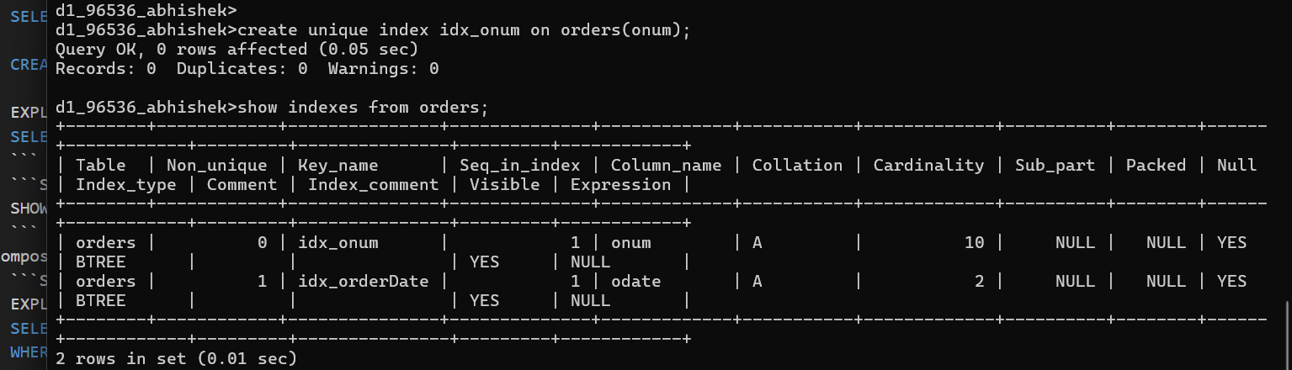
- Create an index that would permit salesperson to retrieve his orders.
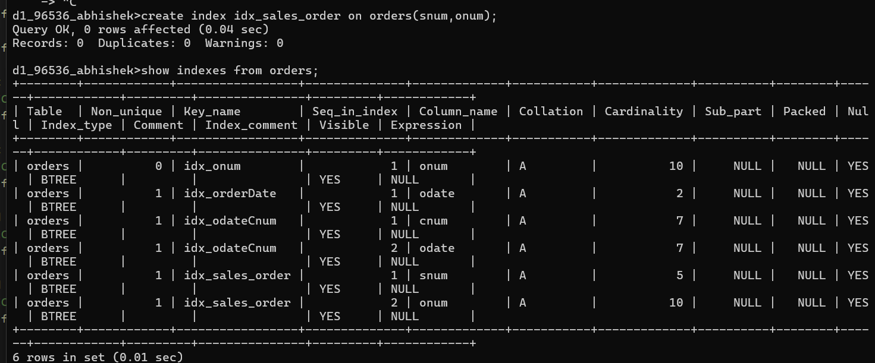

- Let us assume that each salesperson is to have only one customer of a given rating, and this is currently the case. Create an index that enforces it.
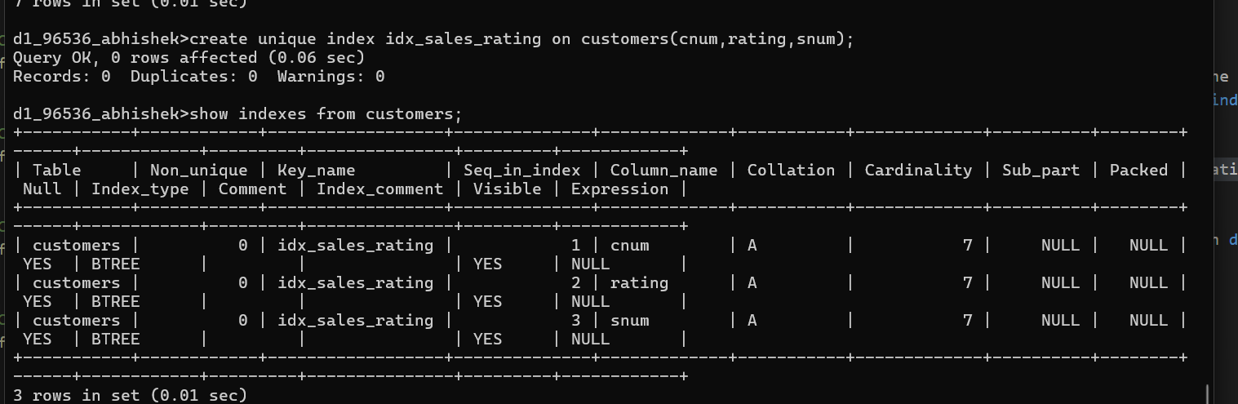

- Create an index to speed up searching order on a given date by given customer.
