- Create a new database named CDAC and connect to it.
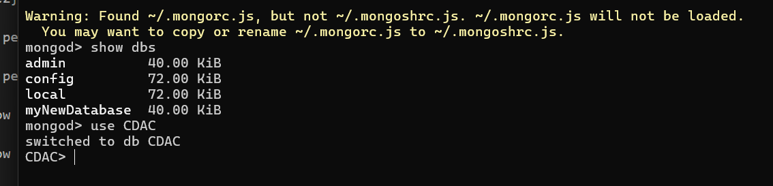
- 2. Display the list of collections in the CDAC database.
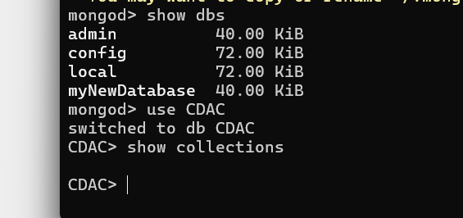
- 3. Create a collection named LIBRARY.
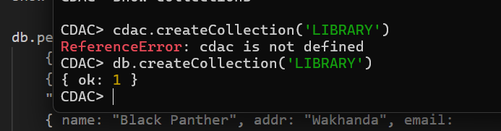
- 4. Insert a document into LIBRARY with: title: MongoDB programming, author: Amit, likes: 100
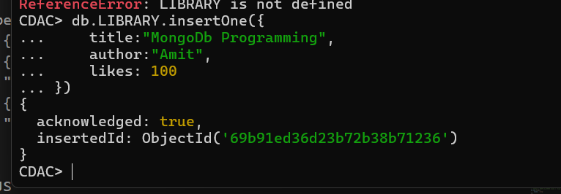
- 5. Display the inserted document and note the _id field.
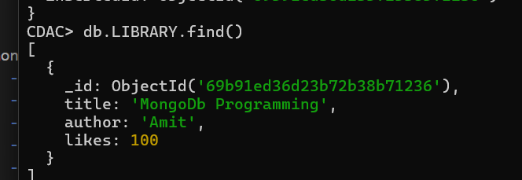
- 6. Insert another document into LIBRARY with: title: MySQL programming, authors: [Jack, Jill], likes: 200
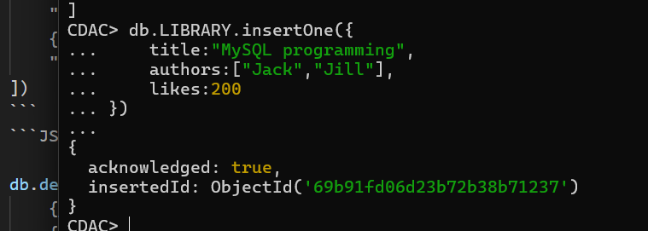
- 7. Display all documents in the LIBRARY collection.
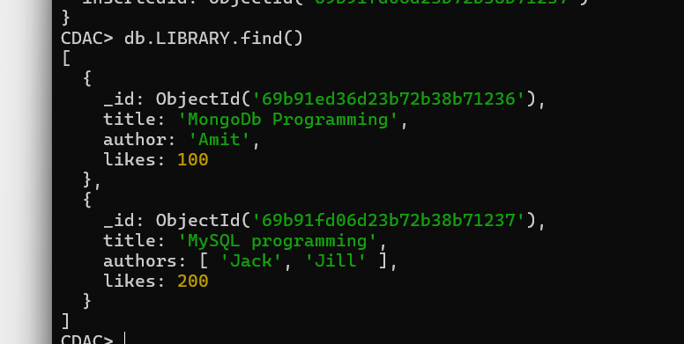
- 8. Display only the first inserted document.
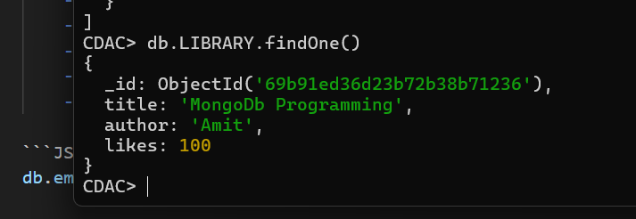
- 9. Display documents using the pretty() method.
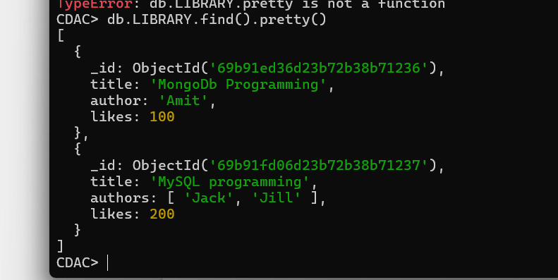
- 10. Update the document where author = Amit to Amit Sharma.
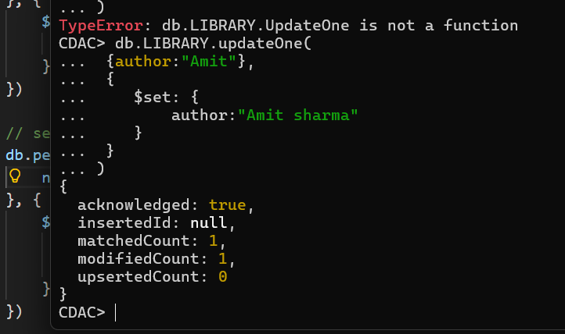
- 11. Delete all documents with likes = 100.
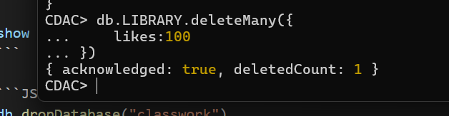
- Drop the LIBRARY collection.
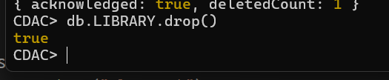
- 13. Drop the CDAC database.
