- Create 'spj' database'. (Database for suppliers, parts and
jobs)
2. use spj database;

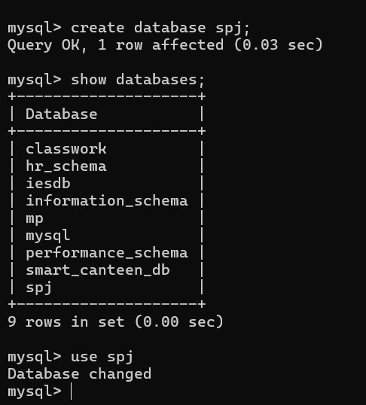

3
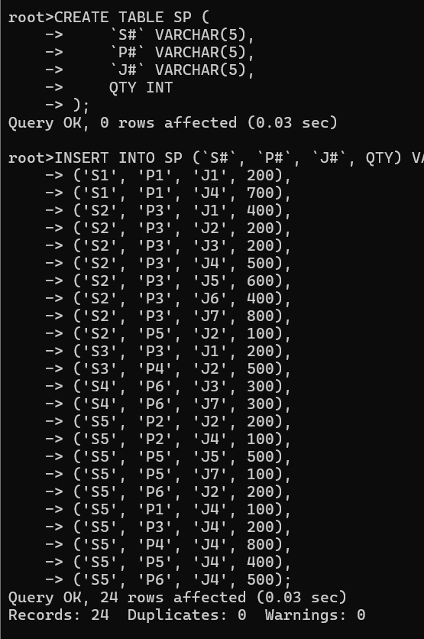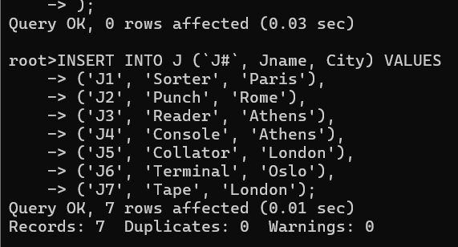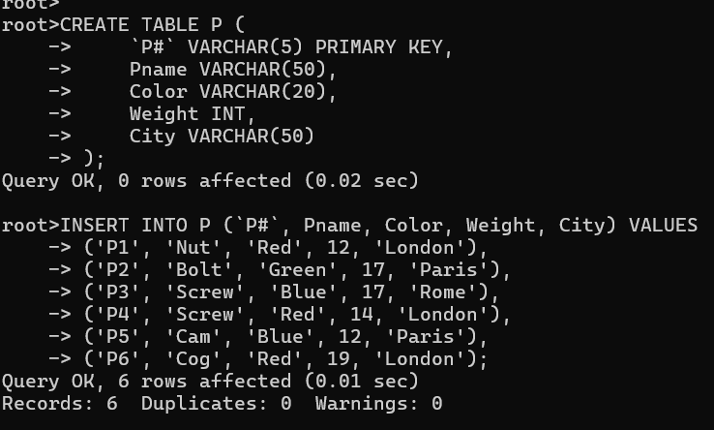
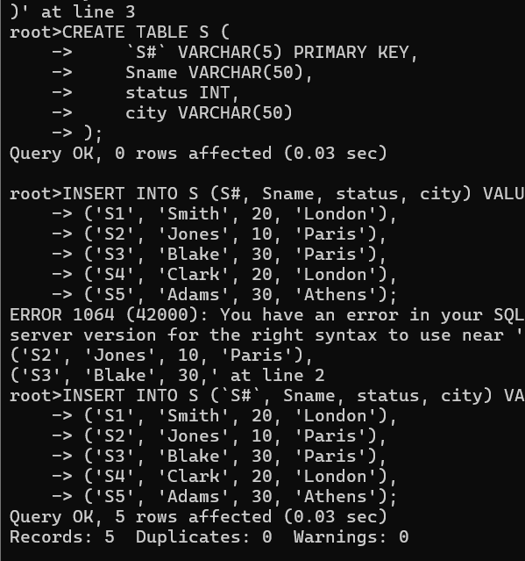

1 Create 'hr' database. Import hr-db.sql.
2 Create 'sales' database. Import sales-db.sql.
3 List all tables in hr database. Display contents of all tables (one by one).
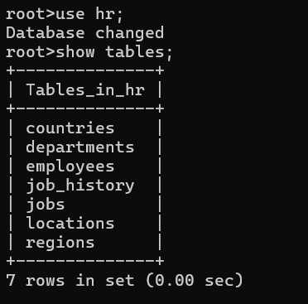
4 List all tables in sales database. Display contents of all tables (one by one)
