- Write a query that produces all rows from the Customers
table for which the salesperson’s number is 1001.
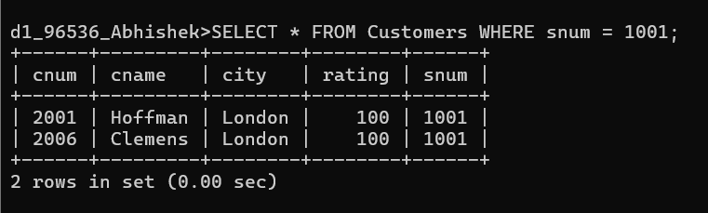
2. Write a select command that produces the rating followed
by the name of each customer in San Jose.
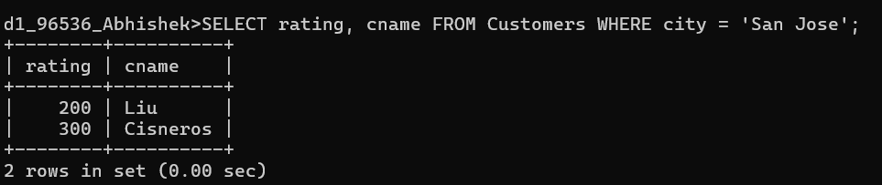
3. Write a query that will produce the snum values of all
salespeople from the Orders table (with the duplicate values
suppressed).
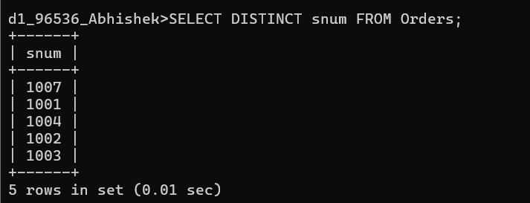
4. Write a query that will display all the orders for amount
more than Rs. 1,000.
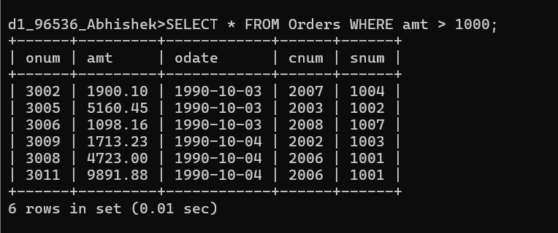
5. Write a query that will give you the names and cities of
all salespeople in London with a commission above 0.10.
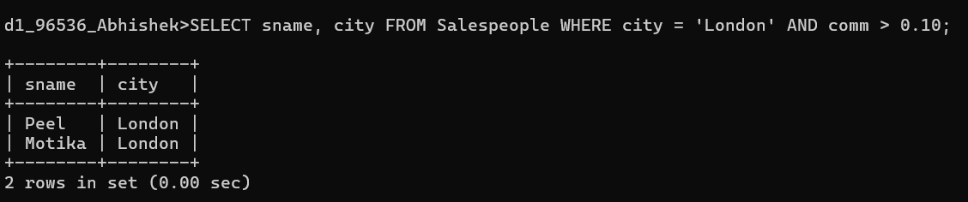
6. Write an SQL query that returns all customers who have a
rating greater than 100, along with the customers located in
Rome regardless of their rating.
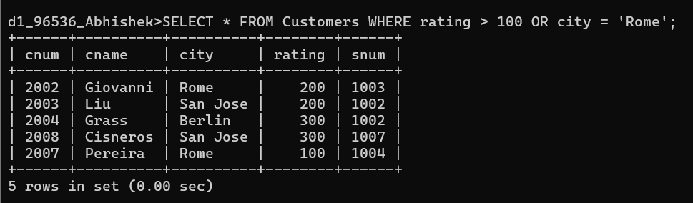
7. What will be the output from the following query?
Select * from Orders where (amt < 1000 OR NOT (odate = ‘1990-10-
03’ AND cnum > 2003));

Output: It will display all orders where the amount is less than 1000, OR any order that was not placed on October 3, 1990, by customer 2004 or higher. Effectively, it excludes only large orders (amt >= 1000) specifically made by customers with cnum > 2003 on that specific date.
8. What will be the output of the following query?
Select * from Orders where NOT (odate = ‘1990-10-03’ OR snum
>1006) AND amt >= 1500;

Output: It will display orders with an amount greater than or equal to 1500, but only if they were not placed on October 3, 1990, AND the salesperson number is 1006 or lower.
9. What is a simpler way to write this query?
Select snum, sname, city, comm from Salespeople
Where (comm >= .12 AND comm <= .14);

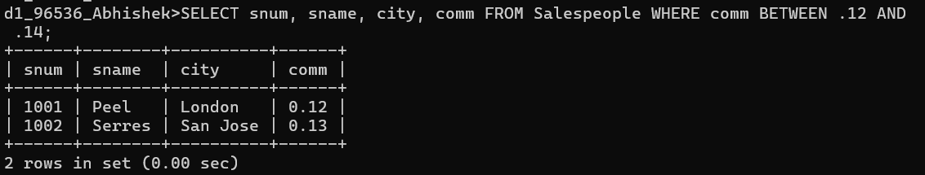
10. Write a query that selects all orders except those
with amount less than 100.
