1Write a query that counts the number of salespeople registering
orders for each day. (If a salesperson has more than one order on a given
day, he or she should be counted only once.).
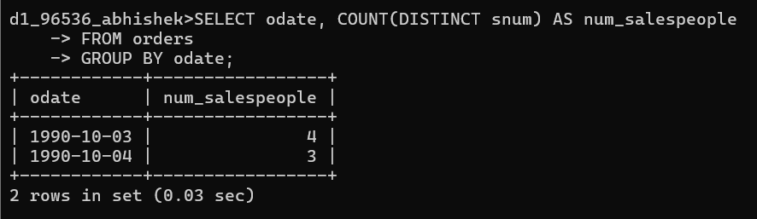

2.
Write a query on the Customers table that will find the highest rating
in each city. Put the output in this form:
For the city (city), the highest rating is: (rating).

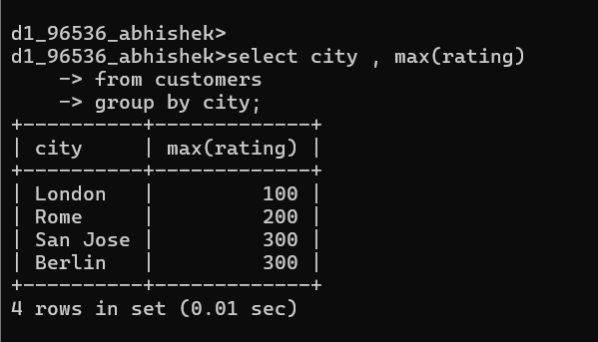

3 Write an SQL query to calculate the total order amount for each day
and display the results in descending order of total orders.
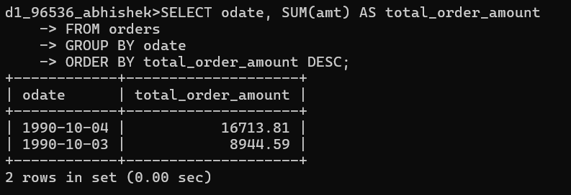

4.
Write a query that selects the total amount in orders for each

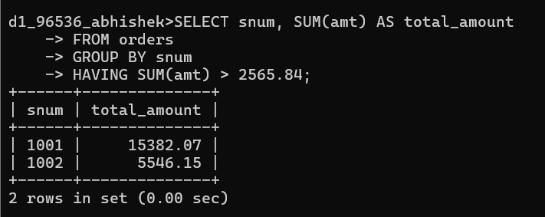
salesperson for whom this total is greater than the average amount of
the order in the table.
(Note Use the average amount value directly →2565.84)

5. Write a query that selects the highest rating in each city.

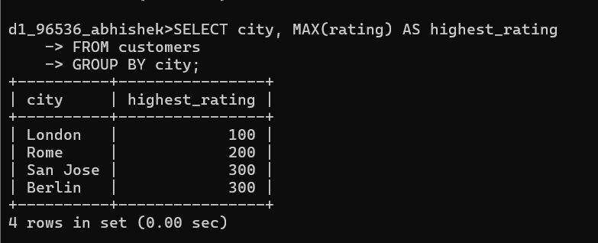

6. Retrieve the maximum order amount for each salesperson from the
orders table, including only those orders whose value exceeds Rs. 3000.
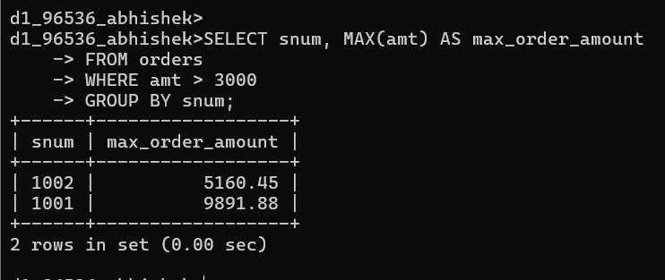

- Write an SQL query to find the smallest order placed by every customer.
