SQL Assignment 6

1) Write two different queries that would produce all orders taken on October 3rd or 4th, 1990.

A) SELECT * FROM ORDERS
-> WHERE ODATE = ANY(SELECT ODATE FROM ORDERS
-> WHERE ODATE = '1990-10-03' OR ODATE = '1990-10-04');

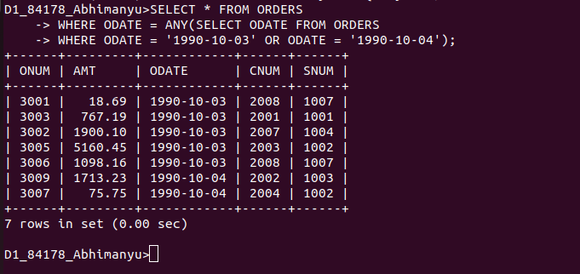

B) SELECT * FROM ORDERS WHERE ODATE IN ('1990-10-03','1990-10-04');

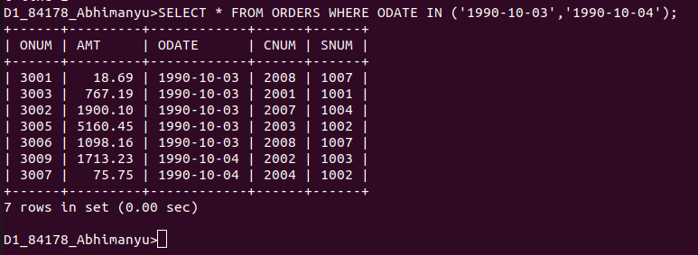

2) Write a query that selects all of the customers serviced by Peel or Motika. (Hint: the snum field relates the two tables to one another).

SELECT * FROM CUSTOMERS WHERE SNUM IN (1004,1007);

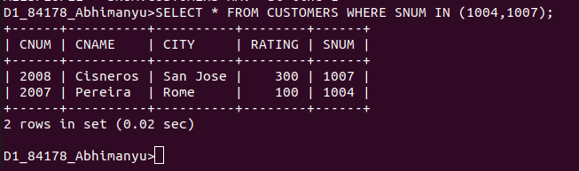
.........................................................................................................................................

3) Write a query that will produce all the customers whose names begin with a letter from ‘A’ to ‘G’.

SELECT * FROM CUSTOMERS WHERE CNAME>'A' AND CNAME<'G';

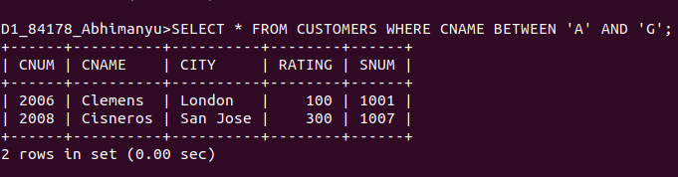
.........................................................................................................................................

4) Write a query that selects all customers whose names begin with the letter ‘C’.

SELECT * FROM CUSTOMERS WHERE CNAME LIKE 'C%';

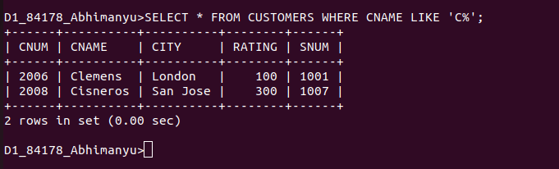

.........................................................................................................................................

5) Write a query that selects all orders except those with zeroes or NULLs in the amt field.

SELECT * FROM ORDERS WHERE AMT !=0 AND AMT IS NOT NULL;




