SQL Assignment 7

1) Write a October 3 query that counts all orders for October 3.
-> SELECT COUNT(*) FROM ORDERS WHERE ODATE = '1990-10-03';

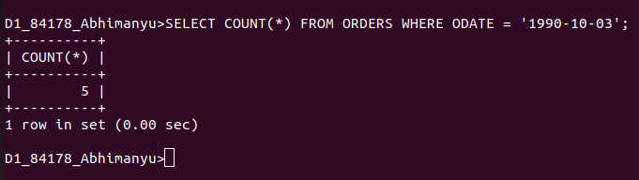
................................................................................................................................................................

2) Write a query that counts the number of different non-NULL city values in the Customers table.
-> SELECT COUNT(CITY) WHERE CITY IS NOT NULL;
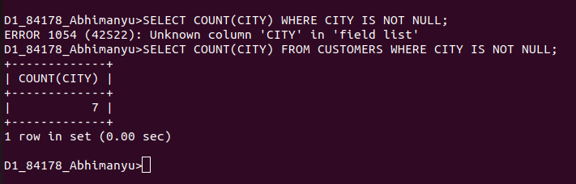
................................................................................................................................................................

3) Write a query that selects each customer’s smallest order.
-> SELECT CNUM,MIN(AMT) FROM ORDERS GROUP BY CNUM;

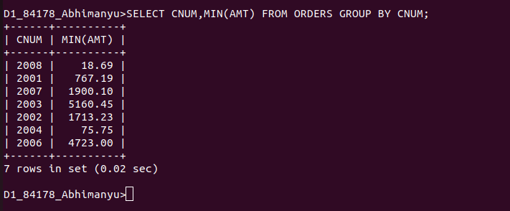
................................................................................................................................................................

4) Write a query that selects the first customer, in alphabetical order, whose name begins with G.
-> SELECT * FROM CUSTOMERS WHERE CNAME LIKE 'G%' ORDER BY CNAME;
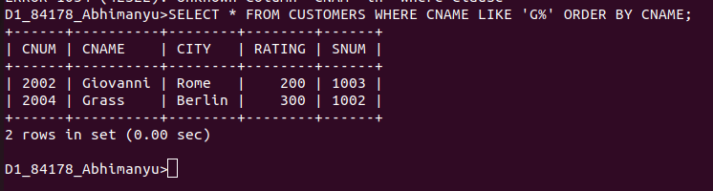
.........................................................................................................................................

5) Write a query that selects the highest rating in each city.
-> SELECT CITY, MAX(RATING) FROM CUSTOMERS GROUP BY CITY;
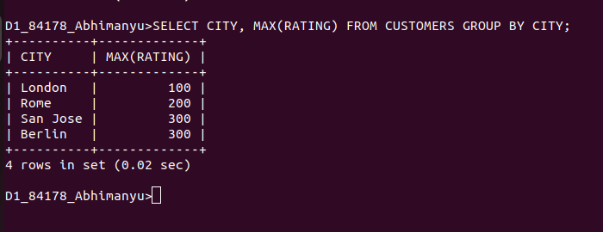
................................................................................................................................................................

6) Write a query that counts the number of salespeople registering orders for each day. (If a salesperson has more than one order on a givenday, he or she should be counted only once.).
-> SELECT COUNT(DISTINCT SNUM),ODATE FROM ORDERS GROUP BY ODATE;




