SQL Assignment No 8

1) Assume each salesperson has a 12% commission. Write a query on the orders table that will produce the order number, the salesperson number, and the amount of the salesperson’s commission for that order.
->SELECT ONUM,SNUM, AMT*.12 "SALESPERSON_COMM" FROM ORDERS;
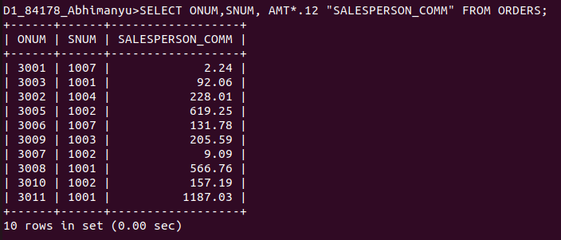
................................................................................................................................................................

2) Write a query on the Customers table that will find the highest rating in each city. Put the output in this form: For the city (city), the highest rating is : (rating).
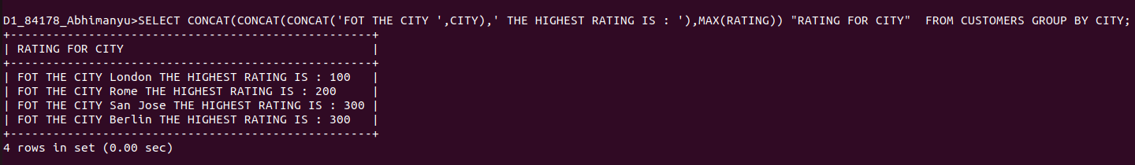
->SELECT CONCAT(CONCAT(CONCAT('FOT THE CITY ',CITY),' THE HIGHEST RATING IS : '),MAX(RATING)) "RATING FOR CITY" FROM CUSTOMERS GROUP BY CITY;

3) Write a query that lists customers in descending order of rating. Output the rating field first, followed by the customer’s name and number.
->SELECT RATING,CNAME,CNUM FROM CUSTOMERS ORDER BY RATING DESC;
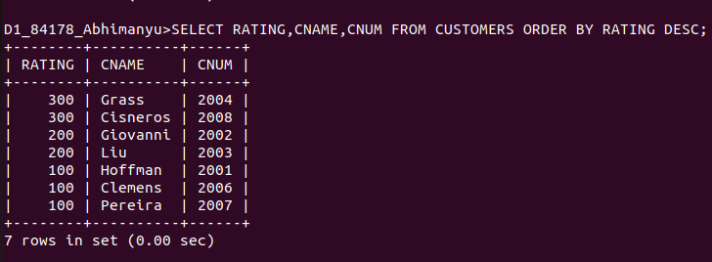
................................................................................................................................................................

4) Write a query that totals the orders for each day and places the results in descending order.
-> SELECT SUM(AMT) FROM ORDERS GROUP BY ODATE ORDER BY 1 DESC;



