SQL Assignment 4

1) Write a select command that produces the order number, amount, and date for all rows in the Orders table.
SELECT ONUM, AMT, ODATE
FROM ORDERS;

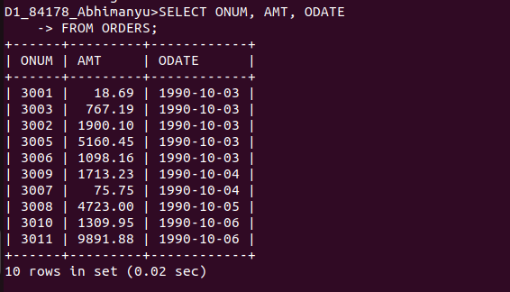
................................................................................................................................................................

2) Write a query that produces all rows from the Customers table for which the salesperson’s number is 1001.
SELECT * FROM SALESPEOPLE
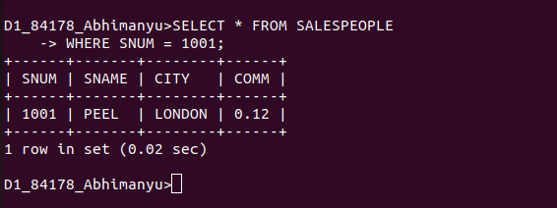
WHERE SNUM = 1001;

3) Write a query that displays the Salespeople table with the columns in the following order: city, sname, snum, comm.
SELECT CITY,SNAME,SNUM,COMM
FROM SALESPEOPLE;
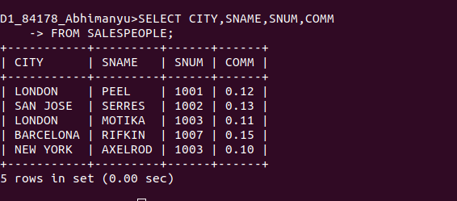
................................................................................................................................................................

4) Write a select command that produces the rating followed by the name of each customer in San Jose.
SELECT RATING, CNAME, CITY
FROM CUSTOMERS
WHERE CITY = 'SAN JOSE';

