ASSIGNMENT NO 1

1. CREATE TABLE SALESPEOPLE
(SNUM INT(4), SNAME VARCHAR(10),
CITY VARCHAR(10), COMM FLOAT(3,2) );

------------------------------------------------------------------------------------------------------------------------

2. CREATE TABLE CUSTOMERS
(CNUM INT(4), CNAME VARCHAR(10),
CITY VARCHAR(10), RATING INT(4), SNUM INT(4));

------------------------------------------------------------------------------------------------------------------------

3. CREATE TABLE ORDERS
(ONUM INT(4), AMT FLOAT(7,2),
ODATE DATE, CNUM INT(4), SNUM INT(4));
------------------------------------------------------------------------------------------------------------------------

4. INSERT INTO SALESPEOPLE
VALUES
(1001, 'PEEL', 'LONDON', 0.12);
------------------------------------------------------------------------------------------------------------------------

5. INSERT INTO SALESPEOPLE
VALUES
(1002, 'SERRES', 'SAN JOSE', .13);

6. INSERT INTO SALESPEOPLE
(SNAME, SNUM, CITY, COMM)
VALUES('MOTIKA', 1003, 'LONDON', .11);
------------------------------------------------------------------------------------------------------------------------

7. INSERT INTO SALESPEOPLE
VALUES(1007, 'RIFKIN', 'BARCELONA', .15);
------------------------------------------------------------------------------------------------------------------------

8.
INSERT INTO SALESPEOPLE
VALUES(1003, 'AXELROD', 'NEW YORK', 10);

------------------------------------------------------------------------------------------------------------------------

9. SELECT * FROM SALESPEOPLE;

+------+---------+-----------+------+
| SNUM | SNAME | CITY | COMM |
+------+---------+-----------+------+
| 1001 | PEEL | LONDON | 0.12 |
| 1002 | SERRES | SAN JOSE | 0.13 |
| 1003 | MOTIKA | LONDON | 0.11 |
| 1007 | RIFKIN | BARCELONA | 0.15 |
| 1003 | AXELROD | NEW YORK | 0.10 |
+------+---------+-----------+------

10. INSERT INTO CUSTOMERS
VALUES
(2001, 'Hoffman', 'London', 100, 1001),
(2002, 'Giovanni', 'Rome', 200, 1003),
(2003, 'Liu', 'San Jose', 200, 1002),
(2004, 'Grass', 'Berlin', 300, 1002),
(2006, 'Clemens', 'London', 100, 1001),
(2008, 'Cisneros', 'San Jose', 300, 1007),
(2007, 'Pereira', 'Rome', 100, 1004);
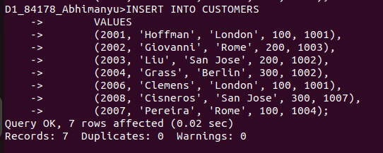
................................................................................................................................................................

11. INSERT INTO ORDERS
-> VALUES
-> (3001, 18.69, '1990-10-03', 2008, 1007),
-> (3003, 767.19, '1990-10-03', 2001, 1001),
-> (3002, 1900.10, '1990-10-03', 2007, 1004),
-> (3005, 5160.45, '1990-10-03', 2003, 1002),
-> (3006, 1098.16, '1990-10-03', 2008, 1007),
-> (3009, 1713.23, '1990-10-04', 2002, 1003),
-> (3007, 75.75, '1990-10-04', 2004, 1002),
-> (3008, 4723.00, '1990-10-05', 2006, 1001),
-> (3010, 1309.95, '1990-10-06', 2004, 1002),
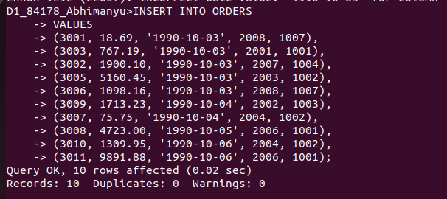
-> (3011, 9891.88, '1990-10-06', 2006, 1001);

