SQL Assignment No 5

1) Write a query that will give you all orders for more than Rs. 1,000.
->
SELECT * FROM ORDERS
WHERE AMT > 1000;
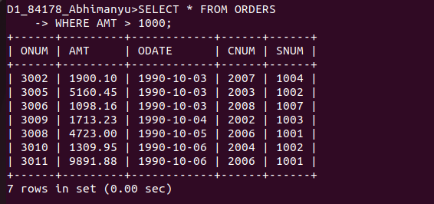
.........................................................................................................................................

2) Write a query that will give you the names and cities of all salespeople in London with a commission above .10.
SELECT SNAME, CITY, COMM
-> FROM SALESPEOPLE
-> WHERE COMM > .10 AND CITY = 'LONDON';

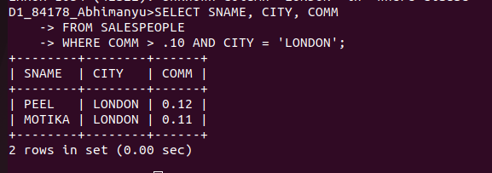

3) Write a query on the Customers table whose output will exclude all customers with a rating <= 100, unless they are located in Rome.
SELECT * FROM CUSTOMERS
-> WHERE RATING > 100 OR CITY = 'ROME';
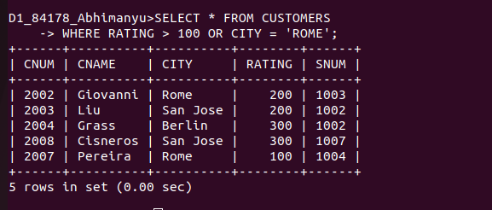
................................................................................................................................................................

4) What will be the output from the following query? Select * from Orders where (amt < 1000 OR NOT (odate = ‘1990-10-03’ AND cnum > 2003));
Here in this command first (odate = ‘1990-10-03’ or cnum > 1000) will get checked.
After that NOT will neglect all those values that has given odate and one has cnum greater than 2003.
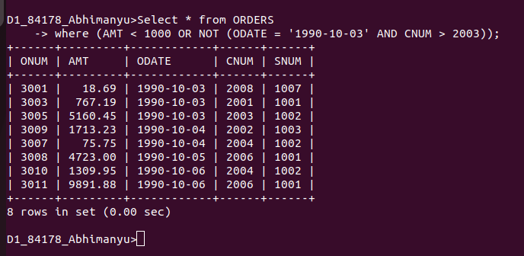
.........................................................................................................................................
5) What will be the output of the following query? Select * from Orders where NOT ((odate = ‘1990-10-03’ OR snum >1006) AND amt >= 1500);
-> Here in this command first (odate = ‘1990-10-03’ or snum > 1006) will get checked in which orders with onum 3001 to 3006 will get selected after that outer bracket will get checked in which selected rows and entities with snum greater than 1500 are neglected by NOT.meaning it willl only select those rows that are not satisfying above conditions.
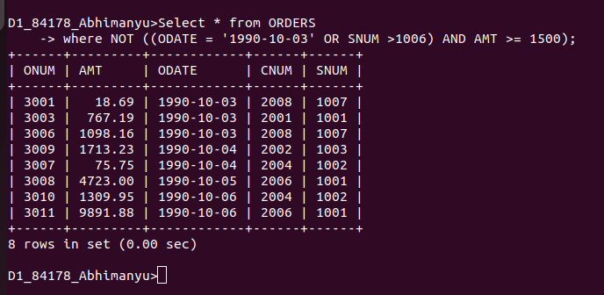

6) What is a simpler way to write this query? Select snum, sname, city, comm From Salespeople (comm > .12 OR comm <.14);
To write it simply you have to use between, to get all the values inbeween.





