SQL Assignment No 10

1) Write a query that produces all pairs of salespeople who are living in the same city. Exclude combinations of salespeople with themselves as well as duplicate rows with the order reversed.
->SELECT A.SNAME, B.SNAME, A.CITY FROM SALESPEOPLE A, SALESPEOPLE B WHERE A.CITY = B.CITY AND A.SNAME>B.SNAME;
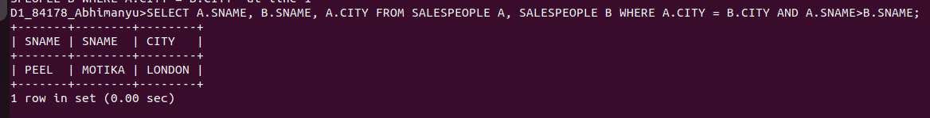
.........................................................................................................................................

2) Write a query that produces the names and cities of all customers with the same rating as Hoffman.
-> SELECT CNAME, CITY FROM CUSTOMERS
WHERE RATING = (SELECT RATING FROM CUSTOMERS
WHERE CNAME = 'HOFFMAN');




