SQL ASSIGNMENT NO 11

1) Write a query that uses a subquery to obtain all orders for the customer named Cisneros. Assume you do not know his customer number (cnum).
-> SELECT * FROM ORDERS
WHERE CNUM = (SELECT CNUM FROM CUSTOMERS
WHERE CNAME = 'CISNEROS');
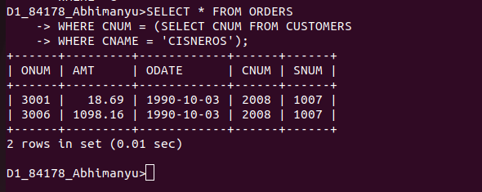
................................................................................................................................................................

2) Write a query that produces the names and ratings of all customers who have above-average orders.
-> SELECT CNAME, RATING FROM CUSTOMERS
WHERE CNUM IN(SELECT CNUM FROM ORDERS
WHERE AMT >(SELECT AVG(AMT) FROM ORDERS));
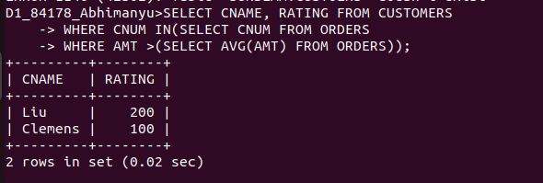
................................................................................................................................................................

3) Write a query that selects the total amount in orders for each salesperson for whom this total is greater than the amount of the largest order in the table.
->SELECT SUM(AMT) FROM ORDERS
GROUP BY SNUM
HAVING SUM(AMT) >(SELECT MAX(AMT) FROM ORDERS);




