SQL ASSIGNMENT NO 12

1) Write a query that selects all customers whose ratings are equal to or greater than ANY of Serres’.
->SELECT * FROM CUSTOMERS
WHERE RATING >=ANY(SELECT RATING FROM CUSTOMERS
WHERE SNUM IN (1002));

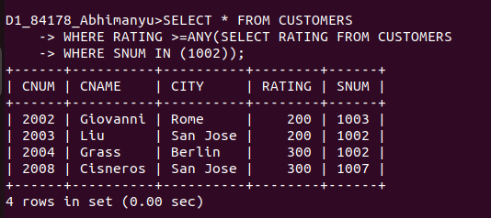
................................................................................................................................................................

2) Write a query using ANY or ALL that will find all salespeople who have no customers located in their city.
-> SELECT SNAME, CITY FROM SALESPEOPLE
WHERE CITY!=ALL(SELECT CITY FROM CUSTOMERS);

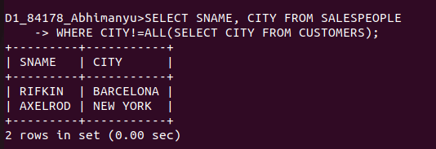
................................................................................................................................................................

3) Write a query that selects all orders for amounts greater than any for the customers in London.
-> SELECT * FROM ORDERS
WHERE AMT > ANY( SELECT ORDERS.AMT FROM ORDERS, CUSTOMERS
WHERE ORDERS.CNUM = CUSTOMERS.CNUM AND CUSTOMERS.CITY =
‘LONDON’);

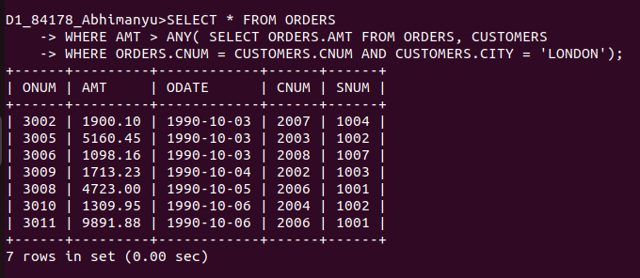
................................................................................................................................................................

4) Write the above query using MIN or MAX.
->
SELECT * FROM ORDERS
WHERE AMT >( SELECT MIN(ORDERS.AMT) FROM ORDERS, CUSTOMERS
WHERE ORDERS.CNUM = CUSTOMERS.CNUM
GROUP BY CITY
HAVING CITY = 'LONDON'
);





