SQL ASSIGNMENT NO 14

1) Write a command that puts the following values, in their given order, into the salespeople table: city – San Jose, name – Blanco, comm – NULL, cnum – 1100.
->INSERT INTO SALESPEOPLE(CITY, SNAME, COMM, SNUM)
VALUES(
'SAN JOSE', 'BLANCO', NULL, 1100);

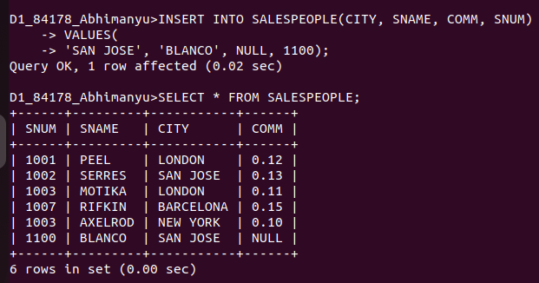
................................................................................................................................................................

2) Write a command that removes all orders from customer Clemens from the Orders table.

-> DELETE FROM ORDERS
WHERE CNUM = (SELECT CNUM FROM CUSTOMERS
WHERE CNAME = 'CLEMENS');
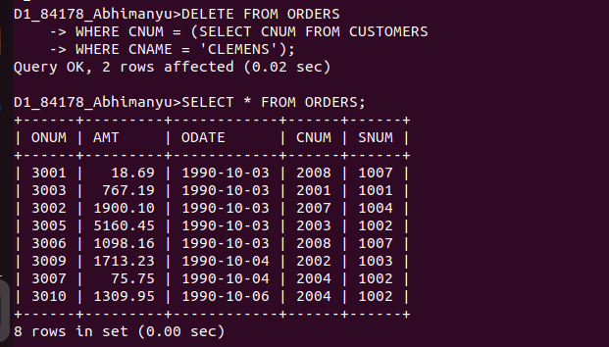
.........................................................................................................................................

3) Write a command that increases the rating of all customers in Rome by 100.
-> UPDATE CUSTOMERS SET RATING = RATING + 100
WHERE CITY = 'ROME';

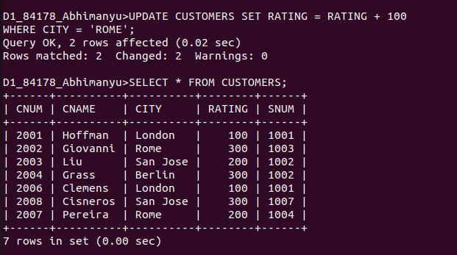

4) Salesperson Serres has left the company.Assign her customers to Motika.

UPDATE CUSTOMERS
-> SET SNUM = (SELECT SNUM FROM SALESPEOPLE
-> WHERE SNAME = 'MOTIKA')
-> WHERE SNUM = (SELECT SNUM FROM SALESPEOPLE
-> WHERE SNAME = 'SERRES');

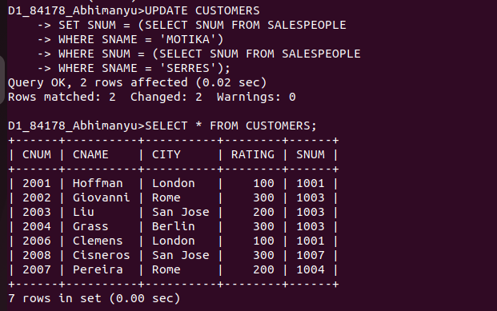

................................................................................................................................................................

UPDATE SALESPEOPLE
-> JOIN(SELECT SALESPEOPLE.SNUM FROM ORDERS, SALESPEOPLE
-> WHERE SALESPEOPLE.SNUM = ORDERS.SNUM
-> GROUP BY SALESPEOPLE.SNUM
-> HAVING SUM(AMT)>3000)
-> AS TEMP
-> ON SALESPEOPLE.SNUM = TEMP.SNUM
-> SET COMM = COMM + COMM* 0.20;

