SQL ASSIGNMENT NO 15

1) Assume there is a table called Multicust, with all of the same column definitions as Salespeople. Write a command that inserts all salespeople with more than one customer into this table.
->
CREATE TABLE MULTICAST
AS
SELECT * FROM SALESPEOPLE
WHERE SNUM IN (SELECT SALESPEOPLE.SNUM FROM CUSTOMERS, SALESPEOPLE
WHERE SALESPEOPLE.SNUM = CUSTOMERS.SNUM
GROUP BY SALESPEOPLE.SNUM
HAVING COUNT(SALESPEOPLE.SNUM)>1);

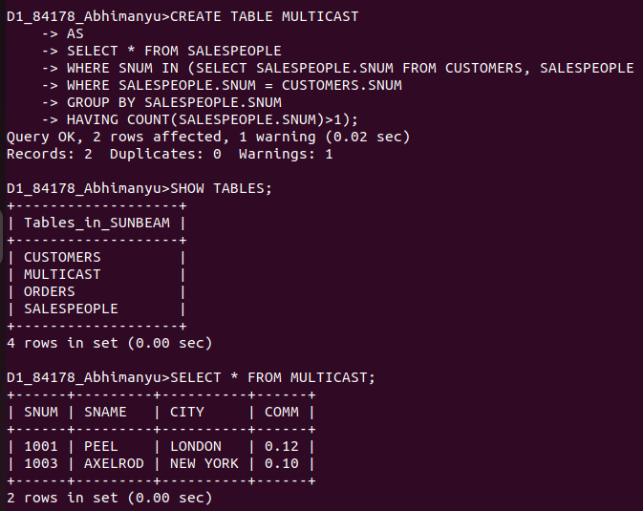
2) Write a command that deletes all customers with no current orders.
->
DELETE FROM CUSTOMERS
WHERE CNUM NOT IN(SELECT CNUM FROM ORDERS
GROUP BY CNUM);

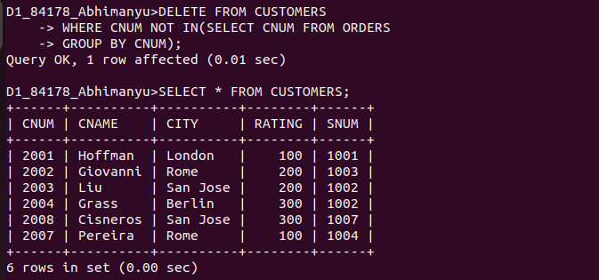
................................................................................................................................................................

3) Write a command that increases by twenty percent the commissions of all salespeople with total orders above Rs. 3,000.
->UPDATE SALESPEOPLE
JOIN(SELECT SALESPEOPLE.SNUM FROM ORDERS, SALESPEOPLE
WHERE SALESPEOPLE.SNUM = ORDERS.SNUM
GROUP BY SALESPEOPLE.SNUM
HAVING SUM(AMT)>3000)
AS TEMP
ON SALESPEOPLE.SNUM = TEMP.SNUM
SET COMM = COMM + COMM* 0.20;




