SQL Assignment No 9

1) Write a query that lists each order number followed by the name of the customer who made the order.
->SELECT ORDERS.ONUM, CUSTOMERS.CNAME FROM ORDERS,CUSTOMERS WHERE CUSTOMERS.CNUM = ORDERS.CNUM;

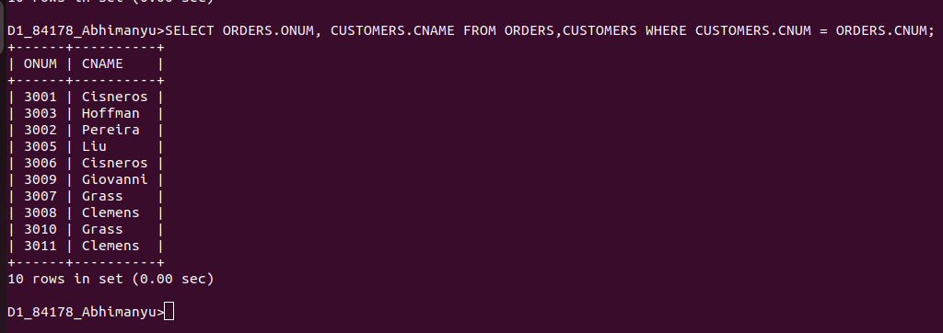
................................................................................................................................................................

2) Write a query that gives the names of both the salesperson and the customer for each order along with the order number.
->SELECT SNAME, CNAME, ONUM FROM ORDERS,CUSTOMERS,SALESPEOPLE WHERE SALESPEOPLE.SNUM = CUSTOMERS.SNUM AND CUSTOMERS.CNUM = ORDERS.CNUM;

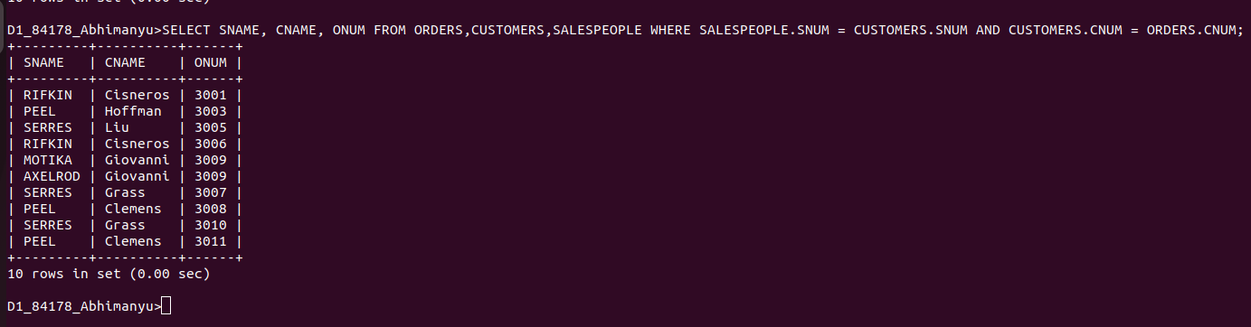
................................................................................................................................................................

3) Write a query that produces all customers serviced by salespeople with a commission above 12%. Output the customer’s name, the salesperson’s name, and the salesperson’s rate of commission.
->SELECT CNAME, SNAME, COMM FROM CUSTOMERS, SALESPEOPLE
WHERE SALESPEOPLE.SNUM = CUSTOMERS.SNUM
HAVING COMM >.12;
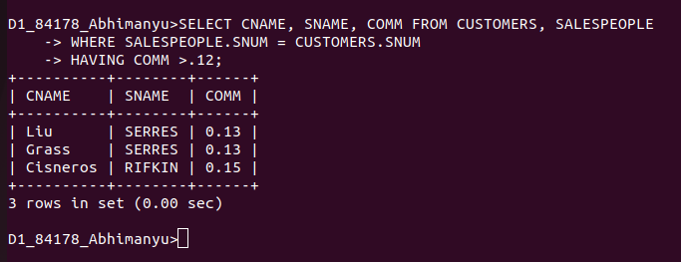
................................................................................................................................................................

4) Write a query that calculates the amount of the salesperson’s commission on each order by a customer with a rating above 100.
-> SELECT AMT,COMM,AMT*COMM, ONUM, RATING FROM ORDERS, CUSTOMERS, SALESPEOPLE
WHERE SALESPEOPLE.SNUM = ORDERS.SNUM AND CUSTOMERS.CNUM = ORDERS.CNUM
HAVING RATING > 100;




