Assignment No 1

1. man - Command to get help about commands
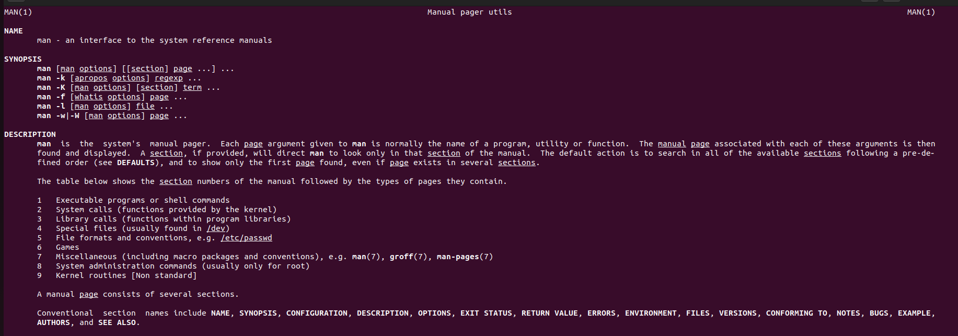
> man man

-------------------------------------------------------------------------------------------------------

2. uname -Print System information
> uname

-------------------------------------------------------------------------------------------------------

3. pwd - Print current directory
> pwd

-------------------------------------------------------------------------------------------------------

4. hostname - Print IP address and hostname of the machine
> hostname -i

5.date - Find today’s date
> date

6. cal - Print calendar for current year
> ncal

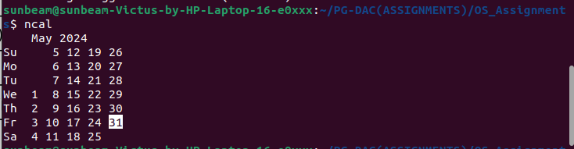

7.ls, dir - See directory structure
> ls
> dir

8. cat - Create file
> cat > myfile.txt
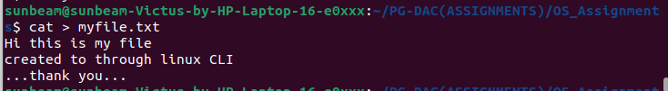

9. cat >> - Append some text into existing file

> cat >> myfile.txt
welcome again
have a good day!
... thank you ...

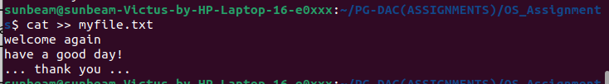

10. cp - Copy a file, Copy a directory
> cp hw/inception.txt bw

>cat bw/inception.txt
Director: Cristhopher Nolan
Actor: Leonardo Dicaprio
Actor: Cilian Murphy
Actor: Tom Hardy
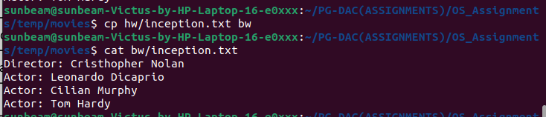

11.mv - Move the files

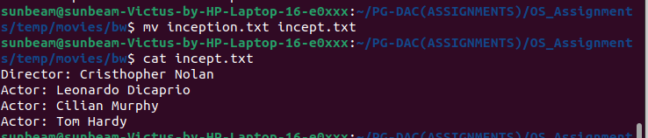

12. mv - Move the files

> mv inception.txt incept.txt
> cat incept.txt

13. tac, rev - Print the file in reverse order, Reverse each line in the file
> tac hw/inception.txt
> rev hw/inception.txt
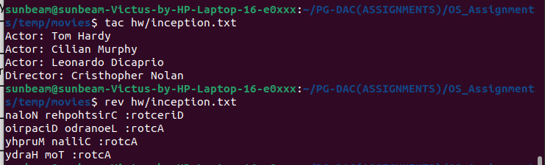

14.wc - Count the words, characters and lines in a file
> wc hw/inception.txt

15. mkdir - Create directory
> mkdir songs
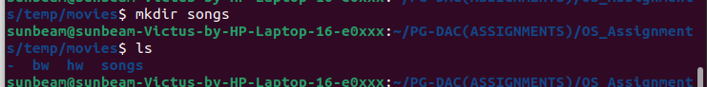

16. cd - Change current directory
> cd songs
17. rm - Remove a file, remove a directory ( with -R )
> rm -r ../bw

18. rmdir - remove empty directory
> rmdir ../songs

19. touch - change the modification time , Create Multiple empty files at once
> touch incept.txt

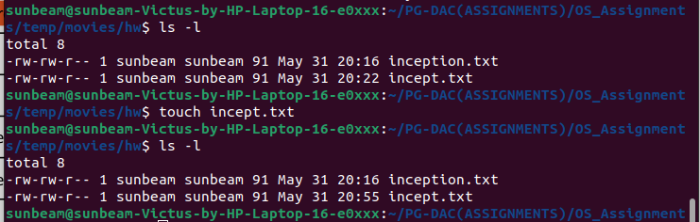

20. sort - Sort file.
> sort inception.txt

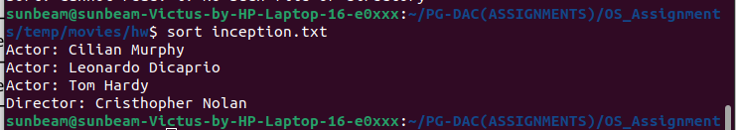

21. uniq - Avoid repetition in a file.

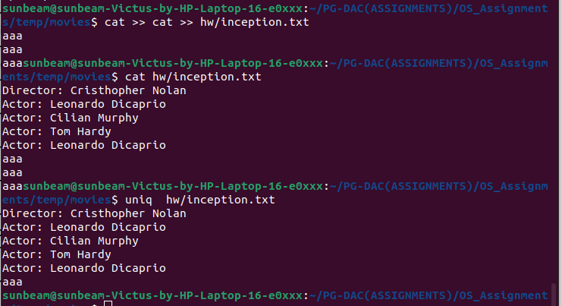
> uniq hw/inception.txt

22. head | Print the specified number of lines from top in the file.
> head hw/inception.txt

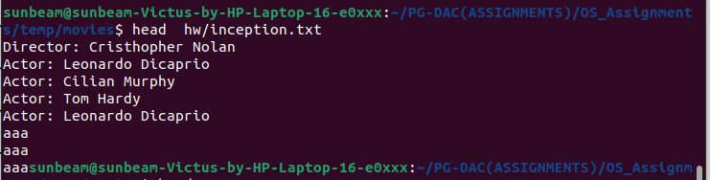

23. tail | Print the specified number of lines from bottom in the file.
> tail inception.txt

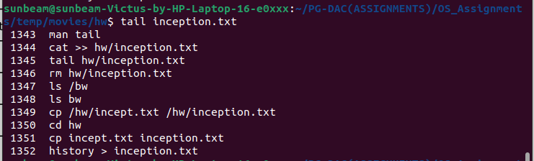

24. factor | Find the factors of a number
> factor 25

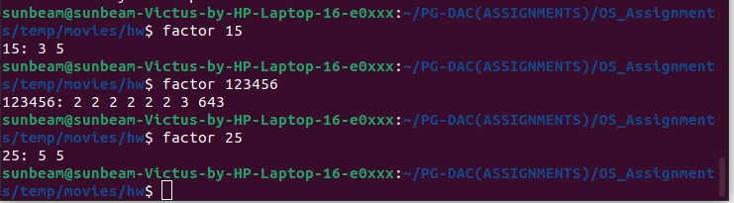

25. alias | Create command shortcut
> alias fact=factor
> fact 25

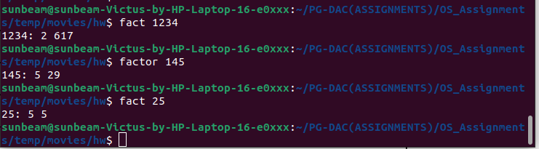

26. unalias | remove the command shortcut

> unalias fact
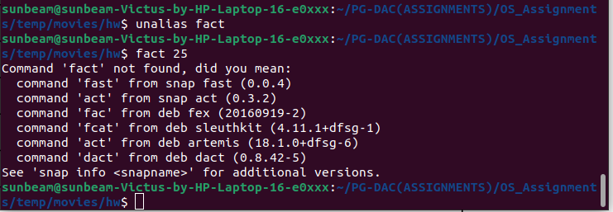

27. echo | Print environment variables individually

> echo shell

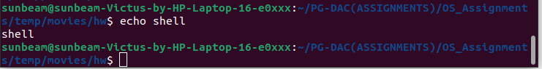

28. ps | Print current processes

> ps

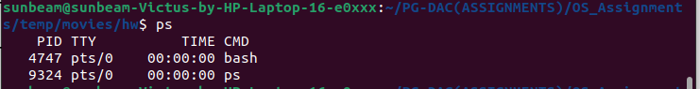

29. kill | Kill the process
> kill pid / kill [-s sigspec] [-n signum ] [-sigspec]

30. env | Print environment variables
> env

