ASSIGNMENT 7

1) Write a query that counts all orders for October 3.
=>SELECT COUNT(*) FROM ORDERS
-> WHERE ODATE LIKE '%10-03';
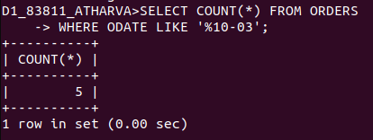

2) Write a query that counts the number of different non-NULL city values in the Customers table.
=> SELECT COUNT(DISTINCT CITY) FROM CUSTOMERS;

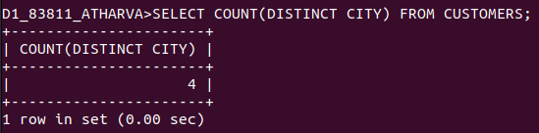

3) Write a query that selects each customer’s smallest order.
=> SELECT CUSTOMERS.CNUM, MIN(AMT) "MINIMUM ORDER" FROM ORDERS, CUSTOMERS
-> WHERE CUSTOMERS.CNUM = ORDERS.CNUM
-> GROUP BY CUSTOMERS.CNUM
-> ORDER BY CUSTOMERS.CNUM;
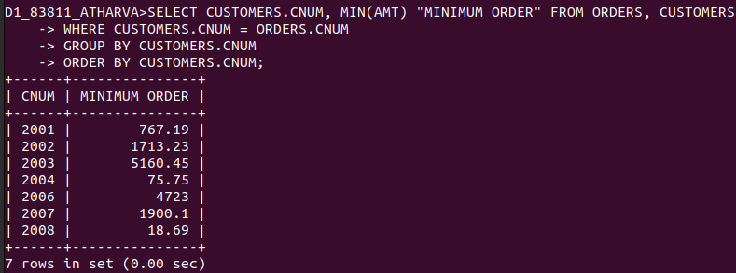
4) Write a query that selects the first customer, in alphabetical order, whose name begins with G.
=> SELECT MIN(CNAME) FROM CUSTOMERS
-> WHERE CNAME LIKE 'G%';

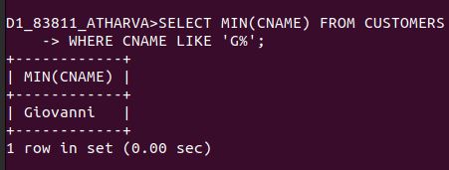

5) Write a query that selects the highest rating in each city.
=> SELECT CITY, MAX(RATING) FROM CUSTOMERS
-> GROUP BY CITY
-> ORDER BY CITY;
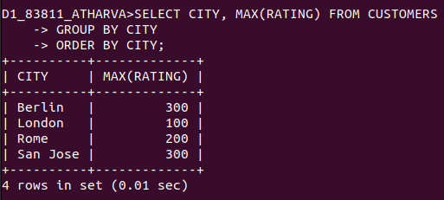

6) Write a query that counts the number of salespeople registering orders for each day. (Ifa salesperson has more than one order on a givenday, he or she should be counted only once.).
=> SELECT ODATE, COUNT(DISTINCT SNUM) FROM ORDERS GROUP BY ODATE;
