ASSIGNMENT 5

Q1. Write a query that will give you all orders for more than Rs. 1,000.
=> SELECT * FROM ORDERS
-> WHERE AMT>1000;
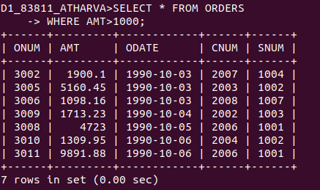

Q2. Write a query that will give you the names and cities of all salespeople in London with a commission above .10.
=> SELECT SNAME, CITY FROM SALESPEOPLE WHERE CITY='London' AND COMM>0.1;
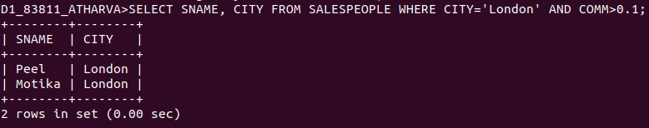

Q3. Write a query on the Customers table whose output will exclude all customers with a rating <= 100, unless they are located in Rome.
=> SELECT * FROM CUSTOMERS WHERE RATING>100 OR CITY='Rome';
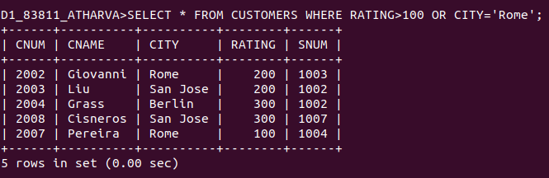
Q4. What will be the output from the following query?
Select * from Orders
where (amt < 1000 OR NOT (odate = ‘1990-10-03’ AND cnum > 2003));
=> SELECT * FROM ORDERS
-> WHERE (AMT<1000 OR NOT(ODATE='1990-10-03' AND CNUM>2003));

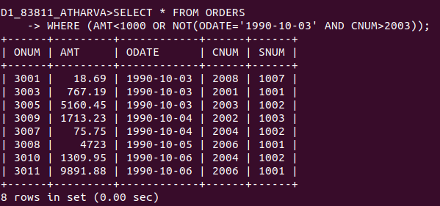

Q5. What will be the output of the following query?
Select * from Orders
where NOT ((odate = ‘1990-10-03’ OR snum>1006) AND amt >= 1500);
=> SELECT * FROM ORDERS
-> WHERE NOT((ODATE='1990-10-03' OR SNUM>1006) AND AMT>=1500);

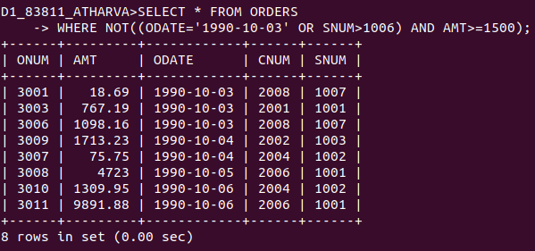

Q6. What is a simpler way to write this query?
Select snum, sname, city, comm From Salespeople
where (comm > .12 OR comm <.14);
=> SELECT * FROM SALESPEOPLE; is a faster and simpler way of writing this query as it returns all the rows in the table.+

