ASSIGNMENT 9

1) Write a query that lists each order number followed by the name of the customer who made the order.
=> SELECT ONUM,CNAME FROM ORDERS, CUSTOMERS WHERE ORDERS.CNUM=CUSTOMERS.CNUM;
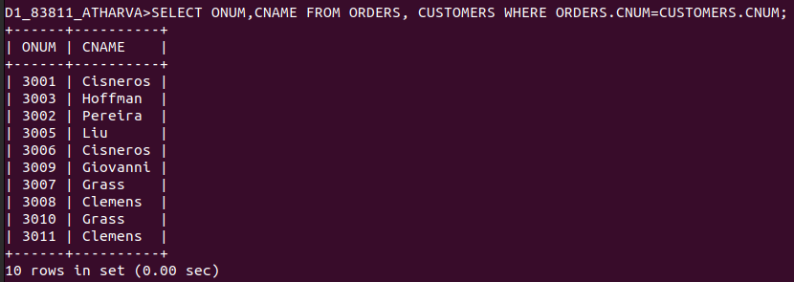

2) Write a query that gives the names of both the salesperson and the customer
for each order along with the order number.
=> SELECT SALESPEOPLE.SNAME,CUSTOMERS.CNAME,ORDERS.ONUM FROM ORDERS,CUSTOMERS,SALESPEOPLE
-> WHERE ORDERS.SNUM=SALESPEOPLE.SNUM AND ORDERS.CNUM=CUSTOMERS.CNUM;
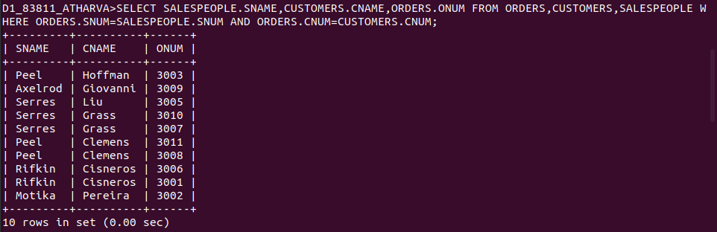

3) Write a query that produces all customers serviced by salespeople with a commission above 12%. Output the customer’s name, the salesperson’s name, and the salesperson’s rate of commission.
=> SELECT CNAME,SNAME,COMM FROM CUSTOMERS, SALESPEOPLE
-> WHERE CUSTOMERS.SNUM=SALESPEOPLE.SNUM AND SALESPEOPLE.COMM>0.12;
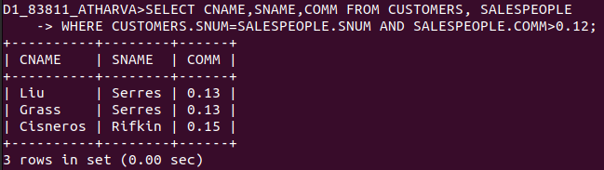

4) Write a query that calculates the amount of the salesperson’s commission on each order by a customer with a rating above 100.
=> SELECT ROUND(AMT*COMM,2) "COMMISSION",ONUM FROM SALESPEOPLE,CUSTOMERS,ORDERS
-> WHERE SALESPEOPLE.SNUM=ORDERS.SNUM AND CUSTOMERS.CNUM=ORDERS.CNUM AND RATING>100
-> ORDER BY ONUM;
