SQL Assignment – 13

Using the UNION clause.

1) Create a union of two queries that shows the names, cities, and ratings of all customers. Those with rating of 200 or greater will also have the words “High Rating”, while the others will have the words “Low Rating”.
Ans:

D1_83725_NISHANK>SELECT CNAME, CITY, RATING,
-> CASE
-> WHEN RATING >= 200 THEN "HIGH RATING"
-> END "RATING_STATUS"
-> FROM CUSTOMERS
-> WHERE RATING >= 200
->
-> UNION
->
-> SELECT CNAME, CITY, RATING,
-> CASE
-> WHEN RATING < 200 THEN "LOW RATING"
-> END "RATING_STATUS"
-> FROM CUSTOMERS
-> WHERE RATING < 200;

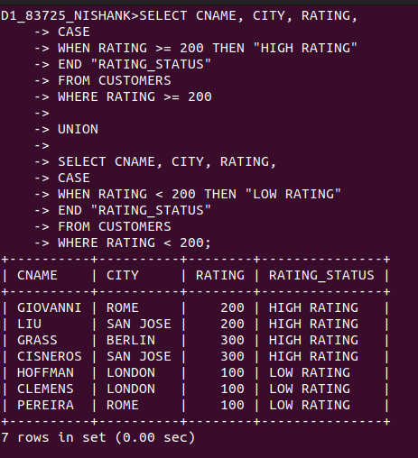

2) Write a command that produces the name and number of each salesperson and each customer with more than one current order. Put the results in alphabetical order.
Ans:

SELECT SNAME SALESPEOPLE_AND_CUSTOMERS_NAME, SNUM SALESPEOPLE_AND_CUSTOMERS_ID FROM SALESPEOPLE
WHERE
SNUM IN (SELECT SNUM FROM ORDERS GROUP BY SNUM HAVING COUNT(SNUM) > 1)

UNION

SELECT CNAME, CNUM FROM CUSTOMERS
WHERE
CNUM IN (SELECT CNUM FROM ORDERS GROUP BY CNUM HAVING COUNT(CNUM) > 1);

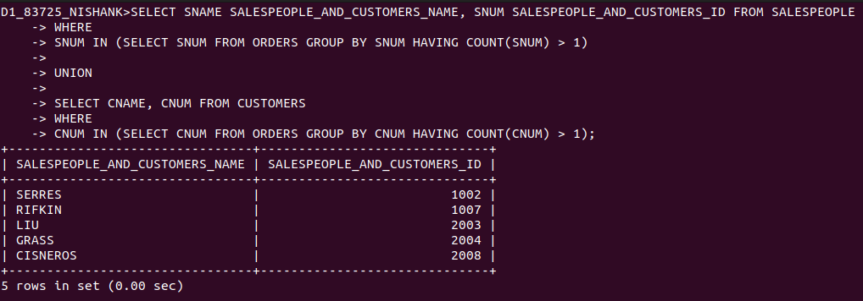

3) Form a union of three queries. Have the first select the snums of all salespeople in San Jose; the econd, the cnums of all customers in San Jose; and the third the onums of all orders on October 3. Retain duplicates between the last two queries but eliminate any redundancies between either of them and the first. (Note: in the sample tables as given, there would be no such redundancy. This is besides the point.)
Ans:

SELECT SNUM FROM SALESPEOPLE WHERE CITY = ‘SAN JOSE’

UNION

SELECT CNUM FROM CUSTOMERS WHERE CITY = ‘SAN JOSE’

UNION

SELECT ONUM FROM ORDERS WHERE ODATE = ‘1990-10-03’;

