Assignment – 5

Relational and Logical Operators.

Q1) Write a query that will give you all orders for more than Rs. 1,000.
Ans:

D1_83725_NISHANK>SELECT * FROM ORDERS
-> WHERE AMT > 1000;

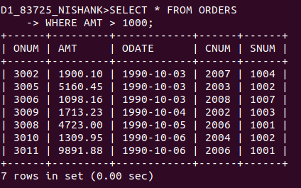

2) Write a query that will give you the names and cities of all salespeople in London with a commission above .10.
Ans:

D1_83725_NISHANK>SELECT SNAME, CITY FROM SALESPEOPLE WHERE COMM>.10;
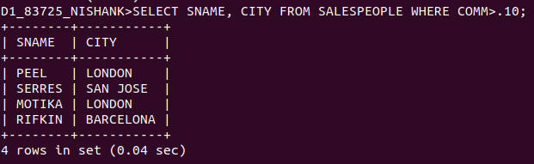

Q3) Write a query on the Customers table whose output will exclude all customers with a rating <= 100, unless they are located in Rome.
Ans:

D1_83725_NISHANK>SELECT * FROM CUSTOMERS WHERE (NOT (RATING <= 100)) OR CITY = 'ROME';

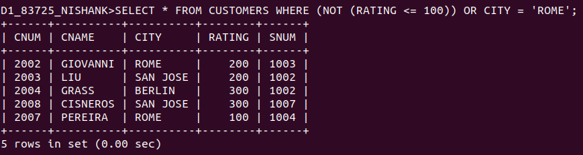

Q4)
What will be the output from the following query?
Select * from Orders where (amt < 1000 OR NOT (odate = ‘1990-10-03’ AND cnum > 2003));
Ans:

D1_83725_NISHANK>SELECT * FROM ORDERS
-> WHERE(AMT < 1000 OR NOT(ODATE = '1990-10-03' AND CNUM > 2003));

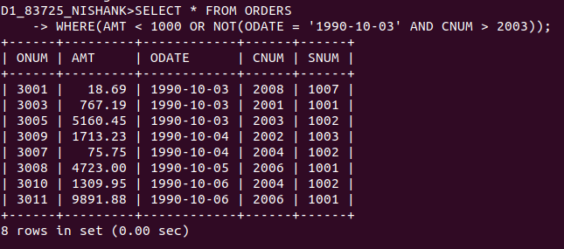

5)
What will be the output of the following query?
Select * from Orders where NOT ((odate = ‘1990-10-03’ OR snum >1006) AND amt >= 1500);
Ans:
D1_83725_NISHANK>SELECT * FROM ORDERS
-> WHERE NOT ((ODATE = '1990-10-03' OR SNUM > 1006) AND AMT >= 1500);

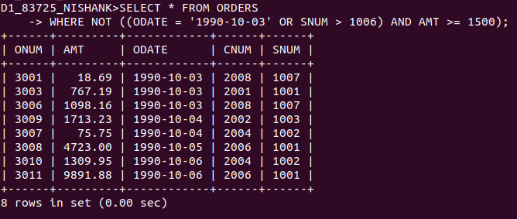

6)
What is a simpler way to write this query?
Select snum, sname, city, comm From Salespeople (comm > .12 OR comm <.14);
Ans:
Trick Question: The query given includes all the values as
comm > .12 OR comm <.14 (logically speaking) will cover all the values.

Therefore, just type:
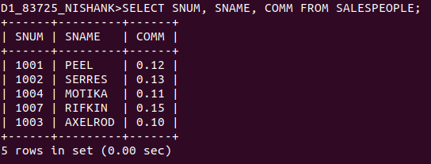
D1_83725_NISHANK>SELECT SNUM, SNAME, COMM FROM SALESPEOPLE;

