Assignment – 6

Using Special Operators in Conditions.

1) Write two different queries that would produce all orders taken on October 3rd or 4th, 1990.
Ans:

Method 1:

D1_83725_NISHANK>SELECT * FROM ORDERS WHERE (ODATE = '1990-10-03' OR ODATE = '1990-10-04');

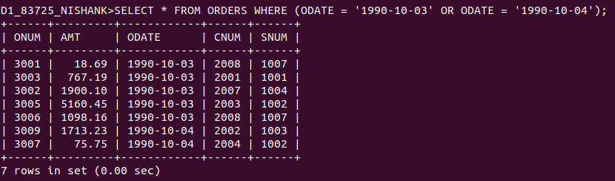

Method 2:

D1_83725_NISHANK>SELECT * FROM ORDERS WHERE ODATE BETWEEN '1990-10-03' AND '1990-10-04';

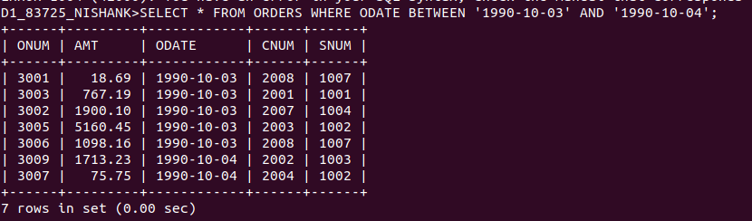

2) Write a query that selects all of the customers serviced by Peel or Motika. (Hint: the snum field relates the two tables to one another).
Ans:

D1_83725_NISHANK>SELECT * FROM CUSTOMERS
-> WHERE SNUM = 1001 OR SNUM = 1004;

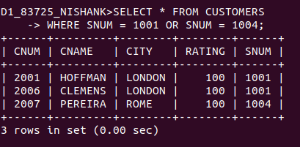

3) Write a query that will produce all the customers whose names begin with a letter from ‘A’ to ‘G’.
Ans:
D1_83725_NISHANK>SELECT * FROM CUSTOMERS WHERE CNAME >= 'A%' AND CNAME <= 'G%';

D1_83725_NISHANK>SELECT * FROM CUSTOMERS WHERE CNAME BETWEEN 'A%' AND 'G%';
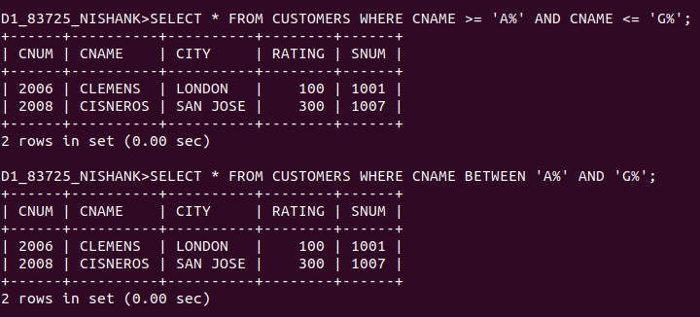

4) Write a query that selects all customers whose names begin with the letter ‘C’.
Ans:

D1_83725_NISHANK>SELECT * FROM CUSTOMERS WHERE CNAME LIKE 'C%';

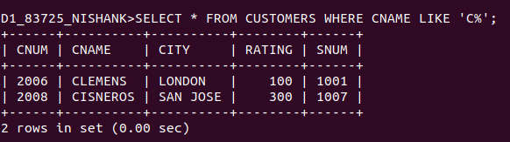

5) Write a query that selects all orders except those with zeroes or NULLs in the amt field.
Ans:

D1_83725_NISHANK>SELECT * FROM ORDERS WHERE AMT != 0 OR AMT != NULL;

