MongoDB Assignment

I completed the Assignment on the day MongoDB was taught to us, but it came to my knowledge later that we had to take screenshots for this exercise, till that time I had closed the terminal, therefore, I did the following Assignment later and this is the file made for reuploading, kindly understand the situation

- Install MongoDB database server
- Create a directory/folder to store MongoDB datafiles
- Set necessary path environment variable

Ans for 1, 2, 3 Q’s:

In Linux, what we directly did is install MongoDB from the official website,
once it got installed, we gave the command mentioned in Q4 and Q5, so from there, we directly started the MongoDB database in the MongoDB Command Line Client

- Startup MongoDB database

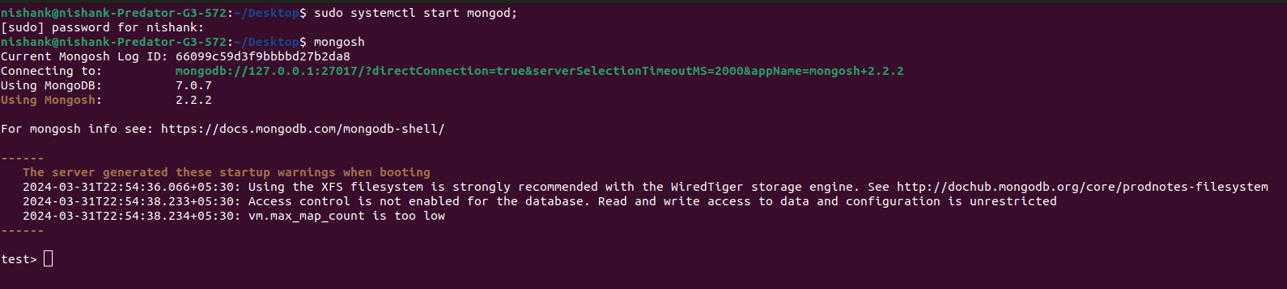

- Connect to MongoDB database through MongoDB shell command line interface

- View list of available databases

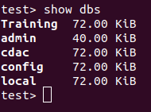

- Create a new database named CDAC and connect to it

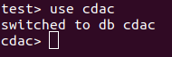

- View list of available collections in CDAC database

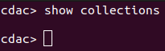

- Create a new collection by the name of LIBRARY

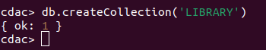

- Insert the following document in the LIBRARY collection:-title:'MongoDB programming', author:'Sameer', likes:100

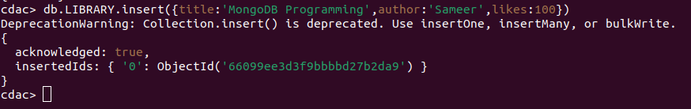

- View the recently inserted document and note the _id field

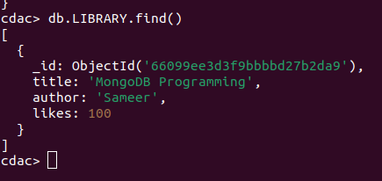

_id (Object ID): 66099ee3d3f9bbbbd27b2da9

- Insert another document in the LIBRARY collection as follows:-title:'MySQL programming', authors:['Jack','Jill'], likes:200

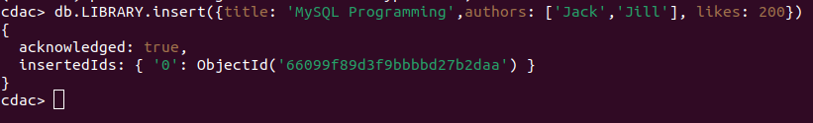

- View the inserted documents
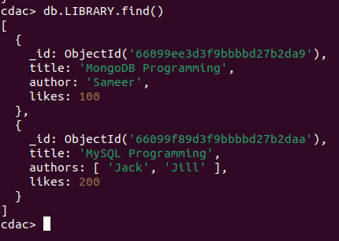

- View only the first inserted document
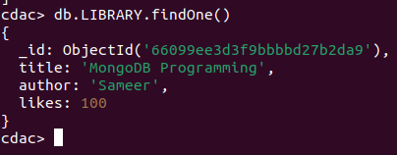

- View the documents using the pretty() method
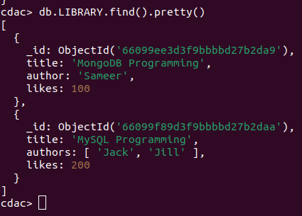

- Update the document where author name Sameer and change it to Sameer Dehadrai

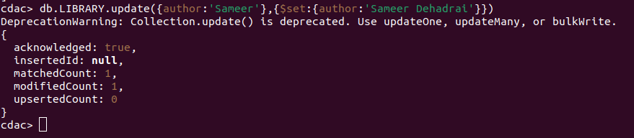

- Delete all documents that have 100 likes

- Drop the LIBRARY collection

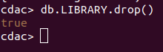

- Drop the CDAC database

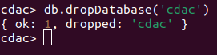

- Exit from MongoDB shell

- Stop MongoDB server

That is applicable in “Windows”, where what we have to do is

1. Press Ctrl + C key in order to stop the MongoDB Server
2. type ‘exit’ in order to exit from the MongoDB shell

