Assignment – 7

Summarizing Data with Aggregate Functions.

1) Write a query that counts all orders for October 3.
Ans:

D1_83725_NISHANK>SELECT COUNT(ODATE) "ORDERS FROM 03-10-1990" FROM ORDERS WHERE ODATE = '1990-10-03';

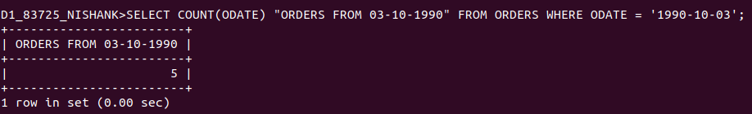

2) CorrECTION Write a query that counts the number of different non-NULL city values in the Customers table.
Ans:

D1_83725_NISHANK>SELECT DISTINCT(CITY) FROM CUSTOMERS;

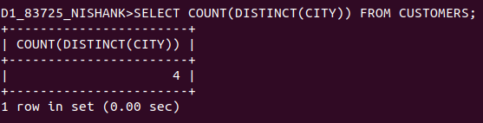

3) Write a query that selects each customer’s smallest order
Ans:

D1_83725_NISHANK>SELECT CNUM, MIN(AMT) FROM ORDERS GROUP BY (CNUM) ORDER BY CNUM;

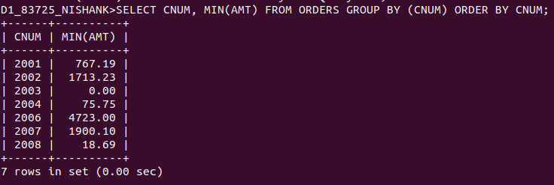

4) Write a query that selects the first customer, in alphabetical order, whose name begins with G.
Ans:

D1_83725_NISHANK>SELECT CNAME FROM CUSTOMERS WHERE CNAME LIKE "G%" LIMIT 1;

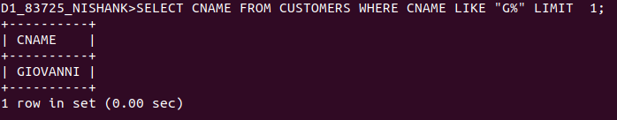

5) Write a query that selects the highest rating in each city.
Ans:
D1_83725_NISHANK>SELECT CITY, MAX(RATING) FROM CUSTOMERS
-> GROUP BY CITY;
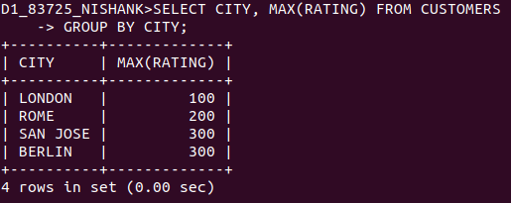

6) Write a query that counts the number of salespeople registering orders for each day. (If a salesperson has more than one order on a givenday, he or she should be counted only once.).
Ans:

D1_83725_NISHANK>SELECT COUNT(DISTINCT SNUM) "ORDERS MADE(PER DAY)", ODATE FROM ORDERS GROUP BY ODATE;

