Assignment – 8

Formatting Query output.

1) Assume each salesperson has a 12% commission. Write a query on the orders table that will produce the order number, the salesperson number, and the amount of the salesperson’s commission for that order.
Ans:
D1_83725_NISHANK>SELECT ONUM, SNUM, AMT*0.12 COMMISSION FROM ORDERS ORDER BY ONUM;

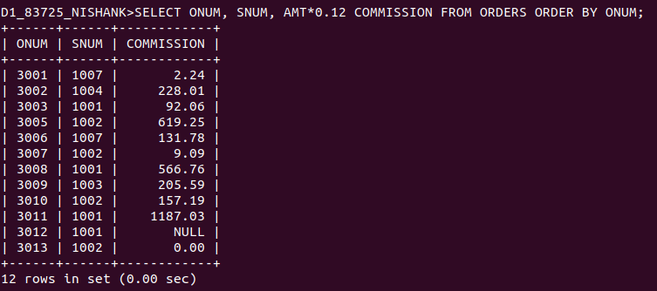

2) Write a query on the Customers table that will find the highest rating in each city. Put the output in this form: For the city (city), the highest rating is: (rating).
Ans:

D1_83725_NISHANK>SELECT LPAD(CITY, 21, 'FOR THE CITY '), LPAD(MAX(RATING), 25, 'THE HIGHEST RATING IS : ') FROM CUSTOMERS GROUP BY CITY ORDER BY MAX(RATING);

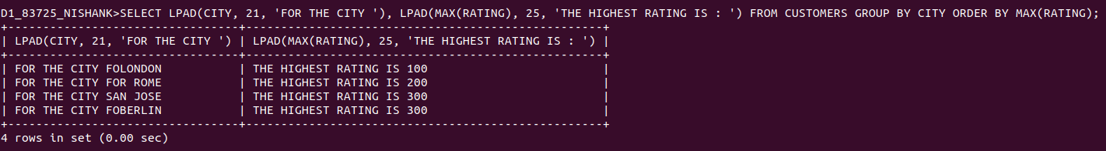

3) Write a query that lists customers in descending order of rating. Output the rating field first, followed by the customer’s name and number.
Ans:

D1_83725_NISHANK>SELECT RATING, CNAME, CNUM FROM CUSTOMERS ORDER BY RATING DESC;

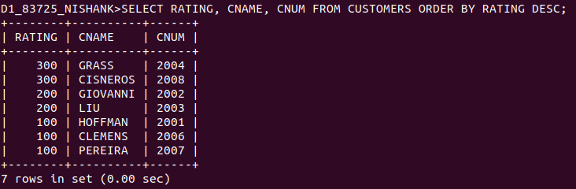

4) Write a query that totals the orders for each day and places the results in descending order.
Ans:

D1_83725_NISHANK>SELECT COUNT(ODATE) "NUMBER OF ORDERS", ODATE FROM ORDERS GROUP BY ODATE;

