Assignment – 9

Querying Multiple Tables at Once.

1) Write a query that lists each order number followed by the name of the customer who made the order.
Ans:

D1_83725_NISHANK>SELECT ONUM, CNAME FROM ORDERS, CUSTOMERS WHERE CUSTOMERS.CNUM = ORDERS.CNUM ORDER BY ONUM;

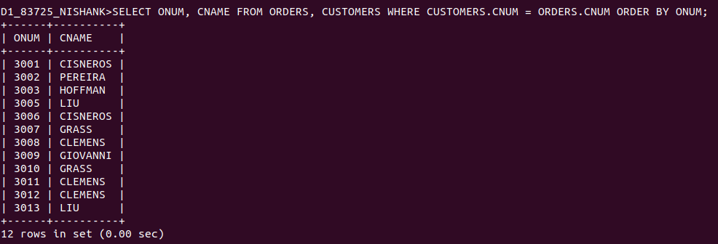

2) Write a query that gives the names of both the salesperson and the customer for each order along with the order number.
Ans:

D1_83725_NISHANK>SELECT SNAME, CNAME, ONUM FROM SALESPEOPLE, CUSTOMERS, ORDERS
-> WHERE SALESPEOPLE.SNUM = ORDERS.SNUM AND CUSTOMERS.CNUM = ORDERS.CNUM
-> ORDER BY ONUM;

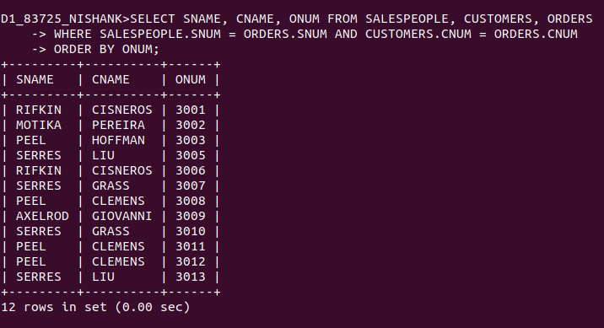

3) Write a query that produces all customers serviced by salespeople with a commission above 12%. Output the customer’s name, the salesperson’s
name, and the salesperson’s rate of commission.
Ans:

D1_83725_NISHANK>SELECT CNAME, SNAME, COMM FROM SALESPEOPLE, CUSTOMERS WHERE CUSTOMERS.SNUM = SALESPEOPLE.SNUM AND COMM > .12 ORDER BY CUSTOMERS.SNUM;

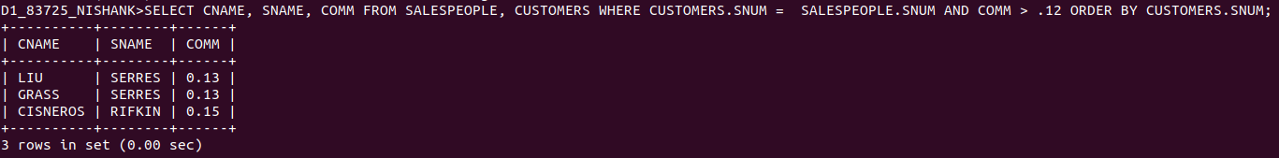

4) Write a query that calculates the amount of the salesperson’s commission on each order by a customer with a rating above 100.
Ans:

D1_83725_NISHANK>SELECT ONUM, CNAME, AMT*COMM COMMISSION FROM ORDERS, CUSTOMERS, SALESPEOPLE WHERE ORDERS.CNUM = CUSTOMERS.CNUM AND ORDERS.SNUM = SALESPEOPLE.SNUM AND RATING > 100 ORDER BY ONUM;

