SQL Assignment – 12

Using the operators IN, ANY, and ALL.

1) Write a query that selects all customers whose ratings are equal to or greater than ANY of Serres’.
Ans:

D1_83725_NISHANK>SELECT CNAME, RATING FROM CUSTOMERS, SALESPEOPLE WHERE
-> RATING >= ANY (SELECT RATING FROM CUSTOMERS WHERE SNUM = (SELECT SNUM FROM SALESPEOPLE WHERE SNAME = 'SERRES')) AND
-> CUSTOMERS.SNUM = SALESPEOPLE.SNUM;

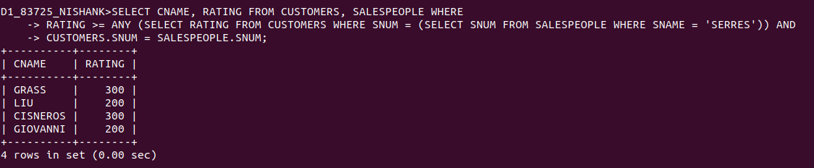

2) Write a query using ANY or ALL that will find all salespeople who have no customers located in their city.
Ans:

D1_83725_NISHANK>SELECT SNUM, SNAME, CITY FROM SALESPEOPLE WHERE CITY NOT IN(SELECT CITY FROM CUSTOMERS WHERE CUSTOMERS.SNUM = SALESPEOPLE.SNUM);

OR

D1_83725_NISHANK>SELECT SNUM, SNAME, CITY FROM SALESPEOPLE WHERE CITY != ANY (SELECT CITY FROM CUSTOMERS WHERE CUSTOMERS.SNUM = SALESPEOPLE.SNUM);

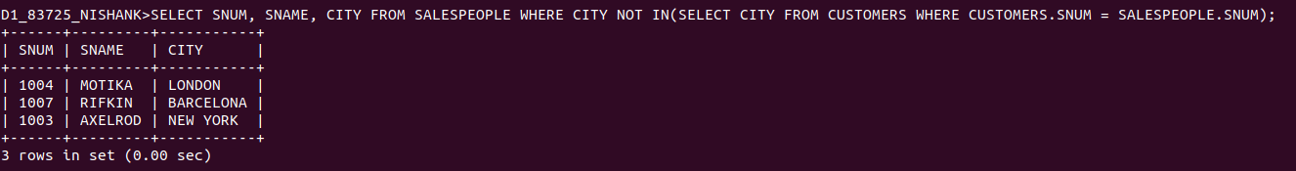
3) Write a query that selects all orders for amounts greater than any for the customers in London.
Ans:

D1_83725_NISHANK>SELECT DISTINCT ONUM, AMT FROM ORDERS WHERE AMT > ANY (SELECT AMT FROM ORDERS WHERE CNUM IN (SELECT CUSTOMERS.CNUM FROM CUSTOMERS WHERE CITY = 'LONDON'));

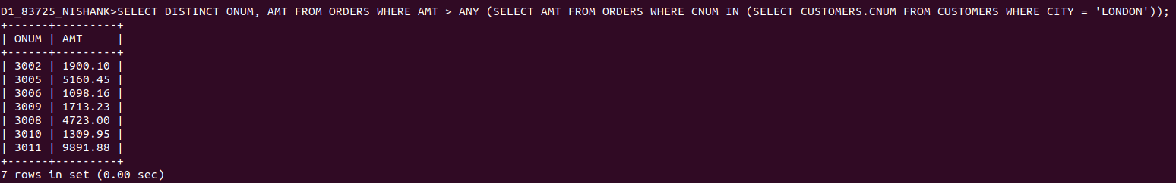

4) Write the above query using MIN or MAX.
Ans:

D1_83725_NISHANK>SELECT DISTINCT ONUM, AMT FROM ORDERS WHERE AMT > (SELECT MIN(AMT) FROM ORDERS WHERE CNUM IN (SELECT CNUM FROM CUSTOMERS WHERE CITY = 'LONDON'));

